James Charles Shoemark’s Story

Two cousins at Gallipoli from different ends of the earth

This is a family which continually changed the spelling of its name. You can find it as Shoemark, Shoemake, Shumark, Shumack, Shoemarke… which makes research difficult.

James’ grandparents, James and Jane Shoemark were born in Ash and Tintinhull respectively but lived in Stoke for most of their lives. James’ father, George, was born in Ash in 1845. His younger brother, Henry, also born in Ash, had a son called Gilbert – James’ first cousin. They were to die ten miles apart and within days of each other.

There is no mention of Gilbert or James Shoemark in the school records, though there is an entry saying that Mrs Dalwood called on 22nd October 1886 asking for A. Shoemake to be put into a lower standard. “He has been very irregular, partly through illness.” This could have been James’ brother, Arthur, or Gilbert’s brother, Albert, both of whom would have been nine or ten years old at the time.

James married Maggie Whitty in 1900 and their baby, Violet, was born in West Coker in 1901. James was two years younger than Maggie and they were obviously struggling to afford a place of their own as at the time of the 1901 census, they were living with baby Violet in Castle Street with James’ parents, George and Harriett (neé Gaylard). James was working as a stonemason like his father. His three sisters also lived in the house, as well as a six year old grandson called Bertie Tavender.

Violet died in 1902 and Doris Kathleen was born in 1903. The family moved to Wash Lane in Montacute. James’ service record mentions a child called Catherine, born on4th February 1905 in Montacute In 1911, James describes himself as a walling mason and Maggie as a glove machinist. Her mother, Jane Whitty, is living with them. Doris – known as Kathleen – is eight years old.

The Commonwealth War Graves Commission describe James as the son of Mrs George Shoemark of New Plymouth, and the husband of the late Margarette Shoemark.

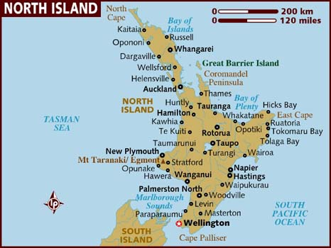

James’ father, George Shoemark, had died in 1911. Did James and his mother emigrate together to New Plymouth? New Plymouth is in the Taranaki region of North Island and is very like Devon in its landscape. It has very English weather, rich volcanic soil and consequently rich dairying and beautiful gardens. New Plymouth is a nice little town and has a beautiful old white church with a sad cemetery full of settler and soldier graves from the Maori Wars in the 1860s.

James enlisted on 11th January 1915. He gives his next of kin as being his wife, Mrs Margaret Shoemark of Back Lane, Montacute. By the time they were sorting out who his medals were to be sent to in 1923, his wife is described as deceased and his medals (Egypt, Gallipoli and 1914-15 Star) were to go to his daughter, Miss D K M Shoemark, c/o Mrs J Whitty of Back Lane, Montacute. The only death of a Margaret Shoemark I can find in that period was a Margaret who died in the Yeovil area aged 35 in June 1913. Could it be that news of his wife’s death had not reached James in New Zealand by the time he joined up eighteen months later in January 1915? It seems very strange.

James was living in Palford Street, New Plymouth when he joined up. He is described as having a fair complexion, grey eyes and light brown hair. He was 33 years old, 6’ ½” and 153 lbs. His occupation was bricklayer, his last employer being a Mr W Coleman. He enlisted into the Wellington Infantry – B Company of 4th Reinforcements.

At the start of the war, Defence Offices throughout the country were besieged with applicants for enlistment. It was decided that Auckland, Wellington, Canterbury, and Otago were each to supply one battalion of Infantry. The Expeditionary Force raised in the Wellington district was called "The Wellington Regiment," and its four companies were called, respectively: the 7th Wellington West Coast Company, usually shortened to the "West Coast" Company, the 11th Taranaki Company ("Taranaki" Company), the 9th Hawkes Bay Company ("Hawkes Bay" Company), and the 17th Ruahine Company ("Ruahine" Company). James was in the 4th Reinforcements, so I suppose would have been placed in whichever company was in need of men.

According to the Regimental history, the 2nd Reinforcements arrived while the Regiment was in camp near Cairo in February 1915. It was their first action. They were defending the Suez Canal.

The Regiment was then ordered to join the Mediterranean Expeditionary Force, under Sir Ian Hamilton.

WHY GALLIPOLI?

By this time the fighting in France and Belgium was deadlocked. There were plans to attack Germany by an offensive through the Balkans or by landing on the Baltic coast as an alternative to the attacks on the Western Front. Then early in 1915, the Russians found themselves threatened by the Turks in the Causasus and appealed for help. The British decided to send a naval expedition to take the Gallipoli Peninsular on the western shore of the Dardanelles, in order to capture Constantinople. The plan was to link up with the Russians, knock Turkey out of the war and possibly persuade the Balkan states to join the Allies.

The naval attack began on 19th February 1915. Bad weather caused delays and the attack was abandoned after three battleships had been sunk and three others damaged, so what had been a naval campaign now became a land attack. By the time troops began to land on 25th April, the Turks had time to prepare fortifications and the defending armies were now six times larger than when the campaign began.

THE WELLINGTON REGIMENT ARRIVES AT GALLIPOLI

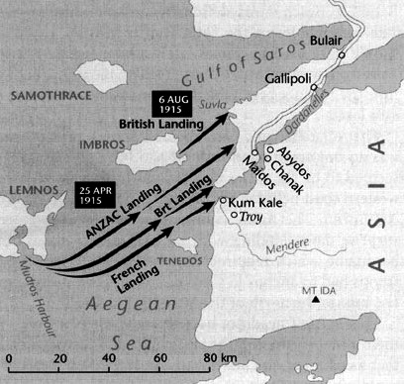
James Shoemark was with the 4th Reinforcements Wellington Regiment, New Zealand Expeditionary force. The Wellington Regiment landed at Anzac Cove [ANZAC Landing] on 26th April 1915 but James may have arrived later.
His cousin, Gilbert Shoemark, arrived with the 7th Bn Royal Dublin Fusiliers on 7th August 1915, landing at Suvla [British Landing]

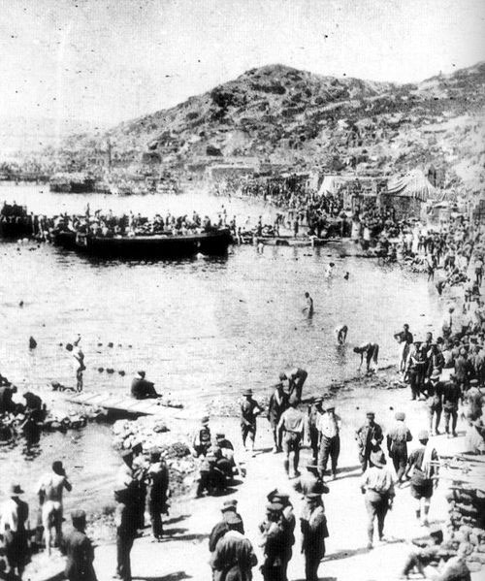
Gaba Tepe – just south of Anzac Cove
On 25th April, the companies of the Wellington Regiment landed at Anzac Cove and took part in the fighting on Walker’s Ridge. They then embarked for Cape Helles for the 2nd Battle of Krithia.

On the 19th May they returned to Anzac Cove by ship. The Regiment then bivouacked in Rest Gully between 23rd and 27th May with periods in the trenches and periods of rest.

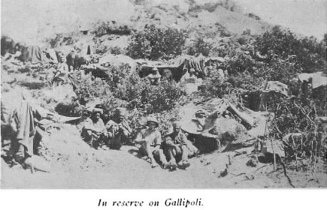

I don’t know when James joined the Wellington Regiment at Gallipoli, but he was in the 4th Reinforcements and the Regimental history writes of the 5th Reinforcements arriving and being immediately plunged into action on 8th August so it was presumably before that date.
The Commanding Officer, Lieutenant Colonel Malone “was a man to whom untidiness was anathema. He disliked it as much in war as he had done in civil life. His first desire on landing was to tidy up the beach a bit…. At Helles, when reinforcements arrived, he quickly set them to work to tidy up the battlefield”.
This may have been the task of James Shoemark and the 4th Reinforcements.
The Regimental history describes the conditions at that time:
“At the beginning of June, the heat by day became oppressive. All ranks reduced their clothing to a minimum. Discarding tunics, a shirt and shorts became the accepted uniform for the trenches. With the advent of hot weather, flies made their appearance in swarms and the sick rate in most Regiments began to mount at an alarming rate. The most prevalent trouble was an epidemic in the nature of dysentery, medical opinion differing as to whether it was true dysentery or merely diarrhoea arising from unsuitable diet. Very few individuals who had been a few weeks in Gallipoli escaped this infection. However, the policy of the Medical Corps and the inclination of the officers and men themselves was to keep on duty to the last possible moment. No one would go sick or allow himself to be evacuated sick unless he were very near the collapsing point.
The direct effect of this epidemic on the troops was that their physical condition became greatly lowered. Men lost weight rapidly, and became thin and gaunt. Despite all the sickness, no change was made in the diet of bully beef, usually very salty, biscuit and thin apricot jam. A few issues of bread were made, but these soon ceased. Assisted by the heat and dust in the trenches and by the fact that the scarcity of water made it impossible to wash clothes or bodies, vermin spread among the troops. The only chance of a wash was by getting leave to visit the beach for a swim. Owing to the large number of men constantly on duty, this was not easy to arrange and as it meant a hot and dusty walk of a mile or more men soon lost the desire to undergo the exertion. No provision, such as later obtained in France, existed for the purpose of de-lousing the men's clothing.”

THE BATTLE OF CHUNUK BAIR 7th – 8th August 1915
[A guide to Anzac Day for New Zealanders]
“One of New Zealand's epic stands on the Gallipoli peninsula was in the heat of August 1915 at Chunuk Bair, one of the three high points on the Sari Bair range. These were the main objectives of the Anzacs' offensive of early August 1915 when they tried to break out of the stalemate with the Turks in the Anzac sector.
The New Zealand Infantry Brigade advanced up Chailak Dere and Sazli Beit Dere during the night of 6-7 August to capture Chunuk Bair. Earlier, their way had been opened by the New Zealand mounted rifles units and the Maori Contingent, which had captured key points (including Old No 3 Outpost and Table Top) guarding the valleys in daring night assaults.
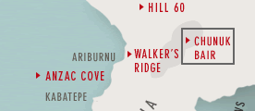
The attack had fallen behind schedule and the New Zealanders were still a kilometre short of the summit when dawn broke on 7 August, sheltering at a position below Rhododendron Ridge that would become known as The Apex. In a mid-morning attack the Auckland Battalion suffered heavy casualties to reach the Pinnacle, 200 m from the summit. When ordered to follow suit, the Wellington Battalion's commander Lieutenant-Colonel William Malone refused to sacrifice his men in a futile attempt, insisting that the attack be mounted that night.
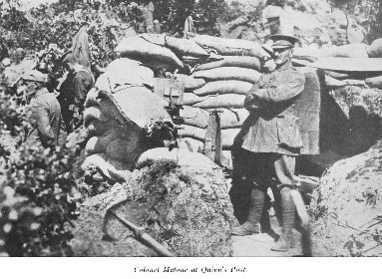
In the pre-dawn darkness of 8 August the Wellington swiftly moved up Rhododendron Ridge on to the summit, which almost inexplicably had been abandoned by its Turkish defenders. When the sun rose, Malone and his men, assisted by some Auckland mounted riflemen and British troops who also reached the summit, engaged in a desperate struggle to hold off the Turks.

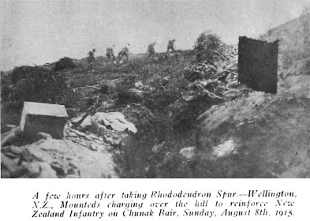
The Otago Battalion and Wellington Mounted Rifles relieved the Wellingtons during the night of 8-9 August only to endure a similar ordeal all through the long summer day. They, too, were relieved during the night of 9-10 August by two British battalions, which almost immediately succumbed to a massive counterattack launched by the Turkish commander, Mustafa Kemal.
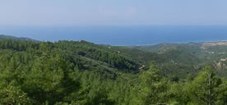
View from
Chunuk Bair
The summit was lost, but the New Zealanders stemmed the Turkish flood down the seaward slopes of the hill. The Apex was held until the end of the campaign.”
James is remembered on the Chunuk Bair Memorial in Gallipoli. This is one of four memorials erected to commemorate New Zealand soldiers who died on the Gallipoli peninsula and whose graves are not known. It bears more than 850 names. The cemetery was made on the site where the Turks had buried some of those Commonwealth soldiers who were killed on 6-8 August. It contains 632 Commonwealth burials, only ten of which are identified.
James is related, not only to Gilbert Shoemark, but also to Bertie Clarke and Cyril Gold.
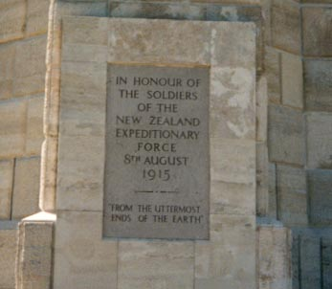
The inscription on the Chunuk Bair Memorial reads:
SHOEMARK, Private, JAMES CHARLES, 10/1982.(23)
Wellington Infantry Regiment, 4th Reinforcements N.Z.E.F.
Killed in action 8th August 1915 age 33.
ENLISTMENT ADDRESS: Fulford St, New Plymouth
Son of Mrs George Shoemark, of New Plymouth
Husband of the late Margarette Shoemark, Back Lane, Montacute, Somersetshire, England

