Albert Bowden’s Story

Albert’s name is on the Stoke Roll of Honour but not on the Ham Hill Monument. He gives his birthplace as Yeovil rather than Stoke sub Hamdon and this might be why he is not on the Monument. His parents, John and Lydia/Lilian Bowden, were living in Castle Street (somewhere near Castle Terrace and the bottom of Bonnie’s Lane) in 1891, and working in the gloving industry. John stated on the census that he was born in Barnstaple and Lydia that she was born in Weymouth, though she changed her mind in subsequent census years and recorded her place of birth as being first Castle Cary and then Yeovil. She also referred to herself as Lilian later on.

There was an A Bowden and T Palmer on the school record books, being punished for truancy on 26th June 1889. If this was Albert, he would have been nine years old. He was obviously a boy with a thirst for adventure because when he enlisted “for the duration of the war” on 3rd October 1914, he stated on his Attestation Form that he had already seen previous service with the 3rd Battalion of the Dorsetshire Regiment.

John Bowden gave his age as 60 in 1891, with Lydia being 26. In 1894, he died and Lydia/Lilian married again – to Walter Shoemark - in 1898. In 1901, the family were living in Castle Street – Walter and Lydia, Albert’s two brothers – Joseph aged 8 and Bernard aged 4 – and two little girls from the second marriage, Kate Maud and Bessie Jane. There is no mention of Albert so presumably he was away in the Army.

Ten years later, he was back living with his family but by this time they had moved to 37 Stanley Street, Senghenydd, near Caerphilly in Wales. Walter, aged 54 (Lilian had chosen a husband closer to herself in age this time) was working as a colliery labourer. Albert was 30 and working as a labourer underground. Bernard is living with them, aged 14, and there were now three little Shoemark sisters, the youngest being Julia aged 8.

James Thorne, another of the Stoke men to die in the War, had been living in Stanley Street with his family for some time. He and Rosina were living in No. 5. Both James and his younger brother, William, were working as coal miners. In 1913 there was a huge explosion in the mine and 440 men and boys lost their lives. Several of the men who died were living in Stanley Street.

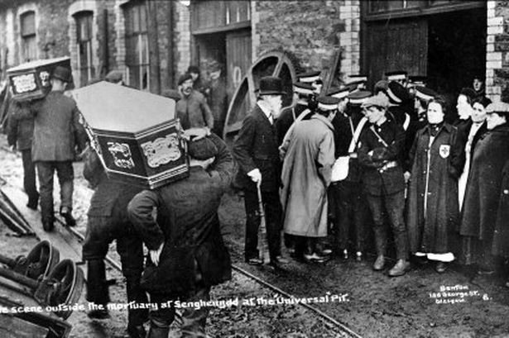
Outside the mortuary of Senghenydd at the “Universal” Pit, 1913

When Albert joined up in October 1914, he was 5’ 9 ½”, with dark hair and blue eyes. He weighed 154 lbs and was 33 year old and unmarried, his next of kin being his mother. He was posted on active service as private in the 1st Battalion of the Dorsetshire Regiment on 4th December 1914.

He would have taken part in the Battle for Hill 60 (22-23rd April 1915) when the first gas attack took place on the Western Front. “It was an undescribably unforgettable image for those of us witnessing this first gas attack at close range” [Lt Max Tiessen].

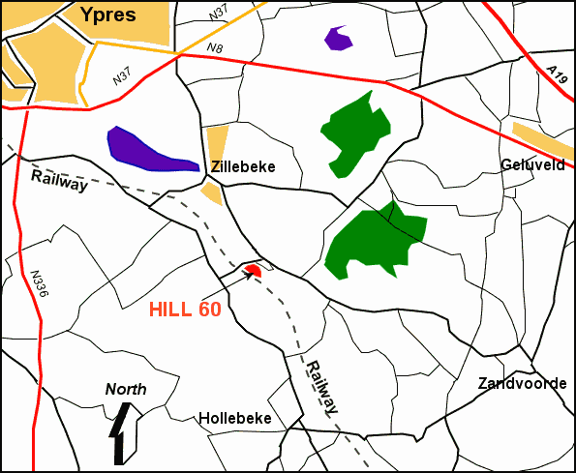

Hill 60 – 2nd Battle Ypres - 1915

The war diary for 2nd Battalion Dorsetshires does not mention gas, but does mention heavy shelling.

On 20th April 1915, they are in 31 Trench, suffering heavily from shelling. There are three officer casualties that day and 24 Other Ranks wounded. Over the next three nights, they are again shelled continuously throughout the night.

On 22nd April at 6.30 p.m. there is “heavy shelling of Ypres and approaches.” They get a message from Brigade telling them that they will not be relieved as arranged. Over these two days there are 10 men wounded and 1 killed.

On 23rd April, they receive orders at 5 p.m. “to reconnoitre route to 2nd line of trenches in event of it becoming necessary for the Bn to withdraw”. “31 Trench again shelled throughout night”. That night they report 7 men wounded.

On 24th April they receive orders at 2 p.m. that “if situation permitted, Bn would be relieved by DCLI and got to Camp F at Ouderdem”, but at 4.00 p.m. they were again told that the relief would not take place. At 6.40 p.m., they reported to Brigade – 2 killed and 17 wounded.
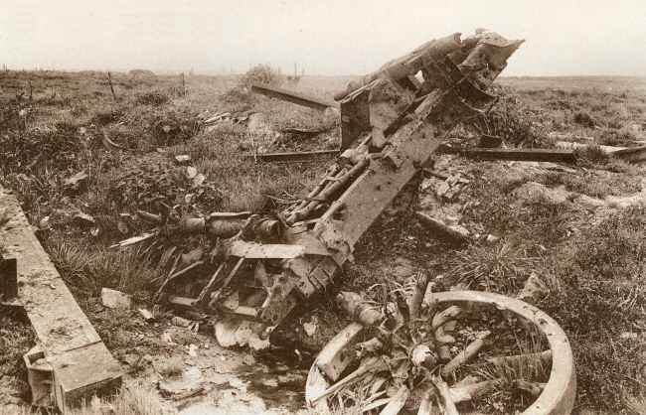
Hill 60 sometime after the war Photo: NELS

At last, on 25th April, at 10.00 p.m. the DCLI relieved the 2nd Dorsetshires. The Germans opened heavy artillery and rifle fire during the relief “but few casualties resulted”.

On 26th April, Battalion moved across country by companies to billets at Kruisstraat. Casualties – 4 wounded.

Albert received a gunshot wound to his stomach on 27th April and was admitted to a hospital in Boulogne on 6th May. He died the next day. He is buried in Boulogne Eastern Cemetery.

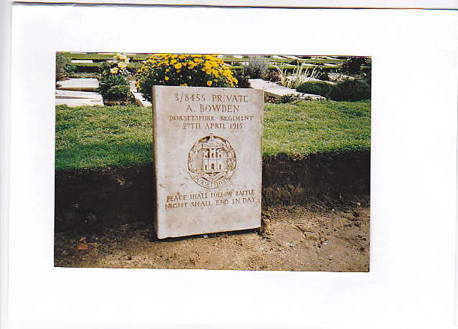

His medals were sent to Lilian in Senghenydd. Lilian wrote to the War Office to say that the parcel containing his personal effects had been broken into.

His brother, Bernard, joined up in December 1914, aged 19 years, but did not see active service.

