Horace Brooks’ Story

Horace Brooks was the hope of his house, due to take over the running of his father’s gloving factory in Stoke, but sadly he died in the last month of the war.

William Brooks, Horace’s father, was from Yeovil, as were William’s parents – Thomas and Martha Brooks. Horace’s mother, Rose Rowsell, was born in Stoke. Her father, Henry, was a carpenter from South Petherton, but her mother was a Gaylard, and the Gaylards were an old Stoke family – this being the third most common name in Stoke in 1841.

Thomas Brooks was a glover, living in the Duke of York Court, Yeovil in 1871 with his wife Martha, William aged 3 (Horace’s father) and Mary Ann, aged 1. In 1873, Alfred was born, followed by Rosie in 1875 and Oliver in 1879 – all in Yeovil. The next child, Thomas Bryant, was born in Barnstaple. Thomas will probably have taken his family to Pilton, near Barnstaple, where there was a glove factory employing 200 workers in the 1880’s.

By 1881, however, the family had arrived in Stoke and were living on Ham Hill. Their last child, Dora, was born in Stoke and baptised in the United Reform Church on 8th October 1882. William, the eldest, was 15 years old. His mother, Martha, died a year after Dora was born. Annie, the eldest daughter, would have been 14 when her mother died. A lot of responsibility must have fallen on her shoulders.

William married Rose Rowsell in 1888 and moved out of the family home, living in Stone’s Lane in 1891. His youngest sister, Dora, aged eight by this time, was staying with them as a “visitor”.

William was working as a glove cutter for Southcombe’s in the 1880’s. He started trading on his own around 1897 as a Glove and Chamois Leather Manufacturer in West Street. This is the earliest known photograph of Southcombe glove cutters c 1880s.
Top row 4th left: William Brooks.

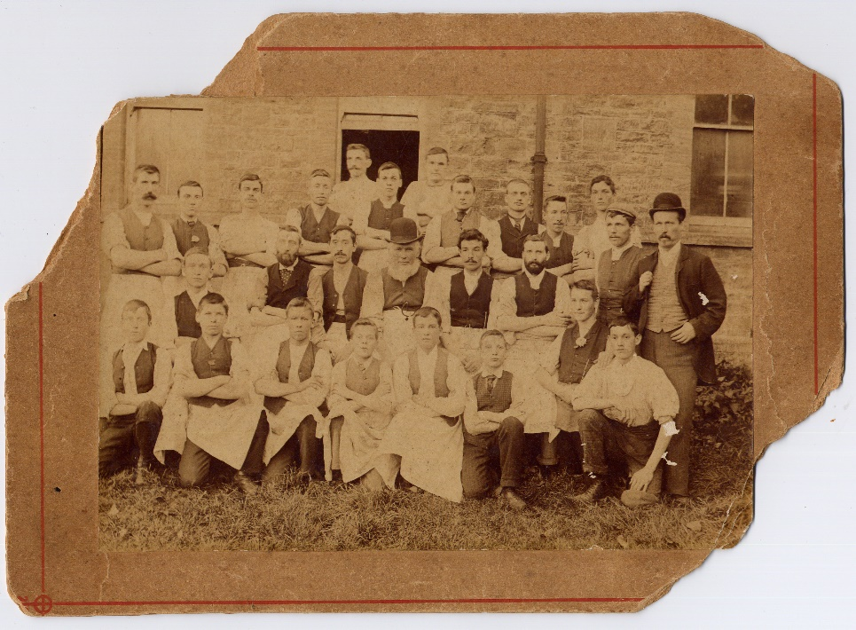

In 1901, William was living on Ham Hill. He described himself as a “Glove Manufacturer” and an employer. Horace had arrived on the scene. He was six years old. His elder sister, Lily, was eight, Myrtle was four, Hensleigh two and Olive (born at 43 Ham Hill) was six months.

William was already a pillar of the community. He became a parish councillor between 1900 and 1905 and was a keen Liberal. He was also at some time a White Star Line agent – perhaps it was William who persuaded young men from Stoke like Percy Wines to emigrate to Canada. On 23rd December 1881, there is an entry in the school log books:

A Christmas tree was given by Captain Chaffey and articles by Messrs Chaffey, Brooks, Gaylard and J W Walter.

In 1908, he moved to a factory in Windsor Lane. The factory was originally a group of old cottages which were renovated or pulled down to build the factory. Until 1914, he specialised in making housemaids’ gloves. After this he became a general glove manufacturer.

Horace was his eldest son and William had high hopes of his taking over the factory in due course. In 1911 Horace was working as a glove cutter apprentice, learning his trade.
He was a keen member of the Boys’ Brigade, reaching the rank of Staff-Sergeant, and taking part in Boys Brigade activities such as a one act play called, “Wait and See What Will Happen”. He was a good footballer, playing for the Stoke Eleven. According to the Western Gazette obituary, he was “much liked in the village for his quiet, unassuming manner.”

Horace Brooks middle, front.

Horace was one of the first to join up when war broke out in 1914. In this picture of the Stoke volunteers, he is in the back row, centre, next to the girl with the flowers in her hat.

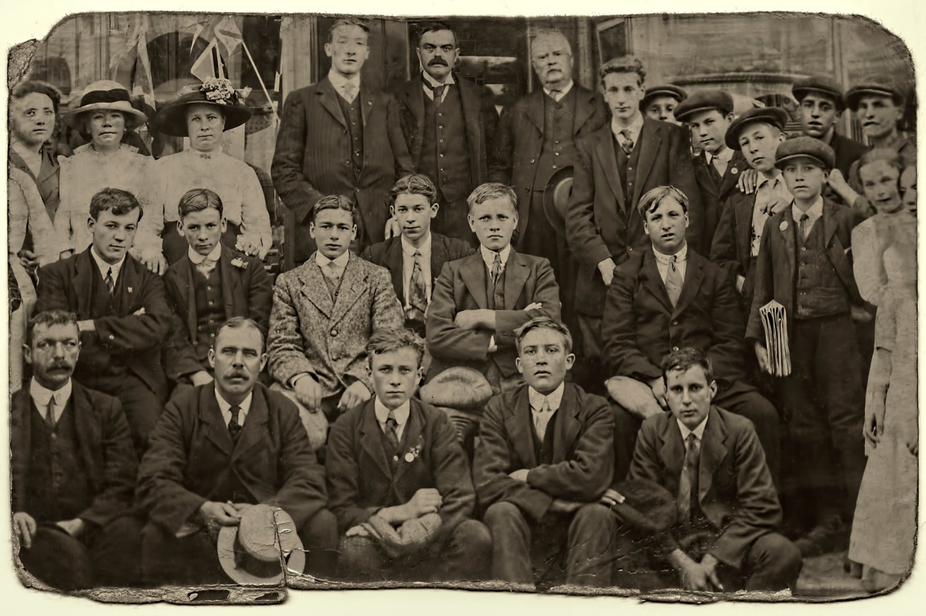

Horace enlisted in the 6th Battalion Somerset Light Infantry on 2nd September 1914. His medical report stated that he was 5’ 9”, 140 lbs with good physical development. All that football had paid off. He describes having finished a five year apprenticeship with “Mr Brooks” on 1st June 1913. The report states that he was 20 years and 1 day but in fact he was 20 years and 1 month. When he applied for a commission at the end of 1917, he gave his birthday as 3rd August 1894.

After a period of training, Horace arrived in France with the 6th Battalion SLI on 21st May 1915.

Everard Wyrall – The Somerset Light Infantry 1914-18

The Battles of Ypres were drawing to a close when the 6th (Service) Battalion of the Regiment landed in France. Since the raising of the Battalion in August 1914, the 6th had spent the first three months in hard training at Aldershot. A move was then made to Witley Camp, Godalming, the Battalion returning to Aldershot again in February 1915, where brigade and divisional training was continued until the middle of April. The 6th Battalion, Somerset L.I. was now in the 43rd Infantry Brigade of the 14th (Light) Division, brigaded with the 6th Duke of Cornwall’s L.I., 6th K.O.Y.L.I., and 10th Durham L.I.
A month later (about the middle of May) spare kit had been sent home and all ranks awaited embarkation orders. A few days later they came, and on 21st May the Battalion crossed the Channel in an S.E. & C.R. mail boat and, on reaching Boulogne, disembarked. The night was spent in the rest camp on the hills overlooking the town.

In June, the battalion had its first taste of life in the front line trenches, almost 2,000 yards north east of Wulverghem. The war diary for Sunday, June 13th : “The trench life was very quiet. A little shelling early in the morning and desultory rifle fire during the day.”

After a week of being in the trenches, the war diary says “The Battalion who were our instructors were full of praise of the bearing and behaviour of the ‘Kitcheners’, whom they saw for the first time.”

At the end of June, the 6th Somersets marched to Ypres. Horace would have witnessed the desolation of Ypres – whole streets of shattered houses.
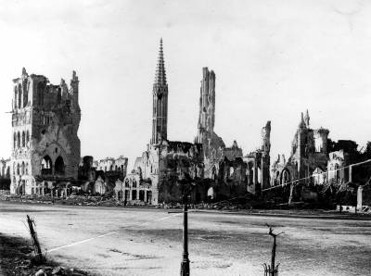
Ruined Ypres

The 6th Battalion took part in the 2nd Attack on Bellewaarde from 25th to 26th September 1915 – part of the Battle of Loos. The 6th Somersets were attached to 42nd Brigade during this time and afterwards the G.O.C. 42nd Brigade sent the following letter to the C.O:-

“Dear Colonel Rawling, I have to thank you and your fine regiment for the great assistance you gave me on the 25th. It was not an easy thing to reinforce, in broad daylight, as you did, and the movement was exceedingly well and quickly carried out. You arrived at a critical time and your dispositions were exactly what was required. The company of your Regiment which formed the garrison for the trenches rendered valuable assistance and I much regret to hear of the losses they sustained.”
[Somerset Light Infantry 1914-18 by Everard Wyrall]

The total casualties suffered by the 6th Somersets during the month were: officers, 3 killed, 4 wounded; other ranks, 26 killed, 107 wounded.
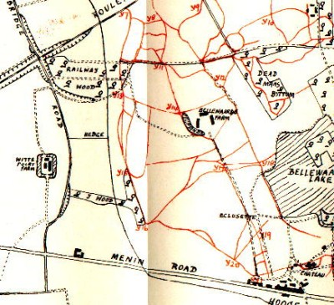
Bellewaarde Farm
6th Somersets were at Railway Wood – “The Battalion held on all day ….”

War Diary

At the end of October the 6th Battalion are billeted at Poperinghe. The Diary records: “Spirits of the men splendid. With incessant rain, plenty of fatigues and no change of clothes and no chance yet of getting warm they can still stand for hours playing and watching football matches.” Horace was still getting his football.

Everard Wyrall writes: The first three weeks of November were passed under the most wretched conditions, but on 23rd the Battalion marched to the front-line trenches just north-east of St Jean, relieving the 10th Durham L.I. Two days in and two days out of the front line was the rule at this period, but between the miserable conditions of the billets and the filthy state of the trenches there was little choice.”

Fortunately, Horace came home on 16th November 1915. There is no mention on his war record of his having been wounded and no report in the Western Gazette of his coming home on leave, but his Military History states that he was home from 16th November 1915 until 19th May 1916. At least he escaped the winter in the trenches.

One of the photographs sent home by Horace

On 25th April 1916, he transferred to the 1st Garrison Battalion of the Hampshire Regiment. I have not been able to discover where this battalion was in 1916 or what it was doing but it was formed in April 1916. Horace moved with it to France on 20th May 1916. Thereafter, his rise through the ranks was meteoric and each time he was promoted it was “in the field” according to his military record.

On 21st May, the day after his arrival in France, he was appointed Lance Corporal. Then Acting Corporal on 24th May. He was promoted to Corporal on 26th July of that year.

On 20th January 1917, he was admitted to the 2nd Australian Casualty Clearing Station with bursitis.
The 2nd Australian Casualty Clearing Station was at Trois Arbres, near Bailleul in January 1917, so we know that Horace was in the Ypres area at this time.
As we are now in our ninth month up at the front, probably a description of the work and conditions of this Hospital may be of interest. As to our location all I can say is, we are in Flanders, and about 7000 yards from the front line trenches, sharing with No. — Australian Casualty Clearing Station the distinction of being the nearest to the line…
Lieut.-Col. H. S. Stacy, The Medical Journal of Australia, May 26, 1917 (pp 437)
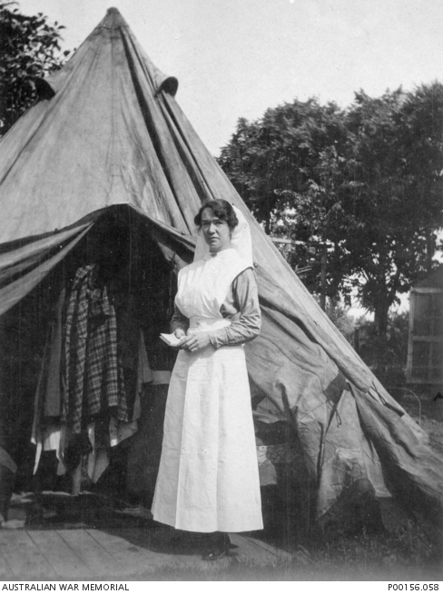
Trois Arbres, France 1916. Sister Ada Smith of the 2nd Australian Casualty Clearing Station near Steenwerck.

AWM

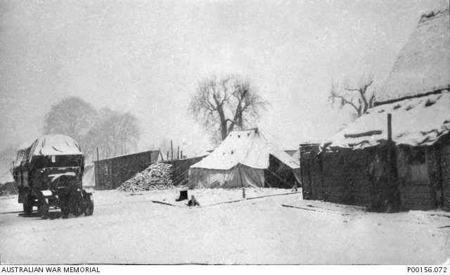
Trois Arbres circa 1917. Tents and buildings of the 2nd Australian CCS near Steenwerck under snow.
AWM

On 4th February 1917, Horace was “discharged to duty,” presumably back to the 1st Garrison Battalion of the Hampshire Regiment.

On 16th June 1917, he was appointed Lance Sergeant, and on 16th October of that year, he came home. The Western Gazette reports that he…

Came home with the rank of sergeant and after taking his commission he joined the 7th Somerset Light Infantry in Ireland and went to France at the end of July.

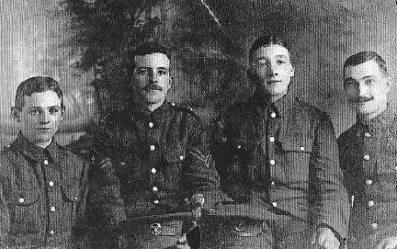

Horace is second from the right

On his application for Temporary Commission, Horace states that he is not married, would like a commission in the Infantry - preferably in the Somerset Light Infantry –
and that he is able to ride. He was posted to the Office Cadet Battalion in Oxford on 8th February 1918.

He went back to France as a 2nd Lieutenant on 26th June 1918. The 8th Battalion went into the front line trenches at Souastre, north of Albert, the day before Horace arrived. Experienced young officers such as Horace who had come up from the ranks, must have been invaluable, especially as some of the men in the battalion were, as the Battalion diary says, “only boys who had seen little or no previous service.”

Although the Western Gazette states that Horace joined the 7th Battalion of the Somerset Light Infantry as an officer, I can’t find any mention of Horace having been in the 7th Battalion, and he was definitely in the 8th Battalion in October 1918 as he is mentioned in the War Diary.

Horace had returned in time for the Advance to Victory which started on 8th August 1918. The 8th Battalion was at Bucquoy on that date.

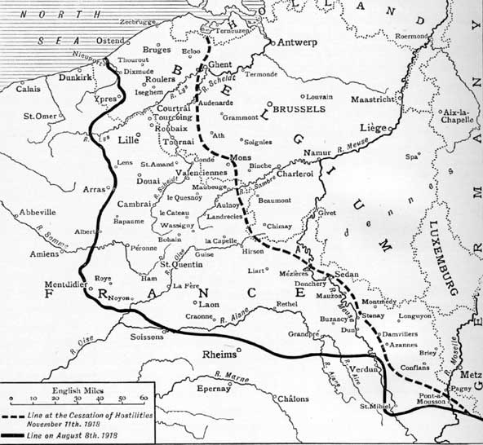
Bapaume
Achiet-le-Grand
Bucquoy, with Souastre just to the west of it.

The 8th Battalion took part in the Battle of Albert at the end of August, fighting around Achiet-le-Grand, Bihucourt and Biefvillers. Between 21st and 26th August they had lost one officer killed (the C.O. Lt.Col. J H M Hardyman was killed by a shell), five officers wounded and 164 other ranks killed, wounded and missing. But the Battalion had captured 300 Germans, 2 trench mortars, 13 machine guns and 3 5.9 howitzers.

By 7th September they were helping in the clearing of Havrincourt Wood, after which the new commanding officer, Colonel Sheringham, received a letter of congratulations from the G.O.C. 63rd Brigade – “Your Battalion has again, therefore, added to its already long list of honours, and I feel sure will continue to do so with the same gallantry and devotion to the end which is now in sight.” Everyone was feeling that the end of the war was approaching. Back in Stoke, Horace’s parents must have felt that he had just about made it through the war and would be on his way home soon.

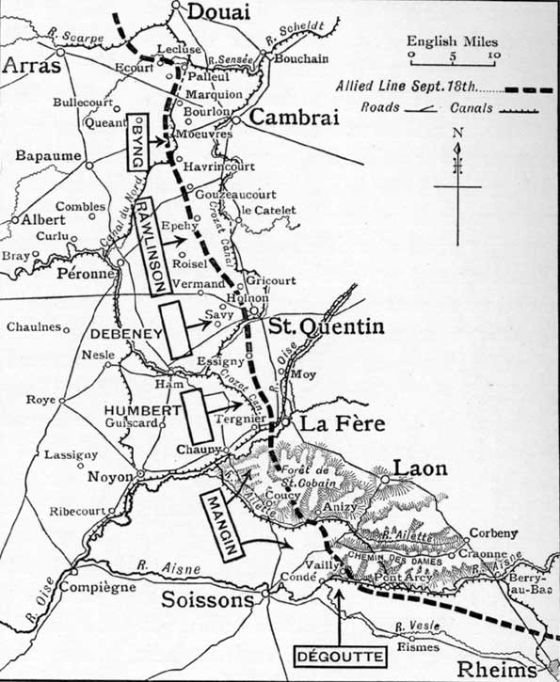
Positions of the British and French Armies in mid September 1918
Havrincourt

By 29th September, the Hindenburg Line was broken.

For the last time the Army was on the march forward over the old Somme battlefields, for the last time the Hindenburg Line had been assaulted, no more a life of seemingly endless days and nights in water-logged trenches, listening to the howling and screeching of the shells as they passed overhead to the back areas, or the hurtle of trench-mortar bombs as they came “plomp-plomp” towards the front and support lines in which men crouched wondering whether the infernal things were going to fall and explode in their trench and make a terrible mess of themselves or their comrades: static warfare had gone – the enemy was on the move, all up and down the line from the fields of Flanders to the Swiss Frontier, everyone knew that the enemy was fighting with his back against the wall in a vain effort to stave off final and ignominious defeat.

So the Somerset men were in great fettle as they moved forward on 30th September as part of the 37th Division, which had been ordered to relieve the 5th Division in the front line between Ribecourt and Beaucamp. The 8th Somersets reached Bertincourt at about 11 a.m. on the 30th and, after the 37th Division had relieved the 5th Division, the Battalion moved to the south eastern corner of Havrincourt Wood. Here the Somersets remained until the 5th October, when the 63rd Brigade moved to the valley north of Gouzeaucourt, still in reserve. [The Somerset Light Infantry 1914-18 by Everard Wyrall]

The 8th Battalion was the only battalion of the Somerset Light Infantry to take part in the Battle of Cambrai and it was for his conduct during this battle that Horace won the MC.

At 10 a.m. on the 10th October, the Battalion was occupying some German practice trenches just east of Caudry. At 2 p.m. orders were received for the Somersets to attack the ridge running south from Briastre, the Lincolns on the right and the Somersets on the left.
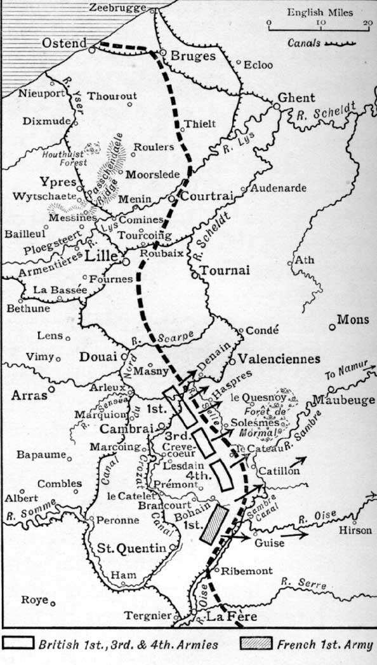
Allied Line 18.10.18
Briastre

The attack began at about 5 p.m. B Company of the Somersets was on the right, D in the centre, A on the left (this was Horace’s company) and C was in reserve.

In spite of heavy machine-gun and artillery fire the advance went on towards the high ground whence the Bosche machine gunners, in posts, raked the line of the Somerset men. In the latter stages of the War the enemy’s machine gunners were the bravest troops in the German Army. With extraordinary tenacity they clung to every position, and when they were forced to retire, fell back, only to take up defensive positions from which they again opened fire on the advancing British troops…
[The Somerset Light Infantry 1914-18 by Everard Wyrall]

The Somerset men reached the ridge, dealt with the machine gun posts and dug in on the other side of the ridge.

When darkness had fallen all Companies sent out patrols to report any available crossings over the River Selle. They returned with the information that no crossings could be found, that the Selle was from twenty to thirty feet wide, and that there were no trees which could be felled for the construction of temporary bridges. But about 3 a.m. on the 11th an officer of the 153rd Company, R.E. said that he would endeavour to erect some sort of bridge. B and C Companies of the 8th Somersets and one company of the Lincolns were then instructed to hold three platoons in readiness to cross the river if ordered to do so.

In the meantime a platoon of A Company, under 2/Lieut. H Brooks, pushed on to reconnoitre Briastre, on the western banks of the Selle: the platoon met with no opposition and reached the middle of the village, where they fell in with the New Zealanders. Soon after day light several Germans were captured in the village; they had concealed themselves all night. This platoon of A Company, finding that another R.E. officer had just completed a bridge over the Selle, pushed across the river whilst Lieut. Brooks went back to bring up the remainder of his Company into the village. He also sent back a message to the Os.C., B and D Companies, and to the Lincolns, to send their platoons down the sunken road. Soon the Battalion had established its front on the eastern banks of the Selle, with the Lincolns on the right and the New Zealanders on the left.

[For conspicuous gallantry and devotion to duty during the operations between 9th – 12th October, Capt. C H Madden was awarded a bar to his M.C.,
2/Lieut. H Brooks the MC, and Corp. G F Tucker and Pte H G Muddle the DCM]

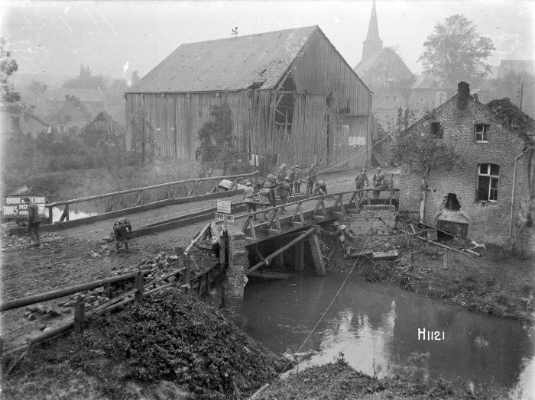
Scene at Briastre – 28th October 1918

During the night of 12th October, the 8th Battalion was relieved and moved back to Caudry in billets, where at last several days of rest and training were given the tired-out Somerset men.
[The Somerset Light Infantry 1914-18 by Everard Wyrall]

After this action, the sergeants in Horace’s Company wrote the following letter:

“To the Adjutant – Sir – We, the under-signed, respectfully beg to recommend Second Lieut. Horace William Brooks for gallant work as described below, between the period 11/10/18 – 18/10/18. (1) For pushing forward reconnoitring on numerous occasions places of obvious danger and difficulty of approach, which were to be occupied by the Company. In almost every instance these places of occupation were of vital importance to the ultimate success of the attack at large. (2) After the Captain had become a casualty, taking command of A Company while the Battalion were advancing. His management of the Company in a very difficult situation, and his coolness and deliberate actions were the mainstay of the Company throughout the engagement. We beg to remain, your obedient servants, (Signed) Stephen James Martin, Sergt. Albert Henry Kirks, Sergt., G Collins, Sergt., W Dolelers, Sergt.”

THE LAST BATTLE OF THE WAR

The 8th Battalion was in the last Battle of the Great War, the Battle of the Sambre.

At 5.30 a.m. on 4th [November] the attack began and apparently made good progress for the Somersets were early on the move. At 6.30 a.m. the Battalion marched off from Ferme Bernier, Salesche, across country to the Louvignies-Futoy road, thence through an orchard to Haute Rive Farm, where Battalion Headquarters were established. A and B Companies then went forward to just west of Byau de Pont à Vache, D Company to an orchard west of A and B, and C Company to the neighbourhood of Fme. Croix Rouge.

Shortly after 9 a.m. Colonel Sheringham sent out an advanced party to see if it was possible to establish Battalion Headquarters at Pont à Vache. For nearly an hour he waited, but as no information came to hand he went forward himself. Passing C Company on the way at Croix Rouge he gave the OC Company orders to go forward. He then found D Company and gave them orders to push forward patrols, keeping touch on the flanks with the 13th Royal Fusiliers. In the valley near Pont à Vache, he found A and B Companies and there learned that the OC, A Company (2/Lieut H W Brooks) had been killed. Both Company Commanders had lost their lives whilst gallantly reconnoitring the country forward with a view to merging with the 1/1st Herts Regiment in a further attack.
[The Somerset Light Infantry 1914-18 by Everard Wyrall]
The War Poet, Wilfrid Owen, was shot and killed on the same day as Horace near the village of Joncourt, while attempting to cross the Sambre Canal. Like Horace, he had been awarded the Military Cross the previous month.

Horace killed near Pont à Vache on 4th November 1918

A telegram arrived at the Brooks’ house on Ham Hill:

Deeply regret Second Lieut H W Brooks Somerset Light Infantry killed in action November fourth Army Council expresses sympathy

The Western Gazette printed the following:

Killed in Action – The death is reported of 2nd Lieut. Horace Brooks, eldest son of Mr W Brooks, glove manufacturer, who was killed while leading his men in a charge on November 4th. Lieut. Brooks joined the Army in September 1914, had seen heavy fighting on the Western Front, and had had many narrow escapes. In October of last year he came home with the rank of sergeant, and after taking his commission, he joined the 7th Somerset Light Infantry in Ireland, and went to France at the end of July. Among the souvenirs he sent home is an iron cross won by a German officer in 1914. Lieut. Brooks had been commended by his CO for bravery in the field in the fighting for Cambrai. In civil life deceased took a keen interest in the Boys’ Brigade, holding the rank of Staff-Sergeant. The deceased was also a good footballer and played for the Stoke eleven. He was much liked in the village for his quiet, unassuming manner. Much sympathy is felt for Mr & Mrs Brooks in their great loss. Another son is in France. Mr Brooks received the following letter from the Colonel:-

“It is with very deep regret that I write to inform you of the death of your son, Horace William. He was shot through the head by a German machine gunner and killed instantly. He was endeavouring at the time to lead his line forward across a difficult bit of country, and must have been hit by a machine gun located in an orchard.

It is a great blow to his company which he has commanded during the past three weeks most efficiently. He commanded the affection of his men, and his gallant example was greatly appreciated as you will see by enclosed document which was put in by the Sergeants of his Company at the conclusion of about four days’ heavy fighting. In this connection I put in a recommendation that he be awarded the Military Cross but have not yet had time to hear the result, which takes time to come out invariably. In any case, whether my recommendation is approved or not, you will be glad to know that I thought so well of your son that I had not only recommended him as above, but also I was intending to send him to an excellent course of instruction for Company Commanders, with a view to making him a Captain.

Your son will be missed by the officers as a pal, by the men as a leader and a pal, and by me as a most efficient officer and loyal friend. He has been buried, and a service is being held in his memory tomorrow. In the same day, Captain Briggs, commanding my other leading Company in fighting, was also killed. Both died instantly.

My warmest and most sincere sympathy goes with this letter to you all at home and I speak for officers and men when I say that we feel for you and we shall cherish and honour the memory of a friend who died in action leading his Company. A fine tradition and climax to a work well done. PS The enclosed is the sort of document I personally should value enormously, coming as it did from the NCO’s under your son’s command. [there followed the letter from the four sergeants]

Horace is buried at the Cross Roads Cemetery, Fontaine-au-Bois.

Horace’s younger brother, Oliver Hensleigh Brooks (known as Duke), survived the war and took over the running of the glove factory.

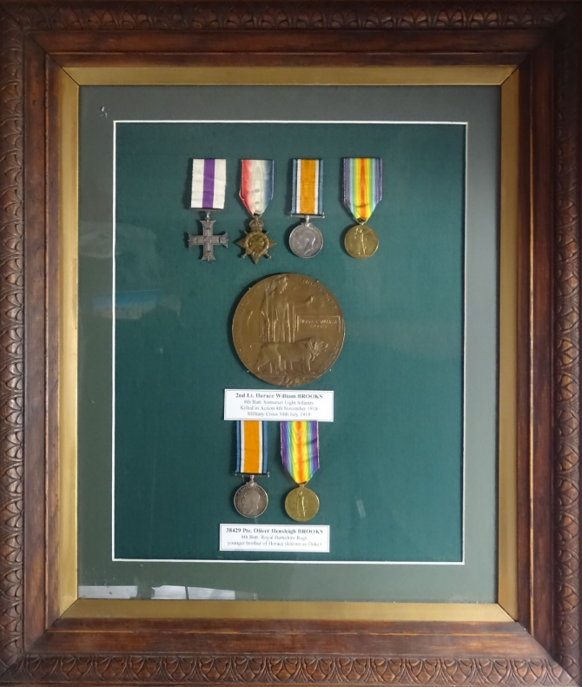

Horace and Oliver’s war medals

