Percy Frampton’s Story

Neither Percy Frampton nor his mother, Annie, were born in Stoke sub Hamdon, but Annie was a Nurse in the village during the War, living in the High Street, and perhaps well known in the Congregational Church as the church magazine printed the following in August 1917:

We would like to express our sympathy with Nurse Frampton
who has been informed that her son, Pte Percy Frampton
11th Royal West Kents, had been killed in action.
As recently as Whitsuntide he paid a visit to Stoke to see his mother.

Percy had actually been adopted by his uncle, John Frampton of Highcliffe, near Christchurch, but when he was killed in France, his personal effects were returned to his mother in Stoke. The reason Percy was adopted was that his own father, Charles, died of cancer in Christchurch after only five short years of marriage, leaving a widow and four young children. Annie Frampton was a trained nurse and had no choice but to leave her children and seek work. There is no trace of who was caring for the children in 1901, but at that time Annie was a “Visitor” and trained sick nurse with the Vincent family in Fulham. Mrs Vincent has a two week old son so perhaps it was the sick mother that Annie was nursing.
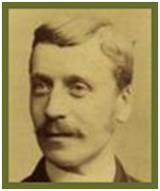

Charles W J Frampton

Percy’s father

Died in 1899

Ten years later, Annie was boarding with a family in Myrtle Cottage, Steep, near Petersfield, still working as a sick nurse.

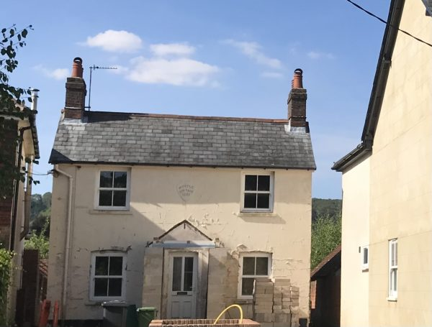

1911 Census – Myrtle Cottage (built 1887)
4 rooms, continuing to live here were:
Thomas Alfred Marsh 46 farm labourer
Jane Marsh wife 51 housewife
Annie Frampton widow boarder 43 sick nurse
William Churchus boarder 28 domestic gardener

Percy was living with his uncle and aunt, John and Jane Frampton, in Highcliffe, Dorset. His sister, Mona Louisa, was working as a servant in Peckham. His elder brother, Arthur, had possibly already joined the army. Fanny, aged 12, is nowhere to be found on the census returns for 1911.

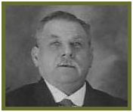

John Frampton, Percy’s uncle
in Highcliffe who adopted Percy

John Frampton owned the “John Frampton Motor and Cycle Works” and was deeply involved with the Methodist Chapel. He and Jane had no children of their own. The Christchurch Times of June 3rd 1939, reports on the celebration of his Diamond Wedding:

"The happiest married pair in Highcliffe this week is Mr. and Mrs. John Frampton, of Grace Villa, who celebrated on Wednesday last their Diamond Wedding. Mr. Frampton, who may be described as virtually the founder of Highcliffe as it is today, and his wife, are among the best known and respected residents of the village, and numerous wishes for their happiness and continued long life have been received; and what is especially treasured is a greeting from their majesties the King and Queen. At the age of 81 (he will be 82 next December, and his wife a year younger), Mr. Frampton is still an energetic gardener. He attends the little Methodist Church, to which his later years have been dedicated, with regularity and unabated enthusiasm. Both Mr. and Mrs. Frampton are enjoying the best of health, despite their years. Married at Kingston Church Portsmouth, on May 28th 1879, Mr. and Mrs. Frampton have dint of grit, perseverance and hard work, won through life's battles until at the celebration of this happy anniversary it would be difficult to find a happier or more devoted pair.”

John Frampton and his wife must have provided stability for Percy at a time when his own family were separated. John had run away to sea as a young lad after the death of his mother so perhaps it was he who encouraged both Percy and his brother to join the army.

In 1912, Percy’s headmaster writes a letter of recommendation, and his mother sends a letter from Steep, giving her consent for him to enlist. He is 14 years and five months old.

The War Office describes him as a “boy….for training as a musician” and recommend that he is “absorbed” as soon as possible. He leaves for Dublin on 17th May 1912 – 3rd Battalion Royal West Kent Regiment – where he is given two sets of innoculations before being sent out to India on 29th October. Percy is 5’3 and weighs 118 lbs. A boy with a fresh complexion, brown eyes, brown hair. He has “slight flat feet”.

There follows two and a half years at different military stations in India where I expect he had to grow up rather quickly. He develops his skills as a bandsman.

On 12th August 1914, he is described as “a very fair musician – intelligent.”

He comes home to England on 29th March 1915. Perhaps he finds it hard to adjust to life back in England because he has two blots on his conduct sheet between coming home and being sent out to France the following year. On 30th July 1915, he was given seven days CB for “refusal to comply with an order whilst on active service”, and on 26th January 1916 he was AOL from 7.30 a.m. till 8.48 a.m. and was given five days’ CB. It is intriguing to think what he might have been doing in that hour and a quarter – unless of course it is a misprint and he was out until 8.48 p.m.

Percy goes to France on 31st May 1916 – just in time for the beginning of the Somme battles. However difficult life had been out in India, it could not have been as shocking as the summer of 1916 in France, and Percy was still only 18 years old.

In August 1916, the Battalion was in the Ploegsteert area, south of Ypres. A relatively quiet part of the line. The War Diary for 11th Royal West Kent regiment for August 1916 reports there was a gas alert at 10.00 p.m. on 4th August. On 5th, a patrol was sent out into no-man’s land which was fired upon by enemy machine guns. Two lieutenants and a corporal were wounded. On 6th August, the enemy were testing the wind with smoke bombs and the smoke came right into the 11th Bn trenches. On 7th August, they bombarded the enemy machine gun emplacements – “no enemy retaliation.” The Battalion was relieved on 9th August by 32nd Royal Fusiliers and proceeded to rest billets in the Rue de Sac, Papot. Casualties for this period in the trenches were: Killed 0. Wounded 2 officers, 7 other ranks.

The Battalion were then moved around in billets from Papot to La Creche on 14th August, to Meteren on 15th, Fletre on 16th August. On 24th August they entrained at Bailleul at 7.00 a.m. for Longpre (in the Abbeville area). On 25th August they were at Brucamps where they started training for the coming offensive [Flers Courcelette].

From 1st to 9th September, the Battalion were training at Brucamps. On 4th September, which is when Percy was supposed to have received a gun shot wound to his left buttock, they were involved in a “Tactical Exercise (Medical)”. Either Percy was wounded earlier on while they were in the trenches, or he was wounded as a result of an accident during training. He was sent home to England on 28th September. There followed nine months in England during which time he had the misfortune to contract syphilus at Caerphilly. The first signs were noticed on 20th November 1916 and he was given treatment at Hilsea Military Hospital in Hampshire.

At Whitsun 1917, he visited his mother in Stoke and then was sent out to France again on 14th June, where he was killed in action on 24th July 1917. It was just before the start of the 3rd Battle of Ypres (Paschendaele).

The War Diary reports that the Battalion was in the Westoutre area, near Ypres, on 23rd July 1917. On the 24th July, the Battalion relieved the 6th Battalion London Regiment in the line behind Hollebeke (Spoil Bank). “Transport and details moved to Murrumbridge and Wood Camps respectively.”

From 24th to 28th July (Percy was killed on 24th) the Battalion is in the trenches. The weather is good. There is heavy German shelling and “a good many casualties.”

From 29th to 30th July, they are “holding the trenches.” Casualties up until 30th July consisted of 2 officers killed, 13 Other Ranks killed and 36 Other Ranks wounded.

The Western Gazette prints the following:

3 August 1917 Nurse Frampton of High Street has received the sad news that her son Percy G Frampton, 11th Royal West Kents, has been killed in action.

Annie sends a letter to the War Office acknowledging receipt of Percy’s personal effects. Sadly, she writes, his watch has not been returned.

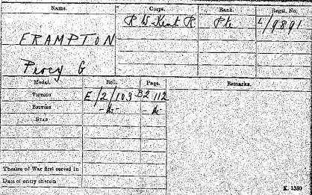

Medal Card

Percy is commemorated on the War Memorial in Highcliffe and is buried in Bus House Cemetery in Belgium.

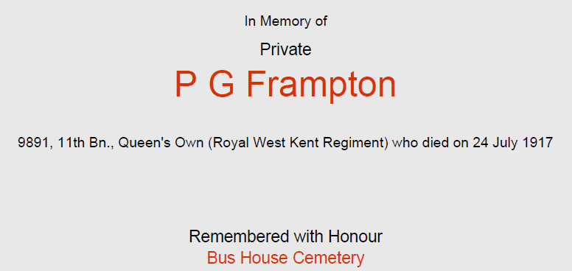

This cemetery stands behind a farm-house that was called "Bus House" by the troops during the First World War. It was made in June-November 1917, but one grave of January 1915 was brought in during the war, and four more were added in April 1918.
Bus House Cemetery contains 206 First World War burials,12 of them unidentified, and 79 from the Second World War, nine of them unidentified. There are also two French war graves within the cemetery.
Commonwealth War Graves Commission

