Percy Wines’ Story

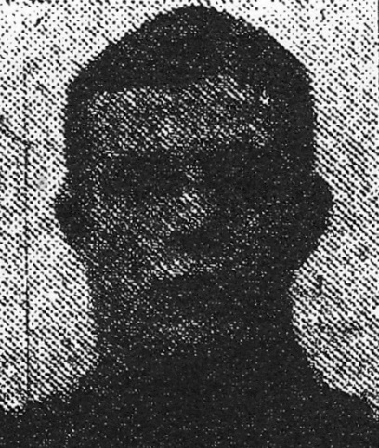
Percy’s grandparents, Robert Wines and Susan (née Taylor), came from South Petherton and this was where their two boys were born – John and Henry (Percy’s father).

By 1891, Robert and Susan were living in the Shepherd’s Cottage at Percombe with Henry aged 22. Next door was their elder son, John, with his wife, Emily.

Henry married a Martock girl, Mary Priddle, in 1893, and Percy was their first born – born in Stoke on 22nd June, 1895. They had six children in all, but only five survived. Their second child, Dorothy Kate, was born in Bower Hinton. The family may have moved there for a couple of years, but they were back in Stoke by 1898 for the birth of their second son, Leonard William. Thereafter, they continued to have their children in Stoke and are on the census returns for 1901 and 1911 as living in Percombe.

Percy would therefore have grown up in Stoke. His father and his grandfather – Henry and Robert – were both shepherds. Perhaps he went out with them to watch them working their dogs. He would have seen his mother caring for sick lambs next to the warm kitchen range. Percy himself, however, does not seem to have followed in his father’s footsteps. In 1911 he was working as a cowman on a farm.

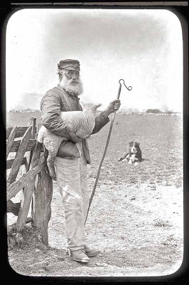
This is William Osmond, Somerset shepherd, in 1873. The life was not idyllic. He earned between 8s and 10 s per week, including Sundays, had a tied cottage at a value of 1s per week, 1 ton of coal and a patch of potato ground worth about £1 per year. This man was unjustly imprisoned for theft for six months and when he came out of prison it was discovered that he had put on 23 pounds in weight because of the rest from the starving slavery of farm labour.

Conditions may have been slightly better by the beginning of the 20th century but life was still hard and Percy decided to emigrate to Canada. Mr Brooks (father of Horace who was to die in France in 1918) was the White Star Agent in the village.

There is a record of a Percy Wines leaving from Liverpool on the “Cymric” steam ship (White Star Dominion Line) on 27th February 1913, arriving in Halifax, Canada in March 1913. His entry is stamped “British Bonus Allowed” – this was money given to the steamship owners by the Canadian Government to encourage immigration of suitable candidates into Canada. On the form Percy had to fill in on arrival, he states that he is 19, single, never been in Canada before, intends to permanently reside in Canada and can read and write. His post office destination is Elgin, Ontario. He has been a farm labourer for four years to date and intends to do the same in Canada. His religion is Congregational. It sounds very much like our Percy. Albert Wilkinson, who emigrated at around the same time, also ended up in Ontario and they were in the same regiment – 2nd Battalion Canadian Infantry (Eastern Ontario Regiment). Albert and Percy did not serve together, however, as Percy was killed in April 1915 and Albert did not arrive until 1916/17.
The “Cymric” at port
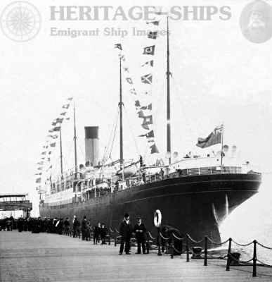

Percy hardly had time to get settled in Ontario before the 1st World War broke out. On 1st August 1914, three days before Britain declared war, the Governor-General of Canada offered help should war break out. On 7th August, Lord Kitchener responded that the Canadians might form a Division. Percy didn’t hesitate. His attestation papers are dated 22nd September 1914. He gives his mother, Mrs M Wines of Percombe, as his next of kin.
From Library and Archives Canada:
The 2nd Canadian Infantry Battalion was organized at Valcartier in accordance with Camp Order 241 of 2 September 1914 and was composed of recruits from Military District 3 (Eastern Ontario). The battalion was commanded by Lieutenant-Colonel David Watson.
The battalion embarked at Quebec on 3 October 1914 aboard CASSANDRA, disembarking in England on 25 October 1914. Its strength was 44 officers and 1083 other ranks. The battalion arrived in France on 11 February 1915, becoming part of the 1st Division, 1st Canadian Infantry Brigade.

ARRIVAL AT THE FRONT

By 15th February 1915, Percy’s Battalion was in the Hazebrouck-Strazeele area.

The Official History describes how between 17th February and 2nd March 1915, each infantry brigade was attached for a week to one of the two British Divisions holding the line in front of Armentieres, to get the accustomed to life in the trenches.

The 1st Canadian Brigade (Percy’s) was commanded by Brigadier General M S Mercer, and they went to the 6th Division on the right. “From the Company Commanders down to private soldiers, everyone was associated with a corresponding member of the host unit for 48 hours of individual training.” There followed 24 hours of platoon training during which each Canadian platoon was made responsible for a definite length of trench.

The Canadians were inspected by Sir John French, Commander in Chief of the British Expeditionary Force, “who reported, from what he ‘saw of them that they were well trained and quite able to take their places in the line of battle’ – an opinion which he later found to be ‘thoroughly justified.’”

IN ACTION – 10th to 12th MARCH 1915

The first action that Percy’s battalion took part in was that of Neuve Chapelle from 10th to 12th March. This was hampered by lack of communication and ammunition on the Allied side but important lessons were learnt from it.

The Canadians’ remaining stay in the Fleurbaix sector was uneventful. Their 24 day tour in the front line ended on 27th March and they went into army reserve at Estaires, five miles behind the line.
Neuve Chapelle

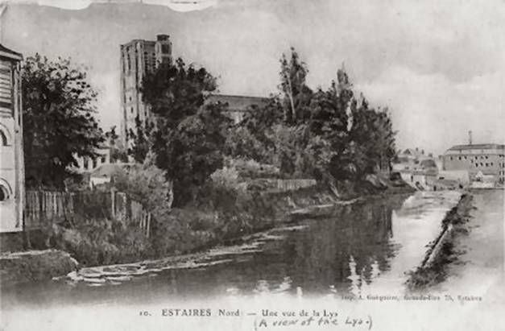

APRIL 1915

On 1st April 1915, orders from Sir Douglas Haig returned the Canadian Division to the 2nd Army under the command of 5th Corps (under Lt Gen Sir H C O Plumer).

On 5th, 6th and 7th April, the Canadians marched across the rolling Flanders countryside to the Cassel area, about 17 miles west of Ypres, to begin a week of preparation for new tasks.

The 1st Canadian Division relieved the French 11th Division between 14th and 17th April. The Canadian sector, 4,500 yards in length, lay astride the valley of the Stroombeek. Between 1,000 and 2,000 yards to the rear was the Gravenstafel Ridge. The Canadian front was held by the 2nd Brigade on the right and the 3rd on the left. The 1st Brigade (Percy’s) was in corps reserve at Vlamertinghe, two and a half miles west of Ypres.

On 20th April, Percy, in 1st Brigade, was in Vlamertinghe, on standby on one hour’s notice to move to Hill 60, an artificial mound of earth thrown up by the excavation of a cutting on the Ypres-Comines railway. It was the highest point overlooking the Salient and both sides wanted control of it.

1st GAS ATTACK – GRAVENSTAFEL RIDGE - 22ND APRIL

Area affected by first gas attack 22 April 1915
1st Canadian Brigade in reserve at Vlamertinghe

1st Canadian Division
Hill 60

While Percy was in reserve at Vlamertinghe, waiting for the order to move to Hill 60, the Germans were getting ready to make the first gas attack of the war. At 5.00 p.m. that evening, they opened the valves of the gas cylinders, releasing more than 160 tons of chlorine gas.

Although a prisoner had apparently given the Allies details of the preparation of gas by the Germans, little attention had been paid to these reports and so the appearance of a cloud of green vapour several hundred yards in length was a complete shock to the troops. “Half suffocated and with eyes streaming and nose and throat burning, their morale broken by this unexpected terror, many abandoned their positions and fled, leaving behind large numbers of dead.”

Sir John French described the effect of the gas:

“The effect of these poisonous gases was so virulent as to render the whole of the line held by the French Division …practically incapable of any action at all. It was at first impossible for anyone to realise what had actually happened. The smoke and fumes hid everything from sight, and hundreds of men were thrown into a comatose or dying condition, and within an hour the whole position had to be abandoned, together with about fifty guns.”

THE STAND OF THE CANADIANS

The left flank of the Canadian Division was left dangerously exposed to serious attack by the crumbling of the French Division, and there was a danger of their being overwhelmed and of a successful attempt of the Germans to cut off the British troops occupying the salient to the east.

In spite of the danger, the Canadians held their ground with a magnificent display of tenacity and courage, and their bearing and conduct averted a disaster.

At 8.30 p.m. on 22nd April, while all this chaos was going on after the release of gas,
the order came to Vlamertinghe for the 2nd Battalion (Percy’s) to be detached from the 1st Canadian Brigade and placed, together with the 3rd Battalion, under the command of the 3rd Canadian Brigade. They were to move up to the Brielen-Ypres Road and then halt, awaiting further orders.

The War Diary for 3rd Canadian Brigade reports the 2nd and 3rd Battalions from 1st Canadian Brigade arriving to assist on the night of 22nd/23rd April. For the last few days of his life, Percy was with the 3rd Canadian Brigade, taking part in the fighting around St Julien.

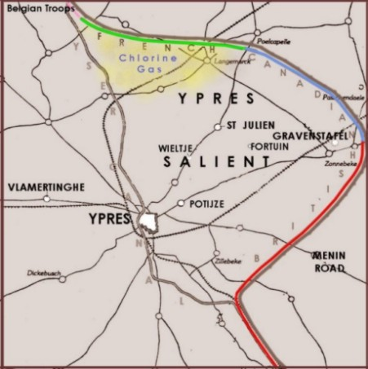
Battle of St Julien

On 24th April, the Germans made a further gas attack. Men were issued with a makeshift respirator, a cotton bandolier to be wetted and tied over the nose and mouth if a gas cloud approached, but these were little use against the chlorine.

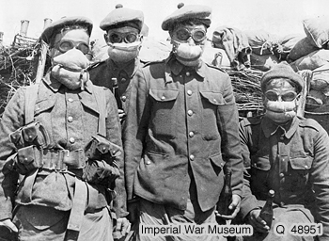
Makeshift protection against gas

The War Diary states that the 3rd Canadian Brigade was relieved during the night of 25th/26th April and moved into bivouac. At 10.00 a.m. on 26th April (the day of Percy’s death) the Brigade was ordered into reserve at La Broque “behind an attack of French and Indian troops. Shelter trenches were dug at La Brique when orders were received to move south of Wieltjs. Troops were moved at 3.00 p.m. on 26th and dug in between St Jean and Wieltjs east of road.”

The Official History reports that by day break of 26th April, 1st and 3rd Canadian Brigades had gone into reserve, each having sustained 1,500 casualties.

There was a report in the Western Gazette on 14th May 1915:

News was received from the War Office by the parents, on Sunday, of the death of Private P Wines, of the Canadians, and James Thorne, of the Welsh Regiment, who were killed on April 22nd in the fighting on Hill 60. On Monday it was officially reported that Fred Trott of the 1st Somersets, had been killed. These are the first of our Roll of Honour who have given their lives for their country, and the sympathy of the whole parish is with the parents and family in their loss.

Percy was not in fact killed on Hill 60 with James Thorne on 22nd April as the Western Gazette implies.

He is remembered on the Menin Gate at Ypres.

