Frank Welch’s Story

Drowned in the Tigris on the way to Baghdad

Frank Welch was the Hon. Secretary to the Working Men’s Institute in 1916. On 1st September 1916, a meeting was held at the Institute to appoint a temporary replacement for Frank, in the person of Mr Bell. Two months later, Frank tendered his resignation “as a result of his living away from Stoke, and he was heartily thanked for his valuable work during the last two years”. [Western Gazette]

Frank lived with his widowed mother, Mary, in the High Street. Mary and her husband, Alfred, had had twelve children but only eight had survived. Frank’s elder brother, Frederick – six years older – died in 1890 aged 17.

Mary née Thorne, was born in Stoke but Alfred came from Norton sub Hamdon. He started out his married life was a groom, but by 1901 was a domestic coachman. He died in 1909 aged 67.

Frank was born in 1878. In 1891 he was living in the High Street with his parents. He was 12 years old and working as an errand boy. The house must have been pretty full as there were four children older than himself and four younger. Ernest E Welch, a year younger than Frank, may well have been the E Welch who was punished with S Palmer for climbing on the school on 14th June 1892.

Frank is mentioned on the Southcombe War Memorial and was described as a “glove cutter leather” in the 1911 census. He was living with his mother, Mary, aged 42, and Mary’s nephew and niece aged 16 and 15.

By the end of 1916, he had severed his connection to the Working Men’s Institute and was serving with the 7th Battalion of the Gloucester Regiment in Mesopotamia, after initially enlisting with the Somerset Light Infantry.

Turkey’s entry into the war on 29 October 1914 had prompted Britain to open a new military front in Mesopotamia (present-day Iraq). British and Indian troops, in less than a month, had occupied Basra and Kurna. They continued to march up the Tigris river towards Baghdad. However, they suffered a defeat by the Turks at Ctesiphon in November 1915 and had to retreat to Kut-al-Amara, where they were besieged.

Troops were sent to relieve the British at Kut-al-Amara (among them Frank’s fellow villager, William Hann RFA, and possibly Bert Clarke with the 7th Bn Gloucesters) but the British surrendered before the relieving force could get to them. This surrender, in 1916, was a big shock to the people back home in Britain, coming after the disaster of Gallipoli in 1915.

However, with reinforced troop divisions and a new leader in General F S Maude, Indian forces again advanced rapidly up the Tigris in early 1917.

It was around this time that Frank Welch joined the 7th Gloucesters as part of the 13th (Western) Division, the only solely British formation in the force fighting in Mesopotamia. Kut-al-Amara was recaptured on 24 February, and Ctesiphon, where the previous British advance had been checked in November 1915, was taken soon afterwards. On 11 March, British troops finally entered Baghdad. The path was cleared for an advance into northern Mesopotamia, towards the heart of the Ottoman empire in Anatolia.

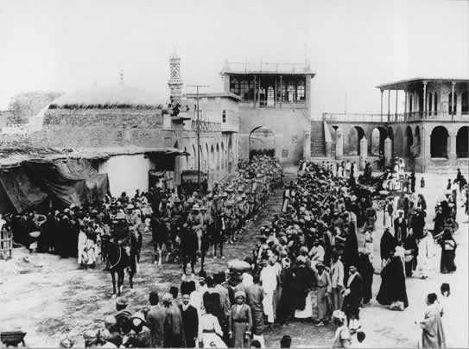

British Troops entering Baghdad – 11th March 1917

Frank’s role in the fighting, however, ended on 20th February, when he was drowned crossing the Tigris during the successful attempt to recapture Kut-al-Amara. He is remembered on the Basra Memorial in Iraq.

