Bert Clarke’s Story

25794, 7th Bn Gloucestershire Regiment

died on 16 December 1916

Remembered with Honour

Amara War Cemetery

Bert’s was a gloving family. His parents, William and Susan Clarke (nee Shoemake), both worked in the gloving industry, as did his brother, Harry. William was born in Milborne Port and the eldest boy, Edwin, was born there in 1878, but the couple didn’t marry until 1882. The 1891 census records the next child, Frances, as a girl but the only Francis Clarke registered in Yeovil in 1881 was obviously male – Francis James – so perhaps the census enumerator did not look at the eight year old very closely. There followed four boys – Harry, George, Bertie, and Arthur – and three girls – Mabel, Lucy and Beatrice (“Beartrice”). William and Susan had nine children and managed to raise them all which must have been something of a record.

The family were living on Ham Hill in 1901, not far from the Trott family. Bertie was ten and would have known the two Trott boys - Frederick aged 19 and
Percy aged 3 at the time - who were in the Somerset Light Infantry and died, one in 1915 and the other in 1916.

Bert didn’t follow his parents into the glovemaking business but became a farm labourer like his elder brother, George.

Bert may well have been one of the lads who joined up at the beginning of the war as by 7th April 1915 he had arrived in France with the 1st Battalion of the Somerset Light Infantry. In April 1915, the 1st Battalion were in the Steenwerck area, just south of Ypres. It was just before the start of the 2nd Battle of Ypres, when the Germans used gas as a weapon for the first time. I don’t know whether Bertie took part in this fighting. It is likely that he did, and then transferred at a later date to the 7th Battalion (Service), Gloucestershire Regiment.

The 7th Battalion was formed in August 1914. It was in billets in Aldershot in February 1915 and landed on Gallipoli in July 1915. On 12th February 1916 it moved to Mesopotamia to join the forces being assembled near Sheik al Sa’ad for the relief of the besieged garrison at Kut Al Amara.

Bert may have joined the Gloucesters in time for the action in Gallipoli, or have been sent out to Egypt to join them in 1916, taking part in the attempt to relieve the siege at Kut Al Amara.

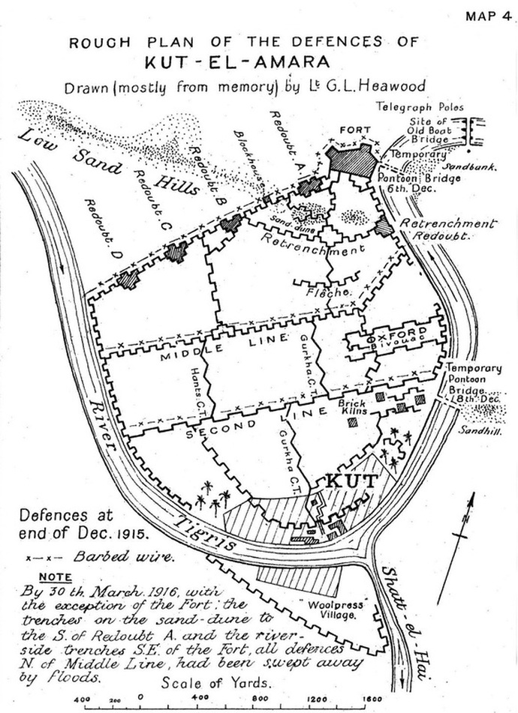

KUT-EL-AMARA
[http://www.lightbobs.com/1916-siege-of-kut-al-amara-cos-account.html]
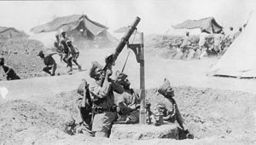

Indian anti-aircraft machine gunners in action during the siege of Kut.

SOLDIERS OF GLOUCESTERSHIRE

https://soldiersofglos.com/announcement/mesopotamia-and-palestine/

“7th Battalion, The Gloucestershire Regiment had landed at Basra in what is now southern Iraq on 4th March 1916, after leaving Gallipoli for Egypt in January. In April, 7th Battalion took part in the costly and doomed effort to relieve the city of Kut, where Major-General Townshend’s Division was encircled by a Turkish besieging army. One officer of the 7th wrote home to his sister on 24th April 1916, describing the Battalion’s attack at Kut on the 21st.

“. . . On Wednesday 21st A. & D. Company commanded respectively by Captains Rathbone and Scammell, were ordered to take up outpost positions 400 yards in front of the main firing line. On that day I was ordered with my Coy. Commander and fellow company subalterns to proceed to the line held by the Worcesters; to reconnoitre, preparatory to reinforcing it with C. Company of the Glosters.
“All four of us ran the gauntlet down a gully full of water open to the fire of machine guns and snipers of the enemy, who could not quite hit us as the banks of the water gully were just too high, and we crouched and kept our heads down, and got safely to the Worcester line.
“. . . I never saw such a bombardment, it looked as if no Turk could live in such a hail of shot and shell – they did though, and when the time came for our fellows (the Worcesters) to advance, they were met with a terrific machine gun fire, which not only prevented out men getting forward, but decimated C. Coy. of the Glosters who were coming up to reinforce the Worcester firing line.
“Hodgson (commanding C. Coy.) had received orders to extend his men right out, and to advance by rushes until he reached our position. The enemy’s machine guns swept up and down their line, and only half C. Company reached the trenches I was in. I saw them coming, and the dear fellows walked and ran through the sweeping fire, as if on parade.”
Townshend surrendered to the Turks on 29th April, and Kut and 13,000 soldiers fell into Turkish hands, where they endured terrible conditions for the rest of the war, and many died in captivity. For the rest of 1916, the situation in Mesopotamia was generally one of stalemate, neither side being strong enough to force the other aside.

Bert died of wounds in Mesopotamia on 16th December 1916 and is buried in the Amara War Cemetery in Iraq.

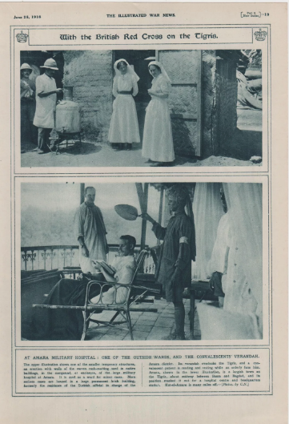

Amara is a town on the left bank of the Tigris, some 520 kilometres from the sea. It was occuplied by the Mesopotamian Expeditionary Force on 3rd June 1915, and it immediately became a hospital centre. The accommodation for medical units on both banks of the Tigris was greatly increased during 1916 and in April 1917, seven general hospitals and some smaller units were stationed there.

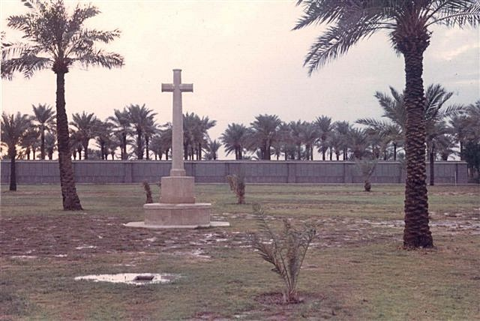

Amara War Cemetery, Iraq

Bert Clarke was cousin to James and Gilbert Shoemark from Stoke who died in Gallipoli. He was also second cousin to Cyril Gold.

