Austin Keetch’s Story

Austin Keetch and George Minchington enlisted in the 8th Battalion Somerset Light Infantry. Both were killed in the battles of the Somme, George in June 1916 and Austin in November 1916.

Commonwealth War Graves have Austin’s father as “Job Keetch” but in fact his name was Arthur James White Keetch. Austin’s middle name was “Job” after his maternal grandfather, Job Caller.

Arthur Keetch was a stonemason, born in Forton, near Cricket St Thomas. He married a Stoke girl, Caroline Caller, in 1874. They lived in Lower Street (North Street) in 1881 with Gertrude (5), Mabel (4) and William (2). Later, they had Julia, Agnes, Rosa Leah, Austin Job and Reginald George. Five girls and three boys. One of their children did not survive. There are three child deaths registered in the name of Keetch for the period – Percy Arthur 1888 (0 years), Wilfrid 1895 (5 years) and Norman 1910 (1 year). Perhaps it was Percy Arthur who was Arthur and Caroline’s lost baby – he would have come between Rosa Leah and Austin in age. But there is also apparently a John Keetch in the Stoke parish church burials who was buried on 29th December 1902 aged only 12 hours.

Austin was born in 1889. The first home he would have remembered would have been on Ham Hill.

On 13th July 1894, a J Keetch was punished at Stoke school for using bad words. This could have been Julia but she would have been 13 and would probably have left school by then. It might have been Austin if he were called by his middle name but he would only have been five at the time.

By 1911, Austin (or Job) was working as a leather brusher. His father had died in 1906, aged 53. I wonder if stone masons often died at an early age because of the hard nature of the work. Austin’s mother, Caroline, was 52 and working as a monthly nurse. His elder brother William (a labourer) was still at home aged 31, as was his younger brother Reggie who worked as a mason. His sister, Rosa Leah, had married James Fane and the young couple were living in the Keetch family home on Ham Hill.

I don’t know what date Austin he joined up but according to “Soldiers Died in the Great War”, he enlisted at Yeovil and was living in Martock at the time. His Medal Roll card cites him as having arrived in France on 11th October 1915. Austin married Ellen M Fane in the Bristol area in the September quarter 1915 – just before he left for France. In 1911, Ellen had been living with her brother, Wyndham Fane, in Castle Street. He was a music teacher and she was his housekeeper.

The 8th Battalion of the Somerset Light Infantry was formed at Taunton in October 1914 as part of the Third New Army (K3) and then moved to Halton Park near Tring as part of the 63rd Brigade of 21st Division. In November 1914, it moved to Leighton Buzzard and then back to Halton Park. In August 1915, it moved to Witley Camp. On 10th September 1915, it mobilised for war and landed at le Havre.

Austin arrived in France just after the Battle of Loos in September 1915, where the 21st Division suffered over 3,800 casualties. He would then have had experience in front-line trenches until his first serious action – The Attack from the Mushroom in December 1915.

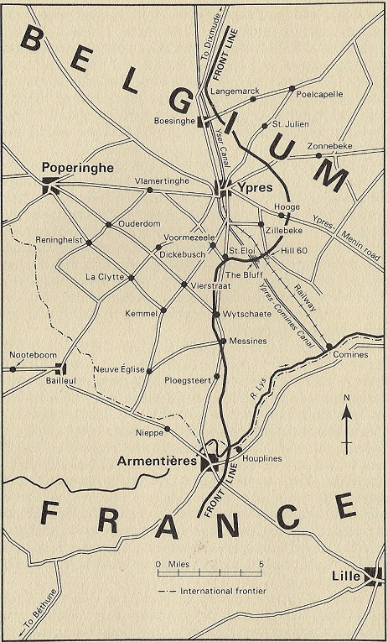
“The Mushroom” – Trench 70 near Armentières

Possibly Austin was wounded in this battle because on 31st March 1916, there is a report in the Stoke under Ham section of the Western Gazette:

Lance Corporal Austin Keetch, SLI, who was wounded whilst fighting abroad, is out of hospital and is visiting his relatives in this village. He is well on his way to complete recovery.

Austin has attained the rank of Lance Corporal by this time.

While he is at home, visiting his relatives in March 1916 (and hopefully seeing his poor wife, Ellen) the 8th Somersets are in the Strazeele area, being congratulated on their smart turn-out by Generals Plumer and Ferguson.

We don’t know when Austin rejoined the regiment but he died in the Battle of the Ancre in November of that year. In April 1916, the Battalion started the journey down from Armentières to the Somme area, where so many of the Stoke men were to die. The 8th Battalion took part in the Battle of Albert where Archie Thorne and Hugh Grinter fell.

“Dawn broke on the 1st July on thousands of men all ready in position to go forward at Zero hour. There were the trench ladders placed ready to assist the attackers into No Man’s Land, the Company Officers and Platoon Commanders with their men, ready to lead them forward. Behind were the troops waiting to support the attack, and behind these again, the carrying parties with ammunition, bombs, tools etc.”

[The History of The Somerset Light Infantry 1914-18 by Everard Wyrall]

On 8th July 1916, the 8th Battalion of the Somerset Light Infantry as part of the 63rd Brigade transferred to the 37th Division and took part in the Battle of the Ancre (one of the last battles of the Somme) in 1916.

It was at the time of the Battle of the Ancre that Austin was killed in action on 19th November 1916. The Ancre is a river which runs through Albert and then south-east to eventually join the River Somme near Corbie. Further upstream it runs by the villages of Beaucourt, Authuille and Aveluy.

Everard Wyrall in The Somerset Light Infantry 1914-18 describes the attack on 18th November:

At 9 p.m. orders were received for operations on the following day – 18th November. Briefly they were as follows: The II and IV Corps were to make simultaneous attacks south and north of the Ancre respectively; the V Corps was to drive the enemy off the spur south of Ten Tree Alley and to establish a line on the spur west of Bois d’Hollande; the 32nd Division, which had taken over the line on the left of the 37th Division, was to make the main attack and capture Frankfurt Trench, pushing its left northwards towards Ten Tree Alley; the 37th Division was simultaneously to occupy and consolidate a line from the River Ancre at R.8.b.o.4 (the crossing S.E. of Bois d’Hollande) through Bois d’Hollande, thence eastwards to the Puisieux Road about R.8.d.6.1 (the junction of the two sunken roads running north from Beaucourt) to junction of Muck Trench and Leave Avenue and to assist the attack of 32nd Division by machine-gun and trench-mortar fire on Frankfurt Trench, directed from Beaucourt Trench.

The 63rd Brigade orders to Lt Col J W Scott (commanding 8th Somersets) stated that his Battalion would, during the night 17th/18th November, “establish strong points in River and Puisieux Trenches and reconnoitre Baillescourt Farm. They will endeavour to assist 56th Brigade S. of River in the capture of Grandcourt in the morning. Posts will be established as soon as possible. Zero hour will be at 6.10 a.m. It is of the utmost importance that the work of patrols and the establishment of the line of posts should be forwarded to the Brigade at the earliest possible moment.”

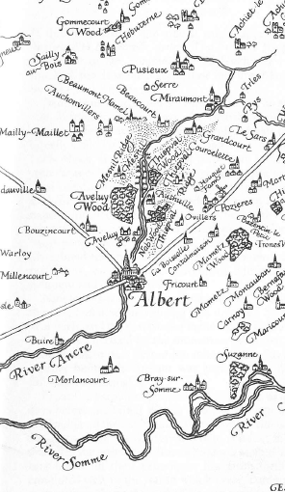

[Map of Somme from Lyn MacDonald’s book, Somme”]

At 1.00 a.m. on 18th the Somersets moved off by companies through Beaucourt and completed a line of posts from Bois d’Hollande in a westerly direction across the open to Puisieux Road. A Company was on the right from Ancre Trench to Bois d’Hollande, B Company came next in the centre and C on the left. D Company, about Ancre Trench, had orders t reconnoitre Puisieux Trench and establish strong points in that Trench and in (Puisieux) River Trench if possible. Two Stokes mortars and two machine guns were attached to D Company to assist in the attack on Puisieux Trench. In the worst weather imaginable the Battalion sent out on their unenviable and difficult task. Snow was falling, the ground was heavy with filthy, clinging mud and the going was terrible. As the patrols neared Puisieux Trench German patrols were discovered out in front of their line and the Somersets, unable to get near the Trench, took shelter in shell holes.

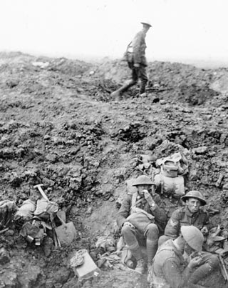

Coming generations will read of those gallant fellows taking “shelter in shell holes” without a tremor, knowing nothing of the remembrance of agony conjured up in the minds of those who went through the Great War in France and Flanders: of the dull misery of plodding through seas of viscous mud, weighted down by equipment, pack rifle and bayonet, ammunition, bombs and rations, clothes soaked through, covered from head to foot in slime, stumbling, slipping, ever expecting death, some even longing for it as a happy release from such untold misery; of the brain atrophied almost by suffering, of the constant expectation of attack and the tremendous nerve tension when moving against a concealed enemy.

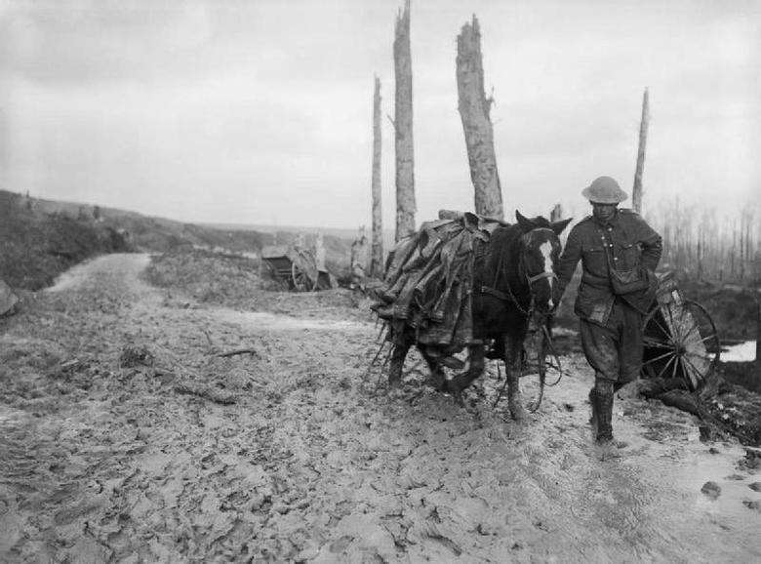

Towards dawn, the guns began to boom and the air was thick with shells shrieking and howling as they passed over head to burst with a roar on the enemy’s positions. At 6.10 a.m., the II Corps attacked north of the Ancre. A thin mist somewhat obscured the view, but the Somersets from their shell holes could just make out the form of the advancing troops.

The next entry in the Battalion Diary is timed 9.20 a.m.: “Received orders to be prepared to attack Puisieux and Puisieux River Trench from S. end to its junction with Miraumont Alley supported by 4th Middlesex.” The order to move was to be sent later.

Owing to the difficulty of crossing very heavy ground swept by continuous shell, machine-gun and rifle fire, it was impossible to get the orders for attack circulated until about 10.40 a.m., and the attack was due to take place at 11 a.m. But Colonel Scott was able to see the OsC., C and D Companies, to whom he gave the following instructions: half of C and the whole of D Company were to attack Puisieux Trench, S. of the Miraumont road, and the remaining half of C was to co-operate north of the road. At 11 a.m., the 4th Middlesex began to arrive and the Somerset men launched their attack.

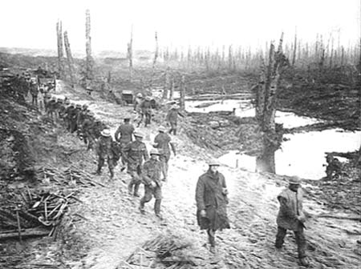

Ancre Battlefield in Nov 1916

Scarcely had the Somersets left their shell-hole positions when they came under very heavy rifle fire from Puisieux Trench and the river banks which were alive with enemy riflemen. On all sides officers and men began to fall and soon casualties became heavy. About 11.20 a.m. Colonel Scott went forward to reconnoitre. He found that C and D Companies were advancing very slowly from shell hole to shell hole, but he also discovered that the attacking companies of his Battalion were under quite a heavy fire from the British guns. He therefore stopped the attack and hurried back to stop the guns firing on his men. In this he was apparently successful for a little later, holding a consultation with the O.C., 4th Middlesex, with a view to a fresh attack later under a new barrage, he ordered patrols to push on if possible.
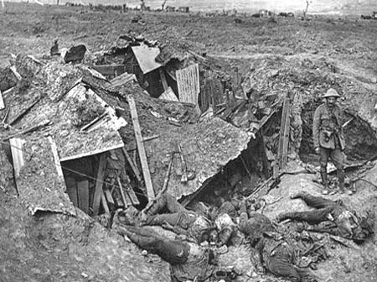

Captured German trench

About 12 noon bombing parties of C Company entered Puisieux Trench south of the Miraumont road and captured 20 Germans in a dug-out. D Company followed quickly and together the two Companies set to work to consolidate the trench. At one time bombs ran out, but fortunately a fresh supply was soon brought up: without bombs it would have been impossible to hold on. A company of Middlesex, followed later by another company of the same Battalion, moved up to support the Somersets, and a covering barrage on Puisieux Trench north of the road was asked for. Meanwhile, A and B Companies, of the Somersets, in accordance with the orders to attack, had been withdrawn from the line occupied.

By about midday the attack apparently ended, for at 1 p.m. the forward companies of Somerset men could see that the attempt to take Grandcourt had failed and men were observed dribbling back along the railway south of Ancre Trench. The results, so far as the Somersets were concerned, are thus given in the Battalion Diary: “Puisieux Trench was held but no further advance was made.”

At 2.30 p.m. the Battalion Bombing Officer was sent up to take command of A Company and explain the situation to B Company, the latter being still under heavy sniping fire. An hour later, orders were sent out to the same officer to reoccupy the line of posts held in the early morning. The latter movement was carried out at dusk.

At 7 p.m. the 4th Middlesex began the relief of the Somersets in Puisieux and Ancre Trenches, while two companies of the York and Lancaster R. took over the line of posts.

By 11 p.m. all companies of the Somersets had been relieved and were located in support trenches and the Quarry just east of Beaucourt.

If the date of Austin’s death is correct, then he survived this horrific day, only to die the following day, 19th November. The entry for the Battalion diary for 19th November reads:

19th November. Remained in support. At night parties went out and brought in the 4 officers who were killed. They were buried near Station Road. Intermittent shelling all day. The Officer left behind came up and 2nd Lt P C Hagen took over the duties of Adjutant.

There is a report in the Western Gazette on 22nd December 1916:

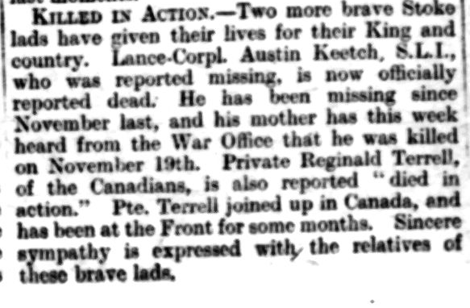
Pte Austin Keetch has been reported missing and grave fears are entertained that he has been killed in action.

The Western Gazette reports on 19th May 1917:

Austin is remembered in Queen’s Cemetery, Bucquoy. Bucquoy is situated on the D919, Arras-Amiens road, 15 km south of Arras.

