Reginald Terrell’s Story

Reginald emigrated from Stoke to Canada some time after spring 1911, but he returned with the Canadian Expeditionary Force on 24th August 1916 and was killed in action on 9th April 1917.

He was brought up by his grandmother, Mary Terrell, whose mother, Hannah, had been a schoolmistress in Stoke for many years. Mary was married for only a short time. She married William Terrell in 1868 but by 1871 he was dead and Mary was living back with her mother, Hannah, in East Stoke. She had her three month old baby, William James, with her, but the older child (Reginald’s mother) Jane Elizabeth, who was two years old, was living with William Terrell’s parents in Lower Street.

Jane continued to be brought up by William’s grandparents, while her brother lived with Mary, but on 23rd May 1893 Jane gave birth to Reginald. I don’t know where Jane was living at this time but she was obviously not in a position to look after Reginald, and it was Jane’s mother who brought him up. Mary had missed out on raising her daughter, but had another chance with her daughter’s son.

Reginald left England for Canada some time after 1911. He enlisted in 126th Battalion Canadian Expeditionary Force in Toronto, Ontario, on 25th November 1915. On his papers, he stated that he was a blacksmith, single, with no previous military experience. His religion was Baptist and he was 5 ft 3 ins tall, chest 33” fully expanded, weight
127 lbs. He had a fair complexion, blue eyes and dark brown hair.

He embarked with his Battalion on the SS Empress of Britain at Halifax on 14th August 1916, arriving in Liverpool on 24th August 1916.

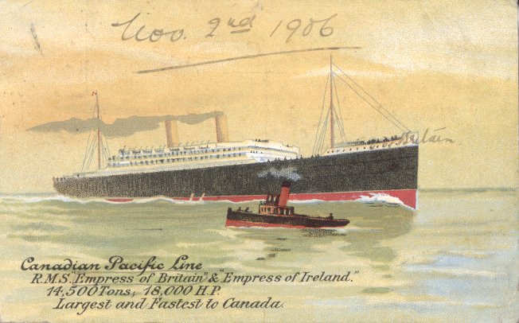
SS Empress was launched in 1905, set eastbound Canada to England speed records in 1906 and 1908, and served as an armed merchant cruiser and troop carrier during the 1st World War
During World War I, Empress of Britd as an armed merchant cruiser and a troop carrier. She
Reginald was with the 109th Battalion, CEF, at Bramshott from 16th October to
4th December 1915 and then joined the 38th Battalion, CEF, at Le Havre, France, on
6th December 1916. On 9th January 1917, he temporarily joined the 4th Entrenching Battalion, CEF, rejoining the 38th Battalion on 16th March 1917, and being killed in action on 9th April 1917. He is buried in Canadian Cemetery No. 2.

These are the dates on his army record (according to “Ken”, a Canadian with an interest in military history who has done a brilliant job of putting information about the 38th Battalion onto the internet), but in the War Diary of 38th Battalion, there is an entry for reinforcement of 148 Other Ranks on 9th December 1916 rather than 6th December, and 14 Other Ranks rejoined the Battalion from the 4th Entrenching Battalion on 4th April 1917 rather than 16th March.

If Reginald joined the 38th Battalion on 6th December 1916, he would have found it in billets in Bruay. On 9th December (when reinforcements of 148 Other Ranks arrived, with Reginald, perhaps, among them) the Battalion was still in billets in Bruay. There was a “complimentary concert at ‘Very Lights’ Theatre that day; Church parade the next day, 10th December, with a heavy snow fall on 12th December. The weather was cold and foggy.

On 30th December 1916, the Battalion marched to Vimy Ridge. They continued in the front line trenches until 5th January 1917 when they came out of the line and went into billets at Villers au Bois. From 9th January 1917, Reginald was with the 4th Entrenching Battalion.

If he returned to 38th Battalion on 16th March, as his army record states, then it would have been in the front line trenches at La Salle Ave-Ersaty. The war diary is very detailed. One gets the impression of troops, new to the war, full of enthusiasm and energy. There is quite a different feel about the Canadian diary to those of other Allied troops at that time.

They talk of aeroplanes being very active on 17th March. The weather was wet. On 19th March, the Battalion moved out under shell fire from the front line trenches to Chateau de la Haie. Three new officers arrived on 21st. Aeroplanes were active during the morning of 22nd March and there was heavy snow in the afternoon. On 23rd March, medals were given out to the men - MM’s, Military Crosses, DCM’s and DCM’s. If Reginald had rejoined the regiment by then, he may have wondered if he might get a medal one day.

On 25th March, the Battalion moved back to the front line trenches, taking up position from Vincent to Ersaty. Four patrols were sent out during the night of 25th/26th March:

“One encountered an enemy post and were fired upon by machine gun. They proceeded southward to near the front line where they heard a large carrying party apparently moving articles which sounded like trench mats but it was too dark to see. They later returned to endeavour to discover the machine gun post. They could hear talking and saw a strong enemy patrol of seven men leaving the enemy trenches…the night was quiet with the exception of our intermittent firing and was very dark.”

The 26th March was a day of considerable activity. “The enemy blew a camouflet opposite the neighbourhood of our front line at Oakley. One of our dugouts was badly affected being filled with gas and flame. Seventeen members of No 13 platoon were gassed. Six were unable to get out and died.”

On 30th March, the Battalion was relieved from the front line, HQ and D company going to the Arras line, B & C companies to Chateau de la Haie and A company to Bijoli line.

On 4th April, “14 Other Ranks reported from 4th Entrenching Battalion”. From 5th to 9th April when the Battle of Vimy Ridge was fought, the Battalion was in the front line trenches, occupying the line from Vincent Street to Pelve Bull.

BATTLE OF VIMY RIDGE

[From: “Fields of Death: Battle Scenes of the First World War” by Peter Slowe and Richard Woods]

Simple Patriotism Wins the Day: 8 and 9 April 1917

The Canadians crossed the Atlantic to fight for King and Country. They did so with enthusiasm and gusto, as volunteers. Their feelings of patriotism were uncomplicated. Like most soldiers, they relished the excitement of war and loathed its horrors, but their simple belief in the rightness of the Empire’s cause made them brave – more effective than the reluctant British drafts of 1917 and more fervent than the ‘blood and steel’ Germans.

At St Eloi on Vimy Ridge, the Canadians looked forward eagerly to their formidable task:
‘The boys were in high spirits and glad of the opportunity to demonstrate again the quality of the New World troops…We would uphold all the traditions of the Canadian Army and our battalion would prove to be one of the best in France!’

Most of the Canadians had only recently arrived in Europe; they were shocked by destroyed villages and churches and by the piteable state of refugees. They marched to the front determined to get back at the monstrous enemy who had caused all that they had seen. The Canadians were fresh to the battle; they had not been sharing terrible winters in trenches with the enemy; they had not been around to hear ‘Heilige Nacht’ at Christmas. They knew they would beat the Germans and that the Germans deserved to be beaten.

Lieutenant Ernest Odell and his platoon entered the Aux Rietz Communication Trench from the Arras-Bethune road, which was being shelled intermittently. It was pitch dark, late on 8 April 1917.

As they started to move down the trench, they got a message to speed up because the shelling had become serious and queues of men waiting to enter the trench from the road were in great danger. Hurrying down Aux Rietz Trench was perilous. Telephone wire, barbed wire and rivulets of muddy water criss-crossed the trench, and when barbed wire caught a running man under his chin, his injuries could be fatal.

Aux Rietz Trench led to the front line. From there, the platoon crept across a stretch of no man’s land, dangerously illuminated by German flares, to their jumping-off trench whence they would attack at 5.31 the next morning.

The time started to drag. Odell and his men simply wanted to get it over with. It started to drizzle, and there were still over two hours to go. Waiting and wondering.

‘Suddenly, I was aroused from my reverie by a voice that sounded between us and our own front line. I listened, and heard the same voice shout out these startling words, ‘Where in Hell is the end of this damned ditch?’ The voice was clear and distinct and betrayed no sign of nervousness or fear. The Huns were strafing our front lines, we all knew he was not a soldier, therefore he must e a civilian…’ He seemed to be carrying a heavy machine-gun and Odell trained his revolver on him and told him to drop his weapons or he would fire. ‘Don’t shoot, friend, don’t shoot. I’m a moving picture man…’ It turned out to be an American Press photographer who had come to see the Canadians go over the top in daylight for the first time, for the newsreels! He was determined to be in the thick of it and to advance with Odell and the first assault troops after the artillery barrage.

The photographer and the rum distribution made the men of Odell’s platoon almost unrestrainable. At 5.30 exactly, the shells of the bombardment whistled overhead to the German lines, one shell every fifteen seconds on every twenty yards of line.

There were desperate Germans SOS signals, and then, at 5.31, ‘I blew my whistle. I knew they could not hear it, but I pointed in the direction of the enemy and everyone was ‘over the top’ like a shot. I cannot describe how I felt. My blood ran quickly, my head seemed to throb, and my heart felt as if it was going to come through my chest.’

Few Germans were left alive by the bombardment. Those that fought on were shot or bayoneted by Odell’s platoon. Those that yelled ‘Kamarad’ were taken prisoner. The French Canadian ‘moppers-up’ took no prisoners – they were following behind Odell’s platoon and could see how many of their fellows were dead or bleeding to death; their special response to ‘Kamerad’ was a bullet.

Odell’s platoon reached their ultimate objective, the Stellung in the fourth line of German trenches. They had lost quite a few men but, compared with others down the line who had met with stiffer resistance, they got off lightly. The Stellung was a well-built trench with a luxurious dug-out full of German coffee, eggs bacon, sausages and fresh water, well appointed with comfortable furnishings and specially decorated notepaper for holders of the Iron Cross.

The photographer recorded the victorious Canadian platoon, and its lieutenant, tucking into a hearty celebration breakfast”.

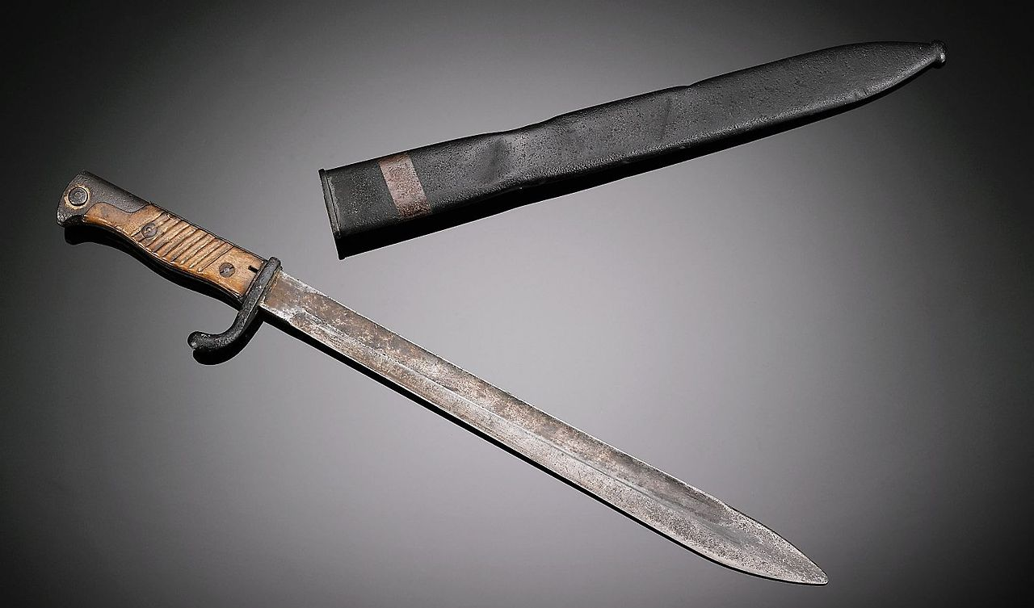

Bayonet from WWI Battle of Vimy Ridge, confiscated from German forces by Lieutenant Ernest Odell when his forces engaged in hand-to-hand combat. Vimy Ridge was part of the Battle of Arras, in the Nord-pas-de-Calais region of France. The battle was fought on land, air and even underground. The Canadian victory became a national symbol of pride and achievement.

Lt Colonel C M Edwards (Officer in Charge of 38th Battalion) telephoned in to Headquarters at 5.54 a.m. – “Everything going splendidly…” At 6.05 a.m. “One officer just returned wounded, not badly hit and not many casualties”.

Sadly, young Reginald Terrell was one of the casualties. He is remembered in Canadian Cemetery No 2 Neuville-St Vaast.





