Gilbert Shoemark’s Story

Two cousins at Gallipoli from different ends of the earth

This is a family which continually changed the spelling of its name. You can find it as Shoemark, Shoemake, Shumark, Shumack, Shoemarke… which makes research difficult.

Gilbert’s grandparents, James and Jane Shoemark were born in Ash and Tintinhull respectively but lived in Stoke for most of their lives. Gilbert’s father, Henry, was born in Ash in 1852. His eldest brother, George, also born in Ash, had a son called James - Gilbert’s first cousin.

Gilbert’s mother, Mary, came from Montacute and their first born, Frederick, was born in Montacute around 1870. The family doesn’t appear on the 1871 census for Stoke so perhaps they lived in Montacute when they were first married, but in 1875 Rosa was born in Stoke, followed by Albert, Sydney and Gilbert (1889).

In 1881, they were all living in Lower Street, Stoke, Henry an agricultural labourer and Mary a glover. There is no mention of Gilbert or James Shoemark in the school records, though there is an entry saying that Mrs Dalwood called on 22nd October 1886 asking for A Shoemake to be put into a lower standard. “He has been very irregular, partly through illness.” This could have been Gilbert’s brother, Albert, or James’ brother, Arthur, both of whom would have been nine or ten years old at the time.

By 1891 the family had moved to Coat, and then on to “Godehill, Dorset”, probably Goathill, just east of Sherborne, where another Frederick was born in 1895.
In 1911, Henry was living at Hornington, Coombe Bissett, with Gilbert, aged 22 (carter on farm) and Frederick George aged 16. Henry’s niece, Mabel Dora Clarke, aged 19, was looking after them as a housekeeper as Mary Shoemark had died in 1910. Gilbert is remembered on the Coombe Bissett memorial.
It is not known when Gilbert joined up but he enlisted at Salisbury and was first with the Wiltshire Regiment before being transferred to the 7th Battalion Royal Dublin. This regiment would have been part of the 30th Brigade of the 10th (Irish) Division. On 27th June 1915, the 10th Division received orders to prepare for service at Gallipoli.

By this time the fighting on the Western Front was deadlocked. There were plans to attack Germany by an offensive through the Balkans or by landing on the Baltic coast as an alternative to the attacks in France and Belgium. Then early in 1915, the Russians found themselves threatened by the Turks in the Causasus and appealed for help. The British decided to send a naval expedition to take the Gallipoli Peninsular on the western shore of the Dardanelles, in order to capture Constantinople. The plan was to link up with the Russians, knock Turkey out of the war and possibly persuade the Balkan states to join the Allies.

The naval attack began on 19th February 1915. Bad weather caused delays and the attack was abandoned after three battleships had been sunk and three others damaged, so what had been a naval campaign now became a land attack. By the time troops began to land on 25th April, the Turks had time to prepare fortifications and the defending armies were now six times larger than when the campaign began.

The 7th Battalion Royal Dublin Fusiliers leave for Gallipoli
“The 7th Battalion embarked on the 'Alaunia' at Devonport at about 7am on Saturday 10th July 1915. They sailed for Gallipoli. They were in up-beat mood aboard the Alaunia. Good food, salt water baths and the sea air combined to make them feel fit. Each day began with a run round the deck. They had the luxury of ice cold oranges from the refrigerator
- Wed 14 Jul 1915 Gibraltar where they had a brief stop
- Sat 17th July 1915 Valletta Harbour in Malta.
- Tues 20th July 1915 Alexandria, Egypt. All kit bags with heavy khaki uniforms and extra boots were landed and taken to the big Army Service Corps stores in the city. The voyage had opened up a whole new world - one highlight was a route march round the magnificent harbour at Alexandria, the ‘Dubs’ taking their leave with a rousing rendering of ‘Tipperary’. They left the next day 21 July 1915
- Saturday 24th July they arrived in Mudros Bay on island of Lemnos. They saw Red Cross boats returning from the Dardanelles full of wounded soldiers which gave a hint of what was to come. The following day they set sail again for Mitylene
- 25 July 1915 arrived Mitylene and were joined a week later by 31st Infantry Brigade. A magnificent concert party was held on board on Sun 1 August by the 6th & 7th Battalions Royal Dublin Fusiliers entertaining about 300 sailors from a French battleship before an inspection the following day by General Sir Ian Hamilton and Staff.
- 6th August the two Battalions were transhipped to HMT Fauvette and departed for Suvla Bay in Gallipoli, arriving at 4am the following morning. They disembarked 7 Aug 1915,
Off the Gallipoli coast they could hear the sound and see the flash from the Turkish guns, shells bursting, men landing from the lighters and stretcher bearers bringing down and collecting wounded on the beach. The whole bay was quivering with the vibration. They arrived in Gallipoli without any maps and any orders. They were without artillery as the 10th (Irish) Division's artillery pieces had been sent to France instead of Gallipoli. Water was in very short supply. When the fight did begin, they even ran out of ammunition and resorted to throwing stones at the Turks.
On landing they had to get past the stretcher bearers, wounded, dying and dead. They took cover under the cliff mixed in with the Inniskilling’s. Some respite came at nightfall, as the Turks were, for the moment, driven back over the summit. They were immediately involved in the attack on Chocolate Hill on 7 Aug 1915. They occupied Chocolate Hill from 8-12 August 1915.”
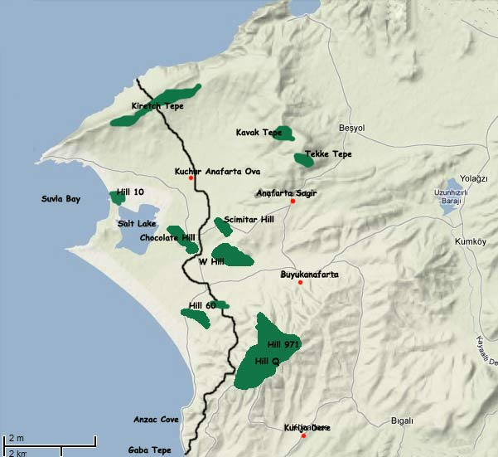
Attack on Chocolate Hill – 8th to 12th August 1915
Chocolate and Green Hills, so named because of their natural colouring, rise from the east bank of the Salt Lake and were captured by the 6th Lincolns and the 6th Borders on the evening of the 7th August.
The 7th Battalion advanced on Chocolate Hill with several hundred soldiers from other Irish regiments. They headed off across the salt lake bed in an easterly direction, then ran over a couple of empty water-courses and through a number of dry, ploughed fields, before crawling through hedgerows. The troops now entered a network of empty but well-constructed trenches at the base of Chocolate Hill. The enemy strategically withdrew to the very top of the hill. Now it was time for a wild and heart-stopping charge up to the summit, using both bayonet and bullet. An officer was signalling the men on with a green cloth tied to a stick.
By the time they had reached the top, all the Turkish defenders had either been bayoneted or shot or had fled into distance. Dead bodies lay in the brushwood on a hill-top that looked like a volcanic landscape in places, thick with smoke and pockmarked with craters of shells sent over earlier by British naval gunners. It was a bleak and lifeless scene, but the Battalion had helped the Irish Division to take its first big objective and there was an intense satisfaction for many of the men in that fact.

The Battle for Kizlar Dagh – 13th to 15th August 1915
The 7th Battalion were then involved in the battle for Kizlar Dagh (Kiretch Tepi) and remained in Kizlar Dagh until their withdrawal on 29th September.
Gilbert died on 16th August 1915. He is listed just as “died” rather than “died of wounds” or “killed in action” so there is no way of knowing whether he died in action on 16th or whether he fell ill earlier and was one of the many who died of dysentery/sickness.
His cousin, James Shoemark who was fighting with the New Zealand troops – Wellington Regiment, died on 8th August 1915 at the Battle of Chunuk Bair. They died just days apart but in different areas of the peninsular. There was little chance that they would have met.
Gilbert is remembered on the Helles Memorial which stands on the tip of the Peninsula and is in the form of an obelisk over 30m high that can be seen by ships passing through the Dardanelles. It is a memorial to men who fell in the campaign and whose graves are unknown.
Gilbert’s body is somewhere high on the Kiretch Tepe, the northernmost Allied position on Gallipoli. Apart from a few shepherds who live in the neighbourhood and herd their goats on the slopes, hardly anyone ever visits this remote spot.
Gilbert is related, not only to James Shoemark, but to Bertie Clarke and Cyril Gold.

