Alfred (George) Palmer’s Story

George was our only Stoke sailor to be killed in the War. He was on HMS Broke at the Battle of Jutland in 1916.

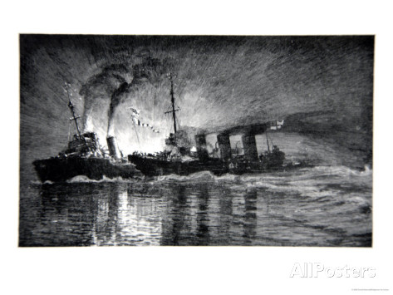

HMS Broke ramming the German Destroyer, illustration from 'The Naval Front' by Gordon S. Maxwell

In 1901, when he was five years old, George was living in Hollow with his grandparents, George and Emma Palmer, along with his three uncles, Albert, Herbert and Ralph, his aunt Alma (aged 9), his sister, Nellie and his brothers, Percy and Charles. His grandfather was a glove cutter and his uncle Albert was a coachman/groom. His grandmother was from Devon but the rest of the family had been born in Stoke sub Hamdon, apart from George and the rest of his siblings who were born in London.

I believe that George Palmer Senior married Emma Cork in Taunton in 1871. Their eldest son was Henry George Palmer who was born in Taunton in 1872. In 1881 George and Emma were living in Whirligig Lane with Henry, Alfred, Eli and Albert.

In 1891, Henry George was still living at home. He was a stonemason, aged 18, and the family lived in West Street. Was Henry perhaps the father of Nellie, George, Percy and Charles? There is a Henry George Palmer whose wife, Lily Rose, died in the Keynsham area aged 21 in 1898, but that was in the beginning of 1898 and the youngest baby, Charles, was born in Lambeth in the summer of that year. Perhaps we will never know.

The school log books report an E Palmer and a J Chant being punished for fighting on 27th February 1885 – perhaps George’s Uncle Eli, who would have been about 8 years old. On 20th May 1892 Thomas and Syd Palmer were punished for climbing on the school tiles. It didn’t do any good, because the following month, S Palmer and E Welch were punished again for climbing on the school. George’s Uncle Sydney would have been 10. If it was him, he was quite an enterprising lad. If he passed on his climbing skills to his nephew, George, they would have come in quite handy in the Navy.

His naval records state that his “date and period of engagements” was 12 years from 1st November 1913, but he joined his first ship, “Impregnable” on 6th March 1912 as a
‘Boy II’, progressing to ‘Boy I’ on 9th August 1913. He was 5’2 ¾ tall (growing two and a quarter inches in the next two years), with brown hair, blue eyes and a fair, fresh complexion. His occupation before joining the service was carpenter’s boy. He served on seven different ships, rising through the ranks from Boy II to AB. Each year, his character was given as Very Good, with his ability as Satisfactory.

On 9th June 1916, the Western Gazette reported George’s death:

Killed in Action. A letter was received from the War Office on Tuesday, stating that Alfred George Palmer AB, belonging to HMS Broke, was killed on 31st ult. Much sympathy is felt for the relatives of this promising young sailor who was home on a short leave only a fortnight since.

HMS Broke, with HMS Swift, sank German destroyers G85 and G42 in the Battle of the Dover Straits, the night of 20/21 April 1917. During the action Broke rammed G42 leading to hand-to-hand fighting by the crews. Commander Evans of the Broke was subsequently renowned as "Evans of the Broke"

Battle of Jutland - [Wikipedia]
Broke formed part of the 4th destroyer flotilla commanded by Captain Charles Wintour onboard HMS Tipperary. During the night of 31 May the flotilla was stationed behind (north) of the Grand Fleet to guard against German attack and was heading south keeping station with the fleet. At around 23.15 Leading Torpedoman Cox on board HMS Garland, fourth ship in the twelve strong line, sighted three ships approaching. These were reported to Captain Wintour, who being unable to determine whether the ships were British or German issued a British challenge signal to the approaching ships. This was immediately answered by a hail of fire at a range of around 600 yards from the approaching German light cruisers, SMS Stuttgart, SMS Hamburg, SMS Rostock and SMS Elbing. Shortly behind them, the battleships SMS Westfalen and SMS Nassau also opened fire with their secondary armament. The ships were the van of the German High Seas Fleet, which was passing behind the British fleet.
The leading British ships, Tipperary, HMS Spitfire, Sparrowhawk, HMS Garland, HMS Contest and Broke all fired torpedoes at the German ships before turning away from the fire. Confusion as to the identity of the opposing ships persisted despite the outbreak of gunfire, so that Broke's captain ordered no torpedoes to be fired until he could positively identify the ships as German. This he did when a searchlight from one of the German ships caught one of her companions for long enough for it to be identified. None of the destroyers further behind felt sufficiently confident to open fire. In accord with standing orders to conserve torpedo stocks, each ship fired only one or two torpedoes, one of which struck Elbing, but in the dark it was unknown which ship had fired it. The German ships had turned away to avoid the torpedoes, and in the confusion Elbing was rammed by the battleship SMS Posen. Tipperary was set on fire in the engagement and sank around 02.00 the following morning. Elbing had to be abandoned and similarly sank around 03.40. Spitfire narrowly avoided being rammed by the battleship Nassau, ripping a hole in the side of the battleship as the two ships collided side to side, but then had to retire from the battle and limped home to England.
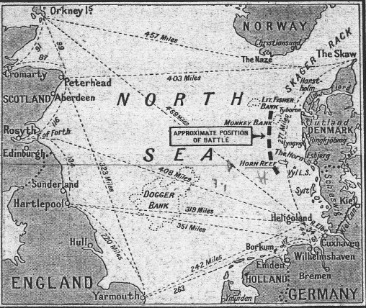

The remaining ships of the 4th destroyer flotilla formed up behind Commander Walter Allen of Broke, who was the half-flotilla leader and now assumed command. At around 23.40 large ships were again sighted and Allen attempted to challenge. Before he could do so, the German battleship SMS Westfalen sent her own recognition signal and then turned on searchlights. Broke attempted to fire torpedoes, but the range was very short, in the region of 150 yards, and the German ship opened fire first. The effect was devastating so that within a couple of minutes 50 crew were killed and another 30 injured, disabling the guns and preventing any effective activity on deck. The helmsman was killed at the wheel, and as he died his body turned the wheel causing the ship to turn to port and ram Sparrowhawk. Both ships had already turned to port from line ahead to line abreast to fire torpedoes.
Sub Lieutenant Percy Wood saw Broke coming towards them at 28 knots, heading directly for Sparrowhawk's bridge. He shouted warnings to crew on the foc'sle to get clear, and then was knocked over by the impact. He awoke to find himself lying on the deck of Broke. Wood reported to Commander Allen, who told him to return to his own ship and make preparations there to take on board the crew of Broke. Two other men from Sparrowhawk were also thrown onto Broke by the collision. Returning to Sparrowhawk, Wood was told by his own captain, Lieutenant Commander Sydney Hopkins, that he had just sent exactly the same message across to Broke. Approximately 20 men from Sparrowhawk evacuated to Broke, while fifteen of Broke's crew crossed to Sparrowhawk.
At this point a third destroyer, HMS Contest steamed into Sparrowhawk, removing six feet from her stern. Contest was relatively unharmed and able to continue underway after the collision. Broke and Sparrowhawk remained wedged together for about half an hour before they could be separated and Broke got underway, taking 30 of Sparrowhawk's crew with her. Broke remained able to manoeuvre, although she had lost her bow. At around 1.30 AM the ship again encountered German destroyers which fired about six rounds into Broke, which managed to return one shot before the ships separated. The ship proceeded slowly towards Britain but by 0600 on 2 June found that she could no longer travel into the high seas with her damaged bow and had to turn back towards Heligoland.. The seas abated and the ship was able to head for the Tyne, arriving some two and a half days after the engagement.

One of the crew members on HMS Broke was a man called Francis Street. He wrote a long letter to George’s family and in July 1916, this was printed in the Parish Magazine:

“…our hammocks were lost at sea and the only personal belongings of your son is a ditty box which I have secured and am sending it on to you.

Coming back to last week, all the Fleet left Tuesday night at 7.30. Wednesday afternoon we came in contact with the Germans and were continually engaging them up to dark. Then at 11.30 that night our ship and other destroyers started to make a torpedo attack on their ships. It was very dark and while we were steaming along quickly, a searchlight switched on us and on to our flag by a big German battle cruiser. We knew then we were discovered and so the only thing to do was to open fire and do our best. We had already sent a large ship to the bottom with one of our torpedoes and were going to do the same with this one. But a terrific gunfire destroyed a vital part of our ship, also killing and wounding several men at the guns. I am sorry to say your son had his leg broken by shrapnel, and when there was a lull he was taken aft and put in a life raft so that if the worst came he would have been safer there. While this was happening, our steering gear was shot away and we had an awful collision with the destroyer, “Sparrowhawk” which knocked a part of our bows off and we were in very great danger of being sunk; but happily, with the assistance of the carpenter and other ratings, we managed to keep afloat. The ship that had fired at us suddenly put her lights out and we thought we were alright, but such was not the case however. A destroyer found us out the other side this time and consequently we had to leave the wounded for our guns again.

After about a quarter of an hours he got rammed by one of our boats and that was the last of her. On going to attend the wounded, I was shocked to find your son had been hit again through the head and the poor fellow had breathed his last. The last words I heard him say were, “Don’t leave me”, but of course I had to go to my gun and hope I settled for a few of the Germans in consequence. We had only 220 men aboard, and I am sorry to say there were 45 killed, 6 missing and 31 wounded, a rather big percentage for a small ship’s company.

In conclusion, I can only repeat my deep heartfelt sympathy for the loss you have sustained but at the same time it was a hero’s death as it was in defence of King, Country, yourself and those that he loved. I shall be glad to be of service to you in anything you might want to know.

I remain

Yours faithfully

Francis Street.

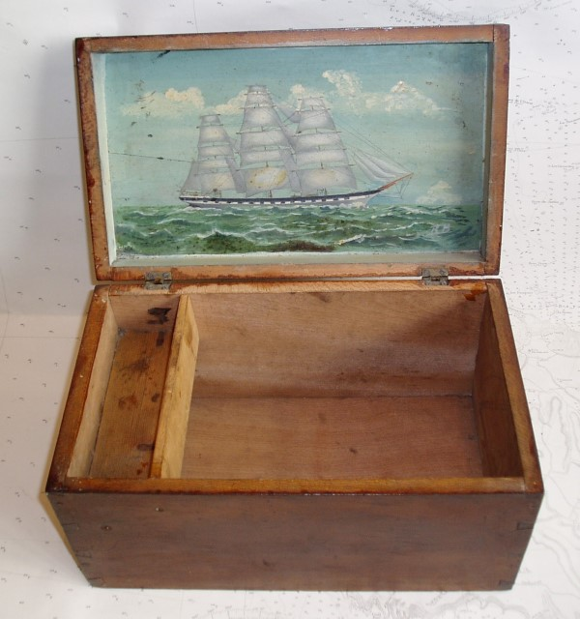
Ditty Box The plain unstained wooden box (12" x 8" x 6"), part of every seaman's kit in the old days, in which he kept his personal possessions such as photographs, letters, curios, etc.
It was good of Francis Street to write such a detailed letter to George’s family. I have not been able to find out anything about him. I wonder if he wrote such letters to the families of other men who died that night.
George is remembered on the Portsmouth Naval Memorial.

