William Eglon’s Story

One of the most touching stories of Stoke in the Great War is that of William Eglon. He never got to the Front or saw any fighting. His family could not be consoled by the fact that he died a hero like some of the other boys in Castle Street, but nevertheless he would not have died if he had not left his home and village and signed up as a soldier.

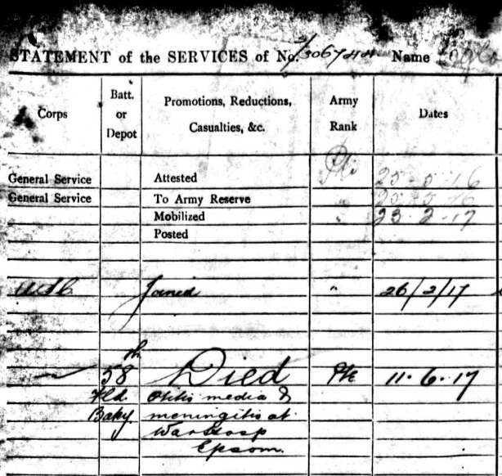
William’s brief war record

William joined up in February 1917 as a young lad of 18. He would be dead less than four months later. At the time of his enlistment he was working in the Stoke under Ham Co-operative Bakery. His parents – Henry (known as Arthur) and Sarah Elizabeth (known as Bessie) Eglon, lived in Castle Street with William’s sisters, Gladys and Muriel. The family all seemed to be known by their middle names. In fact, William even enlisted under the name of William, though he was registered as Ernest William Eglon at his birth in 1898.

William’s father was a stonemason – in 1911 he was working in Portland while Bessie held the fort back in Stoke. The Eglons were a Chiselborough family, arriving in Stoke in the 1890’s, but William’s mother, Bessie, was a Palmer, one of the very oldest Stoke families.

William had a brother, Frederick George, who was three years older, a blacksmith. It is not known whether Frederick (probably known as George!) served in the War. There is no mention of his military career in the Western Gazette or parish magazines but both brothers are mentioned in the Western Gazette in June 1906:

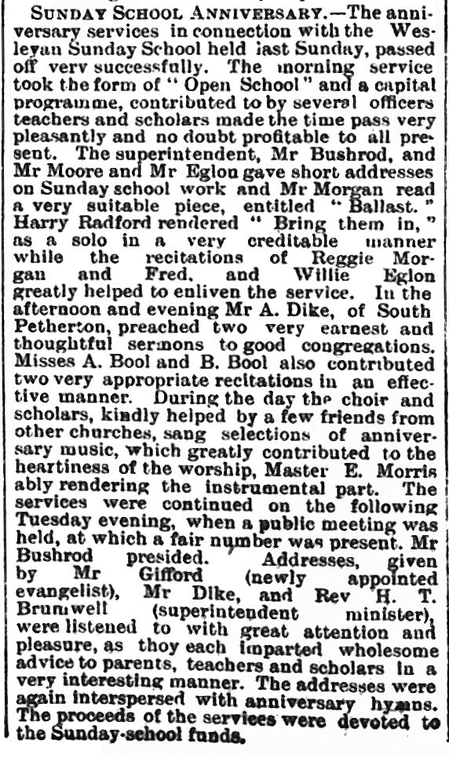

Willie and his brother, Fred, reciting at the Sunday School Anniversary Service in 1906.

Willie also belonged to the 1st Stoke under Ham Congregational Boys’ Brigade, and his name was read out at a Memorial Service in the Congregational Church in 1918.

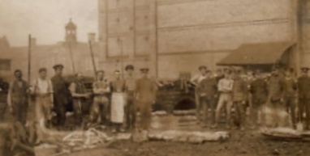

58th Field Bakery Army Service Corps at Chelmsford
(date unknown)

On enlistment at the ASC Depot in Bath on 26th February 1917, William was eighteen years old, 5’7½” tall, with a chest measurement of 36½”. He was sent to the 58th Field Bakery Army Service Corps in Chelmsford on 10th March. Only nine days later, he was admitted to hospital in Chelmsford with an ear infection and temperature. He was transferred to Horton War Hospital, Epsom.
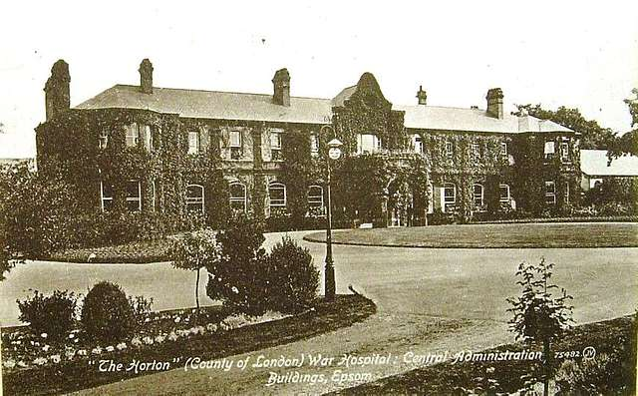

On 29th May, a telegram was sent to Mrs Eglon to warn her that her son was dangerously ill.

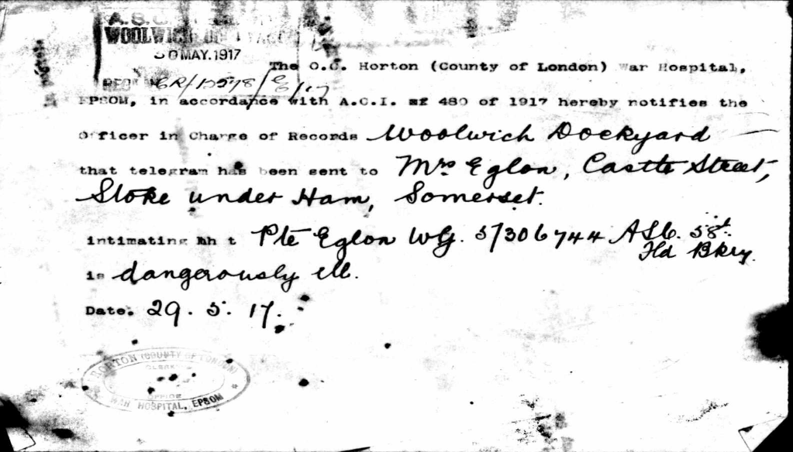

I wonder if his family were allowed to visit him while he was in hospital. He was so young. He had his nineteenth birthday the summer he died. His mother must have longed to have him home to nurse.

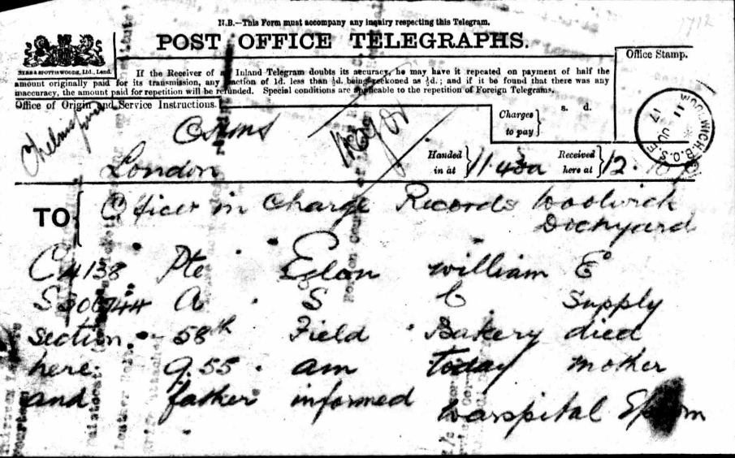
William died of meningitis on 11th June 1917.

On the 15th June, the Western Gazette reported on his death:

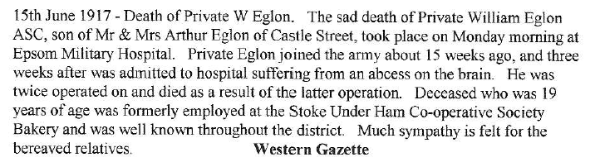

His body was brought home and buried in Stoke Churchyard.

It is especially sad to read the list of William’s personal effects which were sent home:
1 pocket case
5 photographs
14 letters
4 postcards
1 writing pad with stationery
1 waistcoat (member’s ticket Working Men’s Institute in pocket)
1 leather belt and knife attached

He must have kept all his letters from home.

