George Minchington’s Story

George Minchington and Austen Keetch were all in the 8th Battalion of the Somerset Light Infantry. Horace Brooks started in the 6th but was in the 8th Battalion at the time of his death. According to the Western Gazette, George Minchington “was amongst the first of the young men of the parish who responded to their country’s call at the outbreak of the war”. Horace Brooks is seen standing at the back of this photograph, next to the girl in the black hat. Possibly George Minchington is among these men too.

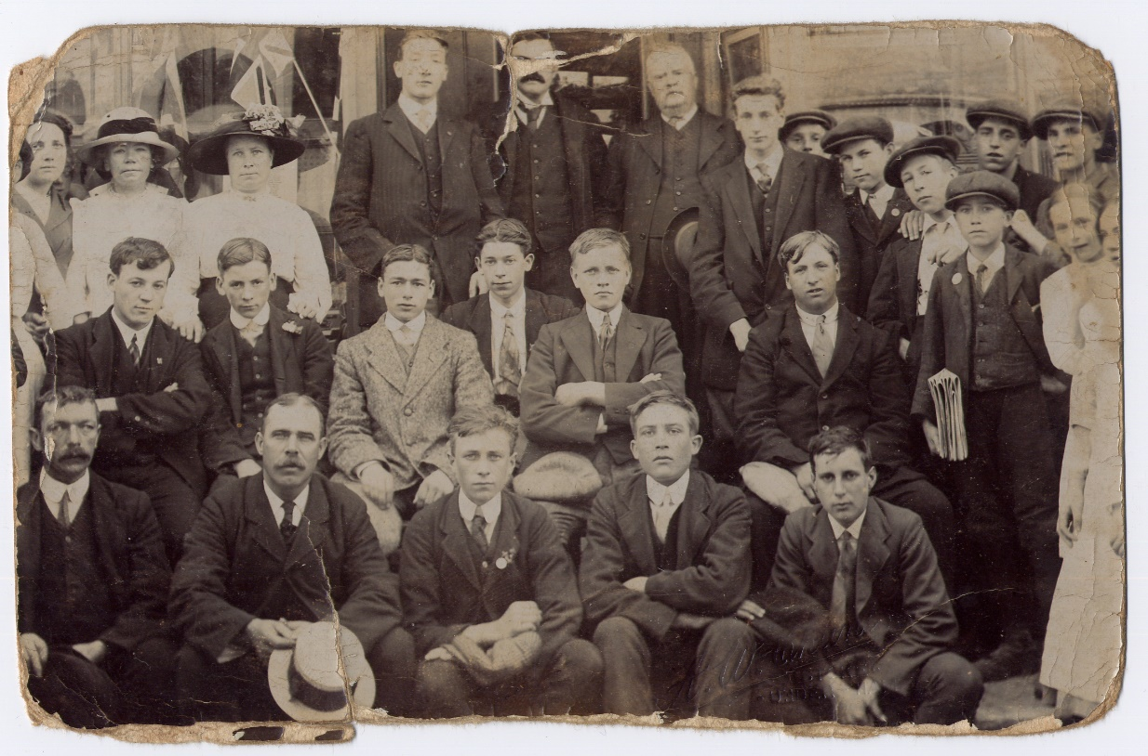

George was born in 1893, either George Chislett (registered June quarter 1893) or George Minchinton (September quarter 1893). The name seems to be spelt both with a ‘g’ and without. His parents married on 18th January 1897. It was a pretty riotous affair according to Alan Richards in his book, “History of a Somerset Village”:

During the incumbency of the Rev William Rowland, vicar from 1884 to 1904, a remarkable wedding took place. At the encouragement of some very over zealous matchmakers, John Chislett (nicknamed Jack Poodloo) was persuaded to marry Elizabeth Minchington (nicknamed Lizzy Chitt). The wedding day was on the 18th January 1897. The church was over full and the vicar had to call order. Afterwards the horse intended to draw the wagon through the village was dispensed with and the wagon was man-pulled, with Stoke Military Band leading the procession. It was like a carnival, the streets were filled with cheering people, and the pubs were open all day

According to the 1901 census return, John Chislett came from Stoke and Elizabeth from Norton. At that time, they were living in Martock and John was a Herdsman, working with cattle. George was eight years old. On that census return, he was described as their son and his name was George Chislett. By 1911, the family were living in Castle Street in Stoke. The couple claim to have had no children and that George Minchington was their son-in-law. George was 17 and working, like his father, as a farm labourer.

He enlisted, like many other Stoke lads, in the first patriotic enthusiasm of the beginning of the war. His medal record card tells us that he was in the 1st Battalion Somerset Light Infantry and went to France on 24th March 1915. Commonwealth War Graves list him as being in the 8th Battalion when he died in June 1916.

The 1st Battalion landed at Le Havre on 22nd August 1914. George arrived in France the following spring on 24th March 1915. The 1st Battalion was at that time in the St Yves sector. They moved out of this sector on 11th April and were billeted in the Noote Boom-Steenewerck area. On 22nd April came the great gas attack – the 2nd Battle of Ypres. There is a report in the Western Gazette on 15th October 1915 about George having been in this action earlier in the year:

15 Oct 1915 – Private G Minchin[g]ton who was wounded in the fight on Hill 60 is home on leave. He has now recovered from his wounds and gives a graphic account of the fighting in the trenches, when his comrade Private F Trott of this place was killed. Private Trott was struck by a shell in the chest and killed instantly, and his brother, who was in the second line, was ordered up to fill the gaps, and found his brother dead. After the fighting, he was one of the men told off to bury the dead, among whom was his own brother. [Western Gazette]

The 8th Battalion did not arrive in France until September 1915 so George must still have been with the 1st Battalion at this time.

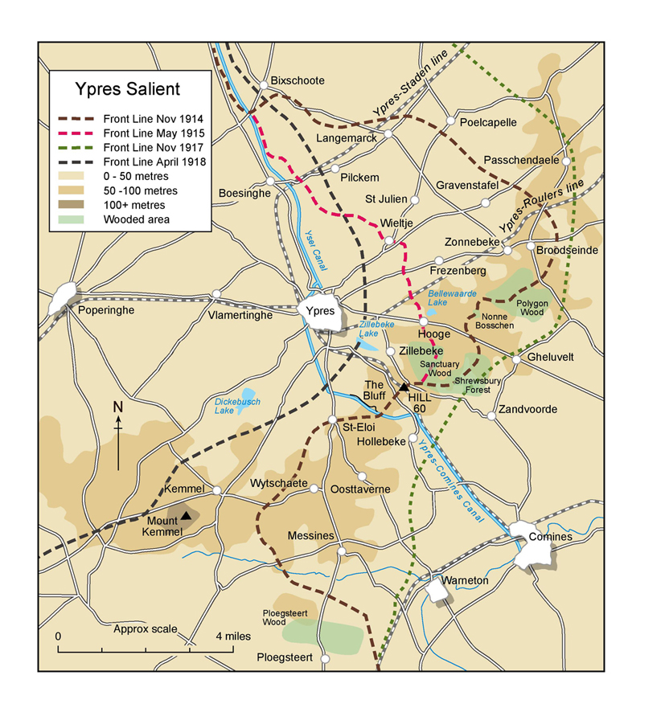
Hill 60
2nd Battle of Ypres
April 22 to May 25, 1915

It was during the 2nd Battle of Ypres that the Germans first used gas as a weapon against the Allies. Lance Corporal Cook of the 1st Battalion Somerset Light Infantry, describes the experience in his diary:

“Early in the afternoon, I was gazing over the top of the trench when I saw a German walking along behind his trenches, and on his back was a large flat container. Suddenly I noticed he was leaving a trail of smoke behind him, which later turned into a dense green mass, and commenced to roll along the ground gradually towards us. The wind was no more than a breeze which pushed this cloud gently along in our direction. With horror I realised that this must be the gas we had heard so much about, I hurriedly went around and warned all the men of what was happening. Only a few of us had been issued with some sort of protection and this consisted of a flat piece of cotton wool about 3 ins square with tapes attached, the pad being kept in position by placing it over the mouth and securing it with the tapes at the back of the neck. I ordered those in possession to put them on at once, and those without to scoop a hole in the ground, which would immediately fill with water, soak their handkerchiefs in it and ram them in their mouth. This being done, I got everybody to line the trench, and when the enemy appeared, to open up rapid fire. It was not long before they emerged from their trenches keeping at a safe distance from the gas cloud in front of them….

Of all the many weapons used in modern war undoubtedly the use of poison gas is the most terrible. We who saw this queer looking bank of mist sweeping across “No Man’s Land” were puzzled at first and did not know what to make of it.”

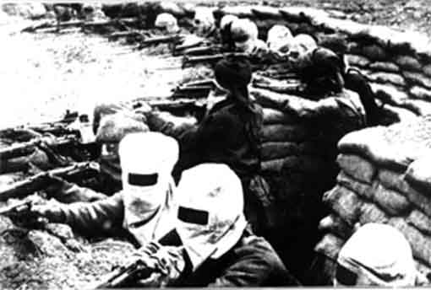

Some time between April 1915 and 1916, George must have transferred from 1st to 8th Battalion. On 14th June 1916 when George was killed, both the 1st and the 8th Battalions were preparing to take part in the first battle of the Somme at Albert.

The Diary of the 8th Battalion Somerset Light Infantry states that on 2nd June 1916, the Battalion marched from La Neuville to Ville where they were billeted for ten days. During this period they were employed on working parties. On 11th June, the Battalion went into the trenches for four days, taking over the left sector of the 21st Divisional front. During this time there was 1 man killed and four wounded. George Minchington must have been the one man killed – on 14th June.

Le Neuville is near Bray sur Somme. I am not sure where Ville was where the Battalion was billeted from 2nd to 11th June, but they might have meant Bray sur Somme, being the nearest large “ville”.

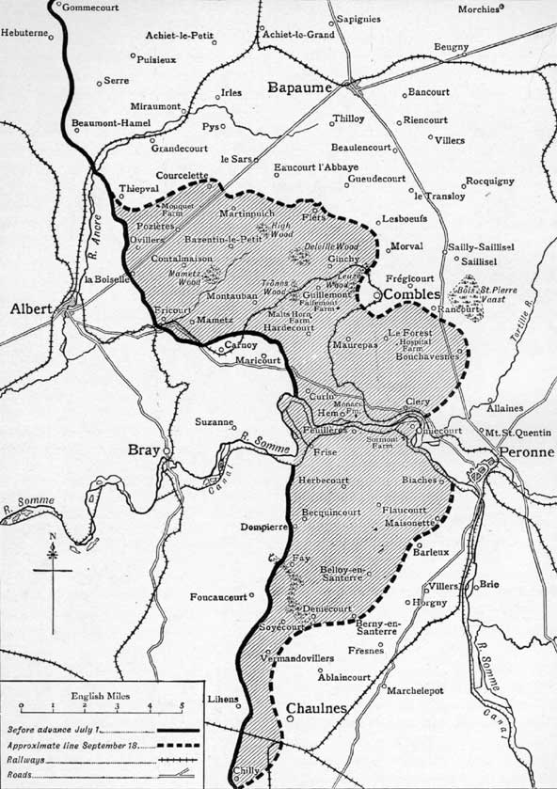
Le Neuville
Becordel-Becourt

George is buried at Norfolk Cemetery, Becordel-Becourt, just east of Albert.

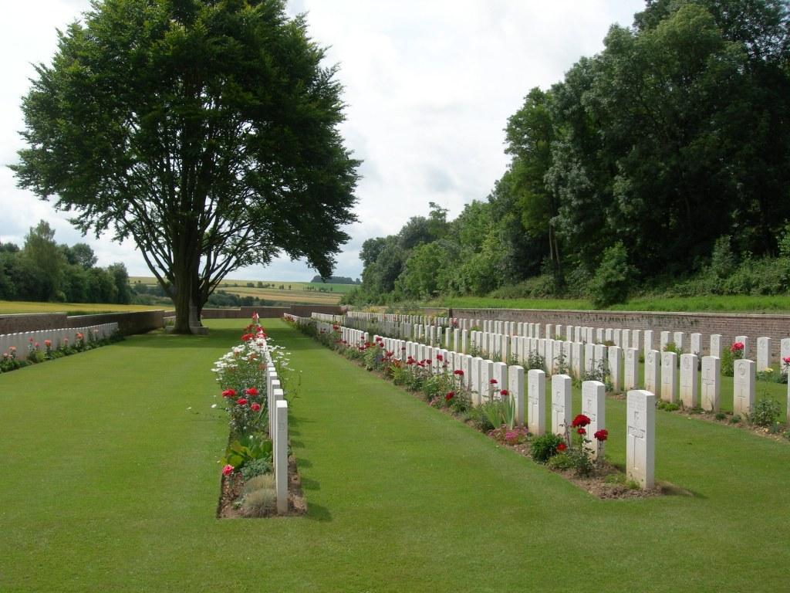

On 23rd June 1916, the Western Gazette reported:

23rd June 1916 – Killed in France – inhabitants generally heard with regret of the death of Private George Minchington SLI which was the result of wounds received whilst fighting in France. Private Minchington was amongst the first of the young men of the parish who responded to their country’s call at the outbreak of the war. As a lad he was associated with the local company of Boys Brigade and was a member of the Congregational Church and Sunday School. Western Gazette

