Cyril Gold’s Story

Military Medal for Cyril Gold of the Green Jackets

Cyril Gold’s name can be found on the impressive Dover Marine War Memorial inside the former railway station.

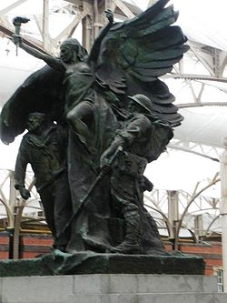

The memorial “was erected as a tribute to the 5,222 staff and employees of the South Eastern and Chatham Railway who served in His Majesty’s colours during the Great War. Of those who served their king and country, 556 men were never to return home”.
[David W Hughes and Neil R Clark 2006]

How Cyril came to be working for the South Eastern and Chatham Railway,
I don’t know, but his name is on that memorial under the Locomotive, Carriage and Wagon Department – Ashford Railway Works:

“Pre his enlistment, Cyril was employed by the South Eastern and Chatham Railway Company as an Assistant in the Road Van Department.

GOLD, Cyril MM Rifleman S/5793
1st Battalion Rifle Brigade
Died 22 July 1917

Enlisted Deptford, Kent”

One might think that perhaps this was a different Cyril Gold, especially as “Soldiers Died in the Great War” list Cyril Gold MM S/5793 as being born in Peckham, Surrey, but all the other details in both “Soldiers Died..” and the Railway memorial are correct for our Cyril. We know from reports in the Western Gazette that the Stoke sub Hamdon Cyril Gold was a Rifleman, that he got the MM in July 1917 and that he died in that month. There is only one Cyril Gold in the Medal Rolls and only one Cyril Gold in the Commonwealth War Graves. I think we have to assume that it was our Cyril Gold who worked for the South Eastern and Chatham Railway Company before the outbreak of War.

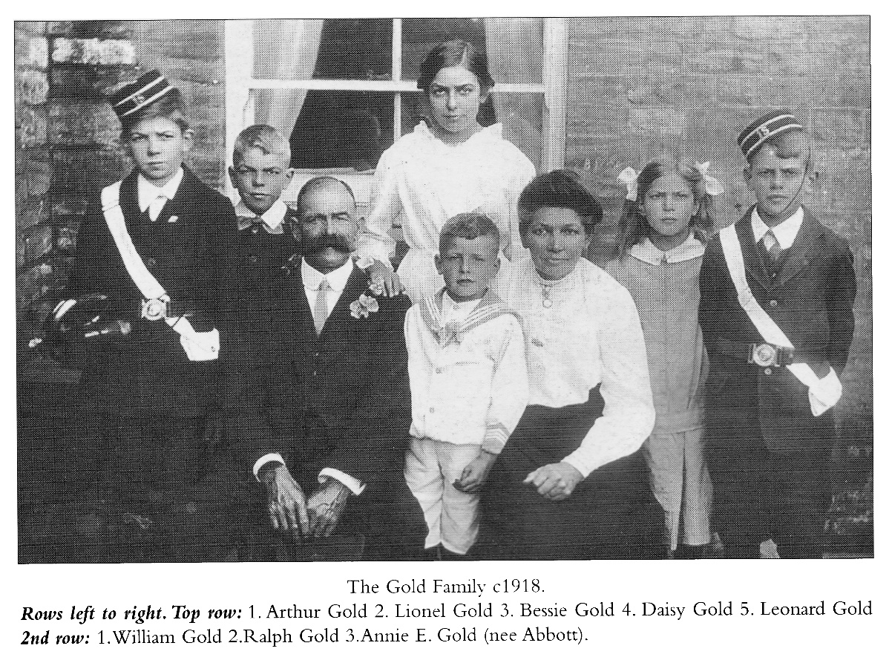
Cyril’s father, William Gold, was born in Bishops Hull, near Taunton. By his first wife, Mary Elizabeth, William had a son called Frederick in 1890. Sadly, Mary Elizabeth died aged 32 in early 1891 and William had to leave baby Frederick with his parents, William and Louisa Gold, at their home in Bishops Hull, while he himself worked as a groom at Overton Farm, West Monkton. The following year, he provided a new mother for young Frederick – Annie Abbott, who was working as a cook at Overton Farm – and Cyril was born to William and Annie in 1894, in Creech St Michael, followed by William, Elsie, Bessie and Leonard.
Between 1903 and 1905, William and Annie moved to Stoke where two more brothers and one more little sister arrived for Cyril.

They were living in North Street in 1911. William was a gardener, and Cyril and William were 17 and 15 and working as grocer’s porter and glove packer respectively. Elsie was 14, and described as a nurse (girl).

Some time between 1911 and 1916, Cyril moved to Kent and worked as an assistant in the Road Van Department of the SEC Railway. We don’t know when he enlisted but we know it was at Deptford, and we know from his medal roll card that he landed in France on 21st July 1915.

The 1st Battalion of the Rifle Brigade landed at le Havre on 23rd August 1914, and took part in the Battle of Le Cateau, the Battle of the Marne, the Battle of the Aisne, the Attack on Ploegsteert Wood and the Christmas Truce of 1914. In 1915, they took part in the Second Battle of Ypres – 21st April to 25th May.

In October 1916, there is a mention of Cyril in the Parish Magazine:

“We are glad to hear favourable accounts of some of the sick and wounded. P Dodge, Batstone, Cyril Gold, Wm Hann and others have been home for a change.”

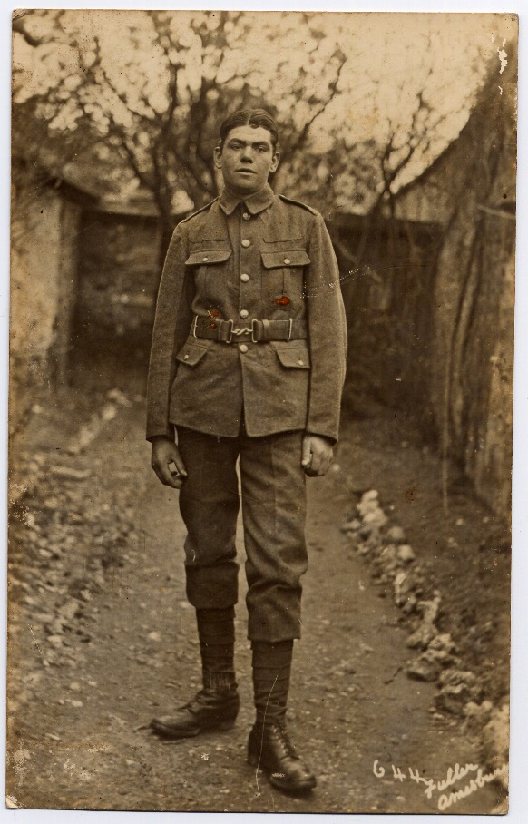

It is possible that Cyril took part in the Battle of the Transloy Ridges – 1 to 18 October 1916 – one of the Battles of the Somme, but he may have been wounded and sent home before this.

Le Transloy [Commonwealth War Graves website]
“The Battles of the Somme; the Battle of the Transloy Ridges, 1 -18 October 1916.
Heartened by the occupation of much of the Thiepval Ridge, Haig determined to continue large-scale offensive operations into the autumn. The Battle of the Transloy Ridges represented Fourth Army's part in this grand design, and its constituent costly attacks were intended to coincide with simultaneous advances by the Reserve Army planned for early October.

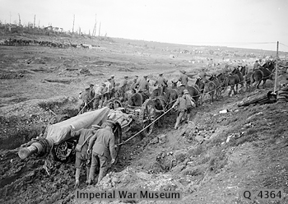
The fighting took place during worsening weather and dreadful battlefield conditions. Fourth Army's objectives necessitated, as a preliminary, the taking of Eaucourt L'Abbaye and an advance on III Corps entire front was launched, after a seven-hour bombardment, at 3.15pm on 1 October. The attack met fierce German resistance and it was not until the afternoon of 3 October that the objectives were secured. Rawlinson’s follow-up attack was delayed by atrocious weather. Starting at 1.45pm on 7 October the advance involved six divisions and resulted in heavy British casualties and little success except for 23rd Division's capture of Le Sars. Continuous rain during the night hampered the removal of casualties and further forward moves. The failure to secure original battle objectives led to a renewed major assault on the afternoon of 12 October when infantry on Fourth Army’s right floundered towards German trench lines in front of Le Transloy, while formations on the left slogged towards the Butte de Warlencourt. Despite the slightest of gains (measured in hard fought for trench yards) the operation was not successful.
Orders for a fresh attack, issued late on 13 October, ignored the desperate conditions and physical state of the attacking troops. The subsequent early morning assault on 18 October (well before daylight) witnessed heroic efforts to advance but minimal gains were made against resolute defenders well supported by accurate artillery fire.”

Whether or not Cyril took part in this action, he was back in France by February 1917.

“February 1917 – J George, P Dodge, S Baker, Cyril Gold,
Ewart Palmer, Sid Trott, Chas Boon are again at the Front.”
[Parish Magazine]
And wounded again that same month:

“23rd February 1917 - Second time wounded - Mr W Gold of
North St has had official intimation that his son,
Rifleman Cyril Gold, has been wounded while fighting
in France. This makes the second time Rifleman Gold
has been wounded during the war. His many friends wish him a speedy recovery.” [Western Gazette]

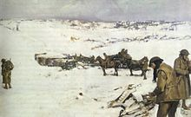

Winter on the Somme 1916-17

The War Diary of the 1st Battalion Rifle Brigade reports a fairly hectic time in the trenches that month. On 2nd February 1917, they were in billets in Suzanne [south west of Maurepas]. There followed ten days of inspections, training in the use of a Lewis gun, bombing and signalling, working parties and camp improvements. On 11th February they moved to Camp 17 north of Suzanne. On 13th February they moved to Asquith Flats, east of Maurepas, to relieve the 1st Seaforths, and came under the command of the 10th Infantry Brigade – involving carrying and working parties to the forward area.

On 16th February the Battalion relieved the Royal Irish Fusiliers in the front line at Bouchavesnes. C company was on the left, I company on the right. A & B companies were in support and reserve at Andover.

On 17th February, the Company on the right was subject to heavy bombardment by H.I. and trench mortar – 15 casualties. Sappers and reserve companies were working during the night on the front line.

On the night of the 18th – 19th February, the Battalion front was heavily shelled by guns of all calibres and heavy trench mortar – 26 casualties. Inter-company relief – B company relieved C on the left. A company relieved I on the right. All companies working on front line and communication trenches until 7.00 a.m. C and I companies went back to Andover Place. The 19th Royal Welsh Fusiliers were on the left. Quiet.
20th February – Enemy quiet. Battalion relieved by 19th Royal Welsh Fusiliers and moved back to dugouts in Asquith Flats.

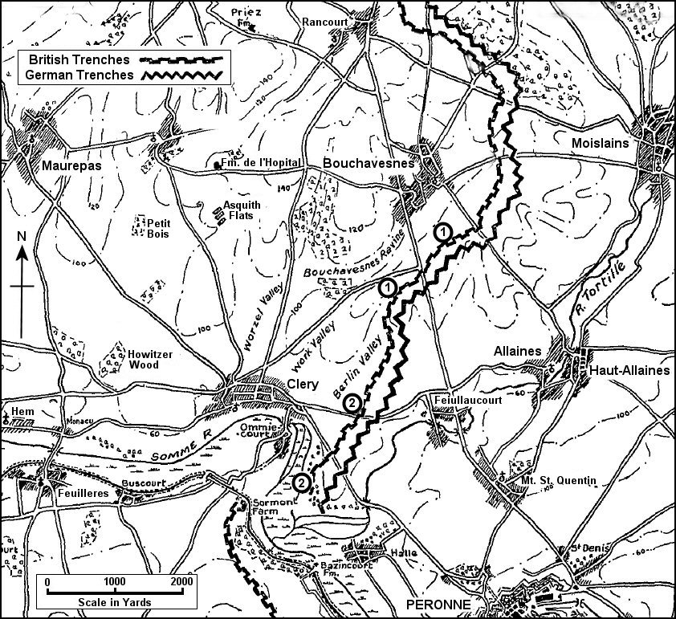
Asquith Flats
Bouchavesnes
British Front-Line Trenches as at January-February 1917

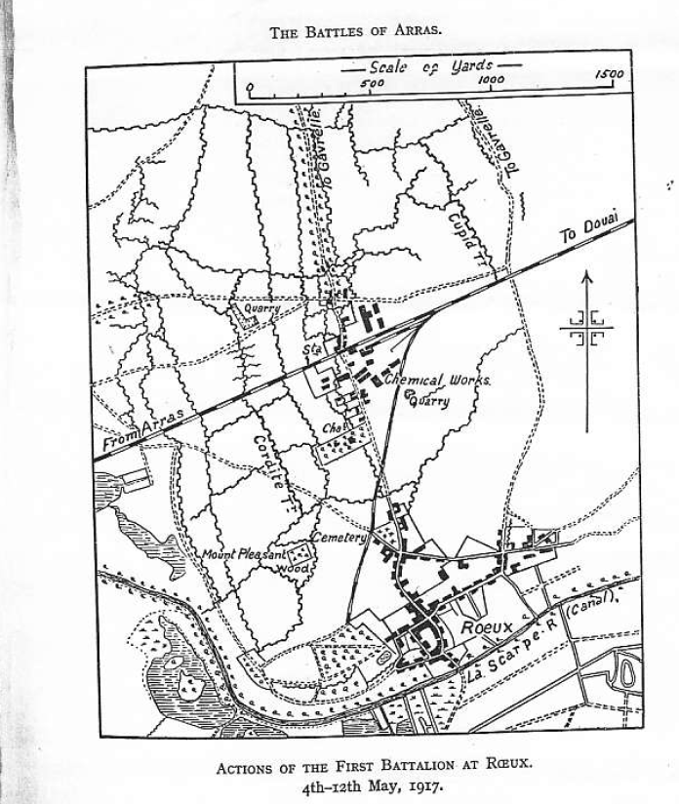
It was for his actions at the Battle of Arras in May 1917 that Cyril Gold was awarded the Military Medal.

[Information about the 1st Battalion in the Battle of Arras is taken from William Seymour’s book, “The Rifle Brigade 1914-18”]

Between 4 – 12th May 1917, the 1st Battalion was in the fighting at Roeux as part of the Battle of Arras. The first objective of the attack was the northern portion of the village of Roeux, consisting of a number of well built houses lying on either side of the Reoux/Gavelle Road. There was a chateau and two large factories and a quarry in which dugouts had been constructed by the Germans.

The 1st Battalion was not in the first attack which was a failure. In order to clear up the situation and to extricate any surviving men from the Chateau and beyond it, orders were issued for all available troops to make another attack after dark.

As part of this plan, on 4th- 5th May A and C companies were ordered to assault the Chateau with the sword without artillery assistance. The assault was attempted at
3.00 a.m. in the face of heavy machine-gun fire but nothing was accomplished and C Company lost two officers wounded, Captain I C Montford and 2nd Lt B J Cunningham, with 40 other rank casualties. In the evening the Battalion was moved to trenches north of the railway.

On 5th May, station buildings north of the railway were bombarded by our heavy artillery all day. At 9.30 p.m. a bombing attack was made by I Company to reconnoitre buildings north of the railway. The buildings were found to be strongly held and the reconnaissance withdrew with the loss of 21 casualties.

On 6th May I Company at 5.30 p.m. made another attempt to occupy the buildings north of the railway and suffered a further 27 casualties.

On 7th May, the Battalion was relieved and went into trenches where it stayed till the night of 10th. Casualties so far 2 officers and 94 other ranks.

The next attack was on 11th May. On the night of the 10th, the Battalion moved up into assembly trenches north of the railway and about 300 yards west of the Roeux/Gavelle Road. A and C Company were in the front line with I Company in support. Zero hour was planned for 7.30 p.m. on 11th.

All day our heavy artillery kept up a slow bombardment. The afternoon was still and hot, and at 7.30 p.m. the sun was shining straight into the eyes of the enemy when the barrage opened… the infantry were able to get out of their trenches with practically no loss. The assault was completely successful. The buildings north of the railway were captured. About 40 prisoners were taken and an equal number of enemy killed in and about the buildings. 3 machine guns and 3 trench mortars were also taken by the Battalion.

At 6.30 a.m. on 12th May, A and C Company attacked the next objective – a trench known as Cupid Trench, 500 yards further east. 1st Battalion Somerset Light Infantry were attacking also on the right side of the railway. The trench was successfully taken and consolidated but unfortunately the troops on the left had not been able to capture the whole of their objective. During the day, A and C Companies were subjected to a very heavy bombardment and suffered over 30 casualties.

The Battalion then withdrew to the neighbourhood of Athies and on 13th went into billets in Arras for two nights.

Cyril was awarded the Military Medal for his part in this action but did not get it until 18th July 1917. We don’t know when Joseph Gummer from Stoke joined up, but if it was prior to May 1917 then he might well have been with the 1st Battalion Somerset Light Infantry, attacking on the right side of the railway on 12th May. The War Diary for 1st Battalion Rifle Brigade reports at the end of May 1917:

Following decorations were awarded for May operations:
Military Medal: Sgt R Cooke, A/Cpl A Williams, Cpl H West, Rifleman C Gold.

In June 1917, the Parish Magazine reports that Cyril Gold was a prisoner but escaped after three days. Meanwhile, news of Cyril’s award of the Military Medal reaches Stoke and is printed in the Western Gazette on 15th June 1917:

“Private Cyril Gold, London Rifles, son of Mr & Mrs William Gold
of North Street, has been awarded the Military Medal for distinguished conduct in the field”.

On 29th June, the Western Gazette prints a full account of how he won the military medal:

The following extract from a letter from the Front will be read with pleasure, as showing the grit of our lads at the Front: ‘On May 4th his Company was supposed to keep behind the front line in reserve, but there were no keeping them back. Once the I Company got in front of the other three Companies and Cyril was leading the men (as you may say) being some distance in front of the lot, an officer caught sight of Gold in the front of them all and asked who it was. One of the men replied, “Gold”, and the officer gave the order, “All you men follow Gold,” and they went forward and captured the ………works. Shortly after Cyril and a chum went out alone to see if any Germans were about, and nearly got surrounded and his chum was wounded and asked him not to leave him. “I won’t”, replied Gold, “whatever happens,” and carried him to shelter, the Germans being so near that they could hear them talking. One said, “they are done for.” After the enemy had passed Gold took his comrade on his back and was making for safety, when a sniper put a bullet through the man on his back. Gold attended to the wound as best he could, and dodging from shell hole to shell hole, eventually reached shelter, where the chum died the following night. As Gold could do no more he thought of his own safety, and crawled for nearly a day. Entering a trench he saw some “jerries”, so taking shelter again in a shell hole he waited till night, and again crawled back to his own line. A sentry saw him, and was about to fire when Cyril shouted, “Don’t shoot, for God’s sake.” And was then taken in the trench, having lost all his equipment. He was taken before his officer and congratulated for what he had done, and was recommended for the M.M.’

Fast on the heels of this report comes the news that Cyril has been wounded again:

“27th July 1917 – Private Cyril Gold who was recently awarded
the Military Medal, has been wounded in action and is now in
a hospital in France”. [Western Gazette]

And then sadly in August 1917:

“We regret to have to record the death of Cyril Gold. It will be in
the minds of some that only as lately as the last Magazine, we gave
the account of how he got his Military Medal, and now we hear how
he got caught by shrapnel which so shattered his leg it had to be
amputated, and he died two days after the operation in a hospital
in Rouen. This adds much to the sorrow of his parents who for a
long time have had a son a prisoner in Germany and we hope
our Father in heaven will help them to bear their troubles.”
[Parish Magazine]

Cyril died on 22nd July 1917 and is buried at the St Sever Cemetery Extension, Rouen

[Commonwealth War Graves]

Cyril is related to James and Gilbert Shoemark and Bertie Clarke.

