Hugh Leigh Norris’ Story

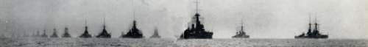

Hugh Norris was not born in Stoke and neither were his parents but we have adopted him because he was the nephew of Helen Walter (née Norris), wife of Walter Winter Walter, and Hugh as a boy used to come to stay with the Walter family in Stoke.

Richard Hensleigh Walter – Hugh’s first cousin – had the war memorial put up in St Mary’s Church in Stoke with a little plaque on it, dedicating it to Hugh who died on 31st May 1916 HMS on “Indefatigable” in the Battle of Jutland.

Hugh was a surgeon, following in the footsteps of his father and grandfather, both called Henry Norris. He was born in Charmouth in 1874. He was educated at Dulwich College and St Thomas’ Hospital, where he qualified in 1898.

He was good at games and at drawing and was a contributor to many journals, including Punch. His grandfather was Captain Marryat of “The Children of the New Forest” fame, and Hugh himself had two books published – “Rice Papers” and “China Side”.



Hugh is on the Navy List as a surgeon from 1898. He married Nina Dyson and they had one child, Helen Lavender Norris, who was born in the Portsmouth area in 1905. In 1916 he was Fleet Surgeon on HMS Indefatigable. This ship was one of the first to blow up in the Battle of Jutland. Hugh was 41 years old.

THE BATTLE OF JUTLAND – 31st May 1916 – 1 June 1916

Before 1916 there had been no major sea battles between the world's largest naval powers, Germany and Britain. The British Grand Fleet kept to the safety of Scapa Flow in the Orkney Islands while the Germany High Seas Fleet stayed anchored in their own ports. In January 1916, the Germans had a new Naval Commander, Admiral Von Scheer, and he was eager for action. Von Scheer planned to lure the British Fleet into battle and trap them. The British found out what he was planning and prepared to meet the German fleet.

Just before 6pm on 31 May, the great fleets of Britain and Germany, totalling some 250 ships, came into contact off the coast of Jutland. Fierce fighting went on all evening with high explosive shells ripping into thick armour plating. Sailors burned to death or were drowned in the icy-cold sea. As darkness came Von Scheer headed back to port and the British fleet concerned about enemy submarines and minefields refused to give chase.
Both sides claimed victory. The Germans said they sank more ships but the British claimed Von Scheer had given up first and fled the scene of the battle. However, when losses were counted Britain seemed to have lost more. Britain lost 14 battleships to Germany's 11. While Germany lost 2,551 men, Britain lost 6,077.

The German High Seas Fleet stayed at home for the rest of the war. They chose to rely on U-boats (submarines). German U-boats caused great problems for the British as they sunk an enormous amount of shipping. The British eventually defeated the menace of the U-boats by employing a convoy system where anti-submarine ships protected other ships in a group.
(source, www.NationalArchives.gov.uk)

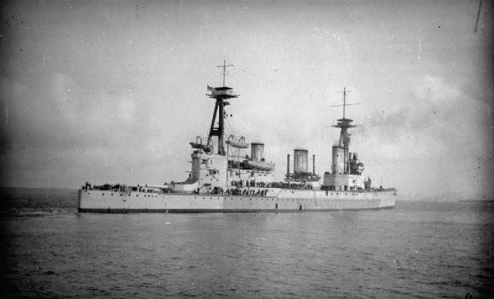
HMS Indefatigable
was the first ship to blow up at the Battle of Jutland

At 16:02, just 14 minutes into the slugging match, she was smashed aft by three 11 in (280 mm) shells fromSMS Von Der Tann, causing damage sufficient to knock her out of line and detonating "X" magazine aft. Soon after, despite the near-maximum range, Von der Tann put another 11 in (280 mm) salvo on Indefatigable's "A" turret forward. The plunging shells probably pierced the thin upper armour, and seconds later Indefatigable was ripped apart by another magazine explosion, sinking immediately with her crew of 1,019 officers and men, leaving only two survivors. [Wikipaedia]

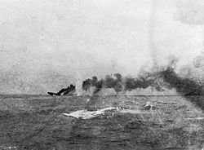
HMS Indefatigable sinking

[Wikipaedia}

(Alfred Palmer of Stoke was on HMS Broke and also died at the Battle of Jutland.)

As well as the plaque in St Mary’s Church, Stoke, there is a memorial to Hugh Norris in the parish church in Charmouth.

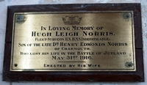

“In loving memory of Hugh Leigh Norris
Fleet Surgeon RN, HMS Indefatigable.
Son of the late Dr Henry Edmonds Norris
of Charmouth.
Who lost his life in the Battle of Jutland
May 31st 1916
Erected by His Wife.”

Hugh is also remembered on the Plymouth Naval Memorial:

