Edward James Taylor’s Story

In loving memory of Pte Edward J Taylor, Coldstream Guards, who fell in action near Cambrai, November 30th 1917, aged 39 years. Erected by his stonecutter friends, Texas, USA

These are the words written on Edward Taylor’s memorial stone in the churchyard of St Mary’s in Stoke sub Hamdon.

Edward came from quite a well to do family. He was born in Stoke in the summer of 1878. In 1881, when he was three years old, he was living on Ham Hill with his father, George Taylor (stone mason employing three men), his mother Sarah (from Milborne Port) elder sister Annie aged four and younger sister Ada aged two, and the family had a servant called Elizabeth Richards, aged 18.

Ten years later, Edward’s father is described as a foreman in the stone quarry. He gives his place of birth as Montacute, although in subsequent census returns, it is said to be Stoke. Young Ada is now 12 and there is also Sydney (10), Julia (8) and Ivy (3). Edward is thirteen and working in the stone quarry. The next family listed on the census for that area is the Keetch family – Austin Keetch who died in the war was aged one year in 1881.

The school log book does not mention Edward, but S Taylor was punished for disobedience on 13th October 1893. Edward’s younger brother, Sydney, would have been about twelve so this could have been him, though there were other Taylors in the village.

In 1901, the family were living on Highway in Stoke. Edward, Sydney and Joy were still at home. Edward was 23 years old and working as a stone mason. His grandmother, Ann from Milborne Port, was living with the family on her “own means.”

Some time between 1901 and 1911, Edward left the country for America. I don’t know what date he set out, but he must have spent some time in Texas because the churchyard memorial was erected by his “stonecutter friends in Texas.” Possibly some Stoke villagers had already emigrated to that part of the world and Edward joined them to work as a stonemason.

War broke out in September 1914 and like several other of the Stoke lads who had gone to live abroad, Edward decided to come home to enlist. He sailed back in the SS Campania (later to be taken over by the Navy and used during the War), arriving in Liverpool from New York in October 1914.
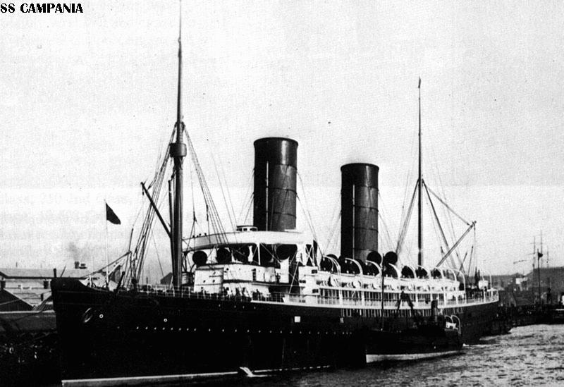

SS Campania

Built for Cunard Line in 1893. Sold to British Admiralty in 1914 and renamed HMS Campania. Rebuilt as aircraft carrier. Sunk after collision in Firth of Forth in 1918

Edward arrived home in the autumn of 1914. We don’t know what date he enlisted but we know that it was in Yeovil and that he joined the 2nd Battalion of the Coldstream Guards. He was 36 years old.
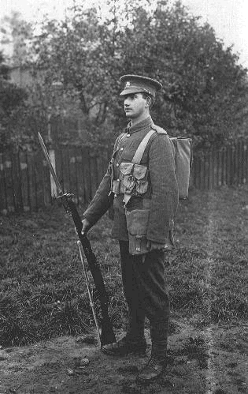
A Private of the Coldstream Guards, August 1914. He wears standard Service Dress and the early version of the 1908 webbing, including large pack. He is armed with the 1903 SMLE with 'long range sights' and a 1907 Pattern bayonet with the hook quillon; this had largely been removed from such bayonets by 1914, but some remained in issue. (©Paul Reed)

The Coldstream Guards is the oldest regiment in the Regular Army in continuous active service, originating in Coldstream, Scotland in 1650 during the Civil War.

Account of Private John L Bouch, 1st Bn Coldstream Guards
[from “Somme” by Lyn MacDonald]

“I enlisted in the Coldstream Guards at the end of August 1914. You’d never believe the training and discipline we went through at the Guards Depot at Caterham. We were subjected to a volume of abuse and scorn which is difficult to imagine. I found out swear words I’d never heard before. I found out a combination of swear words of such degree and magnitude that weren’t imaginable! They called us these things in front of officers and nobody said a word.

“We were run until we were breathless and then we had to run again simply because we couldn’t do a complicated piece of drill as quick as they wanted us to. ‘On the left, form SQUAD!’ When you found that the man next door had two right feet instead of a left and a right and he went the wrong way, the Drill Sergeant would shout, ‘You bloody idiot! Double up the parade ground!’ And up we would all have to go, up the parade ground and back again, up again and back again until he shouted, ‘Have you had enough, you buggers?’ The Drill Sergeant had a voice that carried fifty miles! ‘You’re in the Guards, remember!’ he used to shout, ‘This is not a regiment of the line. You are supposed to be the people to guard the Sovereign, God help him!’

“All our officers were lords, or nearly so. The Honourable Charles Knowles was our Company Commander. Lord Hugh Kennedy was a Lieutenant in charge of Number 12 Platoon. Viscount Holmesdale was another Lieutenant in our Company. I was a Private. We were worlds apart. Even the distinction between Private and non-commissioned officers was very, very marked. In fact a private couldn’t speak to an NCO without standing to attention. At the barracks at Caterham, we even had to stand to attention to speak to an old soldier who was in charge of the barrack rooms – and he was just a private like ourselves!”

I imagine being a private in the Coldstream Guards must have been something of a shock to the system for Edward, straight from America, the land of equal opportunity!

On 27th April 1915, Edward arrived in France with 2nd Battalion Coldstream Guards, being part of 4th (Guards) Brigade, 2nd Division, but in August 1915 the various Guards units that had been with other divisions were all brought together to form the Guards Division.

The Guards Division fought at the Battle of Loos in 1915, the battles of the Somme in 1916, and Passchendaele in 1917.

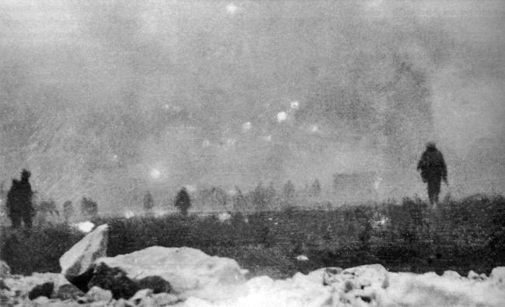

The Guards advancing through gas cloud at Loos, 1915.
Photograph believed to have been taken by soldier

The Guards Division fought at Loos in 1915, the Somme 1916, Passchendaele 1917.

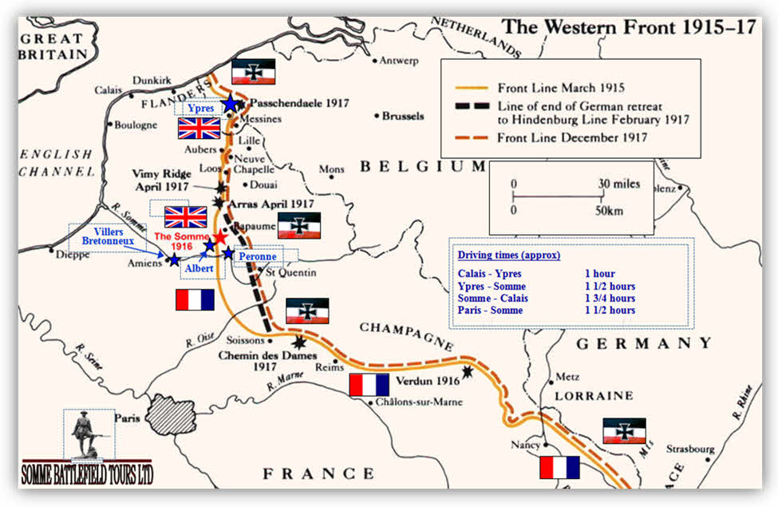

The Battle of Loos was the first major British offensive on the Western Front and was the first time the British used gas as a weapon. Rudyard Kipling’s son John was killed at Loos in September 1915 while serving with the Irish Guards. The photo below was taken of men in the Coldstream Guards taken only a few weeks before the battle. It shows men of a Guards training platoon at their end of their course awaiting posting to the front . Edward by this time would already have been in France but he may have known some of these men.
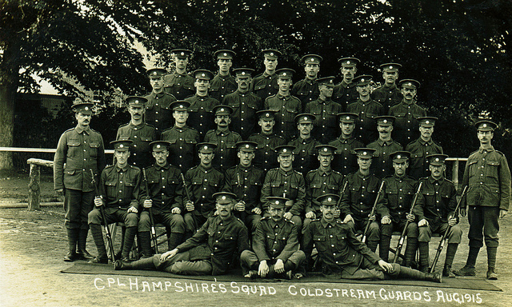

WW1 Photos Centenary Website: 2014-2018 By Paul Reed

THE SOMME

In 1916, the Guards Division moved down from Northern France into the Somme area and took part in the Battle of Flers-Courcelette (where the British army used tanks for the first time) and then the Battle of Morval.

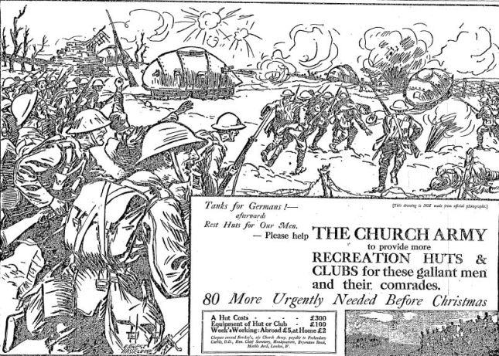
Tanks were developed in great secrecy and came as a surprise to the Germans. This London press advertisement appeared on 12 October 1916, just a few weeks after the Battle of Flers-Courcelette. The cartoonist had clearly never seen a tank but had done his best!
[The Long, Long Trail]

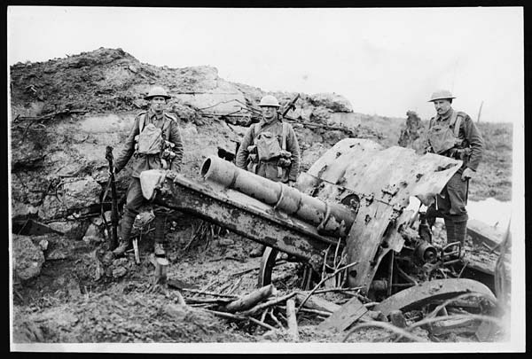
“Men of the Coldstream Guards and a newly captured German 5.9 gun”
(On the Somme 1916)
Photo by War Photographer John Warwick Brooke [Imperial War Museum]

RETREAT TO THE HINDENBURG LINE

In March 1917, the German armies on the Somme carried out a strategic withdrawal known as Operation Alberich. They destroyed everything on the ground that they left: flattening villages, poisoning wells, cutting down trees, blowing craters on roads and crossroads, booby-trapping ruins and dugouts. The withdrawal was to an immensely powerful and shorter line, positioned to take every tactical advantage of ground. The construction of this line had been spotted by British and French aviators in late 1916. British patrols began to detect the withdrawal of German infantry from the Somme in mid February 1917 and a cautious pursuit began, halted only as the Hindenburg Line itself was approached.
[The Long, Long Trail]

The Guards Division took part in this “cautious pursuit” of the Germans.

PASSCHENDAELE

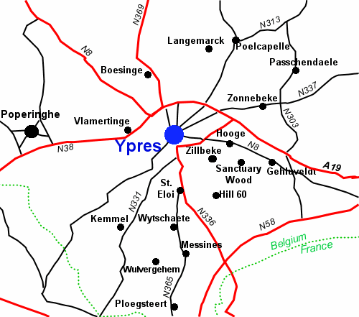
Battle of Pilckem Ridge
July 1917

In July of 1917, Edward’s Division was again in Northern France for what would later become known as the Battle of Passchendaele. On the 31st of July 1917 the 2nd Battalion advanced, crossing the Yser Canal, passing through the 2nd and 3rd Guards brigades and then moved on to secure the crossings of the stream known as Steenbeck. They attacked at 5.20am, advancing in two waves, 150 yards apart. There was very little hostile shell fire while they were west of the canal which they reached with only three casualties. At the canal the barrage intensified but was predicable enough for the commanders to get their troops forward in the gaps in the fire and by 6.20am the whole battalion got across the canal without a casualty. At the German trenches east of the Pilkem Road the fire became a lot heavier and casualties began to mount as they crossed the trench on to the next line machine gun fire became intense.

John Stagg from Stoke was in the Welch Regiment, to the right of the Guards Division during this action.

The Welch Regiment: 1914-18:

In the afternoon, the weather, which had been dull and cloudy at the commencement of the attack, now broke and heavy rain poured down for three days, turning the shell-torn ground into a mass of sticky, slippery mud, pockmarked with deep shell holes full of water, where many a man and animal were drowned. The only way to get up to the Pilckem Ridge from the canal bank was by sticking to the duckboard tracks with reserve troops and Pioneers commenced to lay as soon as it was known that the ridge was ours. These tracks were of course plainly visible from the air, and they were mercilessly shelled day and night by the enemy, while at intervals enemy planes dartred down and swept them with machien gun fire. At the front it was impossible to do anything but lie in shell holes. There was great difficulty in keeping the mud out of the rifles, while nearly every Lewis gun in the Division was out of action, but these were speedily replaced by a reserve store at Divisional Headquarters. The Divisional Artillery moved forward slowly and laboriously to fresh positions under the Pilckem Ridge. It was marvellous how the drivers and ammunition columns managed to keep up a sufficient supply of shells, as they all had to be carried by men in specially made coats with deep pockets, or brought up a few at a time on pack animals.

In September 1917, the Western Gazette reports:

Private E Taylor, Coldstream Guards, is home on leave from France, after many months’ active service.

If this was the first time he had been on leave since arriving in France in 1915, he had certainly done a long stint.

He was back in France by November 1917. The Battle of Cambrai started on 20th November.

"The Battle of Cambrai ranks as one of the most thrilling episodes of the whole war. Tanks at last came into their kingdom. The notion that the Hindenburg Line was impregnable was exploded".
Captain Stair Gillon: The Story of the 29th Division: a record of gallant deeds

.
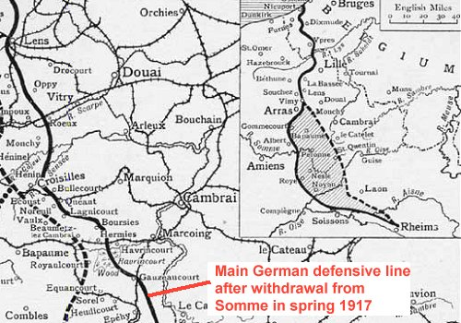

The battle started on 20th November, and the Guards took part in the Battle of Bourlon Wood – 23rd to 28th November.

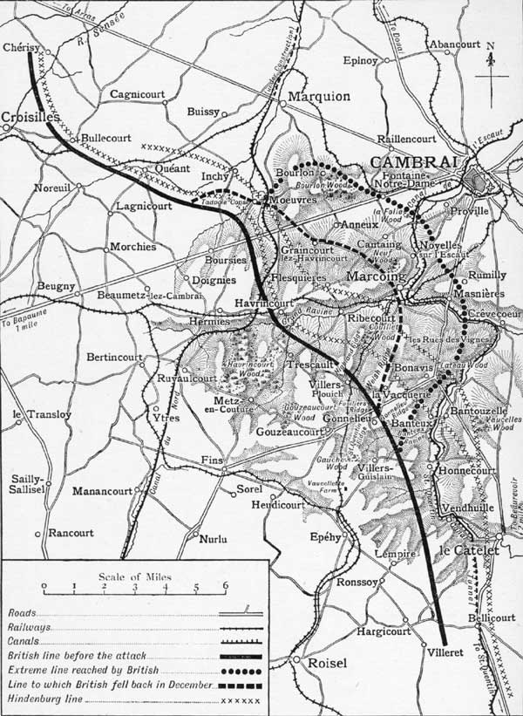
The Guards Division took part in the fighting in Bourlon Wood

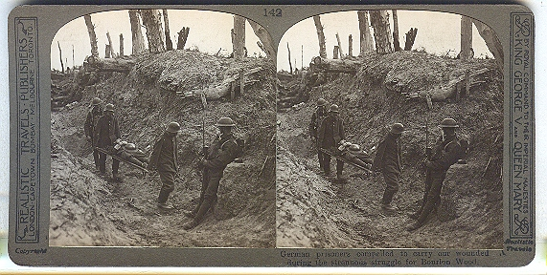
'German prisoners compelled to carry our wounded during the strenuous battle for Bourlon Wood'.

The capture of Bourlon Wood, 23 - 28 November 1917 [The Long, Long Trail}
On 22 November, the GOC 40th Division at Beaumetz-les-Cambrai received orders to relieve the 62nd Division the next day. The 40th was a division of Bantams, men under regulation height. By now the roads were breaking up under the strain of thousands of men, wagons and lorries. It took 40th Divisional HQ 15 hours to travel the 9 miles to Havrincourt. A relief and assault plan was quickly drawn up: 121 Brigade to capture Bourlon, 119 Brigade to go for the wood, both jumping off from the sunken lane. On their right, the 51st would move forward to Fontaine. On the left, the 36th would go in again at Moeuvres. 92 tanks would support these units. They attacked through ground mist on the morning of the 23rd. Some of the units of the 40th had to cross 1000 yards down the long slope from Anneux, across the sunken lane and up the final rise into the wood, all the while under shell fire. There was close and vicious fighting in the wood, but after 3 hours the Welsh units of 119 Brigade were through and occupying the northern and eastern ridges at the edge of the undergrowth. 121 Brigade was cut down by heavy machine gun fire, and few men got as far as the village. 7 tanks did but were unsupported and the survivors withdrew. On the flanks, the 36th and 51st Divisions made little progress, against strengthening opposition.
Over the next few days, further troops were thrown into the battle, including the Guards Division, which advanced into Fontaine. Once his troops had been driven from the wood, the enemy switched all of his artillery onto it. Battalions in the wood were wiped out. Three companies of the 14th HLI miraculously penetrated to the far side of Bourlon but were cut off and gradually annihilated. And it began to snow. The weary troops settled into the newly-won positions. The British now sat some way ahead of the position of 20th November, being in possession of a salient reaching towards Cambrai, with the left flank facing Bourlon and the right alongside the top of the slope which ran down towards Banteux.

“All arms” fighting broke down, the tanks few and impotent in the thick woodland of Bourlon and La Folie, and defeated in the ruined streets of Fontaine Notre Dame. Behind the front, the roads resembled those at Morval a year before, the traffic unable to move through mud and snow, along roads for which there was insufficient stone and labour to carry out adequate running repairs. The “ray of hope” had become a slow, piecemeal and inevitably costly shambles. Third Army closed down offensive operations on 27 November and units were ordered to consolidate. Three days later, The German Army struck back.

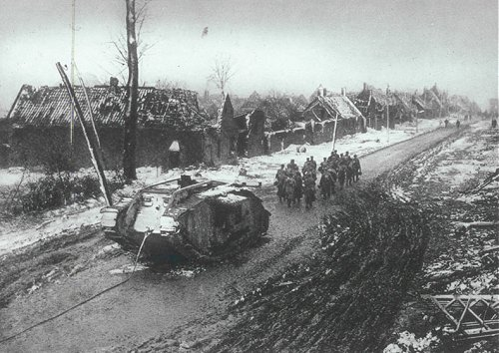

Fontaine-Notre-Dame
A British tank, damaged and captured in Fontaine Notre Dame, in a photograph taken once the Germans had defeated the Guards Division attack through the village.

Edward was killed on 30th November 1917. This is an account of that day written by Rudyard Kipling about the Irish Guard who were in the same action as Edward’s battalion,
2nd Battalion Coldstream Guards, 1st Guards Brigade.

GOUZEAUCOURT
There was no shelter against the driving snowy rain, and the men, without great-coats or blankets, were “very cold, wet and miserable.” The next day was no better, and on the 29th the Fifty-ninth Division took over their area from them while the Guards Division was rearranged thus: the 3rd Brigade at Trescault, the 2nd at Ribecourt, and the 1st at Metz-en-Couture, a wrecked, red-brick village, once engaged in the sugarbeet industry, lying on and under a swell of the downs some four thousand yards west of Gouzeaucourt. The Divisional Artillery was at Flesquières, more than four miles away. The Battalion’s march to Metz was badly delayed by blocks on the road and a general impression spread that trouble was not far off. Individually, the soldier is easy to deceive: collectively, a battalion has the sure instinct of an animal for changes in the wind. There were catacombs in Metz village where one company was billeted whereby it was nearly choked to death by foul gases. This seemed all of a piece with the bad luck of the tour, and the dawn of the 30th November was ushered in by single shells from a long-range gun which found them during the night. Half an hour after they had the order to move to Heudicourt and had digested a persistent rumour that the enemy were through at Gonnelieu, telegrams and orders began to pour in. The gist of them was that the line had undoubtedly cracked, and that the Brigade would move to Gouzeaucourt at once. But what the Brigade was to do, and under whose command it was to operate, were matters on which telegrams and orders most livelily conflicted. Eventually, the Division as a whole was assigned to the Third Corps, the 3rd Brigade was ordered to come up from Trescault and help the 1st, and the various C.O.’s of the battalions of the 1st Brigade rode forward to see for themselves what was happening. They had not far to go. Over the ridge between Gouzeaucourt and Metz poured gunners, carrying their sights with them, engineers, horses and infantry, all apparently bent on getting into the village where they would be a better target for artillery. The village choked; the Battalion fell in, clear of the confusion, where it best could, and set off at once in artillery formation, regardless of the stragglers, into the high and bare lands round Gouzeaucourt. There were no guns to back them, for their own were at Flesquières.
As was pointed out by an observer of that curious day—“’Tis little ye can do with gunsights, an’ them in the arrums av men in a great haste. There was men with blankets round ’em, an’ men with loose putties wavin’ in the wind, and they told us ’twas a general retirement. We could see that. We wanted to know for why they was returnin’. We went through ’em all, fairly breastin’ our way and—we found Jerry on the next slope makin’ prisoners of a Labour Corps with picks an’ shovels. But some of that same Labour Corps they took their picks an’ shovels and came on with us.”
They halted and fixed bayonets just outside Gouzeaucourt Wood, the Irish on the left of the line, their right on the Metz–Gouzeaucourt road, the 3rd Coldstream in the centre, the 2nd Coldstream on the right, the 2nd Grenadiers in reserve in Gouzeaucourt Wood itself. What seems to have impressed men most was the extreme nakedness of the landscape, and, at first, the absence of casualties. They were shelled as they marched to the Wood but not heavily; but when they had passed beyond it they came under machine-gun fire from the village. They topped the rise beyond the Wood near Queen’s Cross and were shelled from St. Quentin Ridge to the east. They overran the remnant of one of our trenches in which some sappers and infantry were still holding on. Dismounted cavalry appeared out of nowhere in particular, as troops will in a mixed fray, and attached themselves to the right of the thin line. As they swept down the last slope to Gouzeaucourt the machine-gun fire from the village grew hotter on their right, and the leading company, characteristically enough, made in towards it. This pulled the Battalion a little to the right, and off the road which was supposed to be their left boundary, but it indubitably helped to clear the place. The enemy were seen to be leaving in some haste, and only a few of them were shot or bayoneted in and out among the houses. The Battalion pushed in through the village to the slope east of it under Quentin Mill, where they dug in for the night. Their left flank was all in the air for a while, but the 3rd Brigade, which had been originally ordered to come up on the right of the 1st, was diverted to the left on the Gouzeaucourt–Villers–Plouich line, and they got into touch with the 4th Grenadiers. There was no attempt to counter-attack. Tanks were used on the right during the action, but they do not seem to have played any material part in the Battalion’s area, and, as the light of the short and freezing November day closed, a cavalry regiment or “some cavalry” came up on the left flank.
The actual stroke that recovered Gouzeaucourt had not taken more than an hour, but the day had cost them a hundred and thirty men killed, wounded, and missing; Lieutenant N. F. Durant killed, Lieutenant (Acting Captain) Joyce, Lieutenant G. E. F. Van der Noot, Lieutenant G. K. Thompson, M.C., and 2nd Lieutenant P.M. Riley wounded. All the casualties were from machine-gun fire; men dropping at the corners of streets, across thresholds in cellars and in the angles of wrecked walls that, falling on them, hid them for ever.
. Edward Taylor is remembered on the Cambrai Memorial, Louverval.
He was also remembered in St Mary’s Churchyard in Stoke. Sadly, though, the memorial which was erected by “his stonecutter friends from Texas” is no longer there.

