Frank Boon

Frank Boon’s father George, worked in the quarry on Ham Hill. He was born in Aller, while his wife, Louisa Willmott, was born in Odcombe. They were married in the Yeovil area in 1877 and by 1881 were living in Whirligig Lane with their two daughters, Alice aged 3, and Kate aged 6 months. Also living with them was 24 year old George Willmott from Odcombe – possibly Louisa’s brother. The children were sent home from school for their fees on two occasions in 1888. Life was not easy.

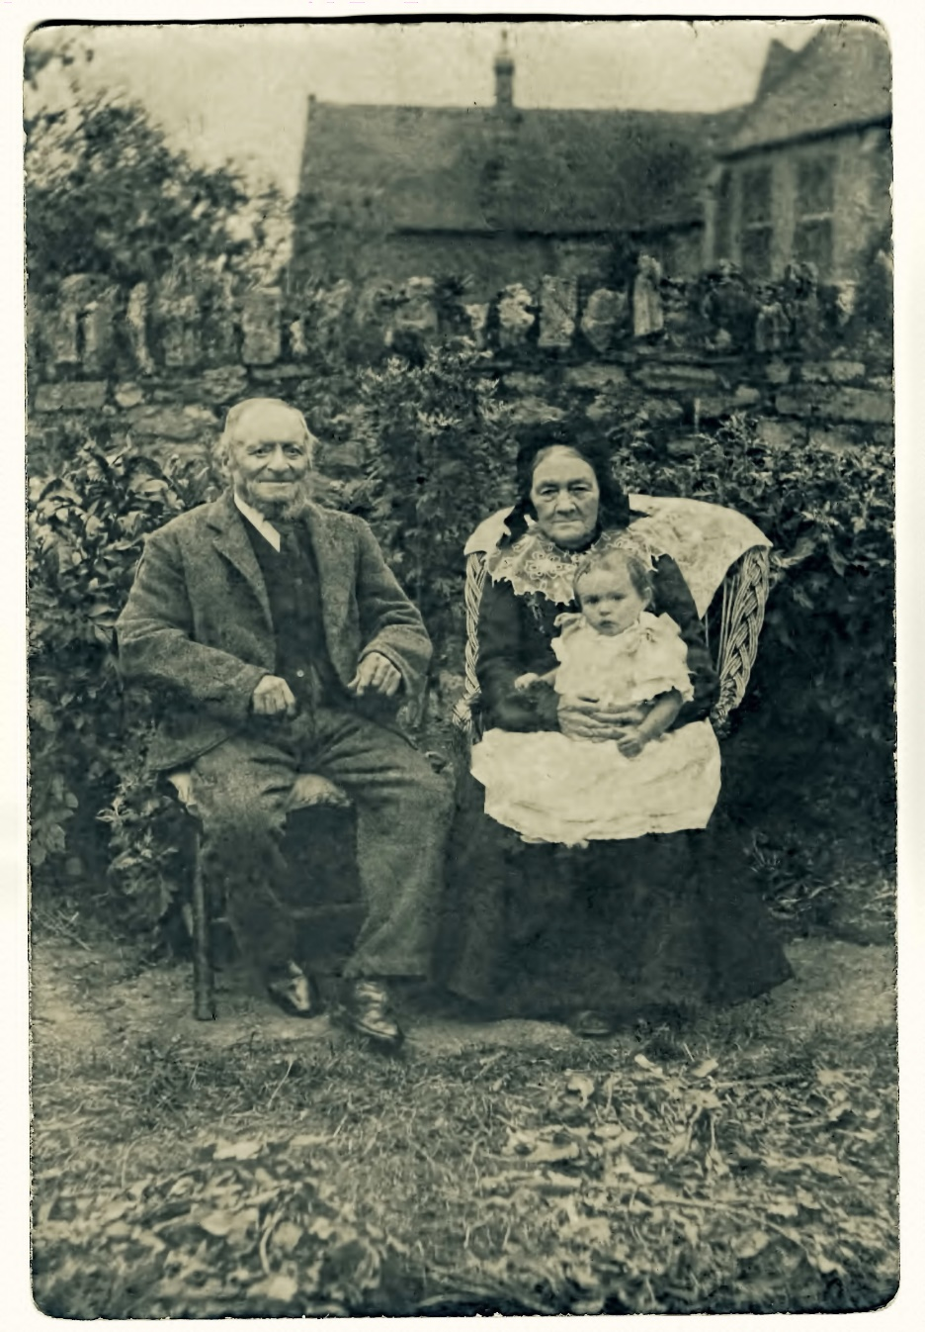
“Granny Boon” in Castle Street
(Stoke Primary School behind the wall)

By 1891, they had moved into Castle Street – probably somewhere near the school – and their family had swelled to include Charlie (Francis Charlie), Daisy, Thomas (Henry Thomas), Flossie Violet, Frank and George. There was a Joseph Henry Boon who was born at the same time as Thomas who died aged four in 1890, possibly Tom’s twin, and a baby Frank who was born and died the year before our Frank.

George, Charles and Tom were all working in the stone quarry in 1901, while Louise worked as a glove machinist.

I don’t know whether Frank started out with his brothers in the quarry, but by 1911 he was described as a “journeyman baker” and he was living as a boarder with 63 year old Jane Hockey, in West Chinnock.

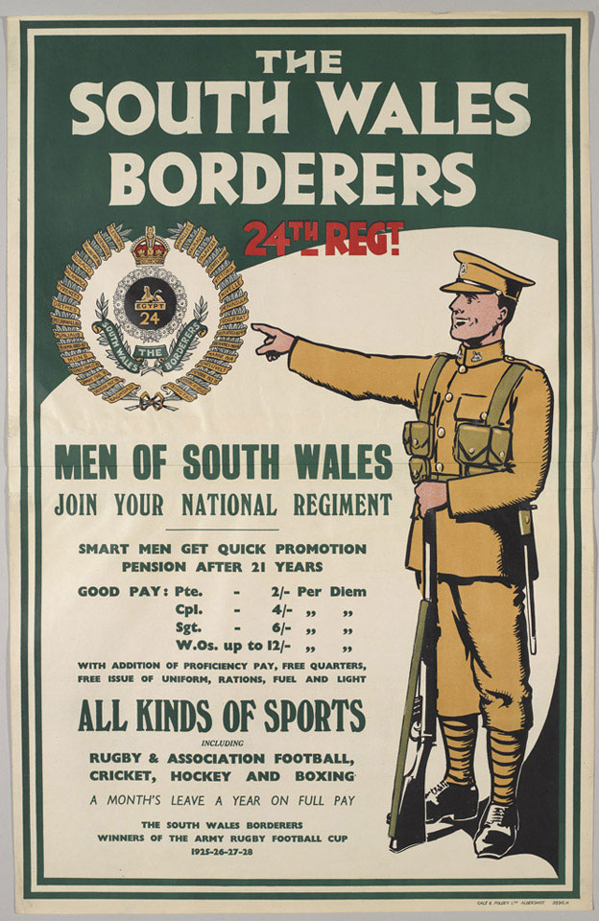

The Western Gazette described him as having been one of the men who answered Kitchener’s call to arms in 1914. Some time between 1911 and 1914, he may have moved to Wales in search of work as so many of the Stoke men did, because it was in Brecon that he enlisted in the 2nd Battalion of the South Wales Borderers.

In 1914, the 2nd Battalion were in China, returning to England on 12th January 1915, where they were billeted near Coventry. After being inspected by the King, they left England in March 1915 for the attack on Gallipoli as part of the 29th Division.

On 25th April 1915, the 29th Division made its historic landing at Helles, landing in broad daylight on open beaches defended by barbed wire, covered at close range by rifles and machine guns. The 2nd Battalion of the South Wales Borderers served throughout the rest of the Gallipoli campaign.

Frank arrived in “the Balkans”, according to his Medal Roll card, on 19th July 1915. Some time between April and June 1915, he had married Florence Wells of Whitchurch, Hampshire.

The Western Gazette reported on 15th October 1915, that both Frank and his brother, Tom who was in the Somerset Light Infantry, had been wounded in the Dardanelles

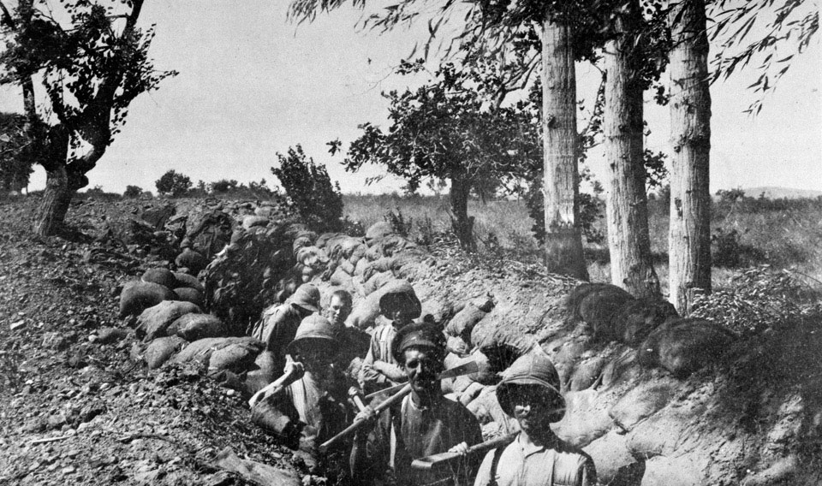

Soldiers dug in at Chocolate Hill, Suvla Bay, Gallipoli - August 1915

Tom was discharged from the Army, which must have been a relief to his family, after having all three of their boys in the fighting at once. Charles was wounded the following summer during the Somme battles of 1916, but survived the war.

According his obituary in the Western Gazette, Frank returned from the Dardanelles for six months’ leave because of dysentery and nervous breakdown. Nearly 30,000 British men were hospitalised with dysentery at Gallipoli, and many soldiers experienced nervous breakdowns. Frank was then posted to France eight weeks before the beginning of the Somme battles on 1st July 1916.

On 1st July 1916, the 2nd Battalion of the South Wales Borderers was attacking Beaumont Hamel. Advancing south of the village, the leading line of men were mown down by machine guns in the first few minutes of the attack. 11 officers and 235 men were killed and missing, and 4 officers and 149 men were wounded out of a total of 21 officers and 578 men. The attack was a failure. Frank Boon was one of the missing.

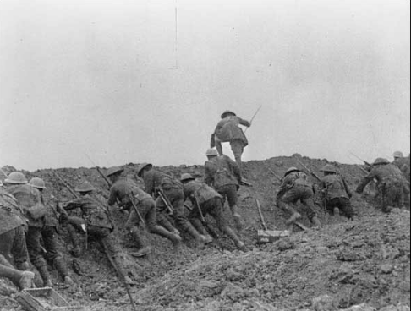

The Western Gazette reports, “a few days ago an official letter arrived asking relatives to presume that he died on July 1st. He was 26 years of age and was a son-in-law of Mr & Mrs Wells, Bell Street, Whitchurch, Hants.”

Florence re-married in 1921. Henry Thomas Boon married Georgina Hamblin in 1917. His grandson lives in the village.

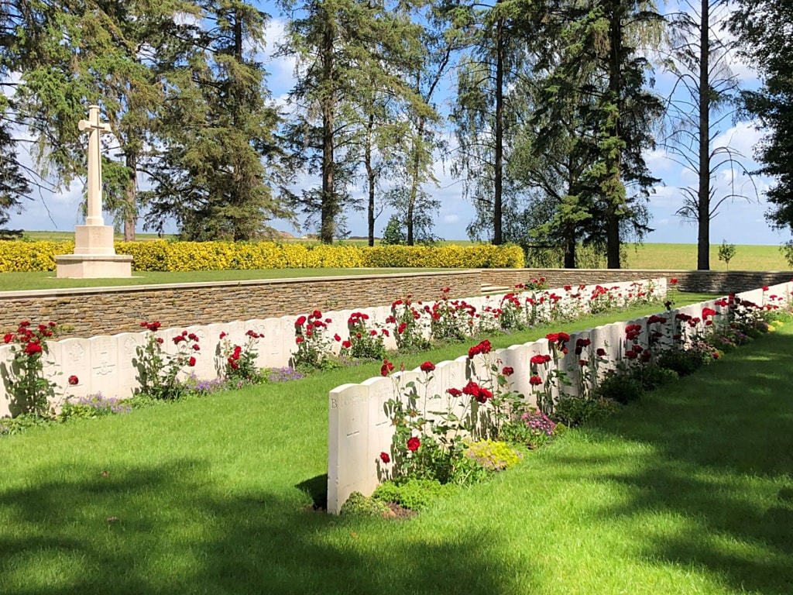

Hawthorne Ridge Cemetery No. 2 Auchonvillers

