Tom Lang’s Story

Keen Sportsman

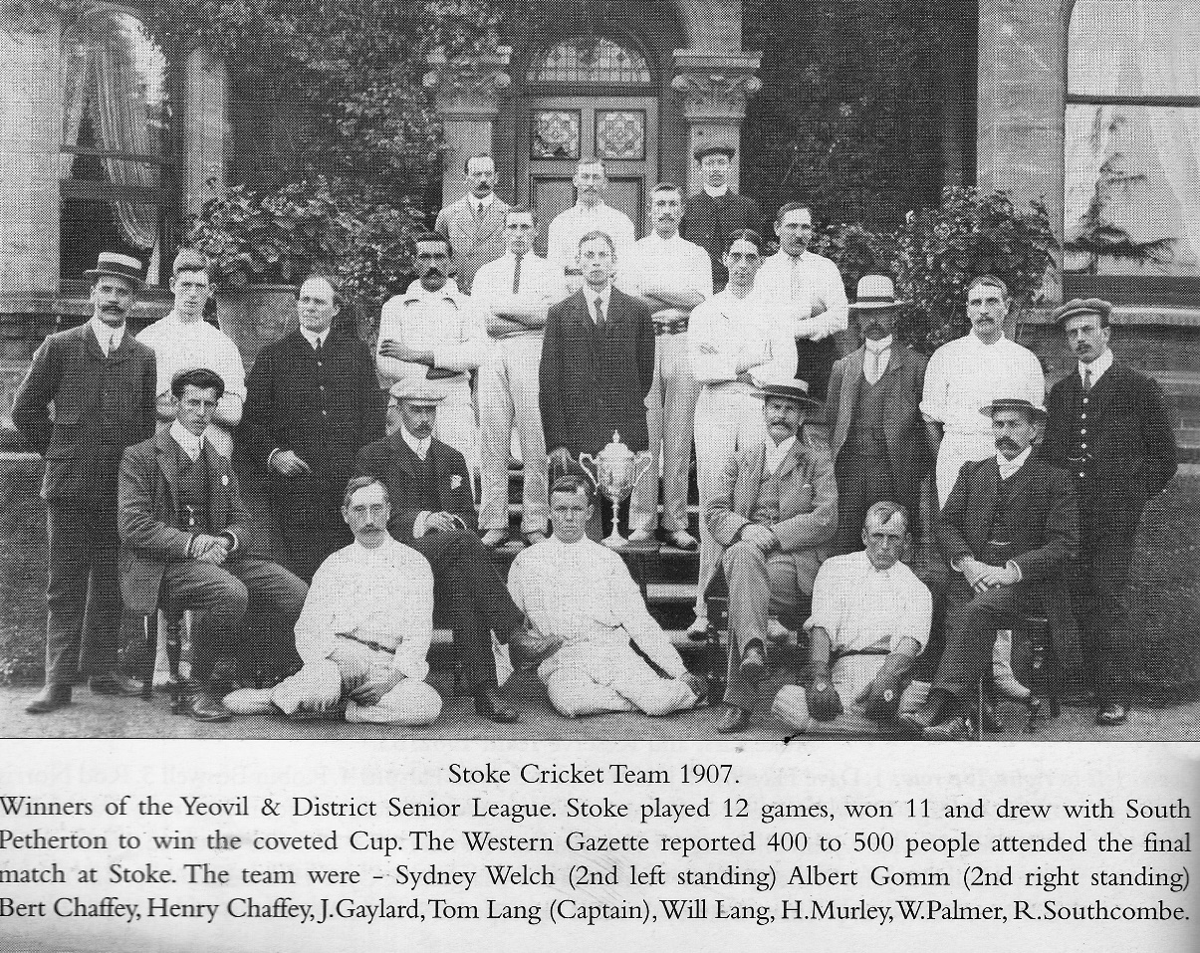
Captain of Stoke Cricket Team 1907

Tom’s grandfather, Walter Lang, was living in Castle Street in 1851 with his widowed mother, Martha. In the spring of that year, he married Dinah Murley, a glover from Whirligig Lane. Murleys and Langs are both families who have been in the village since the 1840’s.

Their first three children, Martha, Saunders and Thomas, were born in Stoke. The rest of their children were born in Guernsey. They arrived in St Peter Port, Guernsey, some time between 1855 and 1857. Walter was working as a quarryman.

‘19th Century Channel Island census returns speak of quarrymen, stone cutters, stone dressers, stone crackers, and stone miners, as well as stone merchants, and as the demand for stone grew so labour had to be imported. Normandy and Brittany were obvious sources, but so too were England and Ireland, and even Scotland.’.
(www.aggregate.com)

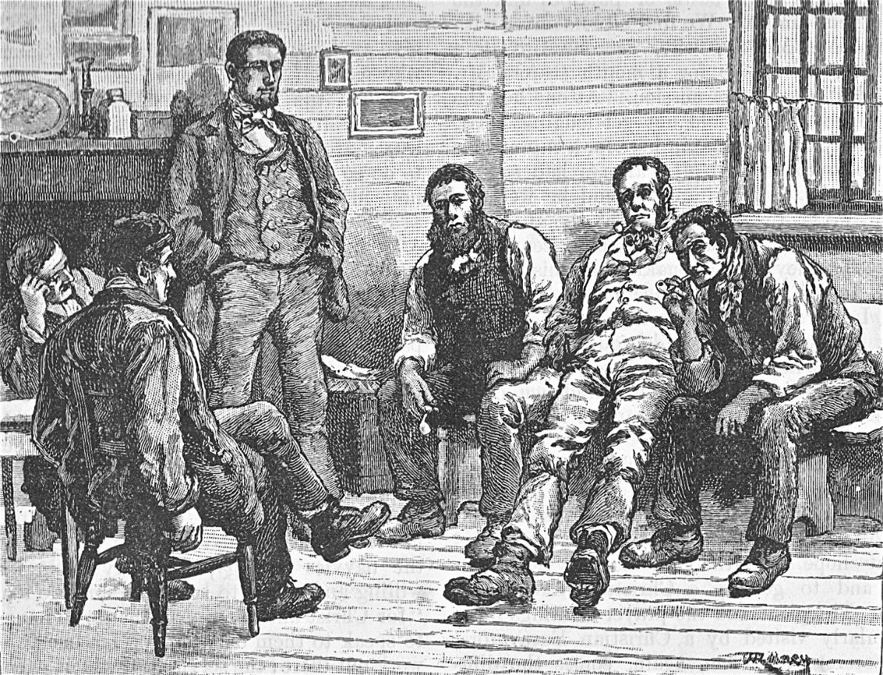

Portland Quarrymen [Weymouthhistory.org]

By 1871 Dinah had returned to Stoke and was living in Lower Street with her six children aged from Martha the eldest at nineteen to Walter the youngest who was three. Saunders was to be the father of our Tom. He was 18 at this time and working as an agricultural labourer. Walter was missing. Perhaps he was still working in Guernsey.

Some time between 1871 and 1881, Walter died, and in 1881 Dinah was living in Castle Street. Martha had left home. Saunders was 28 and working as a stone sawyer.
He married Caroline Weakley that spring. She was 30 years old and the daughter of Robert Weakley of Ham Hill. Her 21 year old brother, George, was a mason. Perhaps he and Saunders worked together in the Ham Hill quarries.

In 1891, Saunders was missing. Caroline was looking after their three boys, William (born Henry William 1881), Tom (born 1884) and George (born 1887). There was another child but it did not survive.

Caroline died in 1894, aged 45. Young Tom was 10 years old. I don’t know whether Saunders was back in Stoke at the time of his wife’s death, or whether he returned home because of it, but he was there in 1901, living on Ham Hill as a widower with the three boys. William and Tom were respectively stone sawyer and mason, aged 19 and 15. George was 13 and still at school.

Five years earlier, there was a report in the school log book:

3 January 1896 T Lang being impudent after being punished, received further punishment.

Tom would have been 12 years old at this time.

In the summer of 1913, Tom married Alice M Patten. They moved to London where Kenneth was born in 1915. Tom was living in Clapham, Surrey, when he enlisted (in Chelsea). We don’t know exactly when he enlisted. Tom and Alice’s second child, Olive, was born in the spring of 1917 and Tom was killed in action on 20th September 1917.

He joined the 423rd Field Company of the Royal Engineers. This was part of the 55th (West Lancashire) Division and at the time of Tom’s death, it was involved in the Battle of Menin Road Ridge (20 – 23rd September) – -Third Battle of Ypres - Passchendaele.

PASSCHENDAELE

The Battle of Passchendaele (or Third Battle of Ypres took place on the Western Front between July and November 1917, for control of the ridges south and east of the Belgian city of Ypres in West Flanders.

The Flanders plain was reclaimed bogland with a network of drainage ditches. In spite of the ditches, in heavy rain the land quickly became waterlogged. When the guns started up and the shells started to fall, shattering the drainage and tearing the earth apart, the countryside rapidly turned into a quagmire.

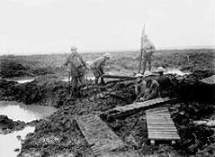
Laying duckboards across the mud 1917
http://ww1ieper1917.wordpress.com/2012/09/19/part-six-actions-on-the-steenbeek/
From “They Called it Passchendaele” by Lyn MacDonald:

Corporal T Newell, Royal Engineers:

It was the rule for any man in the lead to pass back to the man behind him word of any obstruction, like a hole in the duckboard. Word was passed back, “Mind the hole”, and everybody muttered it over his shoulder to the man behind. And then the man behind
Corporal Leake stepped slap into a hole in the duckboard into a foot of watery clay. Leaky turned round to help him out with the bloke cussing and swearing. Leaky, in his broad Yorkshire, whispered, “I said mind t’ole”. The bloke said, “t’ole be buggered. It was a bloody great ‘ole”.

For men like these of the Royal Engineers, the ordeal of the night was, at the same time, better and worse, for they made up the working parties. Their night would be spent in gruelling, sweating labour, often out in front of the line strengthening the trench, replacing barbed wire in front of it; and should a nervous hand inadvertently let go one end of the taut metal it rushed back to spring on to the roll with a ping that seemed to reverberate for miles. Then the heart-stopping flares would go up from Jerry across the way, and resisting the fatal temptation to fling yourself to the ground you froze like a statue in its unearthly glare, hoping to be mistaken for the indeterminate outline of a shattered tree.”

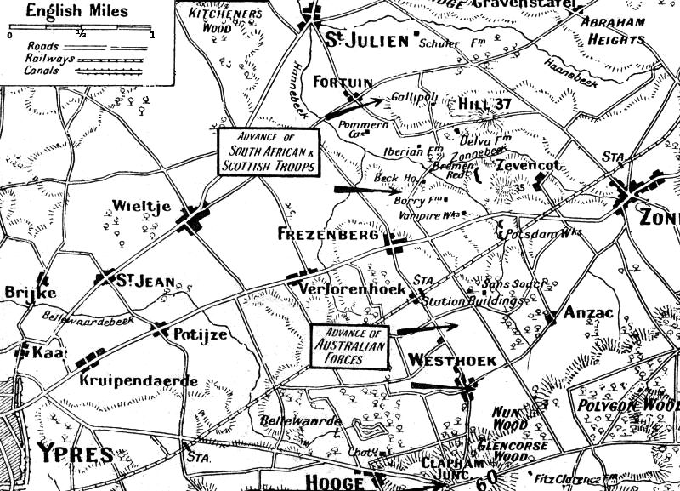
The Battle of the Menin Road

127 officers and 2,603 men of 55th Division became casualties during successful fight for Gallipoli, Schuler Farm and the Hanebeek.

An account of the Battle of the Menin Road by Philip Gibbs, War Journalist

[note: brother in law to Sydney Domville Rowland of Stoke sub Hamdon]

September 20

Our troops attacked this morning before six o'clock on a wide front north and south of the Ypres-Menin road, and have gained important ground all along the line. It is ground from which during the past six weeks there has been that heroic and desperate fighting which I have described as best I could in my daily messages, giving even at the best only a vague idea of the difficulties encountered by those men of ours who made great sacrifices in great endeavours.

It is the ground which in the centre rises up through the sinister woodlands of Glencorse Copse and Inverness Wood to the high ground of Polygon Wood and the spurs of the Passchendaele Ridge, which form the enemy's long defensive barrier to the east of the Ypres salient. Until that high land was taken progress was difficult for our troops on the left across the Steenbeek, as the enemy's guns could still hold commanding positions.

The ground over which our men have swept this morning had been assaulted again and again by troops who ignored their losses, and attacked with a most desperate and glorious courage, yet failed to hold what they gained for a time, because their final goal was attained with weakened forces after most fierce and bloody fighting. The Empire knows who those men were—the old English county regiments, who never fought more gallantly; the Scots, who only let go of their forward positions under overwhelming pressure and annihilating fire; the Irish divisions, who suffered the most supreme ordeal, and earned new and undying honour by the way they endured the fire of many guns for many days.

As long as history lasts, the name of these woods, from which most of the trees have been swept, and of these bogs and marshes which lie about them, will be linked with the memory of those brave battalions who fought through them again and again.” They are not less to be honoured than those who with the same courage, just as splendid, attacked once more, over the same tracks, past the same death-traps, and achieved success. By different methods, by learning from what the first men had suffered, this last attack has not as yet been high in cost, and we hold what the enemy has used all his strength and cunning to prevent us getting. He used much cunning and poured up great reserves of men and guns to smash our assaulting lines.

For the first time on July 31 we came up against his new and fully prepared system of defence, and discovered the power of it. Abandoning the old trench system which we could knock to pieces with artillery, he made his forward positions without any definite line, and built a large number of concrete blockhouses, so arranged in depth that they defended each other by enfilade fire, and so strong that nothing but a direct hit from one of our heavier shells would damage it. And a direct hit is very difficult on a small mark like one of those concrete houses, holding about ten to twenty men at a minimum, and fifty to sixty in their largest. These little garrisons were mostly machine-gunners and picked men specially trained for outpost work, and they could inflict severe damage on an advancing battalion, so that the forward lines passing through and beyond them would be spent and weak. Then behind in reserve lay the German "Stosstruppen," specially trained also for counter-attacks, which were launched in strong striking forces against our advanced lines after all their struggle and loss. Those blockhouses proved formidable things—hard nuts to crack, as the soldiers said who came up against them. There are scores of them whose names will be remembered through a lifetime by men of many battalions, and they cost the lives of many brave men. Beck House and Borry Farm belong to Irish history. Wurst Farm and Winnipeg, Bremen Redoubt and Gallipoli, Iberian and Delva Farm, are strongholds round which many desperate little battles, led by young subalterns or sergeants, have taken place on the last day of July and on many days since. English and Scots have taken turns in attacking and defending such places as Fitzclarence Farm, Northampton Farm, and Black Watch Corner in the dreadful region of Inverness Copse and Glencorse Wood. To-day the hard nut of the concrete blockhouse has been cracked by a new method of attack and by a new assault, planned with great forethought, and achieved so far with high success.

Among the troops engaged on the 2nd Army front were the Australians and South-Africans, Welsh and Scottish battalions, and many of the old English regiments, including the Cheshires, Warwicks, Worcesters, Staffords, Wiltshires, Gloucesters, Berkshires, Oxford and Bucks, York and Lancashires, Sherwood Foresters, and Rifle Brigade. The Divisions to which they belonged were, from north to south, the 2nd Australians, 1st Australians, the 23rd and 41st (with the 21st and 23rd in reserve), the 39th, the 19th, the 30th, 14th, and 8th.

I should like to give the full details of the preparations which have made this success possible and the methods by which some at least of the terrors of the blockhouse have been laid low, but it cannot yet be done, and it is enough now that good results have been attained.

One thing was against us as usual last night. After several fine days the weather turned bad again, and last night many men must have looked up at the sky, groaned, and said, "Just our luck." At half-past ten it began to rain heavily, and all through the night there was a steady drizzle. It was awful to think of that ground about the woodlands, already full of water-holes and bogs, becoming more and more of a quagmire as the time drew near when our men have to rise from the mud and follow the barrage across the craters. All through the night our heavy guns were slogging, and through the dark wet mist there was the blurred light of their flashes.

Before the dawn a high wind was raging at thirty miles an hour across Flanders, and heavy water-logged clouds were only 400 feet above the earth. How could our airmen see? When the attack began they could not see even when they flew as low as 200 feet. They could see nothing but smoke, which clung low to the battlefields, and they could only guess the whereabouts of German batteries. Later, when some progress had been made at most points of the attacking line, the sky cleared a little, blue spaces showed through the black storm-clouds, and there were gleams of sun striking aslant the mists.

This sky on the salient was a strange vision, and I have seen nothing like it since the war began. It was filled with little black specks like midges, but each midge was a British aeroplane flying over the enemy's lines. The enemy tried to clear the air of them, and his anti-aircraft guns were firing wildly, so that all about them were puffs of black shrapnel. Behind, closely clustered, were our kite-balloons, like snow-clouds where they were caught by the light, staring down over the battle, and in wide semicircles about the salient our heavy guns were firing ceaselessly with dull, enormous hammer-strokes, followed by the shrill cry of travelling shells making the barrage before our men, and having blockhouses for their targets and building walls of flying steel between the enemy and our attacking troops. In the near distance were the strafed woods of old battle-grounds like the Wytschaete Ridge and Messines, with their naked gallows-trees all blurred in the mist.

Our men had lain out all night in the rain before the attack at something before six. They were wet through to the skin, but it is curious that some of them whom I saw to-day were surprised to hear it had been raining hard. They had other things to think about. But some of them did not think at all. Tired out in mind and body under the big nervous strain which is there, though they may be unconscious of it, they[ slept. "I was wakened by a friend just before we went over," said one of them.

The anxiety of the officers was intense for the hours to pass before the enemy should get a hint of the movement. It seemed that in one part of the line he did guess that something was in the wind and in the mist. This was on the line facing Glencorse Wood. An hour or two before the attack he put over a heavy barrage, but most of it missed the heads of the battalions. There were many casualties, but the men stood firm, never budging, and making no sound. They all thought that some of their comrades must have been badly caught, but, as far as I can find, it did not do great damage.

All along the line the experience of the fighting was broadly the same. Apart from local details and difficulties, the ground was not quite so bad as had been expected, though bad enough, being greasy and boggy after the rain, but not impassable. The shell-holes were water-logged, and they were dangerously deep for badly wounded men who might fall in, but for the others there was generally a way round over ground which would hold, and our assaulting waves who led the advance were lightly clad, and could go at a fair pace after the barrage.

"I saw wounded men fall in the shell-holes," said a Warwickshire lad to-day, "and God knows how they got out again, unless the stretcher-bearers came up quick, as most of them did; but as for me, I had lain in a shell-hole all night up to the waist in mud, and I was careful to keep out of them."

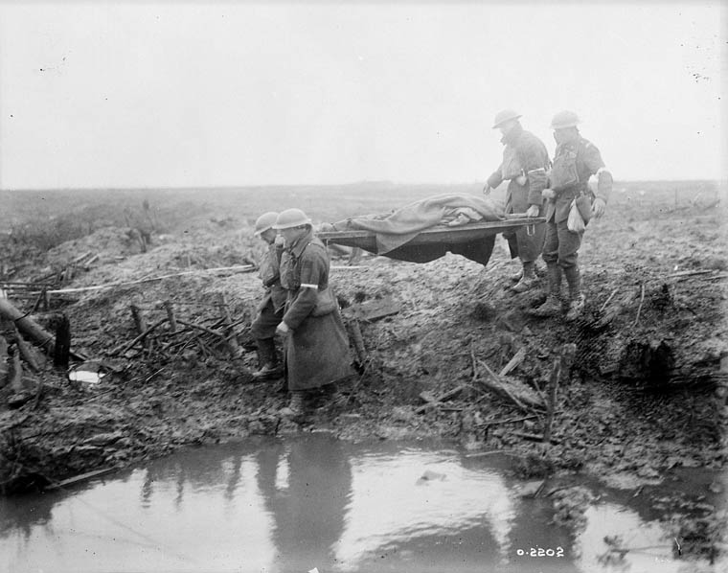

The barrage ahead of them was terrific—the most appalling fence of shells that has ever been placed before advancing troops in this war. All our men describe it as wonderful. "Beautiful" is the word they use, because they know what it means in safety to them.

In the direction of Polygon Wood the plan of attack seems to have worked like clockwork. The Australians moved forward behind the barrage stage by stage, through Westhoek and Nonne Boschen, and across the Hanebeek stream on their left, with hardly a check, in spite of the German blockhouses scattered over this country.

In those blockhouses the small garrisons of picked troops had been demoralized, as any human beings would be, by the enormous shell-fire which had been flung around them. Some, but not all, it seems, of the blockhouses had been smashed, and in those still standing the German machine-gunners got their weapons to work with a burst or two of fire, but then, seeing our troops upon them, were seized with fear, and made signs of surrender.

At nine o'clock this morning the good news came back that the Australians were right through Glencorse Wood. Later messages showed that our troops were fighting their way into Polygon Wood. They swept over the strong points at Black Watch Corner, Northampton Farm, and Carlisle Farm. There was stiff fighting round a blockhouse called Anzac Corner, east of the Hanebeek stream, and it was necessary to organize two flank attacks and work round it before the enemy machine-gun fire could be silenced by bombs.

In another case near here the enemy came out of a blockhouse ready to attack, but when they saw our men swarming up, they lost heart and held up their hands. It is difficult to know how many prisoners were taken here in these woods and strong points. The men's estimates vary enormously, some speaking of scores and others of hundreds.

All this time the enemy's artillery reply was not exceptionally heavy, and, though it was prompt to come after the first SOS signals went up from his lines, it was erratic and varied very much in the success of our counter-battery work, which all through the night and for days past has been smothering his guns.

South of the attack in Glencorse Copse and Polygon Wood the assault in Inverness Copse and Shrewsbury Forest, across the bog-lands round the Dumbarton Lakes, was made by English battalions, including the Queen's, the East and West Kents, the Northumberland Fusiliers, Sherwood Foresters, the King's Royal Rifles, and the West Riding battalions. It was the vilest ground, low-lying and flooded, and strewn with broken trees and choked with undergrowth, but the troops here kept up a good pace, and flung themselves upon the blockhouses which stood in their way.

At an early hour our men were reported to be on a ridge south-east of Inverness Copse and going strong towards Veldhoek. The enemy's barrage came down too late, and one officer, who was wounded by a shell-splinter, led his men, 160 of them, to their first position with only nine casualties.

Most of our losses to-day were from machine-gun fire out of the blockhouses, and that varied very much at different parts of the line. There was some trouble at Het Pappotje Farm in this way, where a party of German machine-gunners put up a desperate resistance, shutting themselves in behind steel doors before they were routed out by a bombing fight. Southward from a strong point called Groenenburg, or "Green Bug" Farm, to Opaque Wood by the Ypres-Comines Canal, the attack by the Cheshires, Wiltshires, Warwicks, Staffords, and Gloucesters was successful, though the enemy still holds out up to the time I write in Hessian Wood, where he is defending himself in a group of blockhouses against the Welsh Regiment and Royal Welsh Fusiliers.

I have dealt so far with the centre of the attack, and I know very little as to the fighting on the north by the 5th Army, except that the Highlanders, London Territorials, Lancashire and Liverpool battalions, and Scots and South-Africans have swept past a whole system of blockhouses, like Beck House and Borry Farm, running up through Gallipoli, Kansas Cross, and Wurst Farm, across the Langemarck-Zonnebeke road.

All through the morning our lightly wounded men came filtering down to the safer places in the Ypres salient and then to the quiet fields behind, and they were in grand spirits in spite of the mud which caked them and the smart of their wounds. Some of them were brought down on the trolley trains, which go almost as far as the battle-line, and some in open buses, and some by German prisoners, but there were many Germans among the wounded—some of them with very ghastly wounds, and these took their place with ours and mingled with them in the dressing-stations, and were given the same treatment. Our wounded told some strange tales of their experiences, but there was no moan among them, whatever they had suffered.

One man of the Cheshires described to me how he saw a German officer run out of a dug-out, which had been a blockhouse blown in at each end by our heavy shell-fire, and make for another one which still stood intact. With some of his comrades, our man chased him, and there was a great fight in the second blockhouse before the survivors surrendered, among them the officer, who gave to my friend a big china pipe and a case full of cigars as souvenirs. He was killed afterwards by one of his own men, who sniped him as he was walking back to our lines.

In another strong point there was a great and terrible fight. The Prussian garrison refused to surrender, and a party of ours fought them until they were destroyed. "It was more lively than Wytschaete," said a man who was in this fight. "It was less tame-like, and the Fritzes put up a better show."

They fought hard round Prince's House and Jarrock's Farm and Pioneer House, not far from Hollebeke Château.

The prisoners I saw to-day were shaken men. Most of them were young fellows of twenty-one, belonging to the 1916 class, and there were none of the youngest boys among them. But they were white-faced and haggard, and looked like men who had passed through a great terror, which indeed was their fate. They belonged mostly to the 207th Prussian Division, and had suffered before the battle from our great shell-fire, which had caused many casualties among their reliefs and ration parties. Many other prisoners belonged to the 121st Division.

I can only give this glimpse or two of the crowded scenes and the many details of to-day's battle. To-morrow there will be time perhaps to write more, giving a deeper insight into this day of good success, which is cheering after so much desperate fighting—over the same fields, although never to so far a goal.

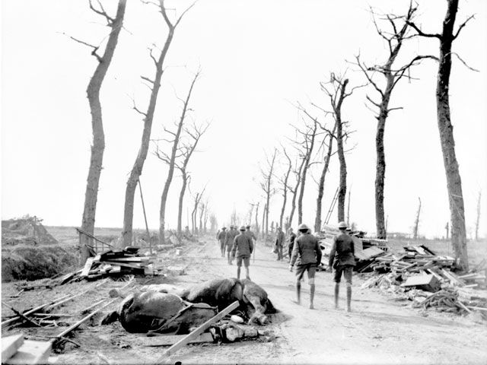
The Menin Road, Ypres, 14 September 1917
[AWM]

There was a report in the Western Gazette on 12th October 1917:

Killed in action – News has been received of the death of Private Tom Lang RE who was killed in action on September 26th . Private Lang was well known in cricket and football circles, and his death will be regretted by a large number of sportsmen and friends.

In fact Tom was killed on 20th September in the Battle of the Menin Road. He is remembered on the Tyne Cot Memorial along with William Male who died on 26th September and Walter Drew who died on 24th October.

[I think the Commonwealth War Graves may have made a mistake here, as Olive was Tom’s daughter, not his wife]

