William Male’s Story

“Right Fears No Might” [Gordon Boys’ Home motto]

Young William Male had had experience of wearing a uniform before signing up for the War. He spent three years at Gordon Boys’ Home from 1912 to 1915, learning to be a shoe maker.

The Gordon Boys’ Home was founded in 1885 as a National Memorial to General Gordon. The aim of the Home was “to educate and train in a variety of trades necessitous Boys from the age of 13 to 17 years in order to fit them for a life of usefulness in civil employment or in any branch of the armed forces in accordance with Gordon’s expressed wishes.” To be accepted at the Home, one needed the backing of a prominent member of society such as a minister of religion or a judge.

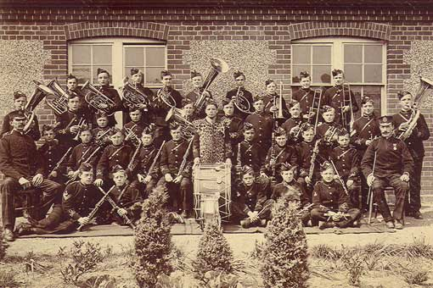

William's father (also named William) was born in Stoke sub Hamdon. He joined the Coldstream Guards in 1890. After three years, he transferred to the Reserve, and joined the Somerset Constabulary on 2nd November 1893. He married Bessie (?Bessie Gove) early in 1898. In October 1899, he was recalled to the colours and sent out to the South African War with the Coldstream Guards. After one year and 113 days, he was invalided back to the UK with enteric fever, and on recovering from this, rejoined the Somerset Constabulary. Young William John was born on 4th August 1898 and was baptised in Othery, Somerset. By 1901, William Senior was working as a policeman in Church Street, West Coker, and another baby, Richard, had arrived.

While working for the Somerset Constabulary, his leg was crushed in a bicycle accident and he underwent several operations but was eventually discharged from the Constabulary, being unfit for further work. At this time, he was living in West Street in Stoke sub Hamdon, with a wife and two sons, struggling to exist on a small pension. William Junior was working at “the Fowl Appliance” for 3/6 per week.

A Miss Helen Hogan from Crest Haven, Spur Hill, Parkstone, Dorset, wrote several letters to the Gordon Boys Home in 1912, and succeeded in getting young William a place there so that he could be taught a trade. She stated that both his parents were of
excellent character who had fallen on bad times due to ill health.

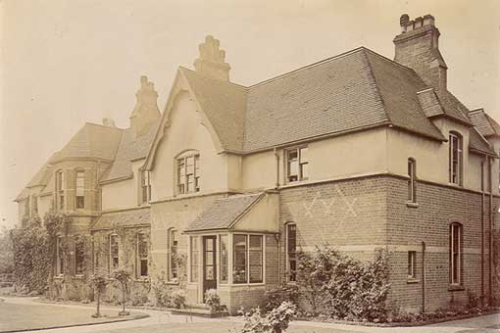
Gordon Boys’ Home, Woking

William arrived at Gordon Boys Home on 5th September 1912. In full dress, the boys wore tartan trousers, a dark blue jersey with G.B.H. embroidered on it and a Glengarry cap with plaid band and Gordon badge. For every day, they wore green cord clothing with brass buttons. Discipline was based on military lines with drill and marching. There were bugle calls the same as those used in the army, to call the boys to meals, collect post, parade etc. There were ranks within the Home like the army other ranks of Lance Corporal, Corporal, Sergeant and finally Colour Sergeant – the senior rank in the Home.

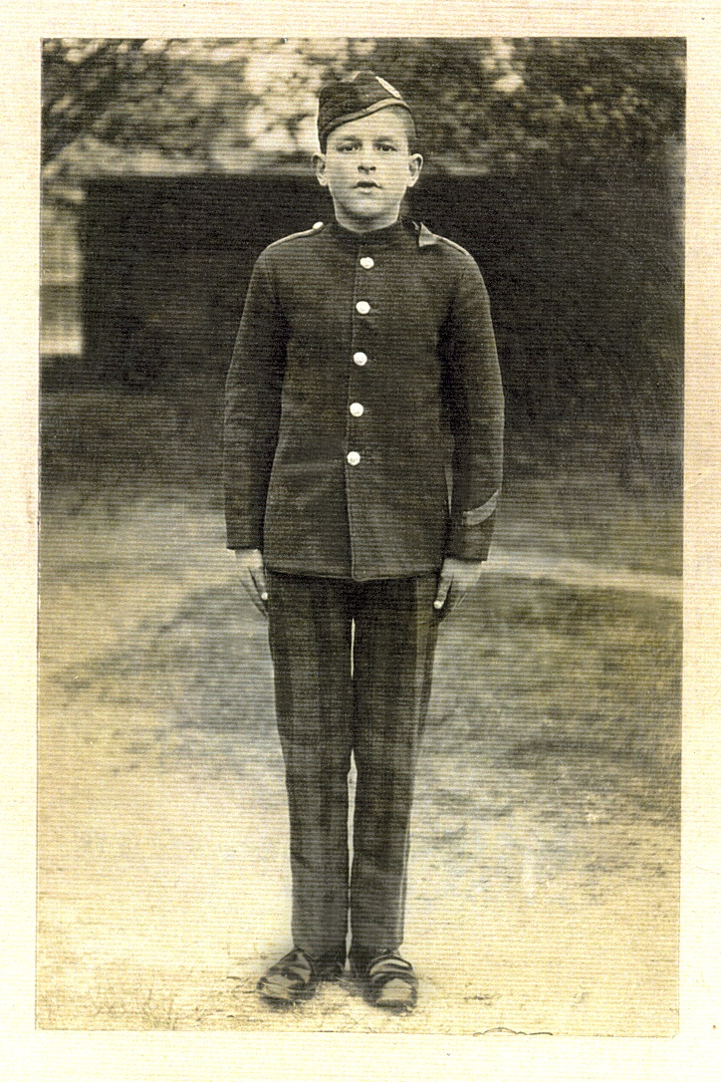
William in his school uniform

“If I had sons, I would certainly teach them a little of most trades, amongst others, bootmaking. You have no idea how feeble one feels not knowing these things… or a little carpentering, black-and-tin smithing, shoemaking and tailoring would be a real gift to a young man.”
General Gordon to his sister, Augusta - Labori (South Africa) October 1875.
[History of Gordon Boys’ Home –
http://www.the-gordonians.org.uk/history-old-gordonians-association.php]

William was taught the shoemaking trade.

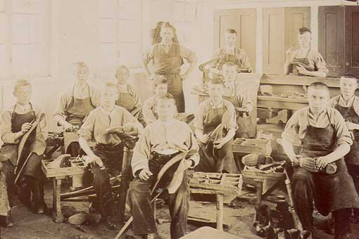
Shoemaking class at Gordon Boys’ Home

William left Gordon Boys Home in September 1915 at the age of 17 to work for a Mr Weaver of 4 Coulgate Street, Brockley, Hants,

No army records survive for William so we don’t know when he joined the Army, but according to “Soldiers Died in the Great War”, he enlisted in Yeovil in the 13th Battalion of the Royal Sussex Regiment. This regiment was under the command of the 116th Brigade in the 39th Division and landed at Le Havre in March 1916.

In 1916, the 39th Division took part in an attack near Richebourg l'Avoue (30 June) in which the Sussex battalions suffered heavy casualties. It was also involved in four of the battles on the Somme: the fighting on the Ancre, the battle of Thiepval Ridge, the battle of Ancre Heights, including the capture of Schwaben Redoubt and Stuff Trench, and the Battle of the Ancre. Depending on when William joined up, he could have taken part in any of these actions.

In 1917, the 39th Division fought in the battles of Passchendaele: Pilkem Ridge, Langemarck, Menin Road Ridge, Polygon Wood and the Second Battle of Passchendaele.

William died on 26th September just after the Battle of Menin Road Ridge. For images of the terrible conditions in the area at the time, look at YouTube “The Battle of the Menin Road” – Andrew Wright.

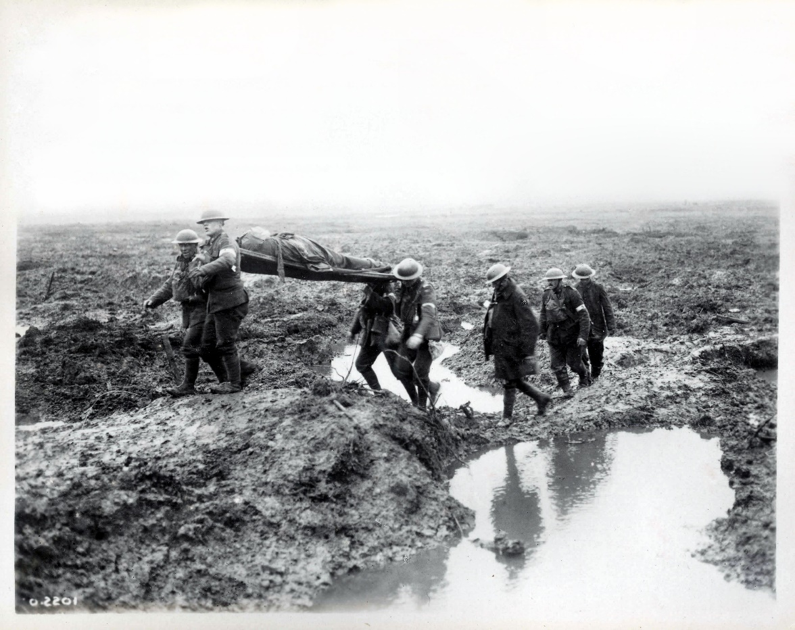

Constant shelling had churned the clay soil and smashed the drainage systems. The heavy rains which coincided with the opening assault, on 31 July, produced thick, clinging mud, which caked uniforms and clogged rifles. It eventually became so deep that, in many places, men, horses and pack mules drowned in it. The shell holes filled with water. With each new phase of the offensive, fresh rain fell to add to the misery.
http://news.bbc.co.uk/1/hi/special_report/1998/10/98/world_war_i/203397.stm

The diary for the 13th Battalion Royal Sussex Regiment for the time of William’s death is as follows:

Shrewsbury Forest:

    - 2nd Lt Wright and 20 men raided enemy dug outs near Lone Star Post.
    - Our artillery barraged twice every 24 hours. Enemy reply feeble
    - ditto
    - Bn relieved by 17th Notts & Derby Regiment and 16th Rifle Brigade. Relief complete by 8.15 a.m. Batt’n went by bus to Broke Camp.
    - Bn. moved up at 7 a.m. to bivouacs at N.9.b in reserve.
    - Time spent in improving camp and training.
    - Relieved fragments of 41st Division in Tower Hamlets section.
    - Reconnoitred line for assembly positions.
    - Relieved by 11 Royal Sussex Regt and 12 Royal Sussex Regt and Bn (less 1 company) returned to Ridgewood at 10.30 a.m. and reorganised.
    - Battn moved up to assembly positions in Tower Hamlets sector relieving the 12 Royal Sussex Regt. Relief complete by 11 p.m.

Tower Hamlets:

26.9.17 Bn attacked at 5.50 a.m. and captured all objectives and about
40 prisoners.

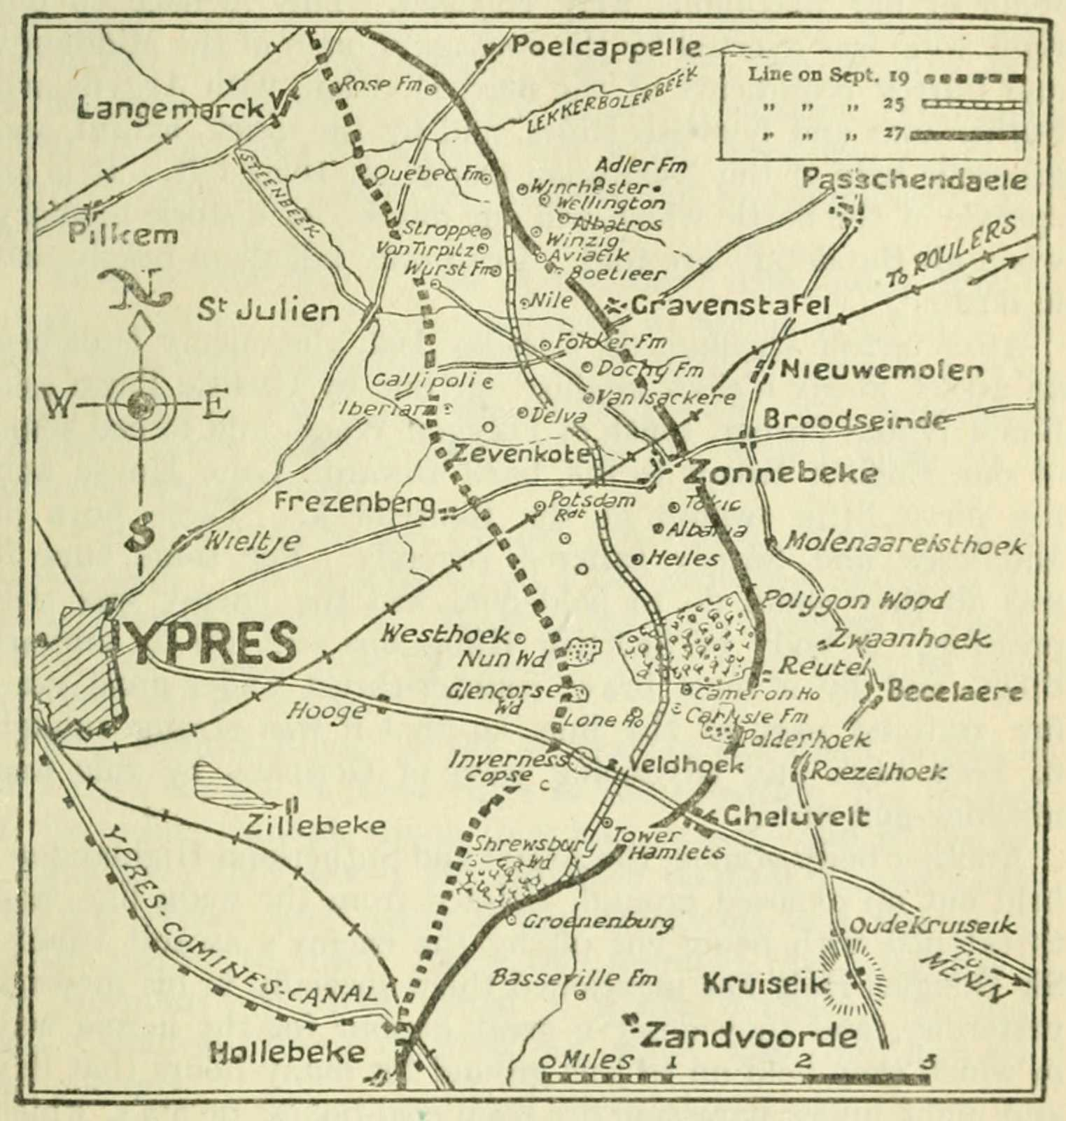
William’s regiment was at Tower Hamlets on the day of his death 26th September 1917.

The war poet, Edmund Blunden, was with the 11th Royal Sussex who relieved William’s regiment on 24th September.

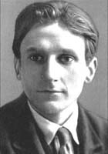
Edmund Blunden, 11th Royal Sussex Regiment

Private W Male's name is recorded on the memorial plaque in the Gordon School Chapel among the 155 ex Gordon boys who paid the supreme sacrifice in the First World War.
All Old Gordon boys killed in action (both World Wars) are remembered in rotation at chapel services throughout the year, by having their names read out to the congregation by the senior boy or girl.

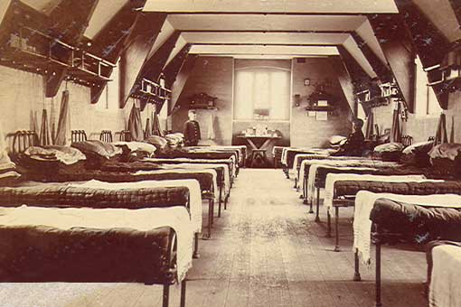

With many thanks to Mr Roy Newman for his help in researching William at the Gordon Boys’ Home

Can you Remember? By Edmund Blunden
Yes, I still remember
The whole thing in a way;
Edge and exactitude
Depend on the day.
Of all that prodigious scene
There seems scanty loss,
Though mists mainly float and screen
Canal, spire and fosse;
Though commonly I fail to name
That once obvious Hill,
And where we went and whence we came
To be killed, or kill.
Those mists are spiritual
And luminous-obscure,
Evolved of countless circumstance
Of which I am sure;
Of which, at the instance
Of sound, smell, change and stir,
New-old shapes for ever
Intensely recur.
And some are sparkling, laughing, singing,
Young, heroic, mild;
And some incurable, twisted,
Shrieking, dumb, defiled.

