Bert Trotman’s Story

Bert Trotman spent over three years serving in the war and died aged 23 on 24th October 1918. His father, Victor Trotman, lost his wife in 1917 and then, right at the end of the war, he received news of his son’s death.

They were a gloving family. Bert’s grandfather, Henry Ryman Trotman, came from Banbury in Oxfordshire and his grandmother, Rosa, from Charlbury, again in Oxfordshire. There were great comings and goings of glovers between that area of Oxfordshire and Stoke sub Hamdon. Henry and Rosa (née Carpenter) were married in Oxfordshire in the summer of 1865 and arrived in Stoke some time between 1878 and 1880 with their children Henry Victor Ryman, William, Victor Albert (our Bert’s father), Minnie and Ralph. Evelyn was born in Stoke in 1880. In 1881, the family were living on Ham Hill. Bert’s first cousin, Ralph (son of Henry Victor Ryman Trotman) was to lose a leg in the war and would present the bronze wreath to the Prince of Wales at the ceremonial opening of the War Memorial on Ham Hill.

Henry Trotman was known in the village later in life as ‘Dr Trotman’ because he was a herbalist. The people of Stoke would go to him for help with their ailments.

His wife, Rosa, died in 1882 aged 34, and Bert’s grandfather remarried. One of the children from the second marriage was Ernest Trotman, half brother to Bert’s father. He was killed in 1915.

In 1891, Bert’s father, Victor Trotman, was 22 and living as a boarder with Charles Hawkins, another glover from Oxfordshire, in Great Field, West Street, Stoke. His wife-to-be, Elizabeth Brown from Somerton, was also living as a boarder, with Joseph Hallett (a gloving family from Milborne Port) in the High Street. She was 20 and a glove machinist. Perhaps they worked together in the same gloving factory. They were married early in 1893 and had four children, all of whom survived. Eveline was the eldest, then Albert Victor (Bert), born in 1896, Linda Theresa the following year (Theresa after Elizabeth’s elder sister) and Roland Hensleigh in 1900.

In 1901, Victor and Elizabeth were living with their four children in the High Street. By 1911, the three elder children were all working in the gloving industry, with Roland (aged 11) still at school.

When reporting that Bert had been wounded in 1918, the Western Gazette stated that he had been one of the many lads who answered Kitchener's call on 1st September
1914.

He was initially in the Somerset Light Infantry but was then transferred to the Machine Gun Corps. His army record has not survived so we don’t know which regiment of the SLI he initially enlisted into but according to the Medal Rolls Index, he arrived in France on 24th July 1915 which is the day that the 7th Battalion SLI arrived in France. I think we can take an educated guess that he was in the 7th Battalion, along with Ben Gaylard, Edward Gillman, Ewart Palmer and Courtney Isaacs. We know that Ben Gaylard and Ewart Palmer arrived in France with the 7th Battalion on 24th July 1915, so there were at least two familiar faces on the boat going over.

The 7th Battalion SLI was part of the 61st Brigade and the 20th (Light) Division, which is described in “The Long, Long Trail”:

“This Division was established in September 1914 as part of the Army Orders authorising Kitchener’s Second New Army, K2. Early days were somewhat chaotic, the new volunteers having very few trained officers and NCOs to command them, no organised billets or equipment. The units of the Division first assembled in the Aldershot area with brigades at Blackdown, Deepcut and Cowshott. Artillery was particularly hard to come by; 12 old guns arrived from India in February 1915! When in the same month the Division moved to Witley, Godalming and Guildford, the artillery had to go by train as there was insufficient harness for the horses. Another move was made, to Salisbury Plain, in April 1915.

The division was inspected by King George V at Knighton Down on 24 June 1915, by which time all equipment had arrived and the Division was judged ready for war.

On 24th July, the 7th Battalion of the Somerset Light Infantry landed at Boulogne. Early trench familiarisation and training took place in the Fleurbaix area.

The Division served on the Western Front for the remainder of the war, taking part in many of the significant actions.

THE SOMERSET LIGHT INFANTRY 1914-1919 by Everard Wyrall

The 7th Battalion disembarked at Boulogne and marched to the Rest Camp above the town, where it stayed until the following afternoon, when it proceeded by train to Wizernes. Here the Somerset men billeted, the remainder of the Brigade occupying billets in the neighbouring villages. On 28th July, the 61st Brigade marched to Hazebrouck – a 15-mile march in very hot weather. The 7th Somersets were billeted in the New Hospital. The march was continued on 29th to Noote Boom and Le Rossignol, near Steenwerck. In this place the Battalion settled down for several days’ training.

The 7th Battalion was involved in the subsidiary actions after the Battle of Loos (25th September to 8th October 1915), carrying out

… fire demonstrations in accordance with orders issued to all units holding front-line trenches in those areas from which infantry or fire attacks were to be made for the purpose of attracting the enemy’s attention from the main operations between Loos and Givenchy.

The section of trenches held by the 7th Somersets on 25th September lay east of La Cordonnerie Farm, the 61st Brigade of the 20th Division then holding a sub-sector east and south-east of Petillon; the Brigade therefore was between the areas of the Actions of Pietre, and of Bois Grenier.

The 7th Battalion from the end of July to the 10th August had remained in billets at Le Rossignol, “carrying on our training,” said Lieut.-Colonel Troyte-Bullock, “and listening to the guns in the distance and wondering when our turn would come to make their close acquaintance.”

It was to come soon enough!

On 10th August the Battalion moved to Armentieres to be attached to the 27th Division for instruction in trench warfare. A and B Companies went into the trenches that night and were relieved on the following night by C and D Companies.

The opposing trenches were not very wide apart, and on the first night the Somerset men were considerably surprised and indignant to hear a voice from the German trenches call out: “Hullo! You Somerset cuckoos.”

In these trenches the Battalion suffered its first casualty, Private C Stephens of A Company being shot by a sniper whilst on sentry-go.

On the 17th the Battalion returned to its old billeting area W. of Steenwerck and remained there until 28th August, when the 61st Brigade moved to Estaires. Work on the defences S.W. of the town kept the Battalion busy for several days, but on the 5th September the 61st Brigade relieved a brigade of the 8th Division in the front line, from south of Petillon to W. of La Boutillerie, the 7th Somersets being in support in farms and posts in the Rue du Quesne.

On 12th September the Battalion relieved the 12th Bn King’s R. in the trenches east of Cordonnerie Farm – A and B Companies in the front line, C in support and D in reserve. The dangers of active trench warfare became almost immediately terribly apparent, for early on the following morning (at about 5.20 a.m.) the ground beneath the section of trench held by B Company suddenly shook, there was a deafening roar and sand bags and earth, equipment and men shot up into the air – the enemy had exploded two mines under the Somerset men. The Germans then opened heavy shell and machine-gun fire on the craters formed by the explosion. Twenty men of B Company were buried in the debris, but with fine courage and tenacity the Company not only set to work to dig them out, but also to consolidate themselves. Five men were killed and twelve wounded by the explosion, and two men killed and five wounded by shell and machine-gun fire. Second-Lieut Mitchell showed great courage and coolness in dealing with a very difficult situation. Both on the 14th and 15th the enemy continued to shell the trenches of the Battalion and hurl trench-mortar bombs into the mine-craters. About 9 p.m. on 16th, whilst D Company was relieving B Company, Captain F M Y Nepean and his orderly were killed by a trench-mortar bomb. On the 19th September the 7th Somerset were relieved and returned to the old billets in Rue du Quesne…..

From the 26th September until the 31st December 1915, the 7th Somersets settled down to a period of trench warfare, unrelieved by hostile attacks: neither was the Battalion engaged in more active operations than sniping, patrolling No Man’s Land, and the usual round of life in the trenches, broken by occasional “rests” behind the front line. On the whole, the sector held by the 20th Division was particularly quiet, and casualties were small – one per day being the average suffered by the 7th Somersets when in the line.

The Western Gazette printed the following on 5th November 1915:

The following letter has been received by the parents of Lance Corporal A V Trotman – “The British General Hospital, Rouen. You will, I am sure, be pleased to hear that your son is now going on very nicely, and we hope in a few weeks’ time to be able to send him back to England. Do not feel anxious about him – Sister Agnes P Smartt.”

There is no way of knowing when he was wounded but it may have been during the September fighting or while in trenches from 26th September 1915 onwards.

We don’t know how long Bert was at home convalescing after he was wounded in the autumn of 1915, but no doubt he was back in France the following year.

At some point – perhaps on his return to France – he transferred to a Machine Gun Company which on 1st March 1918 became the 12th Battalion Machine Gun Corps (consisting of the 35th, 36th and 37th Machine Gun Companies) – part of the 12th Division.

With the 7th Battalion of the Somerset Light Infantry – 20th Division – during the next two years, he would have taken part in the battles of the Somme in 1916, the German retreat to the Hindenburg Line early in 1917, and the Passchendaele battles in the summer/autumn of 1917.

With the 12th Battalion Machine Gun Corps – 12th Division – during the next two years he would have been fighting in the Hohenzollern Redoubt in early 1916, the 1916 battles of the Somme, the Arras offensive in January 1917, and the battle of Cambrai in November 1917.

There was a report in the Western Gazette on 30th November 1917:

The late Mrs Trotman – Much sympathy was expressed with Mr V Trotman and family when the sad news came that his wife had passed away suddenly whilst shopping at Yeovil last week. The deceased lady was much respected by all who knew her, and although she had suffered from heart trouble for some time, her sudden end came as a shock to the parish.

Bert’s mother, Elizabeth Trotman, had died on 24th November, aged 48.

Both the 12th Division and the 20th Division took part in the battles of the Somme in March 1918.

The Commonwealth War Graves Commission states that he was in the 12th Battalion Machine Gun Corps at the time of his death which was the result of a wound he received some time in late September 1918.

On 11th October 1918, the Western Gazette reported:

Wounded in action. Mr V Trotman of High St, has been informed from the War Office that his eldest son, Pte A V Trotman of the Machine Gun Corps, has been wounded in the right arm and is now in hospital at Rouen, France. Pte Trotman was one of the many lads who answered Kitchener’s call on September 1st 1914. His many friends wish him a speedy recovery.

The 12th Battalion Machine Gun Corps was involved in the Battle of St Quentin Canal in September 1918.

The Battle of the St Quentin Canal
On 27 September 1918, the British Third and Fourth Armies made a heavy attack on the Hindenburg Line. The role of 12th Division, still involved in pushing through and past the Epehy defences, was to secure the vantage points up to the St Quentin Canal and to protect the left flank of the 27th Division of the United States Army which was attacking under orders of Fourth Army. Localised actions took place at first before the main attack on 29 September, in which the Division fought up through the formidable mass of enemy trenches in front of Ossus Wood before reaching the western outskirts of Vendhuile. This successful action gave the US Division, 46th (North) Midland and Australian Divisions to the right the chance to break through the Hindenburg Line on this most important day in the final offensive. The Division was now 26 miles from where the offensive had begun on 8 August and for that ground had lost 6229 officers and men. The Division was withdrawn for rest in the areas of Savy, Acq and Aubigny and left III Corps at this point [The Long, Long Trail]

From the War Diary of the 12th Battalion Machine Gun Corps:

Vaux Wood 12th to 16th September: Two casualties occurred during training on 12th September. On 16th September, advanced Bn HQ moved up with advanced Division to Epinette Wood.

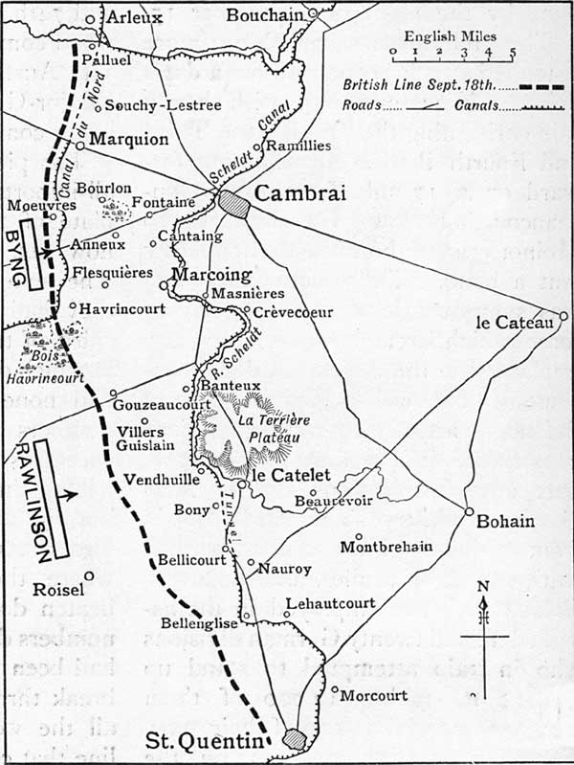
The Battle of Epehy
After a rest in the area of Manancourt, the 12th Division was ordered to renew the attack on Epehy. This took place on 18 September. Enemy strongholds at Malassise Farm and Fishers Keep held on stubbornly and caused heavy casualties but gradually resistance was overcome. Over the next few days further attacks were made against heavily defended posts and trenches; fighting was intense and progress slow.

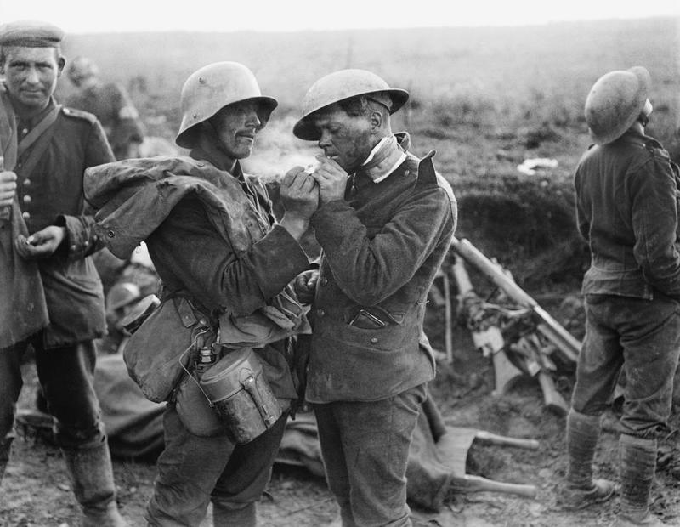
British and Germans at an Advanced Field Dressing station near Epehy 18 September 1918

[Imperial War Museum]

Epinette Wood: 18th to 30th September

18th September: At 5.20 a.m. the 12th Division attacked in conjunction with the 18th Division on the right and the 58th Division on the left. Considerable resistance was encountered. 12th Bn MGC fired a barrage in conjunction with the artillery. Wounded – other ranks 8.

19th September: At 11 a.m. an attack took place to capture the line Braeton Post, Bird Trench, Mule Trench, Room Trench – K26 central. The 12th Bn supported the infantry by firing a barrage in conjunction with the artillery. At 11 p.m. the line held was approx Room Trench, Ockenden Trench, North of Deelish Valley Rd, North end of Old Copse. During the day a fair number of visible targets presented themselves – combined fire from 2 guns silenced a hostile MG in Room Trench and dispersed several parties of the enemy retiring along the road x.26.d to x.27.a and b. The two guns in F.1.b inflicted casualties on parties of the enemy in F.2.a. and X.26.c and d.
The guns in Fir Support expended a fair quantity of ammunition in direct overhead fire against parties of the enemy running away in F.2.b and F.2.c. At 7 pm, our MGs answered an SOS call. Vigorous harassing fire was carried out during the hours of darkness, special attention being paid to Lark Post, Crossbill Rd, Ossus Wood Rd. Wounded – other ranks 11.

20th September: Consolidation. Vigorous harassing fire programme carried out during the night on enemy trenches and tracks.
Wounded – other ranks 7.

21st September: At 5.40 a.m. the 12th Division attacked in conjunction with the Divisions on flanks with the objective the Blue Line, including the Knoll and Fleeceall Post. Our MG supported the infantry in conjunction with the artillery in firing barrage. Enemy still maintaining a stiff resistance. The section of guns attached to “The Queens” took up positions in No 12 Copse where they did some excellent work, stopping a local counter-attack from X.28.c, creating a considerable amount of casualties amongst the enemy and silencing 2 hostile MGs. Section were moved up to Zebra Post in the evening. 1 section at York Post also had some good targets causing much confusion amongst the enemy. At 3.30 p.m. parties of the enemy seen on road X.29.a and b and also X29 central were fired at. Vigorous harassing fire carried out.
Wounded – other ranks 6.

22nd September: A good deal of fighting during the day around strong points – Braeton Post, Heythorpe Post etc. Our MGs did very useful work in silencing hostile MGs, engaging working parties and carried out a vigorous harassing fire at night on Lark Post, Crossbill Rd and Ossus Wood Rd. 9.30 p.m. our MGs fired a barrage in support of an attack by the Division on our right.
Wounded – other ranks 4.

23rd September: Readjustment of Divisional boundaries. Harassing fire programme carried out during the night on enemy tracks etc.
Wounded – other ranks 3.

24th September: At 11.15 a.m. enemy opened a heavy bombardment on our front. 11.30 enemy attacked Dados Loop and Dados Lane, Little Priel Farm and Dados Post. Our MGs played a large part in repelling this attack and causing heavy casualties. The 2 guns at F.4.d were completely successful in stopping the attack on that part of the front, accounting for a very large number of the enemy. The guns in Yak Post did very good work also. Enemy infantry who succeeded in getting a footing in Tombois Farm found excellent visible targets for our MGs and artillery and heavy casualties were created.
Wounded – other ranks 18.

Little Priel Farm is located North of Lempire east of Lempire Rd.

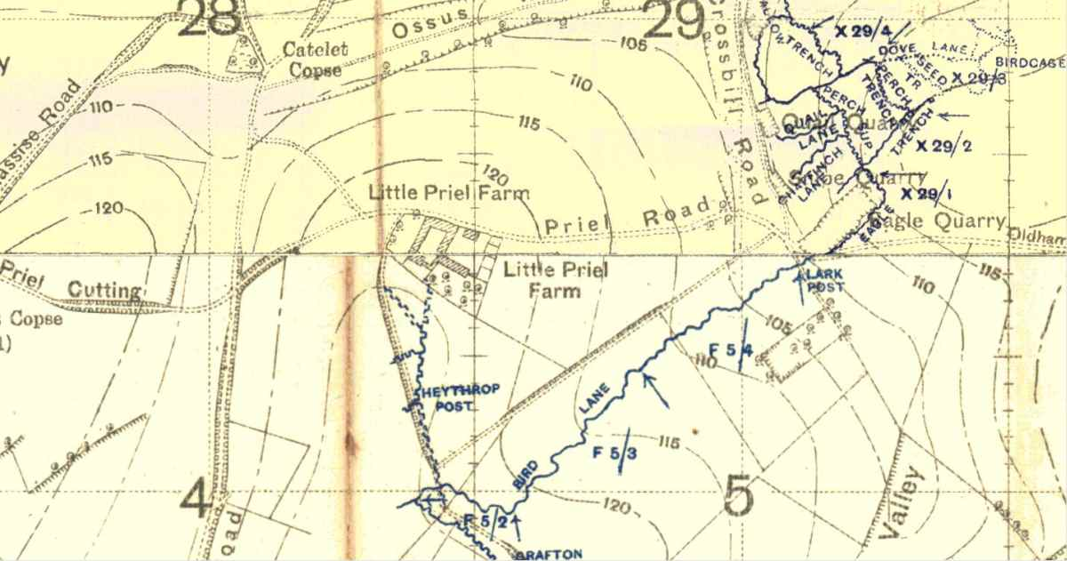

25th September: At 4.45 a.m. the enemy made a silent attack against our front in F.5.c. This attack was repulsed with loss to the enemy. A vigorous harassing fire programme was carried out during the night on Lark Post, Ossus Wood Road, the Quarries in X.29.d and enemy tracks and trenches.
Wounded – other ranks 4 (1 died of wounds)

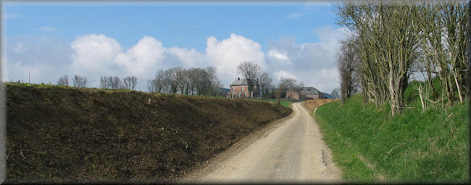
Little Priel Farm from the Quarries

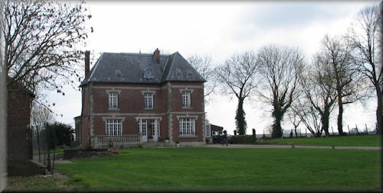
Little Priel Farm

26th September: At 3 a.m. under cover of artillery and MG barrage, a bombing attack was carried out with a view of regaining that portion of Dados Lane and Loop still held by the enemy. At this stage the enemy made a strong counter-attack and our MGs expended a large number of founds on visible targets creating casualties. Night firing programme was carried out on enemy trenches and tracks
No wounded.

27th September: At 5.30 a.m. in conjunction with the Division on our right the 36th Infantry Bde carried out an attack with a view to capturing Dados Loop. Posts were established at x.22.d 55.45 and 78.20. These were driven in by a counter-attack but later in the day were re-established. Our MGs co-operated with the artillery in firing a barrage in support of this attack. A considerable number of rounds were fired during the day on visible targets from York and Braeton Post and targets in the Quarry were engaged with good effect.
Wounded – other ranks 3.

28th September. Vigorous harassing fire carried out at irregular intervals during the night on enemy roads, tracks etc.
Wounded – other ranks 16.

29th September. At 5.50 a.m. 34 machine guns fired a barrage in conjunction with the artillery according to programme in support of the attack by 37th Infantry Bde. Of the 12 MGs allotted to this Bde, 8 were forward guns and 4 were in support. During the day there was a certain amount of confusion, especially around Lark and Tino Trenches. Our forward guns did not actually get into Lark Trench but got up Catalet Trench. One section of MGs were taken up to the junction of Catalet and Stirling Trenches with the Infantry and remained there until bombed from the right left and left rear. The Infantry then decided that the position was no fit to hold and our MGs were withdrawn about 500 yards. These guns then held up the enemy on this line. The right forward guns got into Lark Trench with the Infantry and the support guns remained in position in the original front line of the morning. Vigorous harassing fire carried out during the night on enemy’s tracks etc.
Wounded - other ranks 6.

30th September: Enemy retired from the ground west of the canal leaving several rearguard MGs. All 8 guns moved forward and took up positions about 500 yards west of canal as previously arranged for the 29th and excellent targets were obtained east of the canal and many casualties inflicted on the enemy. The support guns went into position about 800 yards in rear of the front line. On night 30th Sept/1 Oct this MG Coy was relieved by a Coy of the 18th Bn MGC. The remaining guns of the Bn were withdrawn.
Casualties – nil.
Lt Col W G A Coldwell, Cmdg 12th Bn MGC

I have not noted the casualties who died, only those who were wounded, because Bert was wounded in the arm at around this time. I would think it would have been while the 12th Battalion was in Epinette Wood between 18th and 30th September. The language – “excellent visible targets” etc. - strikes the reader as somewhat bloodthirsty from our peacetime perspective, but Lt Col Coldwell certainly gives one the impression of being supportive and proud of his men.

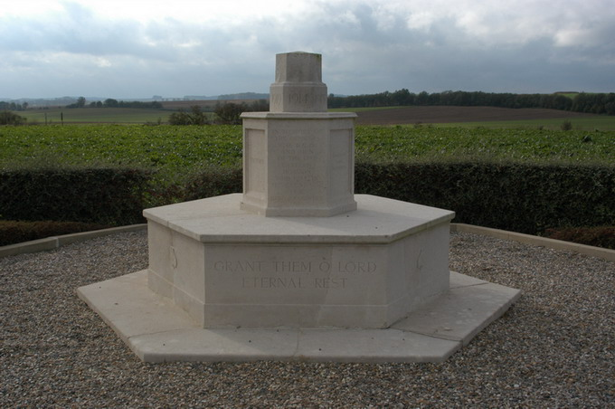
12th Division Memorial at Epehy, near Malassise Farm, Scene of fighting in September 1918

There is a report in the Western Gazette on 1st November 1918:

Much regret was expressed in the village on Saturday last when the sad news reached Miss E Trotman, High Street, that her eldest brother, Bert, had died of wounds in Rouen Hospital. It was reported two weeks previously that Lance Corporal Trotman was seriously wounded in his right arm.

Bert Trotman died on 24th October 1918 aged 23 and is buried at St Sever Cemetery Extension, Rouen. If he had been died during the fighting, he would have been buried at Epehy Cemetery alongside 18 other young men of the Machine Gun Corps. I think he might have preferred to have been buried in the same place as his friends.

