Walter Gomm’s Story

Wednesday August 9th 1916. There was a heavy shelling of our lines during the night, especially between 10 pm and midnight when it became intense. Gas gongs were sounding everywhere, it is all confusion here, nobody seems to know what is happening, and to add to our discomfort gas shells were dropping on our camp.
Diary of L/Cpl A C Cook, 1st Battalion Somerset Light Infantry

Walter Gomm died of gas poisoning near Ypres on 9th August 1916.

His father, William Gomm, was one of those glovers who moved to Stoke for work from Charlbury in Oxfordshire. He married Susan Gomm who was a Stoke girl (maiden name of Wills) in 1879. I cannot find the family on the 1881 census, but according to later census returns their first two children (Albert and Herbert) were born in Stoke sub Hamdon, their second two (Frederick and Susan) were born in Grantham in Lincolnshire, and Harry, Nellie, Bessie, Walter and Florrie were all subsequently born in Stoke. They were obviously living away from the village between around 1886 and 1888.

By 1891 they were living in Percombe. William was a leather grounder (gloves). The children ranged from 11 years to 1 year. Walter was born in the summer of 1897 and the family had moved to Castle Street by 1901.

Walter’s elder brothers, Herbert and Fred, are mentioned in the Castle School records.
On 11th March, 1st April and 7th October 1892, Walter’s elder brother, Herbert, was punished for playing truant. On 4th November,

“Mr Gomm brought his son, Herbert, to school on Wed – he having
played truant on Tuesday. Informed the children that such a boy
might be sent away to an industrial school.”

Herbert was to become a Gunner in the Lifeguards. On 30th April 1915 there was a report in the Western Gazette that he had been wounded in the arm and neck whilst in action in France. “He is progressing satisfactorily and will shortly be conveyed to England.”

On 6th March 1896 Mrs Gomm came to school complaining about her boy Fred (aged about ten) being struck on the head.

In 1898, when Walter was a year old, his eldest brother Albert Joseph Gomm enlisted in the Coldstream Guards and went out to Africa to fight the Boers. He was nearly 19 years old with a fresh complexion, blue eyes and brown hair. He named his next of kin on the enlistment papers as William and Susan Gomm of Castle Terrace. He was discharged from the 1st Battalion Coldstream Guards, being “of good character”, four years later. He had grown an inch and took size 9 boots. He enlisted again on 21st September 1915 at South Petherton aged 35 years 10 months, describing himself as a glover, living at Cartgate. He was married (to Eva) with several children.

Meanwhile, Walter was growing up with his parents in Castle Street, and in 1911 was 13 and hanging and drying leather for a living.

Walter was “one of the first to volunteer” according to the Western Gazette, perhaps encouraged by the knowledge of his brother having fought in the Boer War. His medal record card states that he was in both the 1st Battalion and the 7th Battalion of the Somerset Light Infantry. The Commonwealth War Grave Commission usually cites a man’s regiment as the one he was in when he died and they have Walter’s as 1st Battalion. The Western Gazette also mention that he was in 1st Battalion when they report his death in August 1916. His medal record card states that he arrived in France on 24th July 1915. This is the date that the 7th Battalion arrived in France (with Courtney Isaacs, Ewart Palmer, Edward Gillman and probably Ben Gaylard). I think, therefore, that Walter may have started out in 7th Battalion and transferred later to the 1st Battalion.

The 7th Battalion SLI was part of the 61st Brigade and the 20th (Light) Division which is described in “The Long, Long Trail” as follows:

‘This Division was established in September 1914 as part of the Army Orders authorising Kitchener’s Second New Army, K2. Early days were somewhat chaotic, the new volunteers having very few trained officers and NCOs to command them, no organised billets or equipment. The units of the Division first assembled in the Aldershot area with brigades at Blackdown, Deepcut and Cowshott. Artillery was particularly hard to come by; 12 old guns arrived from India in February 1915! When in the same month the Division moved to Witley, Godalming and Guildford, the artillery had to go by train as there was insufficient harness for the horses. Another move was made, to Salisbury Plain, in April 1915.

The division was inspected by King George V at Knighton Down on 24 June 1915, by which time all equipment had arrived and the Division was judged ready for war.

On 26th July 1915 the Division completed concentration in the Saint-Omer area, all units having crossed to France during the preceding few days. Early trench familiarisation and training took place in the Fleurbaix area.

The Division served on the Western Front for the remainder of the war, taking part in many of the significant actions.’ [http://www.1914-1918.net/]

WALTER ARRIVES IN FRANCE – July 1915

The first time Walter would have been in action with the 7th Somersets was during the Battle of Loos in September 1915, in the second attack on Bellewaarde. The Battalion were situated north of Loos and had orders to distract the enemy’s attention from the main operations between Loos and Givenchy. The 7th Somersets had been in billets in Le Rossignol from the end of July to 10th August, carrying out training and listening to the guns in the distance, wondering when it would be their turn. On 12th September, they moved into trenches east of La Cordonnerie Farm.

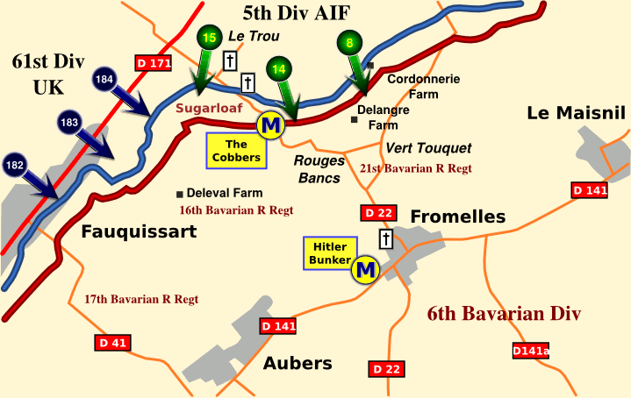
La Cordonnerie Farm
The main action at Loos was south of Aubers

Early on the following morning, two enemy mines exploded, throwing men and equipment into the air. 20 men had to be dug out. Five men were killed and 12 wounded in the explosion.

On 19th September, the Battalion was relieved and returned to billets but on 24th September they were back in the front line. The Diary states, “Most of our artillery having gone south to help the real battle, we were practically without artillery support.” Luckily, the aim of the enemy artillery was poor and did not do too much damage. However, “the Hun machine guns were busy all along the line” and “the Rifle Brigade alone had 300 casualties.”

This is a photograph taken in August 1915 of the front line trenches at Bois Grenier, near Armentieres, just north of where Walter was in September 1915.

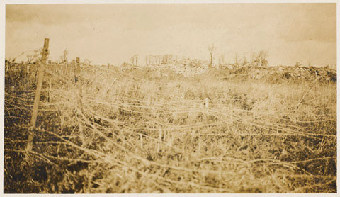

Belts of wire protected the front-line trenches. Soldiers on all sides hated the wire and dreaded getting caught in it. [National Army Museum]

WINTER 1915

From 26th September to 31st December 1915, Walter’s Battalion settled down to life in the trenches, without hostile attacks but engaged in the usual operations of sniping and patrolling No Man’s Land, with occasional rests behind the front line. Their sector was a quiet one, and casualties were small – an average of one per day when in the line.

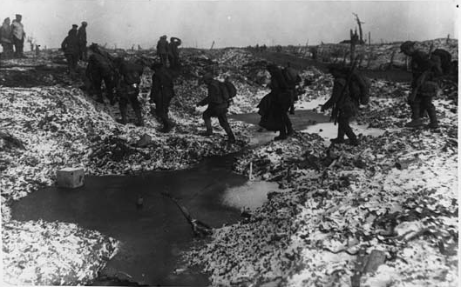
In a barren, snow-covered landscape a group of soldiers cross an icy ditch. They are fully equipped and armed. More soldiers are waiting on the other side for them. In the distance barbed-wire fencing is visible. [https://www.flickr.com/photos/nlscotland/4688661184/]

1916 – THE YPRES SALIENT

On 1st January 1916, the 7th Battalion was at Fleurbaix, moving to Steenbecque on 12th January. They then received orders which would take them into the dreaded Ypres Salient. On 23rd January, they were billeted at Waermers Cappel, in the Arneke area, and on 3rd February had good billets in Wormhaut.

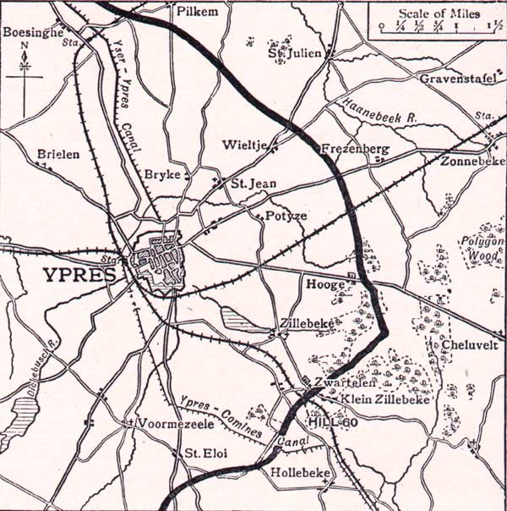
The Ypres Salient
(Wormhaut is west of Ypres)

On 23rd February the 61st Brigade (Walter’s) relieved the 60th Brigade in the front line. In the first four days in the front line in the Salient, three men were killed and 16 wounded. The trenches were water-logged, and there were no dug-outs. Men and officers had to sit on the fire-steps up to their knees in water. They were in the front line for four days and then four days in support. At the beginning of April the weather improved and the ground began to dry up a little.

On 11th April, the enemy attacked. The 7th Battalion were standing to on the west side of the Canal Bank. An SOS went up from the front line at 7.15 p.m. and the Battalion crossed the bridges to the eastern bank. D Company was ordered up to the front line to bring up boxes of ammunition and helped repel the Germans who were trying to break through a gap between the battalions. It is a shame that we don’t know which company Walter was in.

By 10 p.m. on 11th April the situation had returned to normal and the 61st Brigade were relieved by the 60th.

The 7th Battalion was sent to Calais for ten days’ rest. They were back in the Salient on 19th May, relieving the 2nd Coldstream Guards outside the Ypres-Zonnebeke Road.

On 21st May, the Somersets were under attack. The Germans were driven back but two officers were wounded, one other rank killed and 22 other ranks wounded.

Everard Wyrall describes the attack in “The Somerset Light Infantry 1914-18”:

At 12.45 a.m. on the 21st the Germans launched their attack, advancing in three parties, one on each flank and one in the centre. The centre party bumped into the Somersets’ listening post, enabling the latter to give the alarm. The right attack reached the parapet and threw bombs into the trenches of the Somerset men, which caused most of the casualties, but was eventually driven back with bomb and bayonet, whilst the Lewis guns got to work as the enemy retired to his own line.”

There is a report in the Western Gazette on 2nd June 1916 to say:

Wounded and in Hospital – Private Walter Gomm SLI who is
wounded and under treatment in the Canadian General Hospital
France, writes as follows:

“Just a few lines, hoping this will find you in the best of health. I am sorry
to say that I was wounded on 21st May in the forehead and chest, but only
a slight wound in the head. The Germans made a bombing attack on one
part of the line which we were holding. I was lucky, as I had about twelve
bombs close by me. I am hoping to come to London later on.”

Walter Gomm, a thoughtful looking young man, writes to allay the worries of his family.

I don’t know if Walter made it to London but in the summer of 1916 he transferred into the 1st Battalion and on 25th August 1916 there is another report in the Western Gazette:

Death from gas poisoning in France. The sad intelligence was
Received from the Record Office on Friday by Mrs Gomm of
Castle Street on the death of her youngest son, Private Walter
Gomm, 1st Battalion SLI from gas poisoning on 9th August in
France. Private Gomm was one of the first to volunteer and
had seen much fighting. Mrs Gomm has two sons still serving,
another being discharged after going through some of the heavy
fighting earlier in the campaign.

Walter was just nineteen years old. The 1st Battalion SLI was at Canal Bank, near Ypres at this time. Everard Wyrall writes in his “History of the Somerset Light Infantry 1914-18:

“At the close of the second tour, however, [in front-line trenches on the Canal Bank] just as the Battalion was being relieved by the 1st Rifle Brigade on 8th August, the enemy (about 10.30 p.m.) made a violent gas attack, accompanied by heavy shelling. Dense clouds of the noxious fumes floated over the trenches and, although the Somerset men had only three casualties from shell fire, 12 officers and 161 other ranks became casualties from gas poisoning. Of these, six officers …and 27 other ranks died from the effects of gas.”

Lance Corporal Cook of the 1st Battalion SLI writes in his diary:

Tues Aug 8th. There was some curious shells bursting along the line tonight,
I had not seen or heard anything like it before. I was later told it was gas shells,
and that it had caught the Battalion and Rifle Brigade in the midst of relieving
each other.

Thurs Aug 10th. The gas effects they say were awful and much stronger than
that formerly used. It hung about the ground and clung to the men’s clothes,
causing many who went to sleep in their clothes and equipment to develop gas
poisoning. It is horrible to watch the men under the effects of this kind of
warfare, they lie about in a comatose and dying condition, suffering great agony,
frothing at the mouth and gasping for breath.”

I hope Mrs Gomm never heard the details of her son’s death.

Walter’s brothers, Albert, Herbert and Harry all served in the 1st World War and survived.

Walter is buried in Lijssenthoek Military Cemetery.

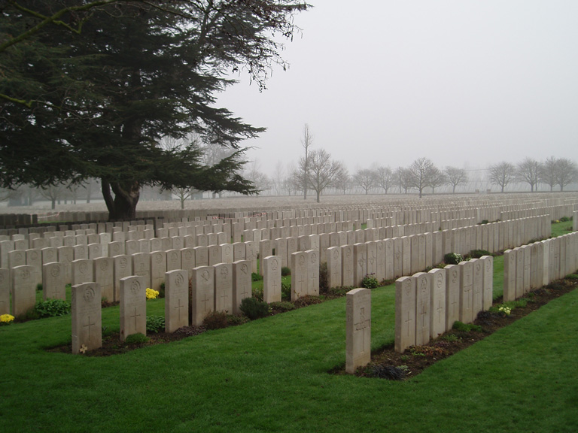

During the First World War, the village of Lijssenhoek was situated on the main communication line between the Allied military bases in the rear and the Ypres

battlefields. Close to the Front, but out of the extreme range of most German field artillery, it became a natural place to establish casualty clearing stations.
[Commonwealth War Graves Commission]

