Hugh Grinter’s Story

“Before the blackness of their burst had thinned or fallen, the hand of time rested on the half-hour mark, and all along that old front line of the English there came a whistling and a crying. The men of the first wave climbed up the parapets, in tumult, darkness, and the presence of death, and having done with all pleasant things, advanced across No Man’s Land to begin the Battle of the Somme.”
(The Old Front Line by John Masefield)

At his birth in 1885, Hugh Grinter was registered as Hubert Walter Grinter, but he was variously called Herbert and Hubert at different times by the census enumerator and by the Western Gazette. I believe his family called him Hugh, so that is what I shall call him.

His grandparents, John and Charlotte Grinter arrived in the village from Hinton St George some time between 1864 and 1870. John is described at different times in his life as a groom, coachman, factory engine driver and gardener. Their first two children, Walter (father of Hugh) and Elizabeth, were born in Hinton St George, and then a third child, Mercy, was born in 1870 after they had moved to Stoke. They lived in East Stoke. In 1883 John’s wife, Charlotte died, aged 51.

Walter was 24. A year later he married the girl who was to be Hugh’s mother, Sabina Russell, whose family lived just a few doors away from the Grinters. The year after that, 1885, John married again – Dorcas Ann Weakley of Stoke. John had three more children with Dorcas between 1886 and 1890, Mabel, Flossie and Lily. There was a Lily Jane Grinter whose death is registered in 1891 - aged one year.

Meanwhile, young Walter and Sabina were not slow in producing a family. Hugh arrived in 1885, followed by two girls and four more boys. Walter worked as a stone sawyer and Sabina as a glove machinist and the family lived in Paradise. In 1908 tragedy struck when Walter was killed in an accident up at the quarry on Ham Hill.

According to the Western Gazette, a large block of stone weighing about four hundred weight fell on him - “Grinter was crushed between the two pieces, and received injuries which resulted in his death about two hours afterwards.” Dr R Hensleigh Walter said that he “found the deceased lying as comfortable as possible in the office. He was perfectly conscious and seemed to have little pain except when he moved…. The condition of the deceased was very grave, and despite all medical attention he died about six pm on Thursday”.

At the time of his father’s accident, Hugh was married and living away from Stoke, but there were six other children for poor Sabina to bring up on her own, the youngest of whom was eight.

Three years after the accident, in 1911, Sabina was living in North Street with Hugh’s younger brothers – William, Joseph, Sydney and Bernard, and his sister Emily. Of these boys, at least three served in the War. William and Joseph were both wounded in the spring of 1917, and Sydney was home on leave in August 1917. Bernard was born in 1900 so may have been too young to enlist.

Hugh had started out in the gloving business but moved to Portland to work in the quarries there. His future wife, Phillis Croad, was living there in 1891 and it turned out that Hugh married Phillis in 1907, while Hugh’s sister, Bessie Grinter, married Phillis’ brother, Jim (Richard) Croad. Two brothers married two sisters.

Hugh was married in Wales and by the time of Jim and Bessie’s marriage in 1911 was living with Phillis (known as Bessie) and their two year old daughter, Hilda, at 78 Bronllyn Rd, Gelli. Hugh was working as a “Ripper Underground”.

The first pit in Gelli was sunk in the 1870’s. There was a gas explosion in 1883 killing five and seriously injuring twenty other miners at the pit. After that, the colliery was sold to the Powell Duffryn Steam Coal Company who retained ownership until after the Second World War.

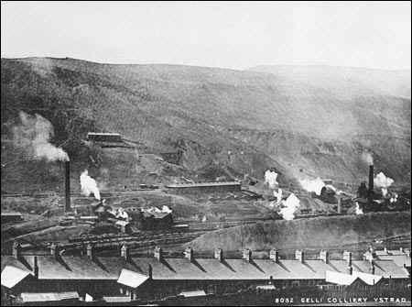
Many of the Welsh miners joined the Royal Engineers and used their skills as Sappers, but Hugh perhaps felt a loyalty to his Somerset roots and joined the 1st Battalion of the Somerset Light Infantry. We don’t know exactly when he enlisted as no army records survive for him but he enlisted at Yeovil, and arrived in France in May 1915. He took part in the Battle of the Somme and died on 1st July 1916. [John Hayward who also went to work in Wales and lived not far from Hugh, at Aberdare, went home to Yeovil like Hugh to enlist in the 1st Battalion of the Somerset Light Infantry. He died in 1915.]

Other Stoke lads who were in 1st Battalion SLI and died that summer on the Somme were Walter Gomm (aged 19), Archie Thorne (aged 21) and Gilbert Trott (aged 22). Hugh was 31 years old when he died so was considerably older than the others. Archie Thorne died on the same day as Hugh.

It is difficult to decipher on Hugh’s medal roll card the exact date in May 1915 that Hugh arrived in France – it could have been 2nd or 25th May. The 1st Battalion fighting in the Battles of Ypres. April 1915 was the time when the Germans first used gas as a weapon. On 23rd April “the atmosphere was sickly from the fumes of gas and flames shot up into the air from burning villages and the ruined city of Ypres.” [History of the SLI 1914-18 by Everard Wyrall]. On 24th/25th May, the 1st Battalion were taking part in the Battle of Bellewaarde Ridge, after which they withdrew to Reigersburg Chateau on the Ypres-Brielen Road where they slept in barns.

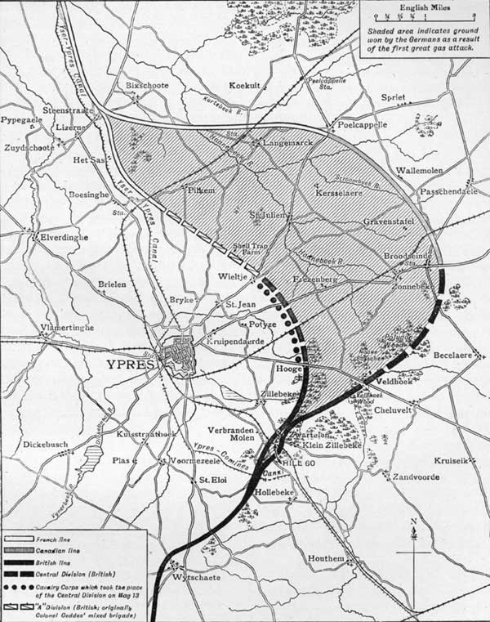
Bellewaarde Ridge
24 – 25 May 1915

The 1st Somersets encountered nothing but the rigours of trench warfare – always dangerous and full of discomfort – from the close of the Battles of Ypres (26th May) until the Battalion assisted the Rifle Brigade in a small attack which took place on 6th July; the Somerset men digging communication trenches to the trenches captured by the Rifles. After satisfactorily completing its task the Battalion went back to bivouacs in Elverdinghe Chateau grounds, having (though not known then) served its last tour in front-line trenches in the Ypres Salient. This operation, though of a minor character, cost the Battalion one officer and 27 NCOs and men killed; three officers and 102 NCOs and men wounded, and 5 NCOs and men missing.

[History of the Somerset Light Infantry 1914-18 by Everard Wyrall]

The Battalion journeyed south into the Somme area and spent the rest of the year in a sector almost unbelievably quiet after the noisy unrest of the Ypres Salient.

On 1st January 1916, the 1st Battalion were still in their quiet sector on the Somme. The early days of 1916 were uneventful but as the weather became finer, there were increasing demands upon the Battalion for working parties, and the words ‘fatigues as before’ are continually appearing in the diaries. So hard were the men worked that on 8th June the Battalion Diary records: ‘ Usual fatigues. The men are evidently feeling the strain of these all-night fatigues as the sick parades are becoming very large’”. It was at this time that George Denman of Stoke, also in 1st Battalion, was admitted to hospital suffering from trench fever. It was the build up to the Battle of Albert – 1st to 14th July.

The 1st Somersets moved to Mailly Maillet on the afternoon of 22nd and two days later the preliminary bombardment of the enemy’s trenches, from the Somme northwards along the whole position to be attacked, opened. A huge number of guns had been brought into action for this purpose and the noise was deafening…. Day after day the bombardment continued with a relentless fury, while at over forty places along the front line gas was discharged over the German lines.

[History of the SLI 1914-18 by Everard Wyrall]

The 1st Battalion of the Somerset Light Infantry (as part of the 4th Division) had orders to attack the German Quadrilateral north of the Ancre and of Beaumont Hamel. At

10 p.m. on the night of 30th June, they marched out of Mailly Maillet to take up positions in the assembly trenches. The Battalion was with the Hampshires and 6th Warwickshires, in close support to the front line which comprised the East Lancs Regiment, Rifle Brigade and 8th Warwickshires.

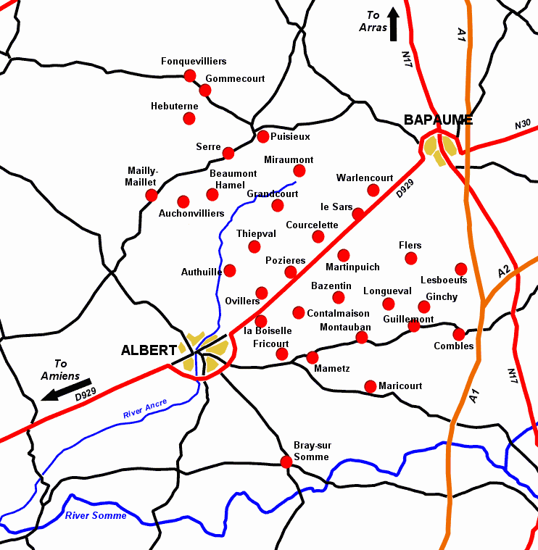
On the night of 30th June, Hugh’s Battalion marched from Mailly-Mallet
Serre

At 7.20 a.m. on 1st July there was a roar as a huge mine under Hawthorne Redoubt, south of Beaumont Hamel, exploded.

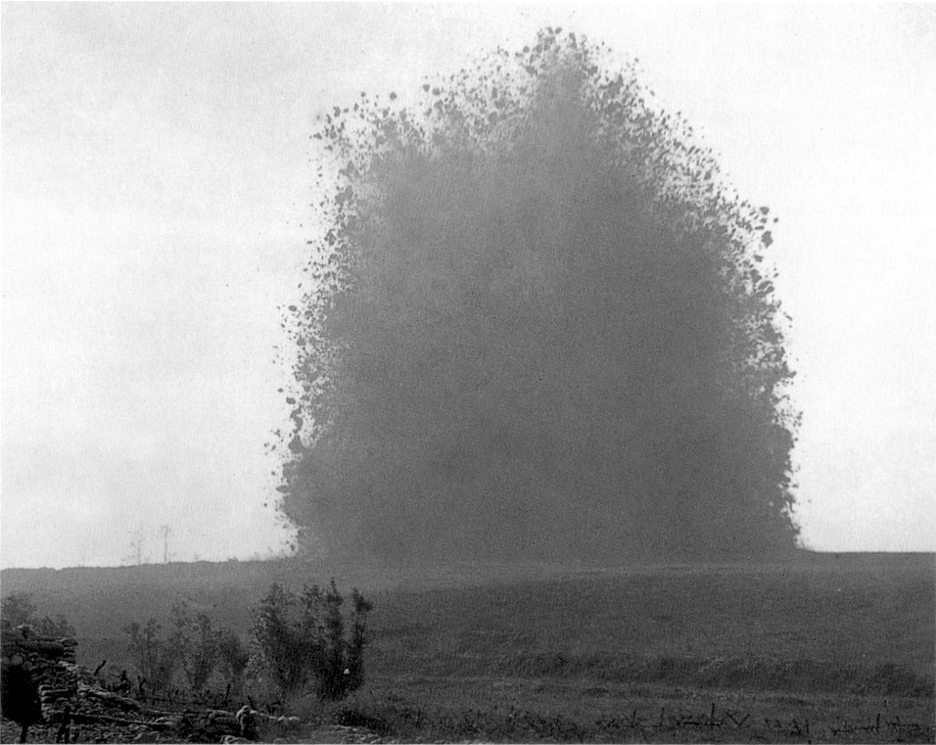

Hawthorne Ridge Mine Explosion 1st July 1916

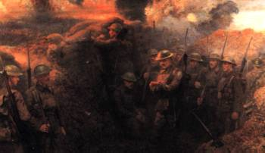

Waiting to go over the top – 1st July 1916 – Unknown artist http://www.worldwar1.com/mapsomme.htm

Ten minutes later, the advance began. An officer of the 1st Battalion said, “The sight was magnificent – line after line of men advancing at a slow trot towards the German lines with hundreds of shells (ours for the most part) bursting behind the German lines”.

Unfortunately, the Somerset men were unable to cross the ridge they were aiming for because it was being swept by machine gun fire, and they found themselves over to the left in the German trenches. “From this point onwards, all is confusion.” There was desperate fighting in the German first and second lines throughout the day. Some of the German front line trenches which had been captured were still occupied by German defenders who hid in their deep dugouts until the British troops had passed on towards the second line. They then came out of their dugouts and, using machine guns and rifles, shot down the advancing British troops from behind.

On the first day of the Somme battles, the casualties amongst the officers were very high and “all up and down the line, platoons, companies and even battalions (as with the SLI) were temporarily commanded by NCO’s”.

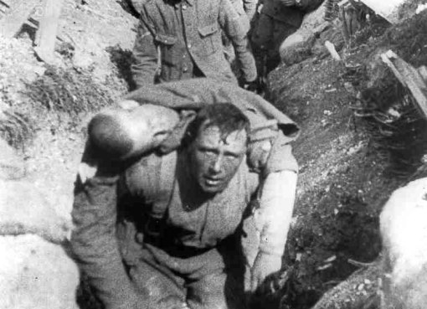

About 4.30 p.m. Major Majendie arrived with reinforcement officers and took command of the battalion which had been collected together in the assembly trenches, and after dark they were relieved by the Royal Irish Fusiliers and withdrew to the old British line.

There had been 26 officer casualties and 438 other ranks were killed, wounded or missing.

[taken from The Somerset Light Infantry 1914-18 by Everard Wyrall]

Extracts from the diary of Lance Corporal A C Cook, 1st Bn Somerset Light Infantry:

“June 28th. [The Battalion is in billets in Mailly-Maillet] We were told that owing to incessant rain and the shocking state of the trenches the great attack would not take place till July 1st. We hoped Jerry would not hear of our change of plans, but I expect he did.

June 29th. Bombardment continues all through the night and day. The attack starts at 7.30 a.m. tomorrow. All private correspondence, cap badges, numerals and spare kit has to be left behind…..the men are in excellent spirits and full of hope for the morrow, it was going to be a welcome change from lying in a trench and taking everything without the opportunity of hitting back…

July 1st. It was a lovely morning and the birds were singing. Breakfast 5.30 a.m., each man was issued with patent cookers for this occasion. The bombardment by this time was terrific, and the enemy lines are one cloud of smoke from the bursting shells, it seemed impossible for anybody to live in such a hell, but to our eyes it was a wonderful and inspiring sight. We actually stood on our parapets to get a better view of the scene, and cheered all the direct hits. Not a soul could be seen, and the enemy guns were strangely quiet. We all thought this was going to be a cake walk….

At 7.20 a.m. a huge mine exploded under Hawthorn Redoubt on our right front, the force of the explosion rocked our trenches. Punctually at 7.30 a.m. the attack was launched. It was an amazing sight, for as far as the eye could see to the right and left, lines of men were advancing across No Man’s Land in perfect skirmishing order as laid down in the drill book; everything was going smoothly and not an angry shot had barred their progress. But just before the forward troops reached the German trenches, the enemy opened up a murderous fire with machine guns…..With a prayer on my lips we went over the top, and had not gone far when the enemy guns opened fire, and we were caught in the middle of No Man’s Land. Men started to fall like nine pins, but we had to push on as the whole frontage was covered by these strategically placed guns…[on losing both my platoon officer and sergeant] I was left in charge of the platoon.. I led the platoon into the German front line.. then on to their second line where I lost control of the men as they rushed from one shell hole to another, and became mixed up with all kinds of units…

The ground everywhere was covered with dead and wounded…our guns had made an unholy mess of the German trenches, but very few dead could be seen, only our own men, for it appears they had been safely stowed away in deep dug-outs during the bombardment..”

Just under a month later, Edward Gillman with the 7th Battalion Somerset Light Infantry marched into Mailly Maillet and moved into the trenches front of Auchonvillers. These trenches and the surrounding country were full of half-buried corpses. Many of these were the men from 1st Battalion who had fought in the attack on Serre on 1st July – “these were reverently laid to rest by their newly arrived comrades.” [The Somerset Light Infantry 1914-19 – Everard Wyrall] Archie Thorne and Hugh Grinter from Stoke had been among those who had died on 1st July 1916.
The Western Gazette reported on Hugh’s death:

“News has just been received that Private Hugh Grinter SLI was killed in action on
July 1st. He leaves a wife and four children to whom the sympathy of the whole
parish goes out.”

Hugh is buried in the Serre Road Cemetery No. 2. The Commonwealth War Graves list him as being the son of Walter and Sabina Grinter, and the husband of Phyllis N Grinter of 17 Weston Road, Portland. Perhaps Bessie had moved back to Dorset from Wales with her four children to be closer to her family.

