Joseph Dodge’s Story

David and Eliza Dodge must have thought themselves especially blessed to have seen all of their sons – Thomas, Arthur, Joseph, David, Albert, William, Percy, and Evan - surviving the Great War. How devastated they must have been when Joseph was sent home with malaria contracted on service in India, and died in 1919! Joseph’s grandson, Graham Dodge, remembers being taken as a child to see his grandfather’s grave in the peaceful cemetery on Preston Road in Yeovil.

Joseph’s six brothers all served in the War

The Dodges were a stonemason family who had lived in Stoke sub Hamdon since the 1850’s. Samuel and Susan Dodge moved to Stoke from Chiselborough with their children, Simon and Ellen. Ellen married a James Gulley in 1847 but was back living with her parents on Ham Hill in 1851 without her husband. She had three boys – Samuel, David and Joseph.

Ellen’s son, Samuel, went to Wales and produced six little Gulleys. David – who would be the father of our Joseph - reverted to the name of Dodge and remained in Stoke. He married (possibly Mary E Stagg who called herself Eliza on the census returns) and their first child, Thomas, was born in Stoke. David worked as a stonemason in Peckham for a little while. Their only daughter, Mary, and their second son, Arthur, were born in Peckham. David and Eliza then returned to Stoke for the rest of their lives. Joseph was born in Stoke in 1883.

When Joseph was 17, he and his brother, Walter, 15, were working as farm labourers, living with their parents and younger brothers on Ham Hill. Joseph was now the eldest child at home. Thomas, Mary and Arthur had moved on, but David (the shepherd lad who was to emigrate to Canada with Albert Wilkinson and join the Canadian troops), Albert (fair haired and blue eyed), William, and the two inseperable younger boys, Percy and Evan, were all living on Ham Hill.

There is a sad newspaper report in the Western Gazette on Friday 30th June 1905, about the death of Joseph’s brother, Walter who by this time was working as an ostler at the Duke of Cornwall in the High Street. According to the newspaper, he was living with his parents in Windsor Lane. He and his younger brother, Albert, and some other boys went swimming down at the mill pond near Petherton Bridge. Walter got into one of the hatches in the mill pond which was about 16 feet deep and it is thought that he got cramp and drowned. His friends had got out of the water and were running around to get dry. When they came back to where they had left their clothes, they realised Walter was missing. His dog was still there, guarding his clothes. Albert ran home to tell his father that Walter had been drowned. They brought up his body six hours later.

Joseph was not living at home at this miserable time. In 1903, he had married Annie Case and moved to Yeovil. He was living at 3 Ivy Cottage, Union Street in 1911 with Annie and their two little boys, Walter and Norman. Another little boy, Kenneth, would come along later. Joseph was working as an engine minder.

By 22nd January 1915 six of his brothers were “serving King and country” – their photographs in the Western Gazette. Joseph not mentioned, nor was his younger brother, William. Perhaps this was because by this time neither Joseph nor William were living in the village.

We know very little about Joseph’s time in the army. We know that he was in the Wiltshire Regiment and the East Yorkshire Regiment but not which battalions he served in or when he first went overseas. However, Graham Dodge says that he sent postcards back to his family from wherever he was stationed, including India.

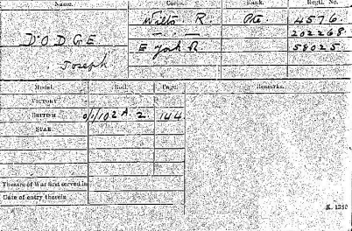

Joseph Dodge’s
Medal Card

He came back to England with malaria and was nursed in a hospital in Liverpool.
He died on 16th February 1919, aged 35.

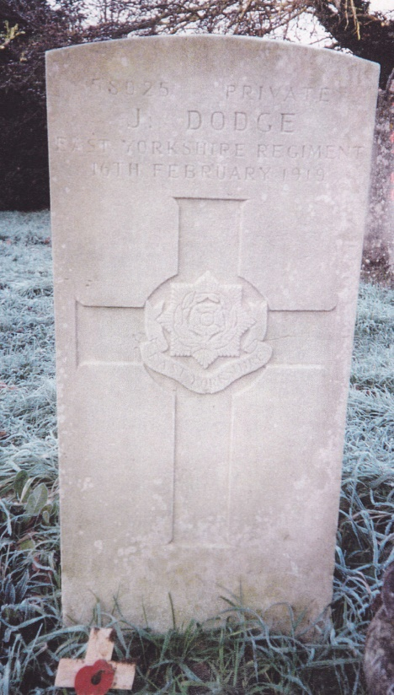

Joseph Dodge
Private
Service Number 58025
East Yorkshire Regiment

