Harold Rice’s Story

Harold Rice and Charlie Hawkins were cousins. Harold’s birth was registered in the name of Howard Thomas Rice in 1897 but he seems to have been known as Harold.

Harold and Charlie’s grandmother was Mary Rice. Harold was the son of her son, William Henry, and Charlie was the son of her daughter, Harriett.

In 1851, both Mary and her future husband, Josiah Rice, were living in Tintinhull. Mary was with her family, the Gilletts. Her father, Thomas, was a Chelsea Pensioner. He and Mary’s mother, Ann, had four children at home. Mary Gillett was described as a glover, and was aged 26. Josiah Rice, her husband to be, was living with his first wife, Ann, and had a thirteen year old daughter, Harriet.

Mary Gillett gave birth to Joseph in 1855 and Harriett in 1860.

Josiah’s wife, Ann, died in 1857, and by 1861 Josiah was living in Martock with Mary Gillett as his housekeeper. Mary’s children, Joseph and Harriett Gillett were living in the house. Josiah married Mary in 1867 and there were then two children of that marriage, James (1863) and William (1868). Josiah was twenty five years older than Mary and he died in 1871, aged 70.

The census returns for that year record Mary Rice as a widow with four children living in Lower Street, Stoke sub Hamdon. Joseph, the eldest, still had his mother’s name of Gillett but Harriett was now called Rice. Either Josiah Rice was her father or he gave her his name after he married her mother. James and William were 8 and 3 respectively.

Harriett, married Ambrose Hawkins and gave birth to Charlie in 1878. By 1891, Ambrose Hawkins was dead, and Harriett had taken young Charlie and his sister back to her mother’s house in Lower Street. Harriett’s brother, William, (or Henry as he was known sometimes) was still living at home, aged 24, so Charlie would have known his uncle well. William worked as a paper box cutter. There were two factories in Stoke engaged in supplying boxes and packaging material for the gloving trade.

William married Mary Jane Dyer in 1896 and Howard Thomas Rice was born the following year. He was 18 years younger than his cousin Charlie Hawkins.

By 1911, William and Mary Rice were living in the High Street with their five children, Howard (known as Harold) was the eldest at 13 and Joe the youngest at 5 months.

Mary’s mother, Mary Ann, was living with the family. Mary Ann came from Ilton. Her husband, Thomas Dyer, came from Long Load.

Harold was one of the youngest of those early, enthusiastic volunteers when War broke out in 1914. He (along with Percy Trott, George Ralph, Horace Brooks and Harry Turner) joined the 6th Battalion of the Somerset Light Infantry, enlisting in Yeovil.

The 6th Battalion of the Somerset Light Infantry was part of the 14th Division which was one of the new divisions of Kitchener’s Army. It was formed of volunteers. Initially without equipment or arms of any kind, the recruits were judged to be ready by May 1915, although their move to the fighting front was delayed by lack of rifle and artillery ammunition.

Harold, George Ralph and Horace Brooks all arrived in Boulogne with their Battalion on 21st May 1915.

Everard Wyrall – The Somerset Light Infantry 1914-18

The Battles of Ypres were drawing to a close when the 6th (Service) Battalion of the Regiment landed in France. Since the raising of the Battalion in August 1914, the 6th had spent the first three months in hard training at Aldershot. A move was then made to Witley Camp, Godalming, the Battalion returning to Aldershot again in February 1915, where brigade and divisional training was continued until the middle of April. The 6th Battalion, Somerset L.I. was now in the 43rd Infantry Brigade of the 14th (Light) Division, braded with the 6th Duke of Cornwall’s L.I., 6th K.O.Y.L.I., and 10th Durham L.I. A month later (about the middle of May) spare kit had been sent home and all ranks awaited embarkation orders. A few days later they came, and on 21st May the Battalion crossed the Channel in an S.E. & C.R. mail boat and, on reaching Boulogne, disembarked. The night was spent in the rest camp on the hills overlooking the town.

In June, the battalion had its first taste of life in the front line trenches, almost 2,000 yards north east of Wulverghem. The war diary for Sunday, June 13th : “The trench life was very quiet. A little shelling early in the morning and desultory rifle fire during the day.”

After a week of being in the trenches, the war diary says “The Battalion who were our instructors were full of praise of the bearing and behaviour of the ‘Kitcheners’, whom they saw for the first time.”

At the end of June 1915, the 6th Somersets marched to Ypres. Harold would have witnessed the desolation of Ypres – whole streets of shattered houses.

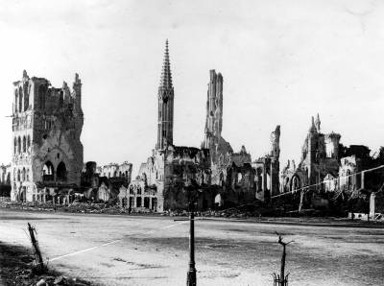
Ruined Ypres

The 6th Battalion took part in the 2nd Attack on Bellewaarde from 25th to 26th September 1915 – part of the Battle of Loos. The 6th Somersets were attached to 42nd Brigade during this time and afterwards the G.O.C. 42nd Brigade sent the following letter to the C.O:-

“Dear Colonel Rawling, I have to thank you and your fine regiment for the great assistance you gave me on the 25th. It was not an easy thing to reinforce, in broad daylight, as you did, and the movement was exceedingly well and quickly carried out. You arrived at a critical time and your dispositions were exactly what was required. The company of your Regiment which formed the garrison for the trenches rendered valuable assistance and I much regret to hear of the losses they sustained.”
[Somerset Light Infantry 1914-18 by Everard Wyrall]

The total casualties suffered by the 6th Somersets during the month were: officers, 3 killed, 4 wounded; other ranks, 26 killed, 107 wounded.

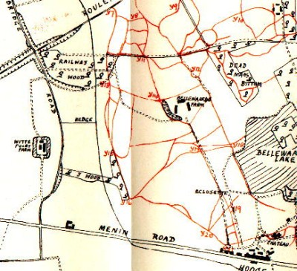
Bellewaarde Farm
6th Somersets were at Railway Wood – “The Battalion held on all day ….”

War Diary

At the end of October 1915 the 6th Battalion are billeted at Poperinghe. The Diary records: “Spirits of the men splendid. With incessant, rain, plenty of fatigues and no change of clothes and no chance yet of getting warm they can still stand for hours playing and watching football matches.”

Everard Wyrall writes: The first three weeks of November were passed under the most wretched conditions, but on 23rd the Battalion marched to the front-line trenches just north-east of St Jean, relieving the 10th Durham L.I. Two days in and two days out of the front line was the rule at this period, but between the miserable conditions of the billets and the filthy state of the trenches there was little choice. On 14th December the 43rd was relieved by 71st Brigade, the Somersets marching to a camp, described in the Diary as ‘G.5.d’ On 16th the Battalion moved to ‘our old Rest Camp A’ occupied six weeks previously. Here the Somerset men stayed until the close of the year without any incident with the exception of a rumour that the 14th Division was going out to Egypt, which rumour was subsequently dispelled by the receipt of orders for the Division to relieve the 49th Division in the Ypres Salient next to the French.”

I would imagine after the misery of the trenches in winter, the idea of going to Egypt must have been particularly attractive.

The 6th Battalion were not in any more major actions until the battles of the Somme in the summer of 1916. Through the winter of 1915 they suffered “the usual period of torment inseparable from winter in the trenches” (Everard Wyrall). The conditions in the line in January 1916 were terrible. “The front line is in an almost impossible condition and no troops can remain there more than 48 hours without much sickness.” (Battalion Diary)

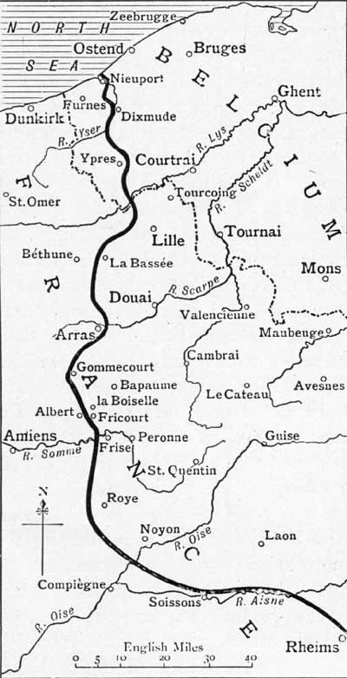
6th Somerset Battalion Somerset Light Infantry – south of Arras in
winter 1915/spring 1916

In February 1916, the Battalion was just south of Arras. They were in a quiet sector of the line and March passed with very few casualties. In April and May, there was a gradual increase in activity. Shelling became more frequent and snipers claimed more victims. The German 150 lb trench mortars (“Crashing Christophers”, the 6th Somerset called them) were beginning to make life uncomfortable in the trenches.

The actor, Arnold Ridley, describes arriving in France around the middle of March 1916. He writes that the 6th Battalion was in the field just south of Arras. It was heavy, sleeting weather. Ridley was wounded within a few days of joining the battalion and was sent home to recover. He was back in France in July.

From the book “Famous 1914-18” by Richard Van Emden and Victor Piuk

“He must have been relieved to hear that his Division was not immediately earmarked for battle. In fact it remained near Arras during July, making its way south to the town of Albert, just to the rear of the Somme battlefield, only on 7 August.

Eleven days later, the 14th (Light) Division with the 6th Bn Somerset Light Infantry was pitched into the fighting, Arnold going over the top on 18 August. ‘I fought all the way through Delville Wood’, he later remarked, recalling that even before they set off for the attack, much of the preliminary British barrage had accidentally dropped on them and not on the enemy. Fifteen men were killed or injured.

The concept that surviving an attack was not the end but only a hiatus between actions was hard to accept, and seemed to come as a shock to many men once the enormous adrenalin rush of going over the top finally dissipated…

‘It wasn’t a question of “if I get killed”, it was merely a question of “when I get killed”, because a battalion went over 800 strong, you lost 300 or 400, half the number, perhaps more. Now it wasn’t a question of saying, “I am one of the survivors, hurrah, hurrah”, because you didn’t’ go home….Out came another draft of 400 and you went over the top again.”

DELVILLE WOOD (15th July to 3rd September)

Delville Wood was sometimes known as Devil’s Wood. It was a tract of woodland, nearly 1 kilometre square. On the west, it touched the village of Longueval, on the east, Ginchy. On 14th July 1916, most of Longueval village was taken by the 9th Division, and on 15th July, Delville Wood was captured by the South African Brigade – all except the north west corner. The South Africans then held on grimly for six days until they were relieved. On 18th and 25th August, the wood was cleared of all enemy resistance by the 14th Division (Harold’s Division) The fighting at Delville Wood was particularly ferocious.

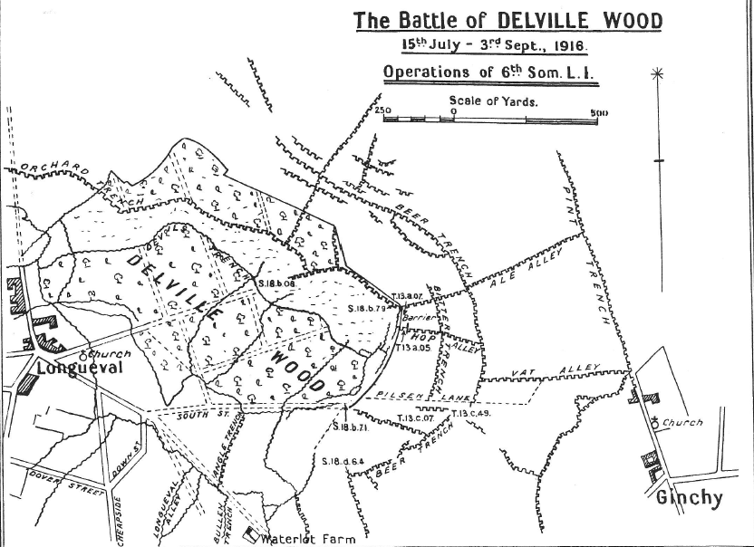
Albert is four miles west of Longueval

Harry Turner wrote to his brother, Ernest, “Well, Ern, take my tip and keep out of it if you can. I know for certain that you couldn’t stick it out here. Our Batt has done some splendid work out here lately and have been highly praised for it. You will see a machine gun that they captured on the 18th August on view in Yeovil shortly.”

He goes on to say he has “come across a good few Stoke boys since I’ve been here. I tell you, it’s a treat to see old faces once more. The chaps out here are pretty jolly and we enjoy ourselves pretty well when we are out of the trenches…. Wardle, H Rice, G Ralph and ?C Male are here in the 6th and are all looking pretty fit, except G. Ralph and he’s got thinner than ever.”

Young Harold must have acquitted himself well in the fighting on the Somme, because there is a report in the Western Gazette on 22nd September 1916 about his promotion:

Military Promotion. Corporal Howard Rice SLI has been promoted to the rank of Sergeant. Sergeant Rice is not yet 19 years of age.

According Everard Wyrall’s History of the Somerset Light Infantry 1914 -18:

“After the Battle of Delville Wood, the 6th Somersets spent several days in billets in Fricourt. On the 26th August, however, the Battalion moved forward again to reserve trenches 300 yards in front of Bernafay Wood……. The 28th and 29th were days of great discomfort. Rain fell heavily and the working parties supplied by the Battalion carried on their duties under wretched conditions. Relief, however, came on 30th, the 6th Somersets returning first to temporary billets in Fricourt and then to a rest camp. On 31st, the Battalion entrained at Mericourt for Selincourt, 20 miles west of Amiens where, until the 12th September, all ranks enjoyed a complete rest.”

Then, the Battalion is back in action again in the Battle of Flers-Courcelette – the first battle where tanks were used. It is during this battle that Harold is fatally wounded.

Battle of Flers-Courcelette - 15th to 22nd September 1916 – first use of tanks

Pen and ink drawing of Tank Battle on the Somme by Captain Bryan de Grineau, RFA

On 14th September, the Battalion was just south of Albert and began to move up towards the front line. Somewhat sarcastically the Battalion Diary states that at 2 p.m. the Somerset marched off ‘to occupy trenches which did not exist between Delville Wood and the Switch trench’. Here, as no tools had arrived, the men began to dig themselves in, using their entrenching tools. The Battalion were ordered into the front line. No rations had arrived, and so the Somerset men had to go into the trenches without them.

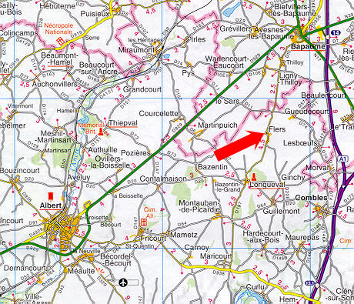
Albert
Delville Wood

Lieut.-Col. T F Ritchie (commanding 6th Somersets) was told he was to attack the enemy at 9.25 a.m. on 16th September. No time was given the Battalion for a reconnaissance of the ground over which the attack was to take place and this resulted much confusion. The barrage was also quite inadequate and heavy machine-gun fire met the advance with the result that the attack broke down with heavy losses.

“The casualties of the 6th Battalion in this affair were truly terrible. Every officer who went over the parapet had become a casualty. Three had been killed, 12 wounded and 2 were missing. In other ranks the Battalion had lost 41 killed, 203 wounded and 143 missing. The ridge between “A-A” and “X-X” Trenches was a veritable death trap, and here the Somerset men, as they advanced, were shot down in dozens by German machine gunners firing from the north and east. [History of the Somerset Light Infantry 1914-18 by Everard Wyrall]

At least nineteen of the men from Stoke who died in the 1st World War were in the Somerset Light Infantry, and many of the Stoke men were killed or wounded during the fighting on the Somme in the summer and autumn of 1916. All along Castle Street one could see the blinds drawn in mourning for husbands and sons and brothers.

6th Battalion War Diary for 15th to 16th September
September ALBERT – GUEDECOURT

15th Bombs, 100 rounds S.A.A. per man & Flares were issued. The Battn. moved off at 7.30 and arrived Pommiers Redoubt at 9.30.
11.15 Orders received to occupy the check line in front of Bernafay Wood.
2 pm To occupy trenches which did not exist between Delville Wood and the Switch trenches, men commenced digging themselves in with their entrenching tools as no tools had arrived. The Transport Officer later brought up the tools under heavy shell fire.
11 pm Orders received that we had to relieve the 42 Bde in the front line, but first of all rations had to be fetched about 2 miles back, parties were sent back at once to get rations and water which had not been issued during the day.
1.30 am No rations had arrived so we moved to the front line and relieved the 42 brigade who had attacked in the morning and had received heavy losses. The line was very vague but we managed to get relief over just before daybreak.

16th September

4.15 Rations only arrived for 2 companies. The other companies ate their iron rations. The worst difficulty was water which was very scarce.
B C A companies attacked Gird Trench and Gird Support supported by D Company but before reaching their first objective, they came under heavy machine gun fire from both flanks which inflicted heavy casualties upon us and we were obliged to dig ourselves in without reaching the objective.
D Company was then sent to the front line but without any further advance. The 6 KOYLI were then called up and kept in reserve in our jumping off position.
Brigade asked us that if we thought it advisable we should attack again at 4 pm, but as we considered it impossible nothing was done.
6.20 Orders were received that the remnants of the battn and 2 companies of the 6 KOYLI would attack Gird Trench again but owing to the short time given us it was found impossible to get orders out, the 2 companies KOYLI attacked as they were already formed up, and a proportion of our men who had received orders but the barrage was again very feeble and heavy machine gun fire was turned on to us, with the result that the attack again broke down with heavy losses. Night had then commenced and parties were sent out to try and collect the various small parties and consolidate the ground won. After great difficulty the trench was discovered. Enough men were collected to hold with the help of one company of the KOYLI. This line was then held and consolidated until relieved by the 13th Batt. Northumberland Fusiliers in the early hours of the morning, just enable the remnants of the b attn to get clear over the crest of the hill by daybreak. Our casualties were every officer who went over the parapet 3 were killed, 12 wounded, 2 are missing. Other ranks casualties were 41 killed, 203 wounded, 143 missing. Operation Orders enclosed with full account.

On 17th September the 6th Somersets were relieved and moved into billets in Ribemont on 18th September where the remainder of the month was spent.

Harold Rice and Harry Turner were among the casualties. George Ralph was one of the 143 Other Ranks missing on 16th September.

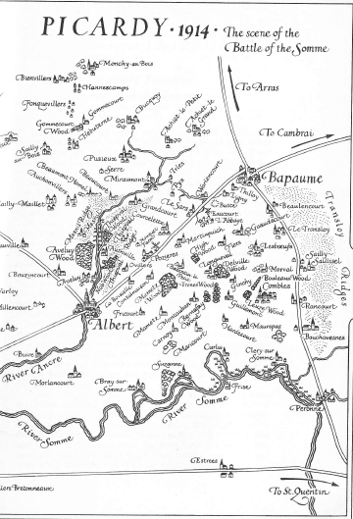
Becordel-Becourt Cemetery
Dernancourt – where the XV Corps Main Dressing Station was based
Pommiers Redoubt
Guedecourt
Delville
Wood
Bernafay
Wood

Harold was admitted to hospital in Rouen on 20th September.

On 29th September, the Western Gazette reported:

Wounded at the Front. News has been received that the following have been wounded in the recent fighting – Pte Henry Follett, Wilts, Pte C Isaac SLI, Sgt H Turner SLI,
Sgt H Rice SLI and Pte Ewart Palmer SLI. It is sincerely hoped that all of them will recover. Stoke has already lost 16 killed in action.

Sadly, Harold did not recover. He died on 3rd December 1916. There was a further report in the newspaper, with a photograph of Harold looking very young:

Death of Sergeant Rice – The parents of Sergeant H T Rice have received news that he has died in hospital in Rouen, where he had been since September 20th, from tetanus. He was admitted suffering from gunshot wounds, and news had come only a week since that he was progressing satisfactorily, and hoped soon to be at home. He was one of the first to volunteer, being only 17 years of age at the time, and he attained the rank of sergeant when only 18. Deep sympathy is expressed with Mr & Mrs Rice in their loss. This brings the Stoke death roll up to 22. No further news has come to hand respecting Private G Ralph, who was reported missing since September 17th.

George Ralph had been killed in action on 16th September but his body was never found and his parents had to wait until the following August 1917 before being told that their son was presumed dead.

Harry Turner died on 17th September.

Harold is buried at the Bois Guillaume Communal Cemetery at Rouen.
Most of the burials in this cemetery were from men who had been nursed at No 8 General Hospital, which was in a large private house in the south of the town.

