Fred Trott’s Story

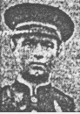

Buried by his brother, Gilbert, after the fighting on Hill 60 in 1915

Cecily Beauchamp, whose son, John Beauchamp II owned the Manor of Stoke in the thirteenth century, compiled an inventory of Stoke. Several villagers are named, among them Hugh Trot. So Trot is a very ancient name in the village. While Fred’s Trott forebears may well have originated from Stoke, his father, Thomas Trott, was actually born in South Petherton. Thomas had a brother called Henry who I believe was the father of Percy Trott, Fred’s cousin who also died in the 1st World War.

His mother, Angelina Hellier, was born in Stoke, and I have traced her family back through the census returns to her father, Thomas, living with his parents in Castle Street in 1841.

The 1901 census shows the family living in West Street. Fred is nine years old. There were eight children: Arthur Joseph, Beatrice, Sidney, Daisy, Fred, Gilbert, Nellie and Minnie. Of these, Arthur, Sidney, Gilbert and Frederick would all serve in the War. Only Arthur and Sidney would come back. .

Both sides of the family were farm labourers and glovers. By the time of the 1911 census, Thomas Trott had added “thatcher” to “farm labourer” as his occupation. The family were living in North Street and Frederick was 19 years old. The brother nearest him in age was Gilbert, about a year younger.

The school log book reports that A Trott was punished for smoking in the store room on 11th October 1895. Could this have been Fred’s elder brother, Arthur, aged 11 years?
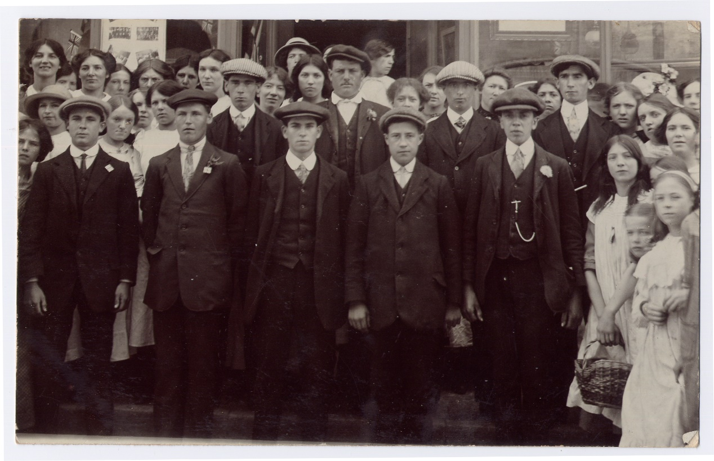
Stoke Volunteers
Fred and Gilbert Trott are in this photograph. One of them is said to be extreme right, back row. The other is either the man standing next to him or on the extreme left, back row.

Fred enlisted in Yeovil in the 1st Battalion of the Somerset Light Infantry. His service number was 15317. Gilbert’s was 15316. They must have been standing in the line together when they enlisted. Ten of the Stoke men who died were in the 1st Battalion.

Fred arrived in France on 21st April 1915. Gilbert had arrived a month earlier, on 24th March.

2nd Battle of Ypres - GAS

The 1st Battalion was with the 4th Division which took part in the 2nd Battle of Ypres. Gilbert would have been in France for a month but Fred would only have just arrived in France by the time of this action where the Germans first used gas as a weapon. On 22nd April 1915 a veil of greenish-yellow mist could be clearly seen rolling across from the German front lines, and there were repeated gas attacks during the fighting around Ypres on 8th May and until 13th May.

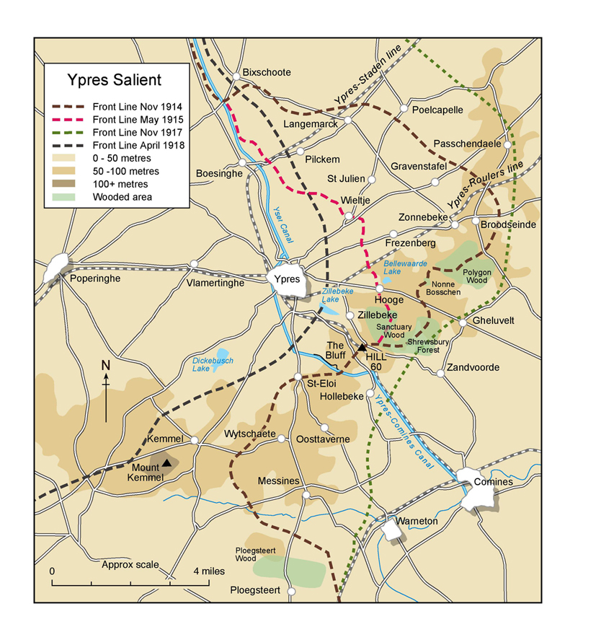
Hill 60
2nd Battle of Ypres

Lance Corporal Cook of the 1st Battalion Somerset Light Infantry, describes the experience in his diary:

“Early in the afternoon, I was gazing over the top of the trench when I saw a German walking along behind his trenches, and on his back was a large flat container. Suddenly I noticed he was leaving a trail of smoke behind him, which later turned into a dense green mass, and commenced to roll along the ground gradually towards us. The wind was no more than a breeze which pushed this cloud gently along in our direction. With horror I realised that this must be the gas we had heard so much about, I hurriedly went around

and warned all the men of what was happening. Only a few of us had been issued with some sort of protection and this consisted of a flat piece of cotton wool about 3 ins square with tapes attached, the pad being kept in position by placing it over the mouth and securing it with the tapes at the back of the neck. I ordered those in possession to put them on at once, and those without to scoop a hole in the ground, which would immediately fill with water, soak their handkerchiefs in it and ram them in their mouth. This being done, I got everybody to line the trench, and when the enemy appeared, to open up rapid fire. It was not long before they emerged from their trenches keeping at a safe distance from the gas cloud in front of them….

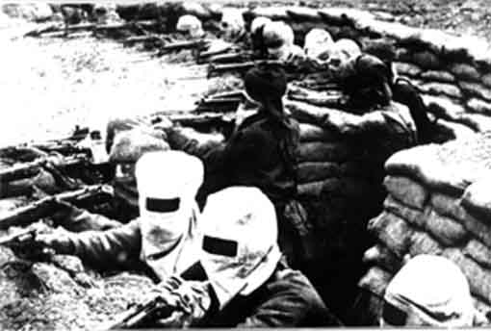

Of all the many weapons used in modern war undoubtedly the use of poison gas is the most terrible. We who saw this queer looking bank of mist sweeping across “No Man’s Land” were puzzled at first and did not know what to make of it.”

Albert Bowden and Albert Minchinton, both remembered on the Stoke War Memorial, were in the 1st Dorsetshires, on Hill 60. Albert Minchinton died on 2nd May, the day after Fred.

The Western Gazette describes on 15th October 1915 how Fred died and how his brother found his body and buried him:

Private G Minchinton who was wounded in the fight on Hill 60 is home on leave. He has now recovered from his wounds and gives a graphic account of the fighting in the trenches, when his comrade Private F Trott of this place was killed. Private Trott was struck by a shell in the chest and killed instantly, and his brother, who was in the second line, was ordered up to fill the gaps, and found his brother dead. After the fighting, he was one of the men told off to bury the dead, among whom was his own brother.

When Thomas and Angelina came to hear of the details of gas poisoning, they must have been relieved to know that their son was killed instantly by a shell rather than by gas.

His brother, Gilbert, died on 27th July the following year, when the Western Gazette reported:

4 August 1916 Gallant Brothers: In the recent severe fighting in France, another of our gallant lads, Private Gilbert Trott, youngest son of Mr Thomas Trott, has been killed. The sad news was received on Wednesday. This is the second son whom Mr & Mrs Trott have lost in the war, and another of their sons, Sydney, has recently arrived at a hospital in Southampton, suffering from wounds.

Frederick Trott and Albert Minchinton are both remembered on the Menin Gate memorial at Ypres.

