Joseph Gummer’s Story

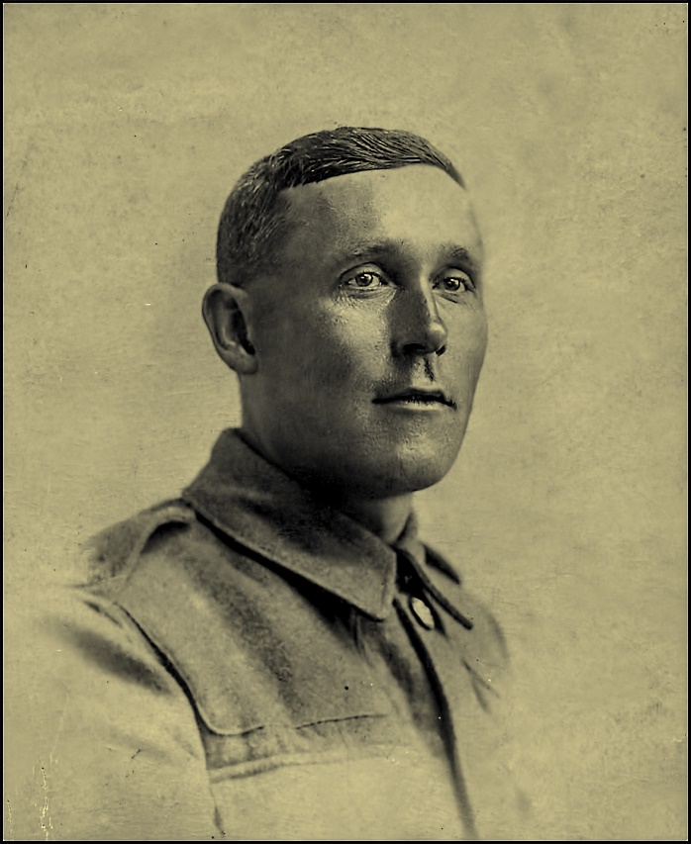

Joseph’s parents had eight children but seven of them died. His father, Joseph, married Martha Jeffery from Martock in 1878. Between 1878 and 1904, there are ten Gummer children registered as dying in the Yeovil area. Seven of these children were Joseph and Martha’s.

Joseph was born in 1885 and survived, only to be killed in the War in 1917.

Joseph’s grandfather, George Gummer, was born in Stoke around 1814, at the time of the Napoleonic wars. He was living in Castle Street in 1841, aged 25 and working as an agricultural labourer. He married Elizabeth Tanner of Chiselborough the following year.
In 1851 the family were living in West Street, near Edward Thorne, Innkeeper. George was described as a carter and Elizabeth as a glover. Their eldest child, Sarah Ann, was seven years old and described as a “nurse maid”. Perhaps she had to look after her two younger brothers, Edwin and John aged respectively four and one. Ten years later, the family were living in Lower Street (now North Street) and two more children had been born – Joseph (our Joseph’s father) was eight and Eliza was three.

Another ten years on – 1871 – and the family are still living in Lower Street, near to Farmer Gale, and Walter W Walter at the Gables. Young Joseph, now 18, is working as a blacksmith, a trade he follows all his life. His elder brothers are no longer at home. There is no mention of his younger sister, Eliza, who would have been around 13 in 1871 but there is a death registered for an Eliza Gummer in 1865.

Joseph married Martha Jeffery in 1878. Their first child, Eliza, was born in the autumn of that year. A little boy, called George after his grandfather, arrived two years later in the spring of 1880. On the 1881 census, the family is living on the High Street. Joseph, the blacksmith, Martha the glover, one girl of two, and one boy of a year old. There is an eight year old girl from Martock living with them called Elizabeth Cox, who is described as a servant (nurse).

Two more children are born but in the summer of 1884, tragedy strikes the family. The four children die one after the other, aged 5, 4, 2 and 1. Two boys and two girls. There is a memory passed down in the family of four little bodies lying on the kitchen table. One can imagine how helpless Joseph, who was likely to have been a big, powerful man, would have felt.

The school records for 1884 report:

14 March Fever. Alice Gillard died this week.
28 March Fever still prevalent.

It is thought that the Gummer children died of diphtheria.

In 1885, Joseph Junior was born. There would be three more children but none of them survived to adulthood.

In 1891, when Joseph was six, the family were living in Castle Street. There were just the three of them, Joseph, Martha and little Joseph. Ten years later, they have moved to East Stoke. Joseph was 16. They lived not far from George Ralph, aged 11, who was to join the 6th Battalion Somerset Light Infantry, and die in 1916. Joseph Junior was described as a Leather Glove Slitter. I wonder why he didn’t follow his father’s footsteps and become a blacksmith.

At this time, 1901, young Joseph’s future wife, Eliza Lawrence, was working as a servant in the house of a schoolmaster in Street. She was 18 years old and working with the family as a domestic servant. She came from a large family in Norton sub Hamdon. Her father was a mason’s labourer and she had three sisters and three brothers. Her two elder sisters, Matilda and Jane, were also in domestic service. Suddenly acquiring a large family must have been exciting for Joseph.

Joseph and Eliza were married in 1909 and set up home in Norton sub Hamdon where their son, Edward, was born in 1910. Joseph was working as a webber in a glove factory. His parents were still living in East Stoke in 1911. A sister for Edward, Olive, was born in 1915.

Joseph’s medal card gives his number as 203846, while the Commonwealth War Graves state that it is 203486. The medal card does not say when he arrived in France but we know he enlisted at Yeovil, was in the 1st Battalion Somerset Light Infantry, and was killed in action on 4th October 1917. He was 32 years old. Edward was seven and Olive two.

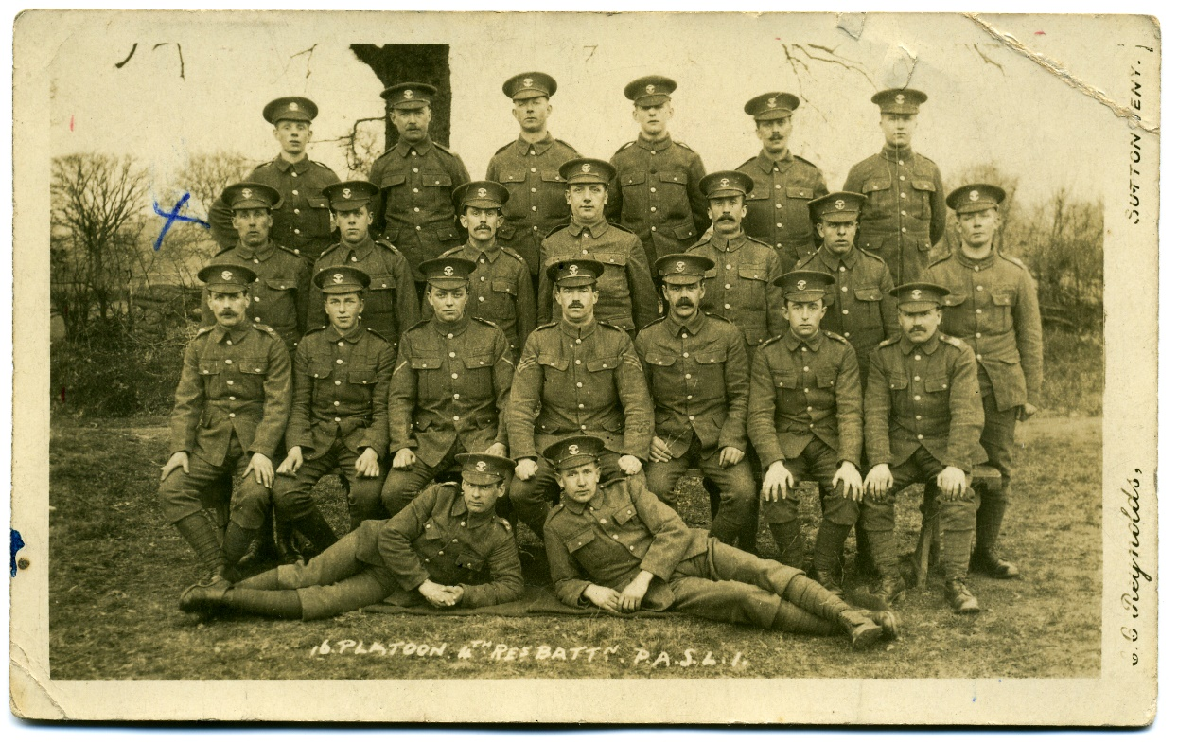

Joseph marked with blue cross

Joseph’s Battalion took part in the 2nd Battles of Ypres in April/May 1915. They spent the rest of the year in a quiet sector of the Somme and the following spring in preparation for the Somme battles which started on 1st July. On that day his fellow Stoke men in the regiment – Archie Thorne and Hugh Grinter - died. The Battalion returned to the Ypres area in August 1916. This was when poor Walter Gomm was killed in a gas attack. By September they were back in the Somme, involved in the fighting on Le Transloy Ridges. Conditions in the trenches in the winter of 1916 were terrible.

The Diary for 12th December 1916 reads, “Rain, snow, howling wind and bitterly cold…. The conditions beggar description: the trenches are flooded and have all fallen in: there is no cover either in front, support or reserve lines, and men are being evacuated sick with frost-bite and exhaustion by the hundred. Today four men were dug out of the mud who had been unable to move for three days.”

The Battalion took part in the First and Third Battles of the Scarpe (part of the Battles of Arras) in April and May 1917. “Gallant and splendid as were the attacks of the assaulting troops, the cost had been great. The Somerset Light Infantry had lost heavily in officers and other ranks and, though they had inflicted equal losses on the enemy, it was poor comfort for the loss of so many valuable lives.”
[History of the Somerset Light Infantry 1914-18 by Everard Wyrall]

After the Battles of Arras, the 1st Battalion had a welcome period of rest. The next action the were to be in would be the Battle of Broodseinde.

We don’t know when Joseph arrived on the scene, whether he joined the Battalion in time for the Battle of Broodseinde or whether he arrived earlier and took part in some of the above actions. There is a mention in the History of the Somerset Light Infantry of a new draft for whom the fighting at Broodseinde was their first action, so it is possible that he was among these new troops:

“A satisfactory feature of the day was the way in which the last draft of
200 behaved. Though, for the most part only nineteen years of age, and never
having been under fire before, they showed the greatest keenness and
determination and behaved excellently.”

PASSCHENDAELE

The action where Joseph died was the Battle of Broodseinde – part of the infamous Battle of Passchendaele, famous for the scale of its casualties and for the mud. George Denman from Stoke was with Joseph in the 1st Battalion and was awarded the MM for his courage during this battle.

The battle of Passchendaele took place on the Western Front, between July and November 1917, for control of the ridges south and east of the Belgian city of Ypres in West Flanders as part of a strategy decided by the Allies at conferences in November 1916 and May 1917. Passchendaele lay on the last ridge east of Ypres, five miles from a railway junction at Roeselare, which was a vital part of the supply system of the German Fourth Army . [Wikipedia]

On the night of 3rd/4th October, the 1st Somersets were ordered to relieve the 20th Division in the Langemarck sector and were in its assembly position by 11 p.m., with the loss of only one man.

“The German defences in front of the Battalion sector consisted first of Kangaroo Trench with a pill box in its immediate rear, next a road running west of Ferdan House and Lemnos House (both of which were in the Battalion area) beyond which was another short length of trench; the road formed the first objective. The Green Line (the final objective) was east of the two houses and ran through Tragique Farm, also in the area to be captured by the Somerset men.” [The Somerset Light Infantry 1914-19 by Everard Wyrall]

Map showing position of 4th Division (1st Bn Somerset Light Infantry)
During the Battle of Broodseinde

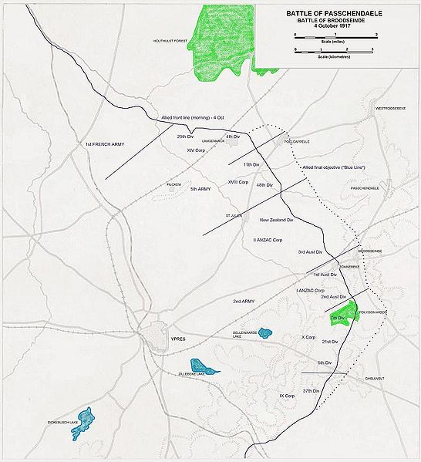

“At about 5.30 a.m. on 4th the German guns became active and many shells fell just behind the rear section of the Battalion. In order to avoid casualties the Battalion moved forward about thirty yards before Zero.

At 6 a.m. the British barrage fell and the advance began. The men had been impressed with the necessity of keeping close on the heels of the barrage and so eager were they to carry out these instructions and thus minimize casualties, that there was a tendency to keep too close and the result was that several men were wounded. Hostile machine-gun fire met the advance of the Battalion, but the Somersets do not appear to have suffered very much from the hostile barrage. The intense darkness made direction difficult to keep and there was a noticeable tendency to ease off to the right.

Kangaroo Trench was found occupied by the Germans, but they gave little trouble. The British barrage had accounted for a good many and the remainder were only too glad to give themselves up. The attack swept on and no serious opposition was met with until the line of the track running south from Lemnos House was reached. On the road, which was the line of the first objective, were several piles of stones and these were held by the Germans, in force. Heavy fire was opened on them and after several had been killed opposition broke down and the Somerset men again advanced. The right of the Battalion, together with some men of the 11th Division (on the right of the 1st Somersets), then attacked a concrete house on the Poelcapelle Road, south of Ferdan House. A German machine gun was firing from the roof of this house and another from the side of it. A Lewis gun was then brought into action and, under cover of its fire, the attackers worked round a flank and got in rear of the house. Several Germans were killed before the remainder (about sixteen of the enemy) and the two machine guns were captured.

On the left another German machine gun at Lemnos House held up the attack for a while, but eventually by means of rifle fire and rifle grenades the gun was knocked out and the house taken.

At this period heavy machine-gun fire was coming from Ferdan House, but the British barrage had halted. The line of the first objective had been captured and reorganisation now took place, direction was checked and Lewis guns and rifles cleaned.

Presently the barrage moved on again and the attack was renewed towards the Green Line, the right of the Battalion being directed on Ferdan House. Heavy machine-gun fire was still coming from the latter as the Somerset men moved forward but, aided by the Lewis guns and the fire of a Stokes mortar belonging to the 11th Division, the house was attacked. The East Lancashires worked round the right flank, the Somersets round the left and the house was rushed and captured. Two German officers and thirty other ranks, several of whom were wounded, were taken, together with two machine guns and two trench mortars. Ferdan House having been captured, the advance was continued to the Green Line, but by now the enemy’s resistance was feeble and although some casualties were suffered from machine-gun fire from the direction of 19 Metre Hill, the line was reached, when the Battalion was reorganized and distributed in depth. Touch was maintained on both flanks. The advanced line of posts ran from Tragique Farm south-eastwards along the Green Line to the right Battalion boundary.

The attack had gone splendidly, but the 1st Somersets had suffered severely. The equivalent of four platoons only could be collected, with about thirty men of the East Lancashire Regiment under one officer. Of the Somersets’ officers there were only five remaining and of these Captain Greetham, who had been ill during the two days preceding the attack, had to be sent back in the afternoon.

About 2 p.m. a German counter-attack developed on the left of the Somersets where a battalion of Seaforths held the line. The latter had to fall back, and in consequence the left of the 11th Brigade had to conform; but rifle, Lewis gun and the fire from captured machine guns was opened on the enemy and the whole line was shortly afterwards re-established. At about 5.40 p.m. another counter-attack was launched by the enemy on the left of the Somersets and again the line was forced back. Finally, the Somerset men had to fall back as the line of the Battalion was ‘continuously shelled by our guns.’ The new line was established from about 50 to 100 yards in front of Lemnos and Ferdan Houses.

Nine officers and 284 other ranks were the casualties of the 1st Battalion in the Battle of Broodseinde.”
[The Somerset Light Infantry 1914-19 by Everard Wyrall]
The diary of Lance Corporal A C Cook of the 1st Battalion SLI, gives his perspective about the terrible conditions of the battle:

“Oct. 4th. The attack is timed to commence at 6 a.m. The thoughts of all of us in the transport lines are with the boys in front. Rain has turned everything into a quagmire, and many a lad exhausted by the hard going and his heavy load will fall into the shell holes which are full of water, and I fear never get out again. Buck board trucks were everywhere leading up to the front line, but Jerry had all these taped and frequently brought shells and indirect machine gun fire on them. The line of the tracks were frequently broken by direct hits and this meant walking around the shell hole which is easier said than done. The ground here has been turned over and over again by shells, large and small. These holes immediately fill with water, so to get around and on to the track again you probably had to go around the edges of many others. A slip and you were immediately immersed in several feet of mud and water and you were very lucky if you got out of it especially on a dark night where your disappearance would not have been noticed.

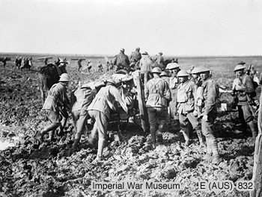

Battle of Broodseinde – 4th October 1917

The debris of war abounds everywhere, gun limbers were scattered, guns of all calibres smashed, horses blown to blazes but very few human bodies to be seen. A good reason why – they were swallowed up in the mud and water of this horrible sector. Roads are made of wooden planks joined together just wide enough for two limbers to pass. They zigzag all over the place, are frequently smashed by shells and immediately repaired by the R.E.s as the shells must be got to the guns and their only route is by these improvised routes. Guns of all calibres are everywhere, in places practically wheel to wheel. It seems to be just madness on the part of Higher Authority to expect any advance over this indescribable morass. My Coy. “C”, were detailed for mopping up purposes. Casualties arriving back say conditions are terrible. There was not much resistance at first but it stiffened up afterwards and the Btn. got it in the neck pretty bad. Objectives appear to have been gained and held in spite of numerous counter-attacks.”

Joseph Gummer is buried at Cement House Cemetery in Langemark..

The Western Gazette reported his death on 9th November:

“Private J Gummer, husband of Mrs J Gummer of East Stoke has been posted as missing since 4th October.”

It looks as if Eliza had moved to East Stoke with the children to be close to her
mother-in-law. Joseph’s father had died aged 59 in 1912. It is comforting to think that his widow, Martha, had Eliza and her two children living near by.

There is an inscription in St Mary’s Churchyard in Stoke sub Hamdon :

In loving memories of Dad, Joseph Gummer, killed in France 1917.
Mum, Eliza, died 17 May 1973 aged 88. Reunited.

