Ernest Trotman’s Story

We are the boys of Old Somerset
We've stuck it ten months and we're sticking it yet.
Our founder Prince Albert, a King but in name,
But the good old swede bashers still add to their fame.
I hope you don't think we're chucking a hint,
But I think you'll admit we are hard as flint.
They call us the Sets but we don't care a fig,
As long as they find us some trenches to dig.
PA's on our cab badge and don't think we're barmy
When we say that the meaning is Pride of the Army.

Written by Stretcher Bearers of the 1st Somerset Light Infantry

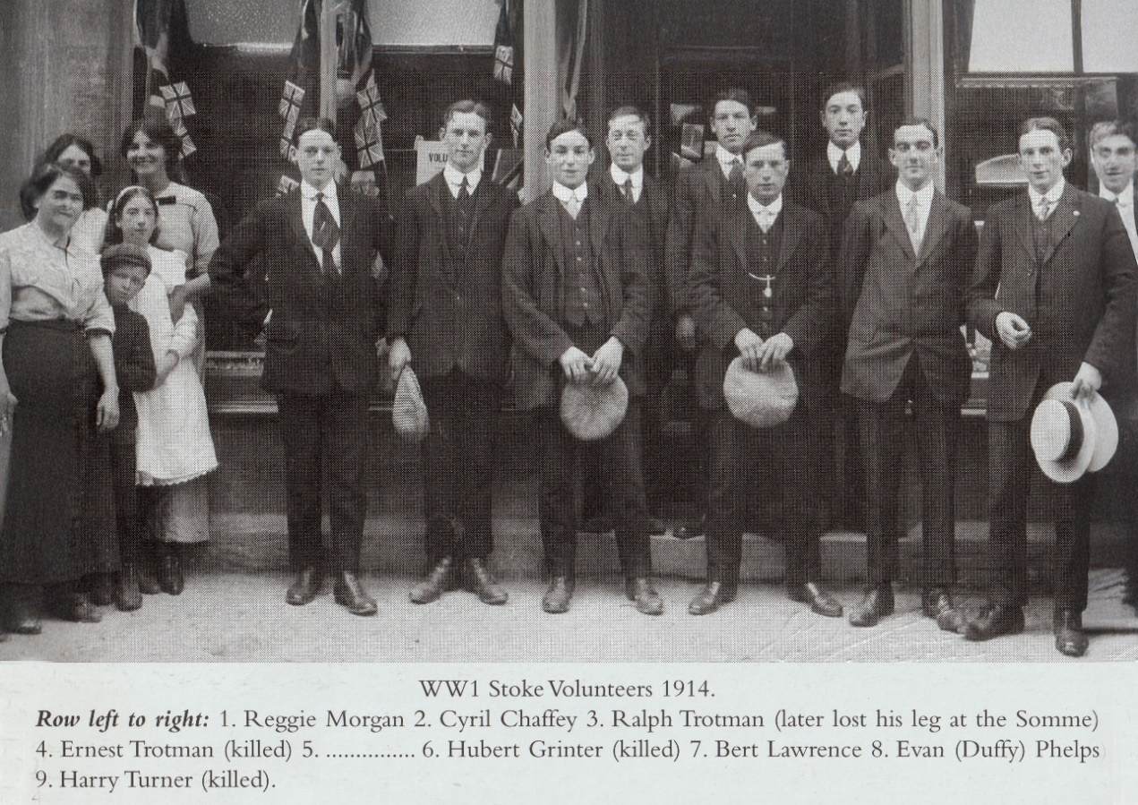

Ernest Trotman’s father, Henry Ryman Trotman, was one of the Oxfordshire glovers, born in Banbury, and his first wife, Rosa, was from Charlbury. There were great comings and goings of glovers between that area of Oxfordshire and Stoke sub Hamdon. Henry and Rosa (née Carpenter) were married in Oxfordshire in the summer of 1865 and arrived in Stoke some time between 1878 and 1880 with their children Henry (full name Henry John Victor Ryman Trotman), William, Victor Albert, Minnie and Ralph. Their next child, Evelyn, was born in Stoke in 1880.

Henry Trotman was known in the village later in life as ‘Dr Trotman’ because he was a herbalist. The people of Stoke would go to him for help with their ailments.

In 1882 Henry’s wife, Rosa, died aged only 34. Henry needed help with all those children and within the year he was married again – to Elizabeth Hutchings, a young widow, who was to be the mother of our Ernest.

Elizabeth was born a Dalwood. She married a Richmond Hutchings in 1876. The Dalwood girls all worked in the cardboard box factory in Stoke. William Stone, who married Elizabeth’s younger sister, Martha, the same year that Elizabeth married Richmond, was an “employer” in the manufacture of cardboard boxes in Street in 1891 and Ernest’s grandmother, Hannah Dalwood, was living with the Stone family in Street after her husband died.

Elizabeth did not have as much luck with her first husband as Martha did with hers. Richmond died in the spring of 1879, leaving her with two little girls, Flora and Eva M. Hutchings. By the time of the 1881 census, Elizabeth had gone back to live with her parents, Thomas and Hannah Dalwood, in East Stoke.

Henry and his new wife, Elizabeth, had a son, Bertie, in Stoke, soon after they were married. They then moved to Pilton, near Barnstaple, where there was a glove factory in Pilton employing 200 workers in the 1880’s. In Pilton, two more children were born – Ernest Randolph Trotman in 1887 and Lily Beatrice in 1889. Of the two little girls of Elizabeth’s first marriage, Eva Mary died in Barnstaple in 1890, aged 12. Flora survived and is listed on the 1891 census as a visitor, aged 15, staying with a Mary Dalwood in Stoke and working in the cardboard box factory.

The score of children so far is ten. Another daughter, Elsie, was born in Martock in 1894, and finally Percy arrived in Stoke in 1895.

By 1901, Henry and Elizabeth and their children were living on Ham Hill. The older ones had flown the nest. The eldest, Henry John Victor Ryman Trotman, had married Fanny Guppy. They were living near Percombe with their five children. One of these was Ralph Trotman who lost a leg in the War and was given the privilege of presenting the bronze wreath for the Monument to the Prince of Wales in the ceremony on Ham Hill in 1923. Although Ernest was his uncle, Ralph was only about eight years younger than Ernest.

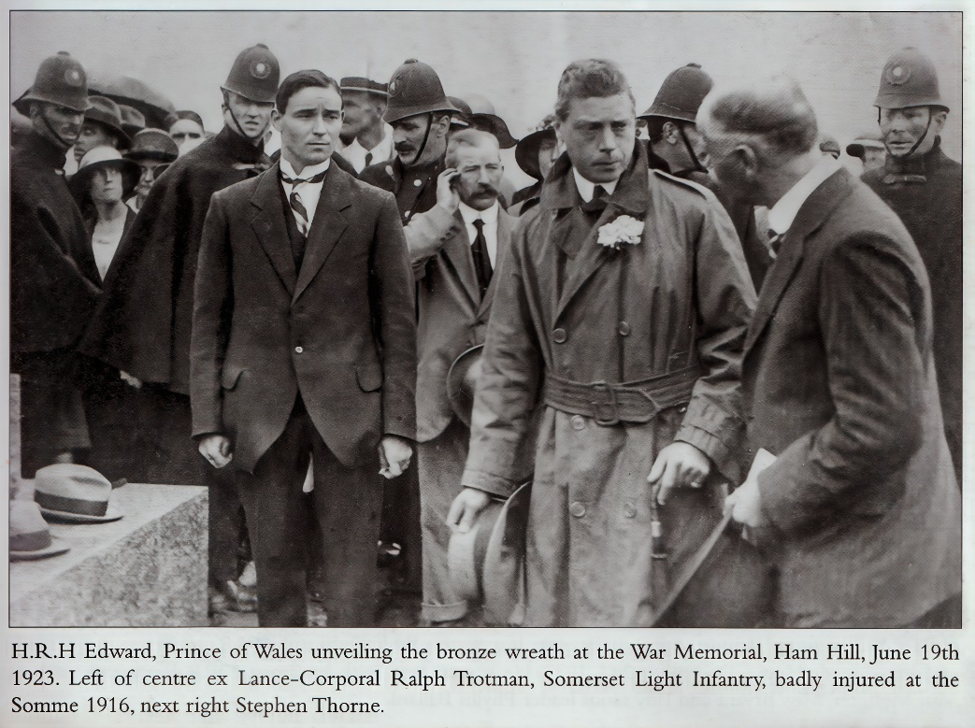

In the family home on Ham Hill in 1901, Evelyn was 17, Bertie 15, Ernest 13 (described as a “house boy”), and Lily 11. Henry Ryman Senior was still working in gloving and Elizabeth in the cardboard box industry.

Ernest Trotman is on the extreme left. Ralph Trotman stands with arms folded in doorway

[Photographic Memories of Stoke sub Hamdon]
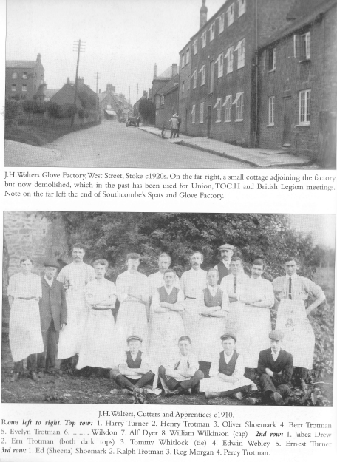

Ernest follows his father into the gloving business. He and his younger brother Percy are in this 1910 picture of
J H Walters Factory Cutters and Apprentices

Ernest enlisted in Crownhill, Devon, in the 1st Battalion of the Somerset Light Infantry. Other Stoke Lads who joined the 1st Battalion were George Denman, Walter Gomm, Hugh Grinter, Joseph Gummer, John Hayward, Archie Thorne, and Gilbert and Fred Trott.

When Ernest arrived in France on 1st June 1915, the 1st Battalion had just taken part in the 2nd Battle of Ypres (22nd April to 25th May 1915) – when gas was first used as a weapon in the War. Fred Trott had been killed on 1st May, hit by a shell. George Minchinton described how his brother, Gilbert, had found his body and afterwards buried him.
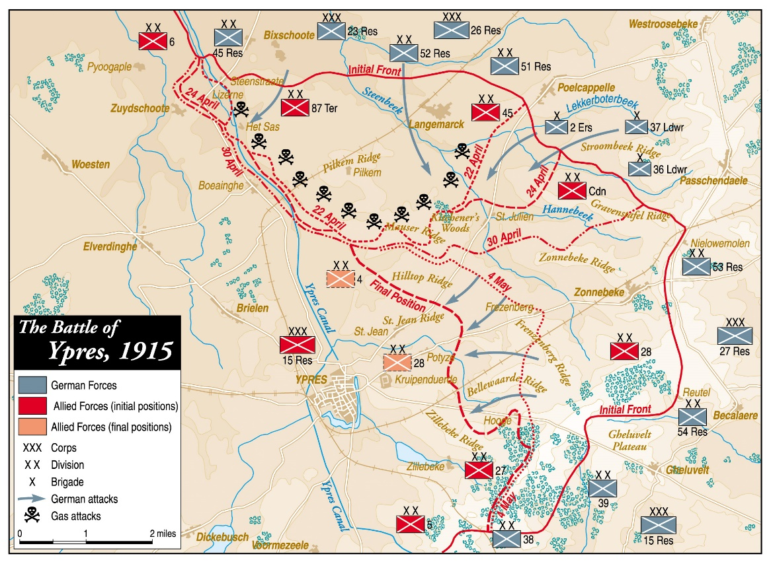
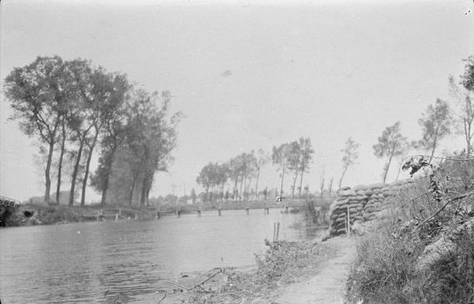

The Canal Bank, north of Ypres, held by the 4th Division after the first gas attack April 1915

The Somerset Light Infantry 1914-19 by Everard Wyrall

The 1st Somersets encountered nothing but the rigours of trench warfare – always dangerous and full of discomfort – from the close of the Battles of Ypres (26th May) until the Battalion assisted the Rifle Brigade in a small attack which took place on 6th July; the Somerset men digging communication trenches to the trenches captured by the Rifles. After satisfactorily completing its task the Battalion went back to bivouacs in Elverdinghe Chateau grounds, having (though not known then) served its last tour in front-line trenches in the Ypres Salient. This operation, though of a minor character, cost the Battalion one officer and 27 NCOs and men killed; three officers and 102 NCOs and men wounded, and 5 NCOs and men missing.

The Western Front Association wrote: The official history of the Somersets written by Everard Wyrall describes the events of the 6th July 1915 as a small-scale attack. Whilst it is small in terms of ground seized it can clearly be seen as enormous in term of sheer human courage, endurance and belief.. The Somersets as a supporting arm to the Rifle Brigade were tested, and prevailed.

Operations on the Yser Canal
[Simon Hughes]
The 1st Battalion Somerset Light Infantry and an analysis of its part in the attack on International Trench 6th July 1915
On the 22nd April 1915 the Germans launched the second Battle of Ypres and in so doing employed the first large scale gas attack of the Great war. Fully exploiting the release of chlorine gas the Germans advanced westwards from the village of Langemarck towards the Yser canal French and British troops met the advance and were engaged with the Germans during the ensuing weeks.
Throughout the course of the Great War The 1st Battalion Somerset Light Infantry formed part of 4th Division 11th Brigade. During the first week of June the 4th Division was transferred to the Sixth Corps under the command of Lieut. General Sir John L Keir. At this time the battalion was made up of professional soldiers together with members of the 3~ special reserves and other replacements.
On the night of 7th ,8th 1915 the 4th Division commenced the relief of the French line which at the time covered the ground between Turco farm (inclusive) to a point on the Yser canal about 600 yards South of the Pont de Boesinghe.
In the afternoon of 8th June 1915 Sir John L Keir inspected the Somersets and made a short address to all officers. His remarks were chiefly directed at platoon commanders, for, as he explained in his opinion the war was a platoon commander's war. A platoon resolutely led could be the means of favourably turning the issue of a battle, while on the other hand irresolute action may bring disaster. This analysis, in the case of the Somersets, subsequently proved to be noticeably accurate. On the 10th June 1915 with these words of encouragement no doubt fresh in their minds, officers of the Battalion undertook reconnaissance of trenches held by the Royal Warwicks.
Their subsequent report was unfavourable. This frontage was on the extreme left of the British line and having only just being taken over from the French was considered by those inspecting to be very poor. Trenches originally built by the Germans and subsequently captured by the French were filthy and odorous. Many putrefying bodies of opposing combatants were laid about. The remains of one German soldier were buried under a parapet with his feet protruding out.
At approximately 8 pm on the 10th June the Somersets commenced the relief of the Royal Warwicks approaching the frontline from the West in two columns. Both columns utilised a swing bridge known locally as 6E across the Yser canal. During this phase of the operation several platoons were temporarily lost due to bad weather and a particularly dark night. It was not until 4am that one of the most difficult and trying reliefs for the battalion so far had been completed.
Facing the Somersets at this point in the line was a German defensive position, which included International Trench. This trench was the Western outpost of German positions known as Farm 14 and Fortin 17. Both these points derived their name from the hillocks on which they stood. Some 600 yards to the rear were second line defences including Zouave house and beyond those further defensive positions culminating in Pilckem village with its natural fortification. It was evident to those examining this position that an attack would be no easy prospect. The selection of International trench as a location for offensive British action was in a sense the choice of the French.. Shortly before the 4th British Division took over the line in that locality, Colonel Dechiselle of the Zouaves planned an operation for the capture of Fortin 17, which was with his trench stores was duly handed over. This plan was to prove the basis for subsequent localised action in this sector.
The Somersets held the frontline opposite International trench until the 15th June when they were relieved by the 1st Battalion Rifle Brigade. During this initial period the Somerset men were subjected to offensive German action in the form of shelling trench mortar attack and sniping. Great efforts were made to improve the defensive qualities of the British trenches with emphasis on parapets and sapheads. Offensive action was taken with rifle and hand grenades and the use of battalion snipers who achieved great success. CSM Thornton of A Company was reported as shooting a German sniper at a range of some 650 yards.
On the 16th June 1915 the Somersets marched back via Elverdinghe to Oosthoek where they billeted in a barn to start refitting and preparing for the line.
On June 17th Second Army Command wrote to 6 Corps in the following terms; "In order to improve the tactical situation on your Left and at the same time to distract the enemy's attention from the vicinity of Hooge, the Army Commander desires that you will consider the feasibility of seizing the small hill (14) and the Farm house ( Farm 14 ) in C.7.a and c on the East bank of the Canal."
6 Corps mindful of the plans earlier prepared by Colonel Dechiselle (which stated that Fortin 17 would have to be captured and consolidated before Farm 14 could be dealt with,) forwarded them to 4th Division ordering an attack on ground now held by the 11th Brigade. Intricate planning for the attack now commenced.
On the 20th June 1915 the 1st Battalion Somerset Light infantry relieved the Rifle Brigade in the frontline opposite International Trench. The Somersets were once again subjected to offensive German action in the form of trench mortars and snipers continued to pose a constant threat. 2/ Lieut. Barnes was shot in the head though not seriously and survived. This position was held until the 26th when the Battalion was relieved in the evening by the Rifle Brigade. The Somersets withdrew to positions at Elverdinghe Chateau and surrounding farms where they again refitted for trench warfare.
Following an ongoing debate between the staff at 6 Corps Headquarters and 4th Division a decision was finally reached to attack and capture the German defences west of the Cinq Chemins Estaminet - Boesinghe road. General Prowse the 11th Brigade Commander selected the 1st Battalion Rifle Brigade to make the attack supported by the 1st Battalion Somerset Light Infantry for the purposes of consolidation. The stage was now set and the date for the assault on the German positions agreed for the 6th July 1915.
On the 30th June 1915 the Somersets again relieved the Rifle Brigade in the frontline trenches. Information provided by the Rifle Brigade that the Germans were attempting to mine from International trench towards the British line saw offensive action in the form of counter mining. The battalion dug a hole in a saphead some 15ft deep and exploded a charge of 201bs. Sniping maintained its constant threat with 2/ Lieut. Williams being killed with a shot to the head. On the 3rd July the Germans fired Gas shells at The Somersets position. Not withstanding the use of gas helmets several men were overcome. During the night a large party of 300 territorials were required to prepare steps in the parapet in readiness for the forthcoming assault.
During night of the 4th July 1915 the Battalion was relieved by the Rifle Brigade. This alternating relief was a familiar process throughout the war as both regiments proved to be permanent features of the 4th Division. No doubt rank and file soldiers of both regiments were familiar and enjoyed a friendly rivalry. A soldier of the Somersets reported in a letter home on the 2nd July 1915. "When we went to the trenches the other day to do another spell we found a piece of paper with the word notice on it. When we came to examine it more closely we found it to have been left by the Rifle Brigade and it bore the following lines;"
We are the boys of the Rifle Brigade,
Doing our bit with rifle and blade.
Holding the trenches at a well known spot,
We're not satisfied without little lot.
Marking our fame in the sands of time,
We are holding the Germs on the left of the line.
As you should know (for its commonly known),
That we belong to the Prince Consort's Own,
Some say we're sweeps because of our dress,
What do we care? We can abow all the rest,
Yes show them how and they know we've had bags
Just have a look at the old cap badge.
Not to be outdone, stretcher-bearers of the Somersets responded with typical West Country humour leaving a note for the incoming Rifle Brigade relief.
We are the boys of Old Somerset
We've stuck it ten months and we're sticking it yet.
Our founder Prince Albert, a King but in name,
But the good old swede bashers still add to their fame.
I hope you don't think we're chucking a hint,
But I think you'll admit we are hard as flint.
They call us the Sets but we don't care a fig,
As long as they find us some trenches to dig.
PA's on our cab badge and don't think we're barmy
When we say that the meaning is Pride of the Army.
At 4pm on the 5th July 1915, whilst the Rifle Brigade held the front line trenches General Prowse the commander of 11th Brigade addressed the Somersets within the grounds of Elverdinghe Chateau regarding the forthcoming assault on International Trench. At 10.15 pm fully briefed the Battalion moved up into advanced positions, in support of the Rifle Brigade on the East side of the Yser canal bank.
The plan of attack agreed at Divisional level was simple in concept. An overwhelming local bombardment followed by an Infantry assault on a frontage of the line some 300 yards in width. The frontline assault was to be conducted by the Rifle Brigade with elements of the Somerset Light Infantry in support. In order to increase the odds of success an 18-pound field gun of the 135th Battery Royal Field Artillery, commanded by Lieut. Robinson, had been moved up and emplaced in the British trenches some 60 yards from the German positions. The movement of this artillery piece was in itself a fine example of military planning and execution. The 18 pounder was taken over a high canal bank, rafted over the water under fire, pulled up a bank at an angle of 45 degrees, then over 3 trenches in full view of the enemy who were using flares and searchlights before being finally placed into a pre-prepared gun pit.
At 5am on the 6th July 1915 the attack on International trench commenced. Artillery fire from 4th Division Artillery, 2nd Group HAR and French 45th DA opened a barrage on the German trenches, batteries and supporting positions. This combined artillery firepower consisted of one battery of 9.2in Howitzers, two batteries of 4.5 in Howitzers, one battery of 4.7 guns, one battery of 60 pounder guns and six batteries of 18 pound field guns. The 18-pound field gun situated in the frontline British trench engaged the German saphead opposite over open sights. Fire from these guns was divided into periods of 10 minutes each. An interval of 3 minutes observation was planned between each bombardment period. The first shell to be fired by the 9.2 Howitzer was a direct hit on the German parapet and blew a large portion into the air destroying the sandbags used in construction. Registration of the British guns over previous days had proved its worth and was now being utilised to good effect. The continuous storm of fire successfully cut the knife rest wire in front of the German trench and the defensive strongpoint at International sap was destroyed. The noise from the Artillery was said to be indescribable. At 5.20 am the German artillery commenced a counter barrage causing damage to the British positions and many casualties amongst the waiting occupants.
At 6am the infantry assault began. B and C companies of the 1st Battalion Rifle Brigade went over the top, crossed some 50 yards of no-mans-land and entered the German trenches with very little loss. The German positions were found to be smashed to pieces. German infantry was found hiding in dugouts and were engaged with bayonet and bomb. The Somerset Light Infantry now moved in support of the Rifle Brigade. C Company moved up to the Western support trench, B Company started digging communication trenches up to the captured line and H Company commenced the construction of a new fire trench behind a hedge to the Left of the captured position.
At approximately 11.30 am numbers 10 and 11 platoons of the Somersets relieved a contingent of the Rifle Brigade in the captured trench and were utilised putting it into a state of defence. The trench and dugouts were reported as being full of German dead and littered with letters and parcels. It was evident a mail supply had recently taken place. Prisoners of the 215th Regiment (Schleswig - Holstein) were taken during the day and sent back to the British lines. Despite the hedges and some natural cover, work on consolidation was both overlooked and disrupted by heavy German fire from the natural defences at Pilckem.
Sergeant Arthur Cook of the Somersets was involved with his platoon digging communication trenches in an exposed position. Continual encouragement was necessary to keep his men on the task. Whilst this part of the operation was underway Cook reports in his diary "Captain Marshall, our Company Commander, came along to inspect the work and asked where a certain platoon Sergeant was. I had to say I had not seen him. He took me with him and we found the Sergeant crouched in a dug out on the canal bank. The Captain took out his revolver and said-Come out before I shoot you and take charge of your platoon. He came out and we started back to the front line when, to my surprise, we ran into my platoon who had abandoned their task in my absence. I fixed my bayonet and drove them all back to their task-including the Sergeant. It is interesting to note that on the 13th July 1915 Sergeant Roman of the Somersets was subjected to a General Field Court Martial.
In an extraordinary twist to this story, we have discovered that the court-marshalled Sergeant was, in fact, Walter Roman from Bridgwater, whose story is also featured on this site. Walter was found guilty of drunkenness and reduced to the ranks. He later died of wounds received on July 1st 1916 on the Somme. Walter had been an international rugby player and had served In the SLI overseas before the war. Simon's opinion is that Walter simply cracked and was caught hiding - it would not have been good for morale to execute such a prominent and popular NCO within the battalion, so he was found guilty of drunkenness.
Resistance in the area continued throughout the day as consolidation of the captured positions continued. British troops on the ground engaged in bombing to the extent that supplies of Grenades became dangerously low necessitating re-supply from the French stores in the Sector.
At approximately 1pm the Germans opened a heavy bombardment of the captured positions. A strong counter attack started to develop from the location of Farm 14 but this was easily repulsed. By half past three the German shelling had become so severe that the old British line had to be evacuated. The captured trench received its share of the bombardment, under the cover of which the Germans made another attempt at a counter attack from the Left. Efforts were made to work along a communication trench towards the new British line. This attack was checked and assistance of defeated in part by the artillery and in part by 2/Lieut. C.A. Gould of the Somersets who with his platoon Sergeant and some of his men went to the three Rifle Brigade bombers engaging the advancing enemy allowing work to continue on deepening the captured trench. The earlier words of Sir John Keir had now proved their worth. Consolidation work continued resulting in the parapet of International trench being successfully reversed.
During the night of the 7th July the Somersets and the Rifle Brigade were relieved by The Lancashire Fusiliers and Royal Warwicks. The Somersets marched back to bivouacs within the grounds of Elverdinghe Chateau.
On the 20th July 1915 Sir John French the C-in-C of the British Army inspected the 11th Brigade. He congratulated them on their performance since arriving in France and made specific mention of the successful assault in which they had participated on the 6th July.
Analysis of this engagement shows the capture of 75 yards of ground over a frontage of some 300 yards. The human cost to the Somerset Light Infantry was 2/Lieut. Webber and 27 NCOs, 5 killed. 2/ Lieuts. Trend Stead and Edwards and 102 NCOs and other ranks wounded. 5 NCOs and other ranks missing.

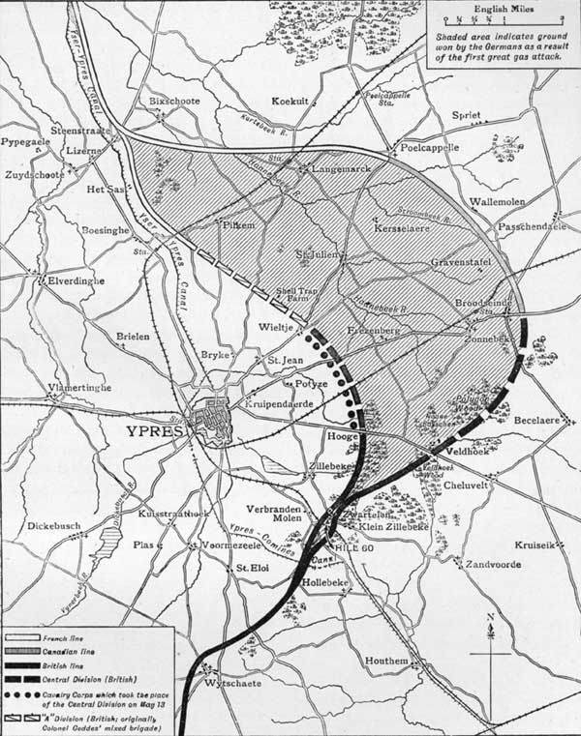
Area of operations July 1915 – SLI

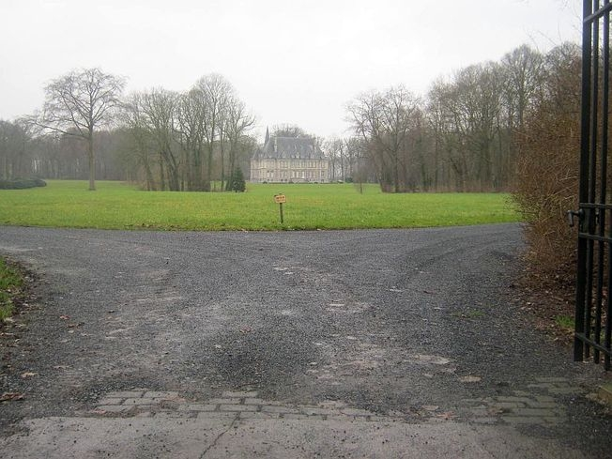
The Elverdinghe Chateau. The original Chateau was destroyed by shellfire but this newer building stands on the same spot.

Ernest was killed in action on 5th July 1915. It was reported in the Western Gazette on 16th July:

News has been received from the front of the deaths of Private E Trotman 1st Somersets who was killed in action, and Private J Hayward.

Ernest is remembered at Talana Farm Cemetery near the village of Boesinghe.

