Gilbert Trott’s Story

Gilbert had to bury his own brother after the battle

Cecily Beauchamp, whose son, John Beauchamp II owned the Manor of Stoke in the thirteenth century, compiled an inventory of Stoke. Several villagers are named, among them Hugh Trot. So Trot is a very ancient name in the village. While Gilbert’s Trott forebears may well have originated from Stoke, Gilbert’s father, Thomas Trott, was actually born in South Petherton. Thomas had a brother called Henry who I believe was the father of Percy and Frederick Trott, Gilbert’s cousins who also died in the 1st World War.

His mother, Angelina Hellier, was born in Stoke, and I have traced her family back through the census returns to her father, Thomas, living with his parents in Castle Street in 1841.

Both sides of the family were farm labourers and glovers, though by the time of the 1911 census, Thomas Trott had added “thatcher” to “farm labourer” as his occupation. The family were living in North Street and Gilbert was 17 years old with three sisters and three brothers, the eldest 26 and the youngest 8. His eldest brother, Bert, was no longer living with the family.

The school log book reports that A Trott was punished for smoking in the store room on 11th October 1895. Could this have been Gilbert’s elder brother, Arthur, aged 11 years?

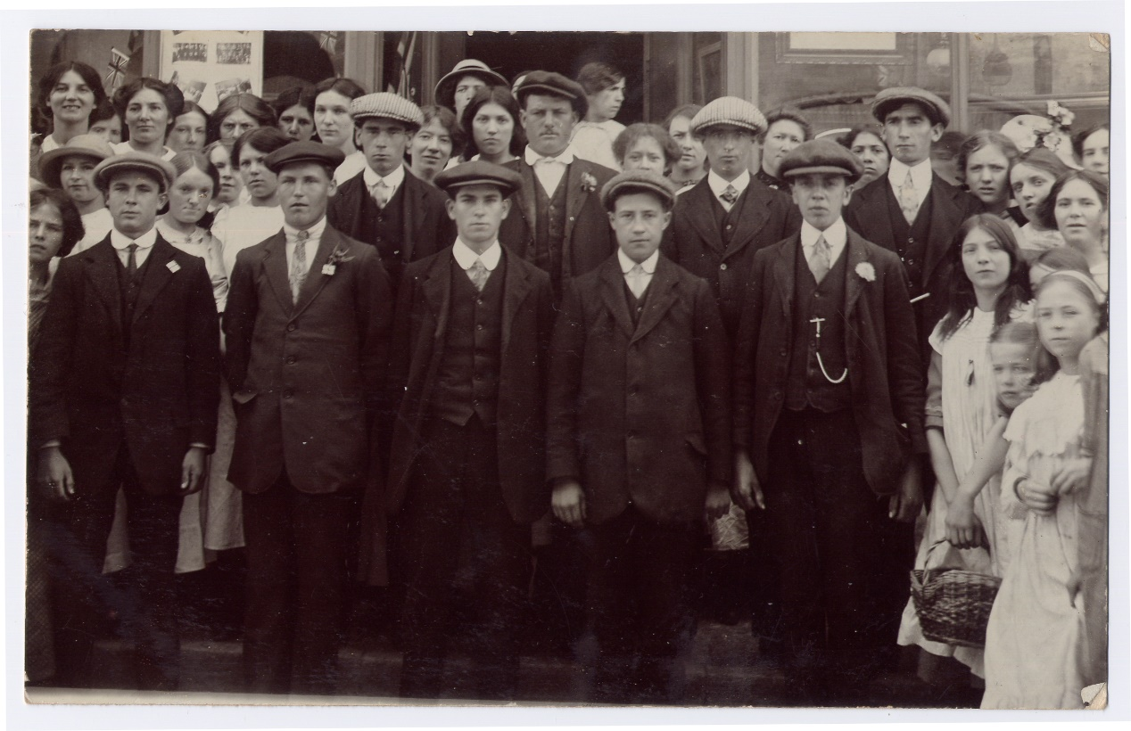
Stoke Volunteers
Frederick and Gilbert Trott are in this photograph. One is said to be extreme right, back row. The other is either the man standing next to him or on the extreme, left back row.
Gilbert and Fred were among the men who joined up when war broke out. They were both in the 1st Battalion of the Somerset Light Infantry. Gilbert’s service number was 15316. Gilbert’s was 15317. They must have been standing in the line together when they enlisted. Ten of the Stoke men who died were in the 1st Battalion.

Gilbert landed in France on 24th March 1915. Fred arrived a month later, on 21st April. Fred arrived in France on 21st April 1915. They were both just in time to take part in the fighting on Hill 60 as part of the 2nd Battle of Ypres where the Germans used gas as a weapon for the first time.

2nd Battle of Ypres - GAS

The 1st Battalion was with the 4th Division which took part in the 2nd Battle of Ypres.
On 22nd April 1915 a veil of greenish-yellow mist could be clearly seen rolling across from the German front lines, and there were repeated gas attacks during the fighting around Ypres on 8th May and until 13th May.

Lance Corporal Cook of the 1st Battalion Somerset Light Infantry, describes the experience in his diary:

“Early in the afternoon, I was gazing over the top of the trench when I saw a German walking along behind his trenches, and on his back was a large flat container. Suddenly I noticed he was leaving a trail of smoke behind him, which later turned into a dense green mass, and commenced to roll along the ground gradually towards us. The wind was no more than a breeze which pushed this cloud gently along in our direction. With horror I realised that this must be the gas we had heard so much about, I hurriedly went around and warned all the men of what was happening. Only a few of us had been issued with some sort of protection and this consisted of a flat piece of cotton wool about 3 ins square with tapes attached, the pad being kept in position by placing it over the mouth and securing it with the tapes at the back of the neck. I ordered those in possession to put them on at once, and those without to scoop a hole in the ground, which would immediately fill with water, soak their handkerchiefs in it and ram them in their mouth. This being done, I got everybody to line the trench, and when the enemy appeared, to open up rapid fire. It was not long before they emerged from their trenches keeping at a safe distance from the gas cloud in front of them….

Of all the many weapons used in modern war undoubtedly the use of poison gas is the most terrible. We who saw this queer looking bank of mist sweeping across “No Man’s Land” were puzzled at first and did not know what to make of it.”

Gilbert’s brother, Fred, was killed by a shell on 1st May. Albert Bowden and Albert Minchinton, both remembered on the Stoke War Memorial, were in the 1st Dorsetshires, on Hill 60. Albert Minchinton died on 2nd May, the day after Fred.

The Western Gazette describes on 15th October 1915 how Fred died and how his brother found his body and buried him:

15 Oct 1915 – Private G Minchinton who was wounded in the fight on Hill 60 is home on leave. He has now recovered from his wounds and gives a graphic account of the fighting in the trenches, when his comrade Private F Trott of this place was killed. Private Trott was struck by a shell in the chest and killed instantly, and his brother, who was in the second line, was ordered up to fill the gaps, and found his brother dead. After the fighting, he was one of the men told off to bury the dead, among whom was his own brother.

The Western Gazette reported on 16th July 1915:

News has been received from the Front of the deaths of Private E Trotman
lst Somersets who was killed in action, and Private J Hayward. Privates G. Trott and
F Talboys (also of the Somersets) have been wounded.

We don’t know whether Gilbert was wounded during 2nd Battle of Ypres which lasted from 22nd April to 13th May, or in the trenches afterwards. “By the middle of May 1915, the Ypres Salient had acquired that evil reputation which clung to it throughout the war. By day and by night shells shrieked and howled through the air, bombing attacks went on, snipers were at work and trench-mortar bombs hurtled across No Man’s Land, bursting with terrific force and churning up the already sore troubled earth, or blowing parapets, traverses and dug-outs to bits.” [Everard Wyrall]

In July 1915, the 1st Battalion moved down to the Somme area and were billeted at Mesnil, a quiet village two or three miles north of Albert. Probably Gilbert was wounded before the move south.

As the weather became finer, there were increasing demands upon the Battalion for working parties, and the words ‘fatigues as before’ continually appear in the diaries. So hard were the men worked that on 8th June the Battalion Diary records: ‘ Usual fatigues. The men are evidently feeling the strain of these all-night fatigues as the sick parades are becoming very large’”. It was at this time that George Denman of Stoke, also in 1st Battalion, was admitted to hospital suffering from trench fever. It was the build up to the Battle of Albert - the start of the Somme battles.

Gilbert would have been with his Battalion on 1st July, along with Hugh Grinter and Archie Thorne who died on that day. George Denman would have been there, alongside Joseph Gummer and Walter Gomm.

Battles of the Somme July to November 1916 http://www.historylearningsite.co.uk/somme.htm

“War is madness,” Pope Francis said on June 2. “It is the suicide of humanity.” This unusually strong language best applies to The Battle of the Somme started in July 1st 1916. It lasted until November 1916. For many people, the Battle of the Somme was the battle that symbolised the horrors of warfare in World War One; this one battle had a marked effect on overall casualty figures and seemed to epitomise the futility of trench warfare.
For many years those who led the British campaign have received a lot of criticism for the way the Battle of the Somme was fought – especially Douglas Haig. This criticism was based on the appalling casualty figures suffered by the British and the French. By the end of the battle, the British Army had suffered 420,000 casualties including nearly 60,000 on the first day alone. The French lost 200,000 men and the Germans nearly 500,000.
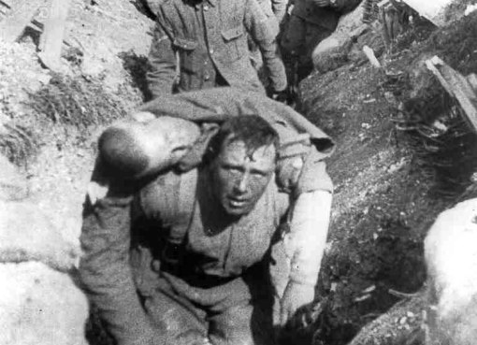

The battle at the Somme started with a weeklong artillery bombardment of the German lines. 1,738,000 shells were fired at the Germans. The logic behind this was so that the artillery guns would destroy the German trenches and barbed wire placed in front of the trenches. The use of artillery was heavily supported by Field Marshall Haig:
The enemy’s position to be attacked was of a very considerable character, situated on high, undulating tract of ground. (They had) deep trenches….bomb proof shelters……wire entanglements forty yards broad often as thick as a man’s finger. Defences of this nature could only be attacked with the prospect of success after careful artillery preparation

In fact, the Germans had deep dugouts for their men and all they had to do when the bombardment started was to move these men into the relative safety of the deep dugouts. When the bombardment stopped, the Germans would have known that this would have been the signal for an infantry advance. They moved from the safety of their dugouts and manned their machine guns to face the British and French.

Battle of Albert – 1st to 13th July

The 1st Battalion of the Somerset Light Infantry (as part of the 4th Division) had orders to attach the German Quadrilateral north of the Ancre and of Beaumont Hamel. At

10 p.m. on the night of 30th June, they marched out of Mailly Maillet to take up positions in the assembly trenches. The Battalion was with the Hampshires and 6th Warwickshires, in close support to the front line which comprised the East Lancs Regiment, Rifle Brigade and 8th Warwickshires.

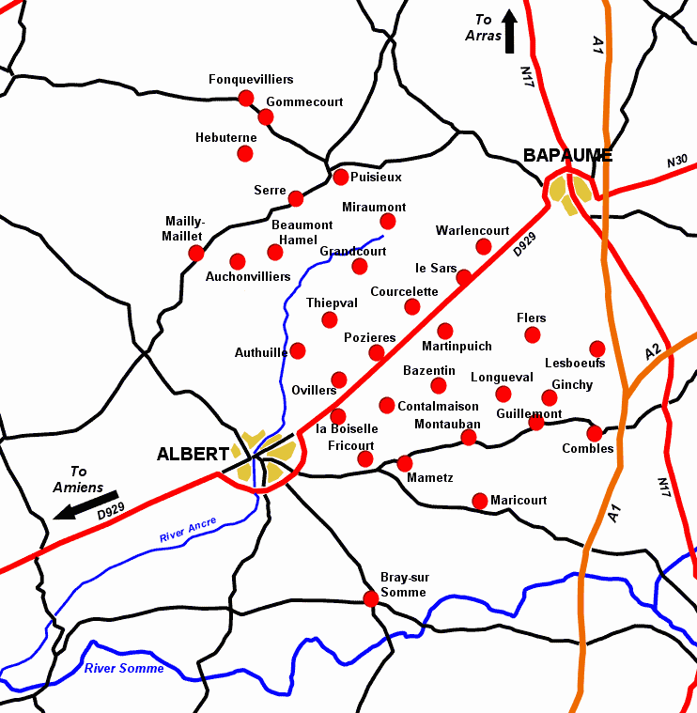
On the night of 30th June, Gilbert’s Battalion marched from Mailly-Mallet

At 7.20 a.m. on 1st July “there was a roar as a huge mine under Hawthorne Redoubt, south of Beaumont Hamel, exploded” [[Somerset Light Infantry - Battles of the Somme] –

said to have been the largest mine exploded in the War, it was 80 feet below the surface and contained over 20 tons of explosive.

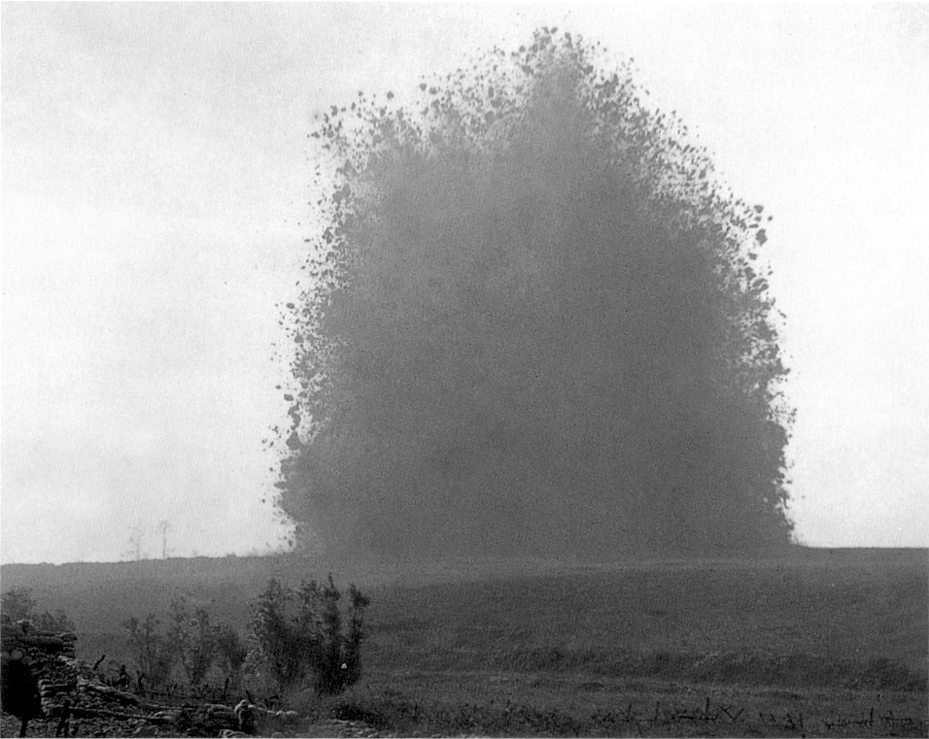

Hawthorne Ridge Mine Explosion 1st July 1916

Ten minutes later, the advance began. An officer of the 1st Battalion said, “The sight was magnificent – line after line of men advancing at a slow trot towards the German lines with hundreds of shells (ours for the most part) bursting behind the German lines”.

Unfortunately, the Somerset men were unable to cross the ridge they were aiming for because it was being swept by machine gun fire, and they found themselves over to the left in the German trenches. “From this point onwards, all is confusion.” There was desperate fighting in the German first and second lines throughout the day. Some of the German front line trenches which had been captured were still occupied by German defenders who hid in their deep dugouts until the British troops had passed on towards the second line. They then came out of their dugouts and, using machine guns and rifles, shot down the advancing British troops from behind.

On the first day of the Somme battles, the casualties amongst the officers were very high and “all up and down the line, platoons, companies and even battalions (as with the SLI) were temporarily commanded by NCO’s”.

About 4.30 p.m. Major Majendie arrived with reinforcement officers and took command of the battalion which had been collected together in the assembly trenches, and after dark they were relieved by the Royal Irish Fusiliers and withdrew to the old British line.

There had been 26 officer casualties and 438 other ranks were killed, wounded or missing.

Extracts from the diary of Lance Corporal A C Cook, 1st Bn Somerset Light Infantry:

June 28th. [The Battalion is in billets in Mailly-Maillet] We were told that owing to incessant rain and the shocking state of the trenches the great attack would not take place till July 1st. We hoped Jerry would not hear of our change of plans, but I expect he did.

June 29th. Bombardment continues all through the night and day. The attack starts at 7.30 a.m. tomorrow. All private correspondence, cap badges, numerals and spare kit has to be left behind…..the men are in excellent spirits and full of hope for the morrow, it was going to be a welcome change from lying in a trench and taking everything without the opportunity of hitting back…

July 1st. It was a lovely morning and the birds were singing. Breakfast 5.30 a.m., each man was issued with patent cookers for this occasion. The bombardment by this time was terrific, and the enemy lines are one cloud of smoke from the bursting shells, it seemed impossible for anybody to live in such a hell, but to our eyes it was a wonderful and inspiring sight. We actually stood on our parapets to get a better view of the scene, and cheered all the direct hits. Not a soul could be seen, and the enemy guns were strangely quiet. We all thought this was going to be a cake walk….

At 7.20 a.m. a huge mine exploded under Hawthorn Redoubt on our right front, the force of the explosion rocked our trenches. Punctually at 7.30 a.m. the attack was launched. It was an amazing sight, for as far as the eye could see to the right and left, lines of men were advancing across No Man’s Land in perfect skirmishing order as laid down in the drill book; everything was going smoothly and not an angry shot had barred their progress. But just before the forward troops reached the German trenches, the enemy opened up a murderous fire with machine guns…..With a prayer on my lips we went over the top, and had not gone far when the enemy guns opened fire, and we were caught in the middle of No Man’s Land. Men started to fall like nine pins, but we had to push on as the whole frontage was covered by these strategically placed guns…[on losing both my platoon officer and sergeant] I was left in charge of the platoon.. I led the platoon into the German front line.. then on to their second line where I lost control of the men as they rushed from one shell hole to another, and became mixed up with all kinds of units…

The ground everywhere was covered with dead and wounded…our guns had made an unholy mess of the German trenches, but very few dead could be seen, only our own men, for it appears they had been safely stowed away in deep dug-outs during the bombardment..

The Battle of Albert continued until 13th July. Gilbert was killed in action on 27th July. The Battalion had moved from the Somme back to the Ypres area.

According to the war diary, the Battalion were resting in billets at Beauval in the Somme area [north of Amiens] on 22nd/23rd July after a “very hot and trying march” the day before. At 9.00 p.m. the Battalion marched to Doullens [about five miles north] and entrained there for Escquelbecq [just south of Dunkirk] arriving at 6.45 a.m. After detraining the Battalion marched into billets at Wormhout. On 24th July, the Battalion rested and cleaned up. Companies were billeted in scattered farms. Billets comfortable and clean. The Battalion left Wormhout about 8.00 a.m. the following morning. It detrained at Poperinghe about 10.15 a.m. and marched two and a half miles to P. Camp which was taken over from 2nd Irish Guards.

During the afternoon of 26th July, the C.O. and Company Commanders reconnoitred Canal Bank. At night, the Battalion relieved the 1st Welsh Guards in support on Canal Bank in left sub sector of left sector, being in touch with the French on their left.

On the morning of 27th July (the day Gilbert died) the C.O. and Company Commanders reconnoitred front line trenches. At night the Battalion relieved the Scots Guards in the front line trenches. No mention of any casualties but the following day, 28th July, “sniping rather bad, especially in the left Coy”. Gilbert could have been killed by a shell or a sniper. The medal roll reports him as “killed in action” rather than of wounds so I assume that he was actually killed on 27th July.

There was a report in the Western Gazette:

4 August 1916 Gallant Brothers: In the recent severe fighting in France, another of our gallant lads, Private Gilbert Trott, youngest son of Mr Thomas Trott, has been killed. The sad news was received on Wednesday. This is the second son whom Mr & Mrs Trott have lost in the war, and another of their sons, Sydney, has recently arrived at a hospital in Southampton, suffering from wounds.

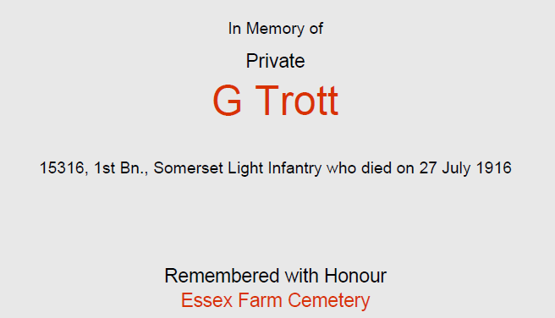

Historical Information
The land south of Essex Farm was used as a dressing station cemetery from April 1915 to August 1917. The burials were made without definite plan and some of the divisions which occupied this sector may be traced in almost every part of the cemetery, but the 49th (West Riding) Division buried their dead of 1915 in Plot I, and the 38th (Welsh) Division used Plot III in the autumn of 1916.
There are 1,200 servicemen of the First World War buried or commemorated in this cemetery. 103 of the burials are unidentified but special memorials commemorate 19 casualties known or believed to be buried among them.
The cemetery was designed by Sir Reginald Blomfield.
It was in Essex Farm Cemetery that Lieutenant-Colonel John McCrae of the Canadian Army Medical Corps wrote the poem ' In Fl

anders Fields' in May 1915.

In Flanders Fields
by John McCrae, May 1915
In Flanders fields the poppies blow
Between the crosses, row on row,
That mark our place; and in the sky
The larks, still bravely singing, fly
Scarce heard amid the guns below.
We are the Dead. Short days ago
We lived, felt dawn, saw sunset glow,
Loved and were loved, and now we lie
In Flanders fields.
Take up our quarrel with the foe:
To you from failing hands we throw
The torch; be yours to hold it high.
If ye break faith with us who die
We shall not sleep, though poppies grow
In Flanders fields.

