Archie Thorne’ Story

Archibald Stephen Thorne was born in the autumn of 1894, the eldest child of Stephen and Annie Thorne.

The Thornes were Castle Street people. Stephen lived there all his life. His parents, Job and Susan, lived there with their eight children in the 1860’s and 70’s until Job’s early death at the age of 27, and Susan continued to live there as a widow until at least 1901. She died in 1909.

Job Thorne (Archie’s grandfather) died in early 1897, leaving poor Susan to care for eight children with ages ranging from 16 to 2 years old, with another baby on the way. The school log book indicates that she was having difficulties. There is an entry for 28th March 1878:

Mrs Thorne visited the school and desired me to punish her son Arthur for fighting other boys out of school hours. I promised to investigate the matter.

Arthur would have been about fourteen at the time. There is a sad entry three years later:

3rd February 1882. Several cases of severe illness among the children.
Francis Thorne died on Saturday morning and another child the next day.

Francis was five years younger than Archie’s father, Stephen, and would have been about five years old.

On a happier note:

16th June 1899. Punished A Dalwood and A Thorne for fighting.

The Dalwoods and Thornes were related. Possibly this was a friendly tussle between Archie and a cousin. He would only have been about five.

In 1910, Archie was one of the handbells ringers in the church. When the Reverend G G Monck arrived in the village in 1908, the bells at St Mary’s Church had been silent since 1877. He bought some handbells so that the ringers would be ready when the bells were restored, and in 1910 Archie Thorne was one of the handbell ringers who gave a performance with Robert Taylor, Oliver Gale and Hensleigh Male, under the leadership of Mr T Gale. Archie was also one of Reverend Monck’s scout troop.

Archie’s father, Stephen, was a plasterer and tiler, and on the 1911 census, Archie described himself as a plasterer and tiler too. He was 16.

He enlisted in Yeovil – probably one of those Stoke volunteers who joined up at the start of the War in September 1914, because he arrived in France on 4th January 1915. Other Stoke men in the 1st Battalion of the Somerset Light Infantry were George Denman, Walter Gomm, Hugh Grinter, Joseph Gummer, John Hayward, Ernest Trotman, Gilbert and Frederick Trott, but Archie was the first to set foot in France.

1st Battalion had been taking part in the Attack on the Birdcage on 19th December 1914, near Ploegsteert Wood, eight miles south of Ypres, where there had been heavy casualties.

There is a report in the Western Gazette on 12th February 1915:

Stoke Men at the Front – During the week gifts of tobacco and chocolate have been sent from the War Relief Fund of Mr F H Walters’ employees to the following men of Stoke serving with the BEF on the continent: Messrs E George, A Thorne, Whitlock, A Jones, W Keetch, P Dodge, E Stagg, S Whitley, T Gaylard and A Dodge.

Archie mentions E Stagg in his letter home on 31st March 1915: “I spoke to Ted Stagg last night. That’s the first time I’ve seen him to speak to. He is looking well.”

In the early part of the year, a new sister had arrived in Stoke – Ella. “I think our Baby must be something like me. I wonder if you could have her photo done so I can see who she is like?” He says he has had a letter from “Hary” who was hoping to get home for a weekend – “how nice, I am glad to know that he can come home even if I can’t”. I wonder if this was Harry Turner who was in the 6th Battalion of the Somerset Light Infantry. He talks of Stoke being “all afire with so many troops about” and wonders if they have dug any trenches on Ham Hill. I presume this is a reference to Stoke soldiers coming home on leave as there is no record of troops being billeted in the village. The family has asked him whether he would like them to send out some cocoa and sugar and he says he doesn’t like to ask for too much but he would be very pleased to get it only wrap it carefully because “parcels have a very rough passage coming across.”

2nd Battle of Ypres - GAS

The 1st Battalion was with the 4th Division which took part in the 2nd Battle of Ypres. Archie was there at the fighting where the Germans first used gas as a weapon. On 22nd April 1915 a veil of greenish-yellow mist could be clearly seen rolling across from the German front lines, and there were repeated gas attacks during the fighting around Ypres on 8th May and until 13th May.

Lance Corporal Cook of the 1st Battalion Somerset Light Infantry, describes the experience in his diary:

“Early in the afternoon, I was gazing over the top of the trench when I saw a German walking along behind his trenches, and on his back was a large flat container. Suddenly I noticed he was leaving a trail of smoke behind him, which later turned into a dense green mass, and commenced to roll along the ground gradually towards us. The wind was no more than a breeze which pushed this cloud gently along in our direction. With horror I realised that this must be the gas we had heard so much about, I hurriedly went around and warned all the men of what was happening. Only a few of us had been issued with some sort of protection and this consisted of a flat piece of cotton wool about 3 ins square with tapes attached, the pad being kept in position by placing it over the mouth and securing it with the tapes at the back of the neck. I ordered those in possession to put them on at once, and those without to scoop a hole in the ground, which would immediately fill with water, soak their handkerchiefs in it and ram them in their mouth. This being done, I got everybody to line the trench, and when the enemy appeared, to open up rapid fire. It was not long before they emerged from their trenches keeping at a safe distance from the gas cloud in front of them….

Of all the many weapons used in modern war undoubtedly the use of poison gas is the most terrible. We who saw this queer looking bank of mist sweeping across “No Man’s Land” were puzzled at first and did not know what to make of it.”

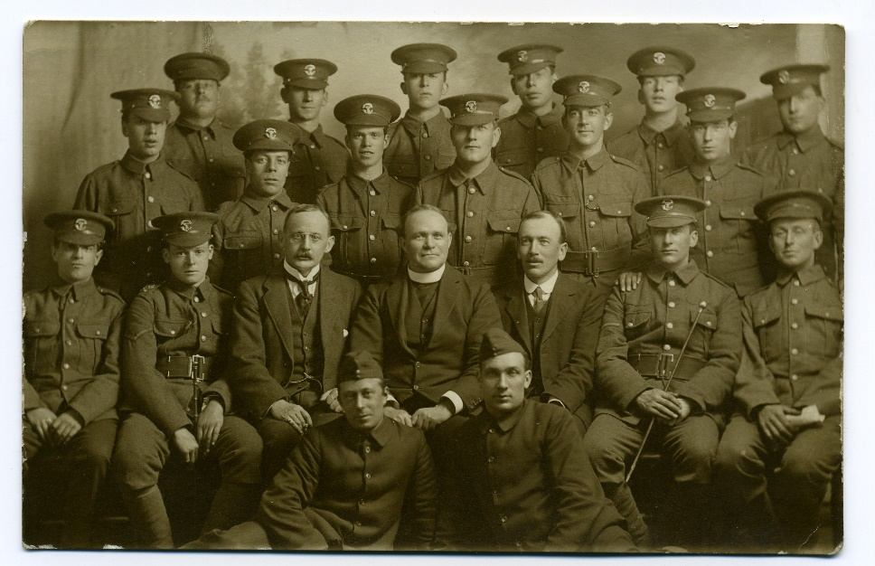
The Reverend Skilton with some of the Stoke Lads [
The Reverend Skilton of the Stoke Congregationalist Church left Stoke sub Hamdon for the Front in May 1915. He told his congregation that he hoped to get in touch with the Stoke men and render them any assistance in his power. He carried out his promise, and there are several reports of the Reverend Skilton having visited in hospital men whom he had known in the village. This is a letter he wrote to Archie’s parents on 29th May 1915 after Archie had had a “whiff of gas”:

Dear Mr & Mrs Thorne

You will be delighted to hear that I met Archie today. He had a whiff of gas last Monday – nothing very much – but he was sent to No 10 Casualty Clearing Station to rest.

This station has some tents in a field opposite this place and Archie recovered and was sent there. Fortunately he saw me pass today and asked an orderly to tell me. I was delighted to see him. He is quite well with the exception of a little weakness.

It was strange to meet him so far away from England and so near the fighting line. We had a good talk about the other boys.

Archie is full of courage and in spite of what he has seen is still ready to do his duty. I have given him my address, and asked him to write me. He may be sent away any hour but whether to his regiment or to the Base I am not sure.

But you can take my word for it that he is all right.

With very kind regards

Yours sincerely

Edward Skilton CF
P.S. I will let you know when he leaves here.
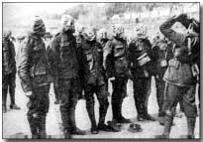
This is Archie’s account of their meeting in a letter to his parents dated 30th May 1915. In an attempt to prevent them worrying about him, he makes no mention of having been gassed.
To my Dear Mother, Father, Sisters and Brothers,
Just a line to let you know how I am getting on. Pleased to say I’m fairly well considering (now don’t worry) I have been in hospital about a week now and am getting on A1 Buff. I should have wrote before only you know when anyone’s rough they don’t feel up to writing, do they? I was what you call run down but I’m a lot better now. I can’t put my address, as I don’t know how long I shall be stopping here. I will drop a line again tomorrow. I saw the Rev Skilton last night – wasn’t he pleased to see me. He was so nice. He brought me some oranges, fags and matches, and is coming across again this afternoon, I think. I hope Dear Mother you are all well. I can’t write a lot now. I will try and write again tomorrow. So long for now (don’t worry). Best love to you all.
Your Loving Son and Brother,
Arch xxxxxx
From what he writes and from what the Reverend Skilton writes, you get a picture of a boy suffering not only from gas poisoning, but from the shock of what he has experienced. It must have been a life saver for Archie to see someone from home.
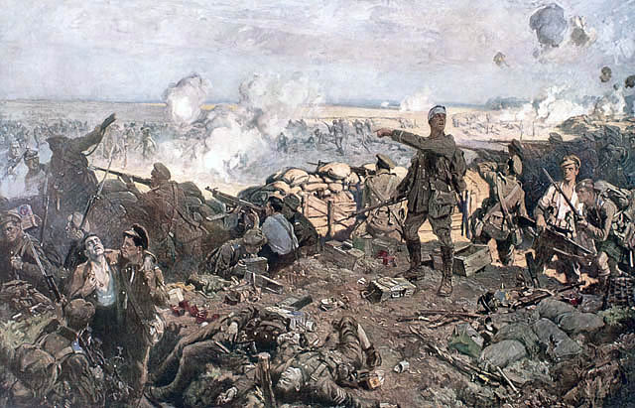
The Second Battle of Ypres by Richard Jack
Archie wrote to his father on 16th June to try to allay his mother’s very natural anxiety on learning that he had been gassed…
Dear Dad
I wish Mother would not worry about me so much. She ought not to because if I was home she wouldn’t like to hear her boy being called a coward or a slacker, would she? No, I am sure she wouldn’t. You tell Mother that I don’t worry. Of course I should like to see you all and I believe that by asking God to help me and putting my whole trust in Him that He will bring me back safely to you all one day. It’s no good worrying, is it Dad? It’s like you to say, I would rather be out here doing a bit than be home looking on. If everybody was to do the looking on, where would England have been today, far worse than Belgium, and I may say no pen or picture can describe the sight of seeing women and children and old men leaving their homes. It is the most pitiful sight that anyone could see. I have seen it and more than once and I have thought to myself what would they do if they got to Stoke, and then I have stopped thinking and looked again at those poor people, somebody’s mother, or father, somebody’s sister, or brother, somebody’s sweetheart. Go, it makes one’s blood boil to see it…
One is tempted to think that what he writes about asking God to help him and putting his whole trust in Him was prompted by what the Reverend Skilton said to him during his visit but the Thornes had clearly brought their children up to think of God and the church as being central in their lives. In his earlier letters he drew emblems with “Faith, Hope and Charity” written on them. He talks in his letters of his mother going to church twice a day and jokes about how good she is.
Archie would have seen the destruction of Ypres by the Germans. Perhaps this is what he is thinking about when he writes about women and children and old men having to leave their homes.
“It was my first close view of Ypres. Though I have done all the real fighting I could get at in my time, I believe I am a kindly-natured man, yet that sight made me madder than anything I have seen or suffered in my life and gave me a real feeling of bloodthirstiness….I think nothing of the man who after passing through Ypres could lay down his rifle before avenging it.”
[Sergeant W F Low, 10th Bn Durham LI –Voices and Images of the Great War by Lyn MacDonald]
I once spoke to Archie’s nephew who told me how very important Archie was to his family and how he was always remembered. One gets that impression from these letters. He was his mother’s first born. The thought of his father “looking on” from Stoke, knowing his son was in danger and wanting desperately to get out to the Front himself, is heartbreaking.
Archie’s sisters

By 1st January 1916, the 1st Battalion had moved from Ypres to a quiet sector on the Somme. There was still an opportunity, however, for Archie to gain promotion through an act of bravery.

His old scoutmaster, the Reverend Monck, was obviously delighted to hear that a brave action by Archie in January 1916 had brought recognition from HQ. He writes in the Parish Magazine in March 1916:

Scout Report – We are proud to receive the following from somewhere in France –
HQ 4th Div 26.1.16 11th Brig. With reference to the report on the injuries received by Pte Crookford, I am directed by the GOC to express his approval of the action of No 15559 Cpl A S Thorne in his promptitude in throwing out the lighted grenade from the trench.”

“O.C. 1 B Somerset L.I. I forward the attached message from the GOC 4th Div which please communicate to Cple Throne together with my appreciation of his prompt and gallant action”
- and can only say “Thank God” for a brave scout.

The Western Gazette also printed a piece about it –

3 March 1916 – Brave Soldier’s Promotion – Corporal Archie Thorne, 6th [sic] Somersets, has been raised to the rank of Sergeant. Recently Sergeant Thorne acted with conspicuous bravery in throwing a live bomb from the trenches and thus saving the lives of his comrades.

On 31st May 1916, Archie wrote a long, chatty letter to his family. The weather is warm and lovely, he says. He writes that he has heard Percy Trott has died of wounds. Percy was in the 6th Battalion. It was he who had to bury his brother, Fred, after the fighting on Hill 60 during the 2nd Battle of Ypres the previous year.

Archie writes about a lady from Southampton who has been writing to him and sending him parcels – “you know the lady I told you about at Southampton – she still sends me a parcel every now and then – well, I generally get one from her about every fortnight and the last one she sent she asked me on her letter if I had a snapshot of myself I would send her. I think it is very kind of her don’t you? She sends me very nice letters and parcels too, quite lucky ay? She must be nice to keep on sending to me, mustn’t she?”

The photograph on the right is of “Archie’s sweetheart” but her name is not known. Perhaps she sent this photograph of herself out to Archie in France. Perhaps he sent her a copy of the photograph on the left. It must have been very sad for these girls who “adopted” soldiers to write to, when letters suddenly ceased and the girls realised that the men whom they would have thought of as friends but had no legitimate reason to grieve for, must have died.

As the weather became finer, there were increasing demands upon the Battalion for working parties, and the words ‘fatigues as before’ continually appear in the diaries. So hard were the men worked that on 8th June the Battalion Diary records: ‘ Usual fatigues. The men are evidently feeling the strain of these all-night fatigues as the sick parades are becoming very large’”. It was at this time that George Denman of Stoke, also in 1st Battalion, was admitted to hospital suffering from trench fever. It was the build up to the Battle of Albert - the start of the Somme battles.

BATTLE OF ALBERT – 1st to 14th July

Ten men from Stoke were in 1st Battalion of the Somerset Light Infantry and four of them died on the Somme in 1916. Two more died who were in the 8th Battalion, two in the 7th and one in the 6th. Hugh Grinter and Archie Thorne (both 1st Battalion) were the only ones to die on the same day – the first day of the Somme – 1st July 1916.

The 1st Somersets moved to Mailly Maillet on the afternoon of 22nd and two days later the preliminary bombardment of the enemy’s trenches, from the Somme northwards along the whole position to be attacked, opened. A huge number of guns had been brought into action for this puprpose and the noise was deafening…. Day after day the bombardment continued with a relentless fury, while at over forty places along the front line gas was discharged over the German lines.

[History of the SLI 1914-18 by Everard Wyrall]

The 1st Battalion of the Somerset Light Infantry (as part of the 4th Division) had orders to attach the German Quadrilateral north of the Ancre and of Beaumont Hamel. At

10 p.m. on the night of 30th June, they marched out of Mailly Maillet to take up positions in the assembly trenches. The Battalion was with the Hampshires and 6th Warwickshires, in close support to the front line which comprised the East Lancs Regiment, Rifle Brigade and 8th Warwickshires.

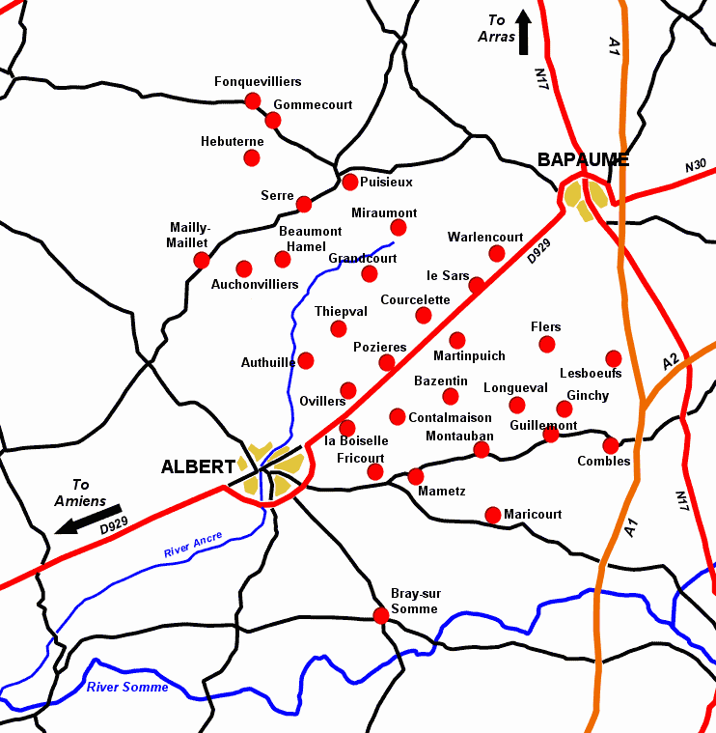
On the night of 30th June, Archie’s Battalion marched from Mailly-Mallet
Serre

At 7.20 a.m. on 1st July there was a roar as a huge mine under Hawthorne Redoubt, south of Beaumont Hamel, exploded.

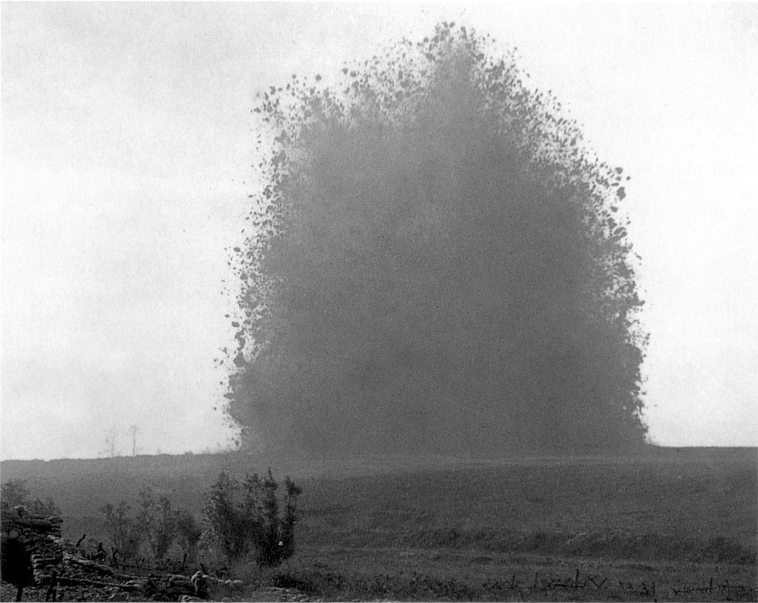

Hawthorne Ridge Mine Explosion 1st July 1916

Ten minutes later, the advance began. An officer of the 1st Battalion said, “The sight was magnificent – line after line of men advancing at a slow trot towards the German lines with hundreds of shells (ours for the most part) bursting behind the German lines”.

Unfortunately, the Somerset men were unable to cross the ridge they were aiming for because it was being swept by machine gun fire, and they found themselves over to the left in the German trenches. “From this point onwards, all is confusion.” There was desperate fighting in the German first and second lines throughout the day. Some of the German front line trenches which had been captured were still occupied by German defenders who hid in their deep dugouts until the British troops had passed on towards the second line. They then came out of their dugouts and, using machine guns and rifles, shot down the advancing British troops from behind.

On the first day of the Somme battles, the casualties amongst the officers were very high and “all up and down the line, platoons, companies and even battalions (as with the SLI) were temporarily commanded by NCO’s”.

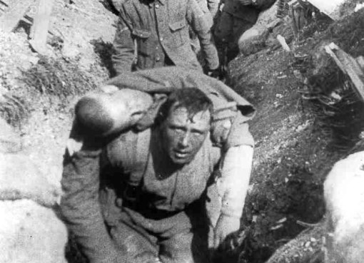

About 4.30 p.m. Major Majendie arrived with reinforcement officers and took command of the battalion which had been collected together in the assembly trenches, and after dark they were relieved by the Royal Irish Fusiliers and withdrew to the old British line.

There had been 26 officer casualties and 438 other ranks were killed, wounded or missing.

[taken from The Somerset Light Infantry 1914-18 by Everard Wyrall]

Extracts from the diary of Lance Corporal A C Cook, 1st Bn Somerset Light Infantry:

“June 28th. [The Battalion is in billets in Mailly-Maillet] We were told that owing to incessant rain and the shocking state of the trenches the great attack would not take place till July 1st. We hoped Jerry would not hear of our change of plans, but I expect he did.

June 29th. Bombardment continues all through the night and day. The attack starts at 7.30 a.m. tomorrow. All private correspondence, cap badges, numerals and spare kit has to be left behind…..the men are in excellent spirits and full of hope for the morrow, it was going to be a welcome change from lying in a trench and taking everything without the opportunity of hitting back…

July 1st. It was a lovely morning and the birds were singing. Breakfast 5.30 a.m., each man was issued with patent cookers for this occasion. The bombardment by this time was terrific, and the enemy lines are one cloud of smoke from the bursting shells, it seemed impossible for anybody to live in such a hell, but to our eyes it was a wonderful and inspiring sight. We actually stood on our parapets to get a better view of the scene, and cheered all the direct hits. Not a soul could be seen, and the enemy guns were strangely quiet. We all thought this was going to be a cake walk….

At 7.20 a.m. a huge mine exploded under Hawthorn Redoubt on our right front, the force of the explosion rocked our trenches. Punctually at 7.30 a.m. the attack was launched. It was an amazing sight, for as far as the eye could see to the right and left, lines of men were advancing across No Man’s Land in perfect skirmishing order as laid down in the drill book; everything was going smoothly and not an angry shot had barred their progress. But just before the forward troops reached the German trenches, the enemy opened up a murderous fire with machine guns…..With a prayer on my lips we went over the top, and had not gone far when the enemy guns opened fire, and we were caught in the middle of No Man’s Land. Men started to fall like nine pins, but we had to push on as the whole frontage was covered by these strategically placed guns…[on losing both my platoon officer and sergeant] I was left in charge of the platoon.. I led the platoon into the German front line.. then on to their second line where I lost control of the men as they rushed from one shell hole to another, and became mixed up with all kinds of units…

The ground everywhere was covered with dead and wounded…our guns had made an unholy mess of the German trenches, but very few dead could be seen, only our own men, for it appears they had been safely stowed away in deep dug-outs during the bombardment..”

Just under a month later, a Stoke man, Edward Gillman, with the 7th Battalion Somerset Light Infantry marched into Mailly Maillet and moved into the trenches front of Auchonvillers. These trenches and the surrounding country were full of half-buried corpses. Many of these were the men from 1st Battalion who had fought in the attack on Serre on 1st July – “these were reverently laid to rest by their newly arrived comrades.” [The Somerset Light Infantry 1914-19 – Everard Wyrall] Archie Thorne and Hugh Grinter from Stoke had been among those who had died on 1st July 1916.

On 14th June 1916, a letter was sent to the Thornes in response to a letter they had obviously sent to the Somerset Light Infantry Record Office at Exeter:

I beg to acknowledge the receipt of your communication of 12th inst relative to No. 15559 L/Sgt A S Thorne 1st Somerset LI and in reply to inform you that no report has yet been received regarding him. Immediately any information is at any time received you shall be at once notified.

The Western Gazette reported on 21st July 1916:
Official intimation has now been received by the parents of Sergeant Archie Thorne of Stoke under Ham, that he was killed in action in France on July 1st - the first day of the advance. He was one of the first to volunteer, and by good conduct and attention to duty soon won his stripes. Much regret is expressed by all who knew him.

The Chaplain who attended the 1st Somerset Light Infantry sent Stephen a letter:

Dear Sir
In reply to your enquiry concerning 15559 Sgt Thorne, A.., I am afraid I have little to add to what you already know. He is officially reported killed in action on July 1st, at which time [difficult to read] he was seen to fall; his grave, in all probability, is in the cemetery known as the Sucrerie Cemetery, which is placed immediately behind the lines we then held. The Sucrerie (a sometime sugar factory) is a little beyond the village of Mailly-Maillet; and the cemetery is within [difficult to read] hundred yards of it. I am afraid these are the only details of place[?}I can give you at present.

I may add that all graves are well cared for and each one has a cross with the name of the fallen officer or man upon it. If it were possible, I would go myself to make certain whether Sgt Throne is buried in that cemetery or not; but I am afraid it is impossible.

If at any time I should come to hear of further details, I will let you know.

I am

Yours faithfully

J P Halet C.F.

In fact, Archie has no known grave but is remembered on the Thiepval Memorial.

There is also a tablet on the wall of St Mary’s Church in Stoke where he rang the handbells:

In loving memory of Archibald Stephen Thome, Sergeant SLI,
who fell in action in
France July lst 1916.
And how can man die better
Than facing fearful odds Macaulay
Erected by his father and mother, Stephen and Annie Thome.

Archie’s Sisters

