George Denman’s Story

“…this man showed great devotion to duty. The remainder of his Lewis gun team became casualties, but he still worked his gun. He went into the open to collect magazines and spare parts, so that he could keep his gun in action.”

George Denman was born into an enterprising family who was not afraid to leave the safety and familiarity of home and travel in search of work when the necessity arose. Perhaps his courageous behaviour in October 1917 which won him the Military Medal, was due to this spirit of intrepidity.

George’s father, John Denman, and his great uncle, John Gillard, were both stone masons, born in Stoke. In 1881, John Denman was 19 and living with his uncle in Peckham. John Gillard’s son, another John (aged 15) had been born in Canterbury. It would be interesting to know what building projects they were involved in, in Canterbury and London.

George’s mother was from a gloving family. Her parents were born in Wootton, near Woodstock in Oxfordshire. Some time between 1871 and 1881, Jane’s parents – Edwin and Sarah Boswell – moved to Stoke under Ham with their family in search of work. The oldest boy, Thomas, had left the family home by the time of the 1881 census, but Jane was then 17, living with Edwin and Sarah in Lower (Castle) Street, together with her two younger brothers, George aged 15 and James aged 12. There was also a little boy of two, Francis, who was Edwin’s grandson, born in London. The family had been called “Buswell” when they lived in Wootton.

In 1889, John Denman married Jane Boswell, and two years later they were living in the High Street with their little one year old son, Arthur.

By 1901, they were living in Highway and George had appeared. The family now consisted of John and Jane Denman, Arthur, Emily, George and Kate.

George was 19 years old when war broke out in 1914. He is mentioned on the Southcombe’s Roll of Honour so presumably he followed his mother’s side of the family into the gloving industry, rather than working as a stone mason like his father. He enlisted in the 1st Battalion of the Somerset Light Infantry as a private. The 1st Battalion fought on the Western Front for the whole period of the war.

Richard Kemp, Researcher to the Rifles (Taunton office) writes that George embarked for France and Flanders on 25th November 1915 and joined the battalion on the 28th November. On 8th June 1916 he was admitted to 17 Casualty Clearing Station and then to 14 General Hospital suffering from trench fever.

The first time he is mentioned in the Western Gazette is on 18th August 1916 – his mother – living in Castle Street - had received information that her son, Private George Denman, was seriously ill in hospital suffering from trench fever. Everard Wyrall writes of this period, “the early days of 1916 were uneventful as far as the 1st Somersets were concerned. But as the weather became finer it was possible to note the increasing demands upon the Battalion for working parties, and the words ‘fatigues as before’ are continually appearing in the diaries. So hard were the men worked that on 8th June the Battalion Diary records: ‘ Usual fatigues. The men are evidently feeling the strain of these all-night fatigues as the sick parades are becoming very large’”. This was the build up to the first Battle of the Somme starting on 1st July 1916. If George had not been taken ill, he might have fared the same as his fellow Stoke soldiers in the 1st Battalion, Hugh Grinter, John Hayward and Gilbert Trott, who all died that summer.

George rejoined the battalion on 15th September 1916. It was by now up north in the Ypres area. They were soon to move south again. On 18th October, the battalion was involved in a series of attacks against the Le Transloy Ridges.

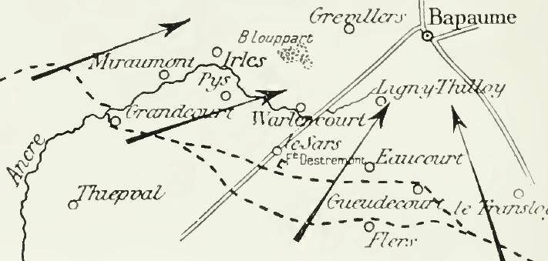

The weather was awful during this fighting. The trenches were narrow and shallow
and the troops were knee deep in filthy mud. There was heavy shelling but the Battalion had more casualties from trench foot and exhaustion than from enemy action.
Le Transloy

At the end of October, the Battalion moved to Mansell Camp, Carnoy for a rest.
The Diary reads: “All ranks who had had no sleep for 8 nights enjoyed the luxury of tents”.

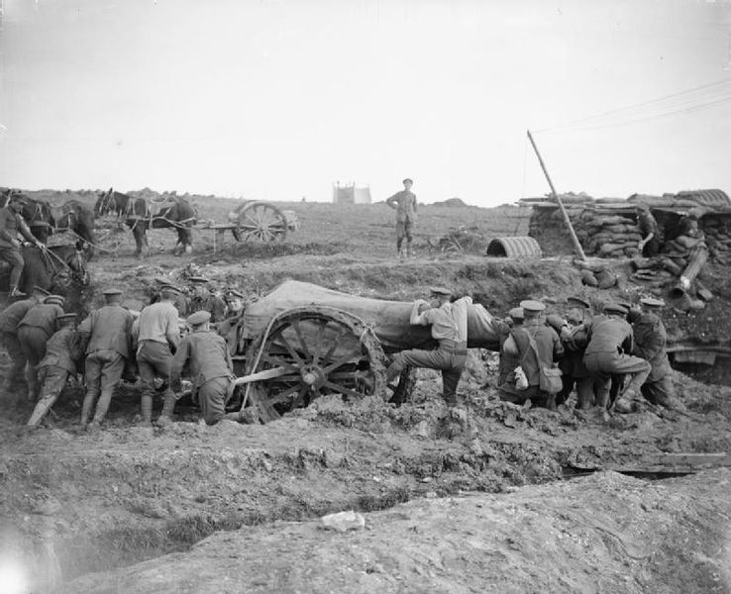
Battle of Le Transloy – October 1916 – Swinging a 60 pounder Mk I gun round.
[Wikipaedia]

In January 1917, George was in hospital having accidentally scalded his foot. The record states “accidental” to show that it was not considered to be a self-inflicted wound. One could not have blamed George if it had been self-inflicted. The Diary for 12th December reads, “Rain, snow, howling wind and bitterly cold…. The conditions beggar description: the trenches are flooded and have all fallen in: there is no cover either in front, support or reserve lines, and men are being evacuated sick with frost-bite and exhaustion by the hundred. Today four men were dug out of the mud who had been unable to move for three days.”

On 1st August 1917, George had gastro-enteritis, but rejoined his battalion on 20th. The Congregationalist Church Magazine mentions that he is home on leave in August 1917.

He was appointed Lance Corporal on 21st October 1917, and Acting Corporal on 9th December.

On 9th November 1917, the Western Gazette reported that George’s parents had heard that George had been awarded the Military Medal for conspicuous gallantry in the face of the enemy. On the 14th December, a fuller account was printed in the paper: “In the attack on 4th October 1917 near……, this man showed great devotion to duty. The remainder of his Lewis gun team became casualties, but he still worked his gun. He went into the open to collect magazines and spare parts, so that he could keep his gun in action.”

Richard Kemp confirms that George’s MM was awarded for action in Langemarck on 4th October. There is a footnote in the war diary to say that notification was received by the battalion on 23rd October 1917 that six men of the battalion had been awarded the Military Medal for Gallantry. Private Denman was named as one.

Richard Kemp suggests that more than one of the six MM’s were awarded for knocking out pill boxes.

“The following is part of the Commanding Officer’s account and it seems reasonable to suppose that the action that he described would have resulted in at least one award for gallantry: The right of the battalion, together with men of the 11th Division, then advanced against the concrete house at V19a60.15, which was in the 11th Division’s area. One machine gun was firing from the top of the house and another from the side. A Lewis Gun was brought into action, and under cover of its fire our men worked round a flank and got in rear. Several Germans were killed here, and sixteen prisoners taken, together with two machine guns. It is not possible to link Private Denman’s MM to this action but it is certainly the sort of action that may have attracted the award of more than one of the six MMs which were awarded to men of the battalion on 4th October 1917.”

Four months later, on 14th April 1918, the Western Gazette printed a letter which Mr & Mrs Denman had received: “Your son was killed by a shell on 27th March 1918, and his death was instantaneous. He was a very brave and excellent corporal, well beloved by everyone in the battalion. His death is a great loss to the company.”

It was just before the 1st Battle of Arras.

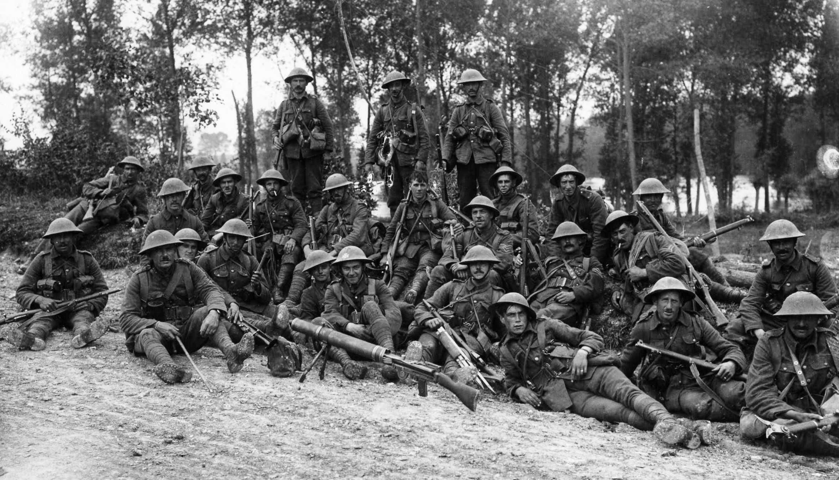
Soldiers at Battle of Arras - 1918

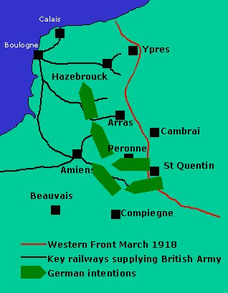
Western Front

March 1918

Corporal Denman is buried at plot 1V, Row B, Grave 10, in Roclincourt Valley Cemetery (Pas de Calais). There are ten other men of his battalion buried there and all were killed between 28th March and 2nd April 1918.

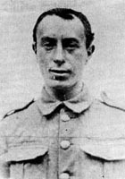
Isaac Rosenberg, the war poet, died in the same area as George on 1st April 1918.

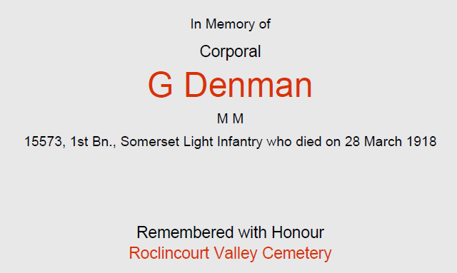

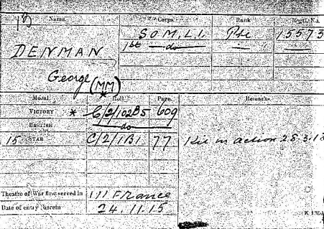
Medal Card

