Albert Ewart Whitley’s Story

Albert Whitley and the two cousins, Gilbert and James Shoemark, all died within days of each other in August 1915 in Gallipoli.

Albert’s father, William, was a glover from Woodstock. He came to Stoke for work in the gloving industry and married a Stoke girl, Rosina Webber Thorne, in 1883. The Thornes were an old Stoke family. Rosina’s grandfather, John Thorne, was living in the High Street in 1841. In 1885 Albert and Rosina’s son, Arthur William, was born, followed by Seymour two years later, Albert Ewart in 1889, then four girls, Laura, Ethel, Lilian and Violet.

When Albert (or Ewart as he was called later) was eleven, he was living with his parents and six brothers and sisters in West Street.

Albert’s elder brother moved to Cardiff to work on the railway. Albert, perhaps encouraged by this, also went to Wales in search of work and in 1911 he was boarding with James and Roseina Thorne at No 11 Aber Fawr Terrace, Abertridwr, along with Tom George aged 19. They were all from Stoke. James and Roseina had three young children. Albert calls himself ‘Ewart’. He and Tom are both coal miner hewers. Tom George would become a submariner in the war and James Thorne would die at Ypres in April 1915.

We don’t know when Albert enlisted but we know he was with the 1st Battalion Royal Munster Fusiliers who arrived at Suvla Bay, Gallipoli on 20th August 1915.

War diaries are not always very descriptive of actions but the officer who wrote the War Diary for the Royal Munster Fusiliers gives a good picture of the assault on Hill 112 and Scimitar Hill where Albert was killed on 21st August.

20th August 1915

4.00 a.m. Arrived V Beach, Suvla Bay on SS “Asmanieh”.
9.00 a.m. Commenced disembarking. Shelled a bit coming ashore – no damage.
7.30 p.m. Battalion marched off to Chocolate Hill
11.00 p.m. Arrived Chocolate Hill

21st August 1915

4.00 a.m. Battalion led to hollow in open between two hills. 14 casualties from rifle bullets on the way up.
8.00 a.m. Received our orders for the attack. Objective: Hill 112.
3.00 p.m. 1st Royal Munsters took part in second phase of attack. First two companies went forward.
3.40 p.m. Whole countryside in flames from shells setting fire to gorse.
3.50 p.m. Received message from ‘Y’ company to say that all officers had been either killed or wounded and the majority of men. Whole attack disorganised and split up by fires which were spreading in every direction, burning many of our wounded alive.
4.20 p.m. Lancs Fusiliers ordered to reinforce survivors of the Battalion and take them on to Hill 112.
5.00 p.m. Lancs Fusiliers unable to advance owing to heavy machine gun fire. Message received from Captain Wilson that he had a few survivors with him but that the men were all split up into little groups, taking cover where they could from the fire and burning gorse.
5.15 p.m. After repeated messages to Brigade stating that 11th Division which was supposed to be supporting us on the right, had not appeared, were informed that they were doing magnificently and had stated that they were in possession of Hill 112.
6.05 p.m. Some units of the 11th Division suddenly appeared over the crest line of Chocolate Hill behind us and had to be told not to open fire on our backs.
6.30 p.m. Message received from?our C.O. that he and 20 men had succeeded in getting back to our firing line and were in the trenches held by the Dublin Fusiliers.
6.50 p.m. Message received from Captain Murray that he had about 40 men with him in a trench 50 yards in front of firing line. They were ordered back to our HQs by the Brigade.
8.00 p.m. Survivors of the Battalion, numbers 140, formed up in hollow behind Hill 53. Battalion strength before action 717. Throughout the night men continued to come in and by the morning there were nearly 300. Nine officers were casualties.

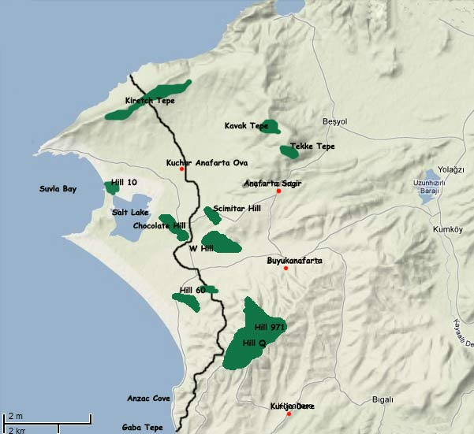

I hope that Albert was one of the men killed on that first rush, rather than one of the poor wounded men who were burned.

His body was not recovered and he is remembered, like Gilbert Shoemark (who died on Kiretch Tepe on 16th August, five days earlier) on the Helles Memorial.

