Fred Hellier’s Story

Air Mechanic 2nd Class
22580
7th Balloon Section, Royal Flying Corps
who died on
Sunday 16th September 1917. Age 28.

Son of Mr & Mrs Thomas Hellier, of Castle Street, Stoke under Ham, Somerset

Fred was born in 1886 into a large, lively family. His father, Thomas, worked as a stonemason on the Hill, and his youngest sister, Hilda (born when his mother, Sarah, was 52) “sent by God to look after me in my old age”) used to trot up with his breakfast every day before school; whereupon the other masons used to say to Tom, “here’s your little maid”. Tom, who was one of the stonemasons who worked on Bath Abbey, was described as “a loving man”.

Out of all Tom’s children, it was felt that Fred would be the one to get on in life. His niece, Lily, remembered the feeling of pride his family had in him, and there was the sense that the Helliers were not only saddened, but diminished by his death in 1917.

The Helliers lived in the High Street, and then Castle Street, and Fred went to Castle School where he may or not have been the F. Hellier punished on 28th September 1900 for climbing the school wall. Fred’s brother, Tom, was a member of the Congregationalist Church, and Fred was a witness to his sister, Emily’s marriage there in March 1913.

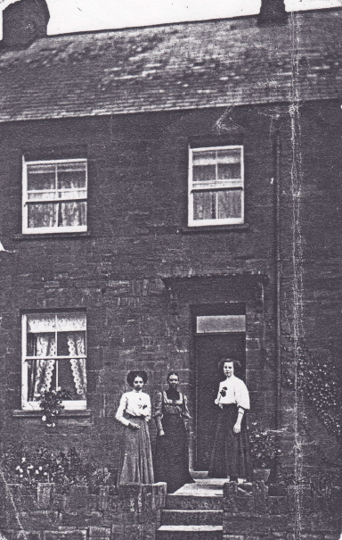
The Hellier family home in Castle Street

All the Helliers appear to have been good singers and performers. Fred’s brothers and sisters used to enjoy dressing up and putting on plays at home. Fred and his sister, Emily, took part in two plays at the Church School in 1913, with Emily playing the Baroness in Cinderella that Christmas. After the war, Fred’s elder brother, Edward, would visit his nephews and nieces and they would be spellbound by his stories. He used to turn cartwheels and somersaults in the street when he was in his 70’s.

Fred’s eldest brother, Arthur, went to live in Wales where he had a shop at Gilfach Goch. It is said that he would allow the miners to take goods on tick when their families were starving during the strikes. Fred moved from Stoke to 16 Scotch Row, Gilfach Goch, to live with Arthur and his young family in around 1913, and remained in Gilfach Goch until he enlisted in 1915. His niece, Lily, was about two at this time but could remember his living with them, and thought she could remember his going off to war. Fred worked at the power station. The Tonrefoil and Gilfach Goch Electric Light Company had been formed in 1903 and was still viewed with suspicion by the older inhabitants. It must have been interesting to be involved with such an innovative project, and the fact that Fred was employed as a Manager by the time he enlisted in 1915, says much for his determination and industry. It was a responsible post for a young man in his late twenties.

Fred Hellier at the Tonrefoil and Gilfach Goch Electric Light Company

It is not known whether Fred joined the RFC when he enlisted, or whether he transferred into it later on, but at the time of his death in September 1917, he was Air Mechanic 2nd Class in the 7th Balloon Section, Royal Flying Corps. Kite balloons
were used for spotting enemy positions and directing the line of fire. They were captive balloons, equipped with telephone and signalling apparatus and were usually situated only a short distance behind the front line.

Fred Hellier RFC

There is a photograph below of Fred in RFC uniform at the hospital at Norton-sub-Hamdon. It is not known when this was taken, whether he was one of the wounded or on leave and visiting. [Fred is sitting next to the nurse with the arrow on his chest]

The height requirement for the Kite Balloon Service was 5’9” – no problem for Fred, as the Helliers were in general a tall family. He may have done his training at the Balloon Training Centre at Roehampton, learning how to control the huge bulk of the balloon in the wind. Once in France, a ground crew would consist of about 50 men. Under the command of the Flight Sergeant, the crew had to control their balloon on or near the ground with 60 foot ropes, four or five men on each rope. The balloon sometimes had to be walked more than half a mile to the flying ground.

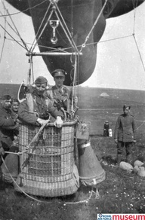
Fred was in the 7th Balloon Section. On 9th October 1916 G.O.C. Aden wrote to the C in C India saying that there was recently a kite balloon section in Egypt without work. Could it be sent to Aden so that it could overlook what the Turks were doing? On 12th October, there is a request for the balloon section which recently transferred from Egypt to Malta, to be sent to Aden. There seems to have been some confusion as to which balloon section was to be sent to Aden but in the end No 13 section was sent to Aden and No 7, which had been on the Doiran Front, was sent home.

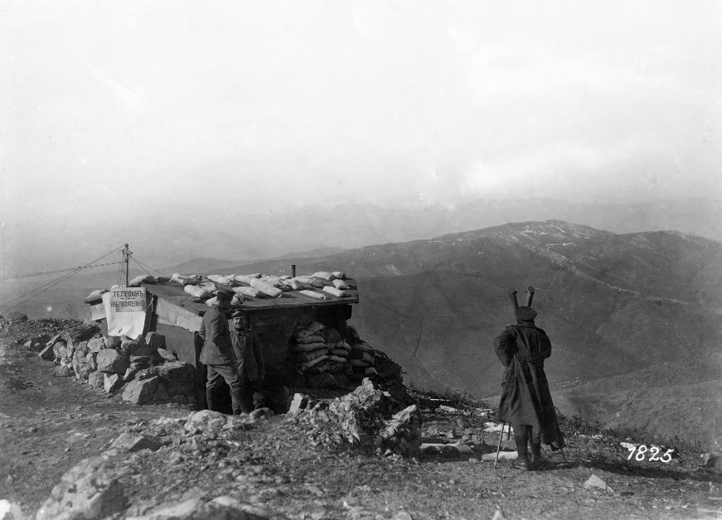

A Bulgarian telephone station with trench periscope observing the enemy's position at the Doiran front, March 1917 (German Official Photograph/National Archives)


Lake Doiran

This is a painting by William T Wood who was an acting corporal in 22 Balloon Company RFC in Macedonia.


[Salonika Campaign Society]

By the time of Fred’s death in September 1917, No 7 Kite Balloon Section was in the Ypres area.

Flights were generally made in the afternoon or evening when the light was behind the observers so it would probably have been around this time that Fred was hit by shrapnel in the stomach while getting out of a captive balloon.

A local news report for 21st September 1917 reads – “Air Mechanic Hellier Dies of Wounds – News was received last week that Air Mechanic Fred Hellier, RFC, had been seriously wounded. In a letter from his officer, it is stated that he was up on an observation balloon when he was fired on by the enemy.” “Other ranks” did carry out observer duties from the Balloons, nearly always with one of the observer officers from the section. German ground artillery often fired to try to puncture the balloon and it was probably in the course of this that Fred was hit and wounded.

Fred died of his wounds on 17th September 1917, and was buried at Zuydcoote.

In the autumn of 1917, while the XV Corps was holding the Nieuport
section, the 34th and 36th Casualty Clearing Stations were posted at
Zuydcoote. The Military Cemetery contains, for the most part,
the graves of officers and men who died in these hospitals.
[Commonwealth War Graves Commission]

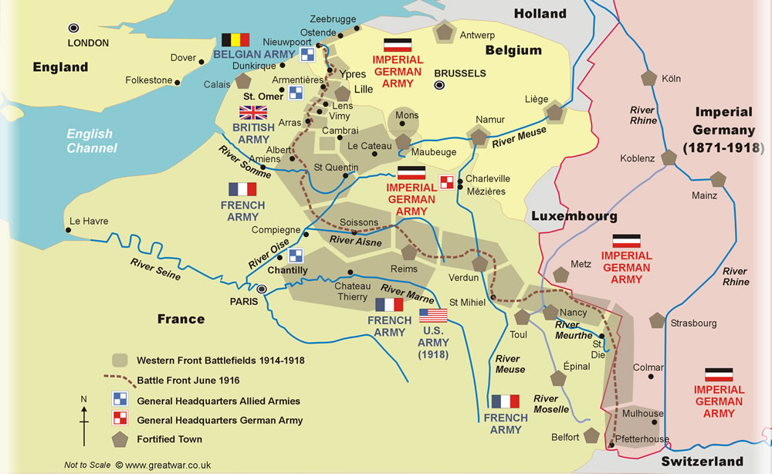

Map showing Nieuwpoort and Dunkirk – Zydcoote is just east of Dunkirk

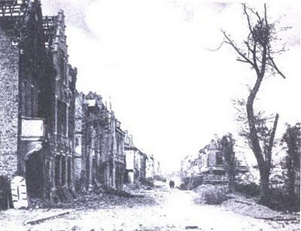
Nieuwpoort

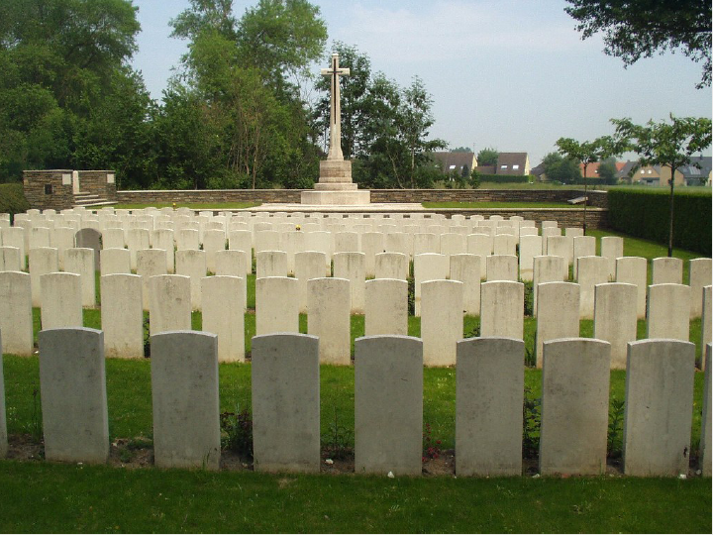

Fred is remembered in the Magazine of the Royal Aero Club of the United Kingdom Roll of Honour as “Died of Wounds”:

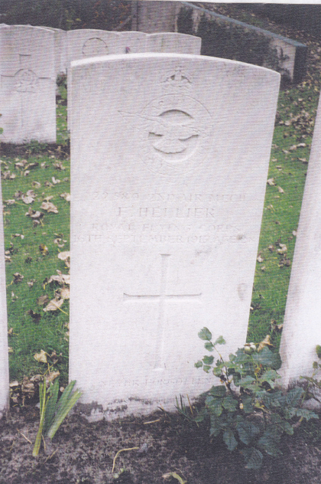

Zuydcoote Military Cemetery, near Dunkirk

Many thanks to Dawn Robson for her research on Fred Hellier

