John Hayward’s Story

John Frederick Hayward was really not a Stoke lad at all, but in marrying Emmie Dodge, he married Stoke sub Hamdon. Emmie’s mother was Sarah Jane Chant whose family had been in Stoke for generations. “Chant” was one of the five most common surnames on the 1841, 51, 61, 71, 81 and 91 census returns.

John’s father-in-law, Edward Dodge, had lived in Stoke for most of his married life and in 1911 was still living in the village (a coal merchant) with his wife and two unmarried daughters.

John was born in Chiselborough. On the 1911 census, when he was living in Wales, he puts his place of birth as Stoke under Ham but according to all the other census returns, he was born in Chiselborough and the family had moved to Middle Street,
Norton sub Hamdon by 1881. His father, Isaac, was a stone sawyer, born in Bridgehampton/Ilchester.

John was described as a Post Errand Boy of 12 years old in 1891. He was living at 20 Middle Street with his parents, two sisters and two brothers. His mother, Eliza, like his wife, had the surname “Dodge” but she was born in Chiselborough.

John’s whereabouts between 1891 and 1907 are a bit of a mystery as I cannot find him on the 1901 census, but in 1907 he married Emmie Dodge and by 1911 they had moved to No 6 Dowlais Street, Aberdare, South Wales. John was working as a Brakesman on the railway and Emmie was looking after their two year old daughter, Evelyn, who had been born not far away in Ferndale.

It was a time of industrial strikes in the mines in South Wales. In 1910 there was a strike in the Aberdare Valley at the Lower Duffryn Colliery over the fact that managers decided miners were no longer allowed to take home scrap wood for firewood.

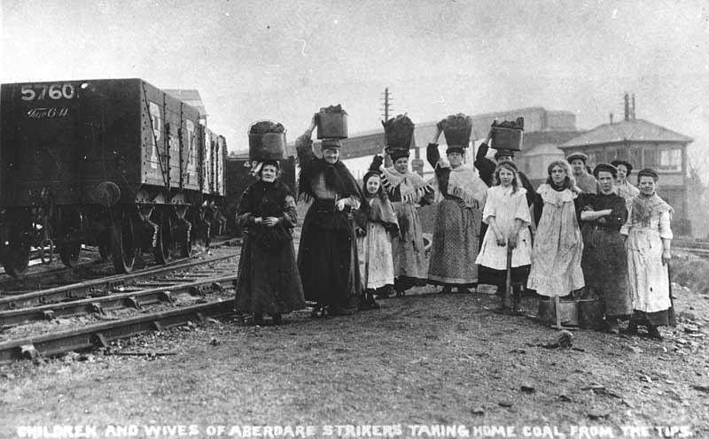

Aberdare Leader 12th November 1910
The Strike
Serious Riots at Aberaman
Sixty Persons Injured
Window Smashing at Aberaman
On Thursday night stones were freely thrown and several windows were smashed. A huge stone was flung through the window into the shop of Mr Gwilym Evans, grocer, Cardiff Road. Four valuable prize fowls were stolen from an out-house in Belmont Terrace.
Serious riots occurred on Tuesday evening. The strikers concentrated their attentions on the coal washeries, which are owned by the Powell Duffryn Colliery Co. It had not been anticipated that anything untoward in the district would happen in view of the fact that the dispute will shortly occupy the attention of the Coal Conciliation Board, and consequently the dispute came as a surprise, and very quickly the news spread throughout the district that an attack was being made on the washery.
Some 200 or 300 people assembled outside the Aberaman Institute, and marched in a body to the storm centre, which is situated between Cwmbach and Aberaman some mile and a half from Aberdare.
Many hundreds of women accompanied the strikers. When within a few hundred yards of the washery some 200 lads were dispatched as a sort of advance guard to the washery, but they were turned to rout by the police. There were about 30 policemen guarding the washery, but they did not anticipate any serious trouble, and at the time when the 200 youths came on the scene a portion of the police were at tea. They were, however, immediately summoned, and were soon confronted by 2,000 strikers, many of whom were armed with sticks and other weapons.
The policemen ranged themselves in front of the power-house and the other premises, but very quickly they were made the object of a most hostile demonstration, and stones and other missiles were hurled at them in a reckless manner, and with a total disregard to life and limb or property.
The strikers climbed over a fence, and, with what object they had in view can only be conjectured, set fire to some straw which was stored in a railway wagon.
This very quickly became a huge conflagration, but it was soon put, out although it smouldered for hours.
The police played a water hose on the strikers, but they had to abandon this method of dealing with the crowd, as it had very little effect upon them. Fusillades of stones were again hurled at the police and many were injured-Inspector Rees, Llandaff; Sergeant Griffiths, Barry Dock: and two other Constables being seriously hurt, more particularly the former, who suffered a severe gash in the face.
Seeing that the demonstrators were in an ugly mood, the police had to resort to more severe measures, and they were compelled to charge the crowd with drawn truncheons.
These methods proved successful, and the crowd dispersed in all directions, hundreds running along the railway line, and others down the canal bank.
Scenes of a remarkable nature were witnessed on the canal bank. In consequence of the stampede many were jostled into the canal, but they struggled back on to the bank. It is stated that about 60 strikers were more or less injured. One person had his hand seriously burnt by contact with a live electric wire, while another fractured his leg. The injuries of most of the others consisted of serious wounds on the heads.
A reporter mistaken for a 'blackleg' was struck on the head and elbow with stones and sticks.

Not far away, in Gilfach Goch, the elder brother of Fred Hellier of Stoke (7th Balloon Section Royal Flying Corps, died 16th September 1917) was letting the striking miners take goods on tick from his shop because their families were starving.

In early 1913, a son, Leslie, was born to John and Emmie.

Hugh Grinter (another Stoke man who died on the Somme in 1916) lived about eleven miles away at Gelli. He and his wife, Bessie, had a daughter, Hilda, who was the same age as John and Emmie’s Evelyn. Hugh Grinter and John Hayward enlisted at Yeovil into the 1st Battalion of the Somerset Light Infantry. I wonder if they visited each other’s homes and discussed whether or not they should join up after Kitchener’s Call to Arms in August 1914.

John Hayward was certainly one of the earliest to join up as he left for France on 2nd May 1915 and would probably have had six months’ training before that.

He would have arrived in France in time to take part in the 2nd Battle of Ypres which took place between the end of April and the end of May 1915. It was meant to divert Allied attention from the Eastern Front and to be a means of testing the use of chlorine gas.

John had not yet arrived in France when the first canisters of gas were released on 22nd April and a veil of greenish-yellow mist could be clearly seen rolling across from the German front lines, but there were repeated gas attacks during the fighting around Ypres on 8th May and until 13th May.

.
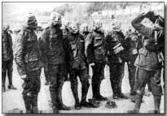

The Allied lines still held on, though German forces secured additional high ground to the east of the town from 8-12 May. On 24th May, a heavy German assault forced a further Allied withdrawal, although little extra ground was ceded. By the end of May a want of supplies and manpower obliged the Germans to call off the offensive. They conceded failure and gave up their attempts to capture the town of Ypres, choosing instead to demolish it through constant bombardment. I expect John would have seen the “desolation of Ypres.”
“It was my first close view of Ypres. Though I have done all the real fighting I could get at in my time, I believe I am a kindly-natured man, yet that sight made me madder than anything I have seen or suffered in my life and gave me a real feeling of bloodthirstiness….I think nothing of the man who after passing through Ypres could lay down his rifle before avenging it.”
[Sergeant W F Low, 10th Bn Durham LI –Voices and Images of the Great War by Lyn MacDonald]
Losses during the 2nd Battle of Ypres are estimated at 69,000 Allied troops against 35,000 German, the difference in numbers explained by the use of chlorine gas. Although the Allies condemned the use of gas as barbaric, they quickly developed their own form of gas warfare and released gas canisters at Loos at the end of September 1915.

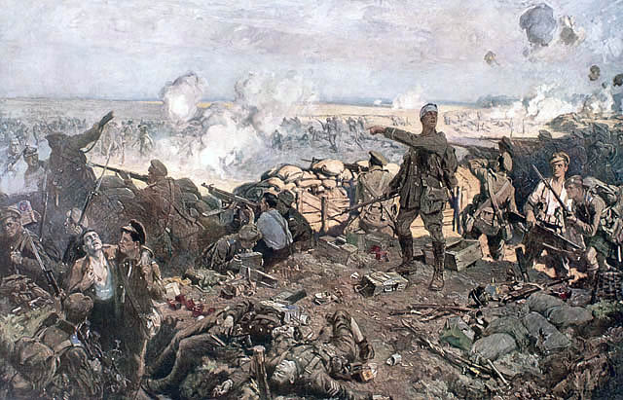

The Second Battle of Ypres by Richard Jack

John Hayward died of wounds on 10th July 1915, at Etaples. He could have been wounded during the Battles of Ypres in May, or in a “small attack” made on 6th July, or simply while he was in the trenches.

According to Everard Wyrall in The Somerset Light Infantry 1914-18:

“The 1st Somersets encountered nothing but the rigours of trench warfare – always dangerous and full of discomfort – from the close of the Battles of Ypres (26th May) until the Battalion assisted the Rifle Brigade in a small attack which took place on 6th July; the Somerset men digging communication trenches to the trenches captured by the Rifles. After satisfactorily completing its task, the Battalion went back to bivouacs in Elverdinghe Chateau grounds…. This operation, though of a minor character, cost the Battalion one officer and 27 N.C.O.’s and men killed, three officers and 102 N.C.O.’s and men wounded, and 5 N.C.O.’s and men missing.

Perhaps John was one of these “102 N.C.O’s and men wounded”. He would have been sent to a base hospital in Etaples.

John is buried at Etaples Military Cemetery. He has company there – Dr Sydney Rowland, son of the Reverend William Rowland of Stoke sub Hamdon, is also buried at Etaples.

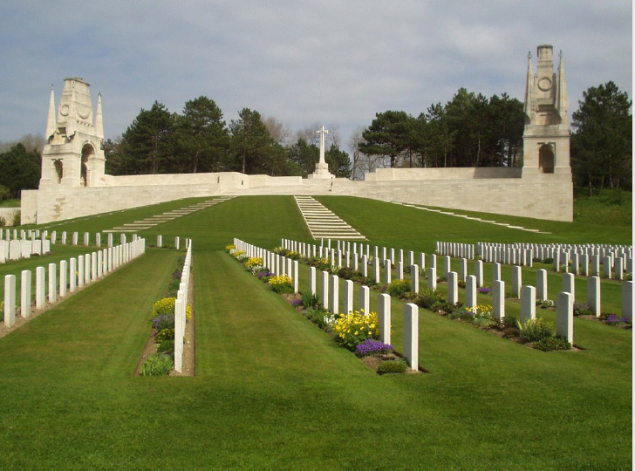

The Western Gazette reported on 16th July 1915:

War Casualties.

News has been received from the front of the deaths of Private E Trotman lst Somersets who was killed in action, and Private J. Hayward.

John’s wife, Emmie, returned to live in Stoke with the children, Evelyn and Leslie, and according to the Commonwealth War Graves Commission, was living in West Street. Emmie died aged 43 in 1922.

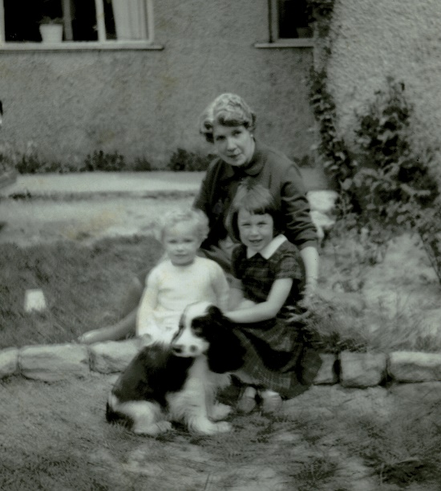

This is a photograph of John’s daughter, Evelyn, with her two granddaughters. It was kindly lent to me by Evelyn’s son. Evelyn never talked about her childhood in Wales with her father; it was as if her life started when she returned to Stoke with her mother and brother at the time of the 1st World War. Perhaps she shut that part of her life off because it was associated with her grief about her father’s death. The paths of so many families were changed because of the war.

Evelyn’s son joined 1st Battalion of the Somerset Light Infantry when the time came for his National Service, not knowing at the time that this had been his grandfather’s regiment.

