James Thorne’s Story
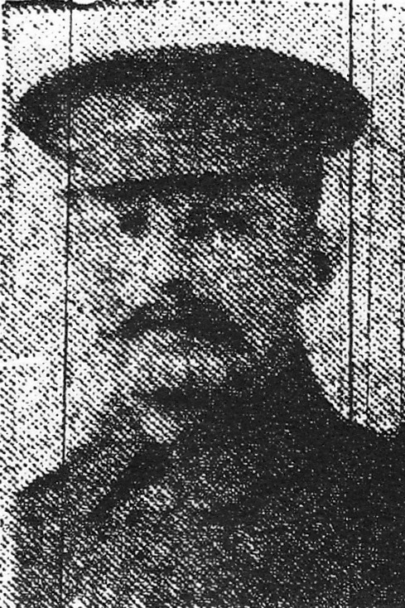
James was out in France for just over a month before he was killed. He was another of the young men from Stoke who went to Wales in search of work and was living there when war broke out in 1914.

He was born in the summer of 1875 to Joseph and Louisa Thorne. The Thornes were an old Stoke family. James’ grandparents, Samuel and Ann Thorne, were living in Higher Street in 1841.

James’ parents, Joseph and Louisa, were married in 1872, and had nine children, eight of whom survived. James, I think, was the second child. His elder brother, George was born in 1873. James’ father had lived with his family in the High Street before he was married and after his marriage, he continued to live in the High Street but was living in Percombe in 1891 when James was 16 and working as a shepherd.

By 1901, James had moved to 5 Stanley Street in Senghenydd, with his wife, Rosina. Both were from Stoke. James’ 16 year old younger brother, William, was living with them, and both were working as coalminers.

They were probably working at the Senghenydd coal mine. In 1913, there was a huge explosion in the mine and 440 men and boys lost their lives. Several of the men came from Stanley Street where James and his family lived.

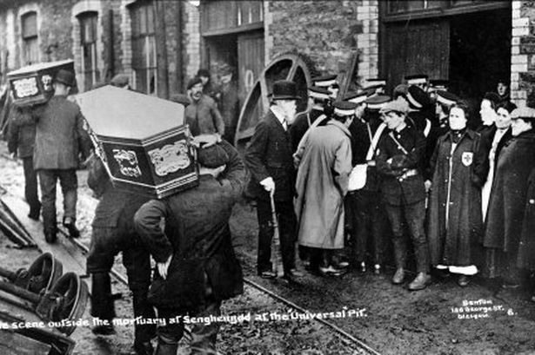

However, when the 1911 census was taken, James and Rosina were living about a mile south of Senghenydd, in No 32 Aber Fawr Terrace, Abertridwr. The coal mine at Abertridwr was called the Windsor Colliery. Hopefully, James was working here rather than at Senghenydd at the time of the 1913 explosion.

In fact, an accident had happened at the Windsor Colliery too, not many years earlier. On Sunday 1st June 1902, sinkers were at work deepening the shaft, when the platform on which they were working collapsed tipping nine men into 25 feet of water, which had gathered in the sump. Three managed to escape drowning by clinging onto floating debris but the other six lost their lives.

When war broke out in 1914, joining up must have seemed in some ways a safer option than working down the mines. Perhaps for wives like Rosina, never quite sure whether their husbands were going to make it home at the end of their shift, enlistment in the army was not as much of a worry as it was to wives whose husbands had safer jobs.

Rosina is a little inconsistent about her age in the census returns, but if she is the Rosina Chant who married James Thorne in Pontypridd in 1899, and was working as a draper’s assistant with Charles and Elizabeth Rowsell from Yeovil in Regency Street, London, in 1891, then she was actually ten years older than he was.

James’ family in 1911 when they were living at No 32 Aber Fawr Terrace, Abertridwr, consisted of James, aged 38 and working as a coal miner, Rosina,
Ivor aged six, Bertha 8 and Beatrice 2. James’ children were all born in Abertridwr. Ewart Whitley and Tom George from Stoke were living with the Thorne family, aged 21 and 19 respectively and both working as coalminers.

Ewart Whitley’s father, William, married Rosina Webber Thorne in 1883. There may be a family connection between James Thorne and Rosina but I have not been able to discover it. Ewart was to die at Gallipoli in 1915. Tom George served in the submarine service and survived the war.

James enlisted in the Welsh Regiment and arrived in France on 11th March 1915. In little over a month, he was dead.

Now there is a mystery about which Battalion James was in. I have not been able to find any army record existing for him. The Medal Rolls Index has him down simply as being in the Welsh Regiment – but it has him down twice as if perhaps he may have changed Battalion. The Commonwealth War Graves Commission say that he was in 2nd Battalion.

The Western Gazette reported in May 1915 that he died fighting on Hill 60, along with Percy Wines of the Canadians, and he is buried at Bedford Hill Cemetery near Hill 60, but on 22nd April, at the time of James’ death, the 2nd Battalion was further south, in the Neuve Chapelle area, and about to take part in the battle of Aubers Ridge (May 1915).

The 1st Battalion of the Welsh Regiment, however, DID take part in the fighting on Hill 60, being part of the 84th Brigade in the 28th Division. James may well have started out in the 2nd Battalion and been transferred to the 1st.

There was a report in the Western Gazette on 14th May 1915:

News was received from the War Office by the parents, on Sunday, of the death of Private P Wines of the Canadians, and James Thorne of the Welsh Regiment, who were killed on April 22nd fighting on Hill 60.

Battle of Hill 60

From: http://echoesofwar.blogspot.co.uk/2009/01/hill-60-and-queen-victorias-rifles.html

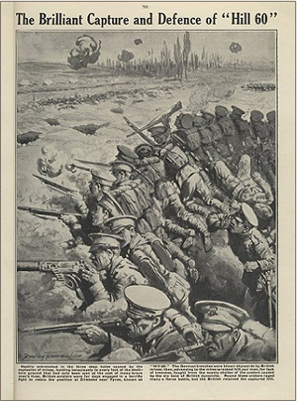
Hill 60 was a low rise on the southern flank of the Ypres Salient, named for the 60 metre contour which marked its bounds. It wasn’t a natural hill but was created by the ground removed whilst constructing the railway line nearby. The Hill had been captured by the Germans on December 10, 1914 from the French forces. During the race for the sea, it was obvious the Hill had to be retaken. A great deal of the fighting around Hill 60 was underground as can be seen by the memorials today. The British immediately began tunnelling a number of mines beneath the Hill. By April 1915 twenty one mines had been completed. At 19:00 on April 17, 1915 the mines were detonated, demolishing a large part of the Hill and killing many German soldiers occupying the trenches. The British battalions suffered only seven casualties in capturing the Hill.

A German counter-attack succeeded in recapturing the Hill but the British regained possession on April 18. Fighting continued until April 22.

Hill 60 was eventually taken by the Germans following a gas attack on 5 May, 1915. The two Alberts from Stoke – Bowden and Minchington – both fought and died with the 1st Dorsets on Hill 60, and Percy Wines with the Canadians.

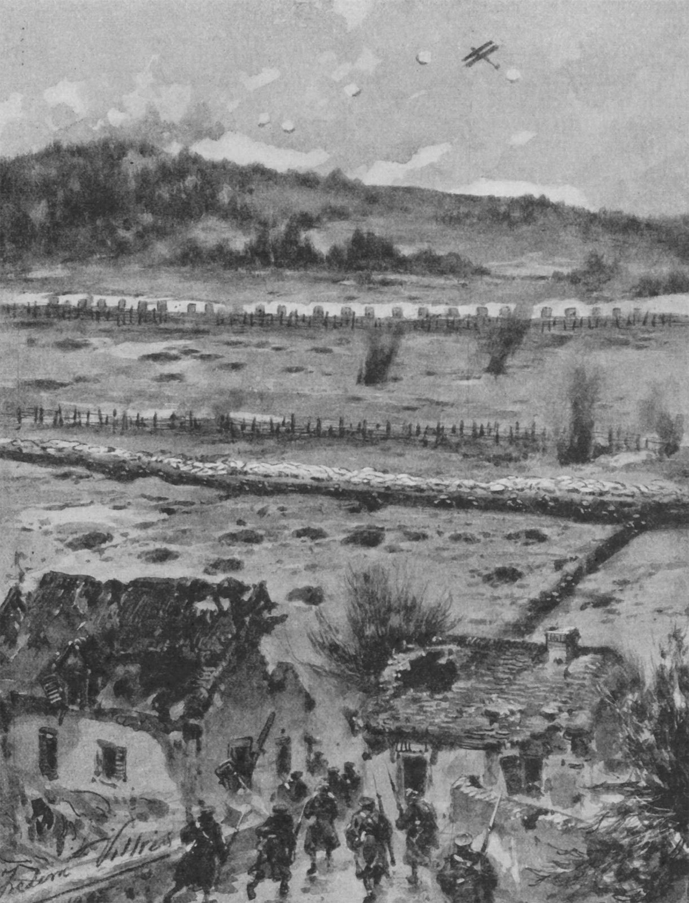

Sketch of German position at Hill 60 in early April 1915

Private Charles Blane of the Scottish Borderers writes in “Voices and Images of the Great War”:

We arrived in the trenches about 1 a.m. on the morning of 17 April and during the day we were told that Hill 60 was going to be blown up at 7 o’clock and that we were to be prepared for it.

At 7 p.m. exactly the hill was blown up and it was an awful sight to see, practically the whole hill blown up, for the miners or Sappers had undermined it like a spider’s web, and there must have been a tremendous amount of explosive used.

There were Welsh miners working beneath Hill 60, possibly known to James.

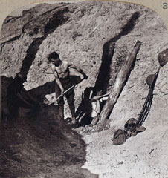
‘Sappers and miners at work on a tunnel under Hill 60, overlooking the Ypres salient, blown up April 1915’

[National Army Museum]

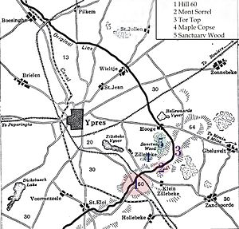
Bedford House Cemetery where James is buried
Hill 60 - 17 April – 7 May 1915

James is buried in the Bedford House Cemetery, south of Ypres and west of Zillebeke.

.

