Walter Drew’s Story

Ellen Drew lost her husband when she was only 48. Her eldest son, Walter, must have been a support to her. His brothers, Herbert and Frederick were respectively six and fifteen years younger than Walter.

Walter’s family on his mother’s side, the Haines, had been villagers in Stoke for at least sixty years. His great grandfather, Samuel Haines, was living in the Lock’s Lane area on Ham Hill, in 1841. Walter’s grandfather, another Samuel, was married three times. Walter’s mother, Ellen, was the daughter of his second wife, Eliza, who died in 1867. Samuel went on to have four more children with his third wife, Ruth.

Walter’s father Thomas Drew, was a shoemaker, born in the St Luke’s area of London around 1859. He is possibly the Thomas Drew aged 12 who was living with the Cross family in South Petherton as a shoemaker’s apprentice in 1871. Thomas’ father, according to Thomas and Ellen’s marriage entry in the Stoke records, was a Stephen Drew, but there is no mention of a Stephen Drew in any of the census returns for the village, though there is a Charles Drew, shoemaker, living with his family in the High Street.

Thomas and Ellen married in Stoke in 1879, and two years later were living in Highway. Nathaniel Haines, Ellen’s youngest half-brother, aged 12, was living with them. Ellen was working as a glover. Their first son, Walter, was born in 1881. By 1888, Thomas had moved with Ellen and Walter to the shoemaking town of Street, where Herbert and Frederick were born. In 1901, Thomas describes himself as a “boot and shoe channeller,” and Walter, aged 19, as a “boot machine tender.”

In the autumn of 1907, Thomas Drew died at the early age of 48, leaving Ellen a widow with three boys of widely disparate ages. On the 1911 census for Street, Walter (29)was listed as a council labourer, Herbert (23) a gardener, and Frederick – aged 14 – working in a “Skin Factory”.

Some time after 1911, Ellen came home to live in Ham Hill again. Perhaps it was after her two oldest boys had joined up and she felt the need of support from her family. Walter had enlisted early in 1915.

He joined the 9th (Service) Battalion of the Devonshire Regiment and when you read about the actions that regiment took part in, you realise how amazing it was that he survived until 1917.

The Battle of Loos 25th September 1915 – Assisted the 8th Battalion in the capture of the German guns. The C.O., Adjutant and three Company Commanders were all killed and the Battalion decimated.

July 1st 1916 - Opening day of the Battle of the Somme offensive. All officers except one Lt. became casualties: 17 Officers and 447 O.R.s.

14th July 1916 - Supported 8th Devons in the attack on the Bazentin Ridge.

20th July 1916 - Attack on High Wood: over 100 casualties.

3rd – 9th September 1916 – Fighting around Ginchy.

May – August 1917 – Fighting around Bullecourt and the outposts of the Hindenburg Line. Attack and capture of Croiselles.

October 1917 – 3rd Ypres, Battle of Paschendaele. Attack astride the Ypres-Menin road in attempt to capture Gheluvelt. Attrocious conditions: untold odds, very heavy shelling, appalling mud. A battle against pill-boxes and machine-guns, with very heavy casualties.

I have not been able to trace Walter’s service record, and there is no mention in the local papers of his having been wounded and sent home between 1915 and 1917, so we have to assume that he took part in most of these actions.

He was killed the day before the action at Gheluvelt on 24th October 1917.

The War Diary of the 9th Battalion of the Devonshires records that on 23rd October, the Battalion moved from camp at Westoutre to camp at Scottish Wood.

Scottish Wood was given that name by the Liverpool Scottish in 1915. It was 4 km south west of Ypres and was used as a rest area. Westoutre is also south west of Ypres and south of Poperinge.

On the night of 24th/25th October the Battalion moved up from Zillebeke Lake to a position opposite Gheluvelt.

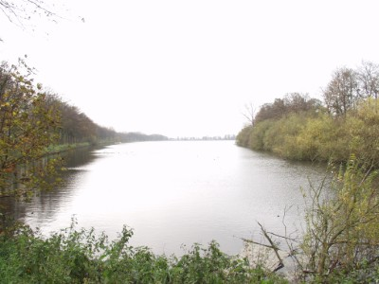

Zillebeke Lake, frequently under German artillery fire throughout the War

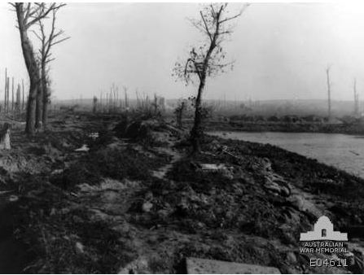Tis area w
Zillebeke Lake in 1917fr
The dispositions of the Battalion were:

No 4 Company in Front Line
No 2 Company in Close Support
Nos 1 and 3 Companies in Reserve

By the time the relief was completed that night there had been 27 casualties due to shellfire.
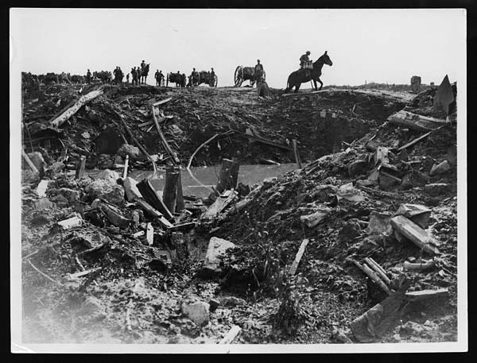

On the road to Gheluvelt - 1917

Walter was listed as missing His mother did not get confirmation of his death until nearly a year later, when it was officially concluded that he had been one of those killed that night. He was 36 years old, and is remembered on the Tyne Cot Memorial. There are 11,956 Commonwealth servicement of the First World War buried or commemorated in Tyne Cot Cemetery; 8,369 of these are unidentified.

His brother, Frederick (Somerset Light Infantry), was wounded in action in Egypt (probably in 1917) but survived the war.

Walter is remembered on the Tyne Cot Memorial:

