Albert Wilkinson’s Story

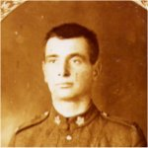

Complexion: Dark
Eyes: Brown
Hair: Black
Religion: Methodist
Height: 5’ 10”

Albert John Wilkinson was the only son of William (Plummy) Wilkinson and Harriet Locock (though Plummy went on to be married twice more and produce six more children).
Plummy himself was the only child of John and Ruth Wilkinson. In 1871 the little family of three were living in “Castle” in Stoke. Plummy was four years old. Some time after this, his father left Stoke to find work in Wales. He was obviously not a good correspondent because when Plummy was seven or eight years old, he and his mother, Ruth, walked all the way to South Wales to try to find him. They stopped at Shepton Mallet Workhouse, among other places.

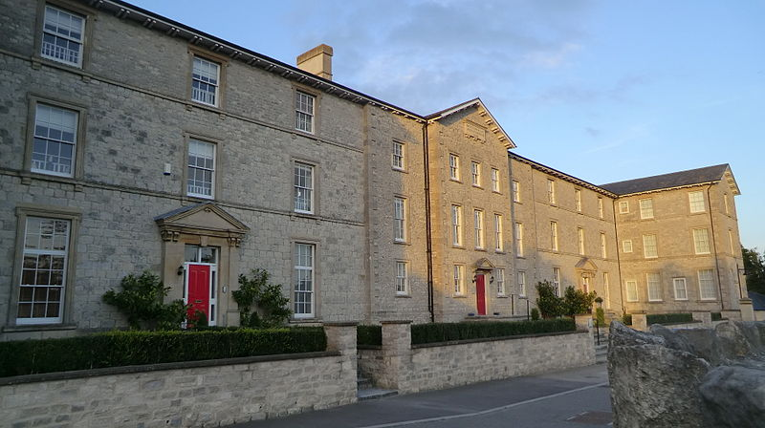

Shepton Mallet Workhouse (became Norah Fry Hospital)

The building looks rather fine with the sunlight on it, but must have struck fear into people who had to stay in it in the 1870’s.

Poor Ruth died in 1874 in South Wales and Plummy’s father wanted to keep him there with him but his parents, John and Hepzibah Wilkinson, fought to have custody of him and he was brought back to Stoke to live with them.

In 1881, Plummy was 14 years old and living with John and Hepzibah in West End, Stoke, along with his three aunts, Susan, Emily and blind Mary, and Hepzibah’s mother, Susan. His father eventually returned from South Wales and remarried and Plummy lived with him for a little while but this was not a success.

In the spring of 1889, he married Harriet Locock, daughter of Walter and Jane Locock of Bower Hinton, and Albert was born on 1st June 1889. Harriet was said to have died in childbirth. Her death is actually registered for the year after, 1890, but she may have been ill after the birth and never recovered.

In 1891, Plummy was living in West Street with Albert aged two, and Hepzibah, Albert’s great grandmother. A year later, on 1st August 1892, Plummy married Martha Marsh and they had five children, the youngest born in 1904.

By 1911, Albert had left home and was living as a lodger with the Seaman family in Englishcombe near Bath. He was 22 years old and working as a mason’s labourer. Herbert Thorn from Stoke was also lodging there and working as a mason’s labourer - house builder.

According to his army record, Albert spent two and a half years in the Somerset Light Infantry prior to his service in the 1st World War.

Some time after this and before the start of the war, he decided to emigrate to Canada, and leaving his dog, Budget, with his father, went to work on a farm in a sparsely populated area of Canada, with his friend, David Dodge. There was family tradition that Albert left the country after a little trouble where he was caught poaching rabbits.

In Canada he and David Dodge had a team of horses and did jobs on farms. One day, David forgot to put the lid back on a horse trough and the farmer’s child fell in and was drowned. David felt so badly about it that he couldn’t face the family and decided to join up. Albert joined up with him, volunteering to serve with the 2nd Battalion Canadian Infantry (Eastern Ontario Regiment). His attestation papers describe his complexion as dark, eyes brown, hair black, religion Methodist and height 5’10”.

From 28th August to 7th October 1916, he attended the School of Infantry at Kingston, Ontario, passing the required examination to qualify as Sergeant. His previous army experience and his deep, carrying voice (inherited from his father) gave him an advantage in drilling recruits.

His friend, David Dodge, was then given a posting to go overseas and, in order to go with him, Albert relinquished his rank and took a demotion to private.

BATTLE OF ARRAS

Albert died in the summer of 1917. I don’t know when he and David arrived in France but they may well have been with the 2nd Battalion Canadian Infantry in the Battle of Vimy Ridge, part of the Battle of Arras where the main combatants were the Canadian Corps, of four divisions, against three divisions of the German Sixth Army. The battle took place from 9th to 12th April 1917. The objective of the Canadian Corps was to take control of the German-held high ground along an escarpment at the northernmost end of the Arras Offensive.

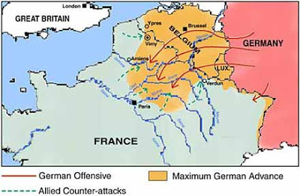

Supported by a creeping barrage, the Canadian Corps captures most of the ridge during the first day of the attack. The town of Thélus fell during the second day of the attack, as did the crest of the ridge once the Canadian Corps overcame a salient of considerable German resistance. The final objective, a fortified knoll located outside the town of Givenchy-en-Gohelle, fell to the Canadian Corps on 12 April. The German Forces then retreated to the Oppy-Méricourt line. The battle was the first occasion when all four divisions of the Canadian Expeditionary Force participated in a battle together and thus became a Canadian nationalistic symbol of achievement and sacrifice. [Wikipaedia]

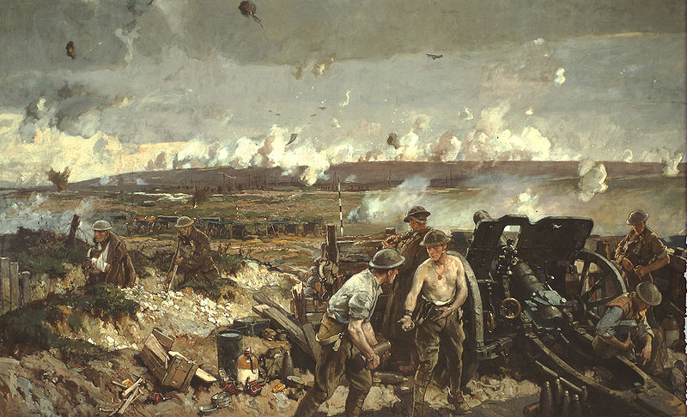
The Battle of Vimy Ridge - painting by Richard Jack

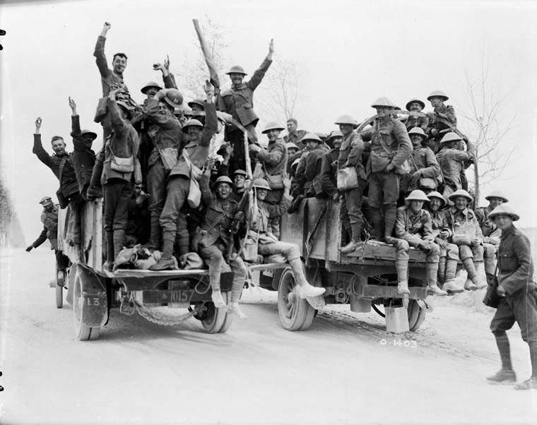
Happy Canadians who captured Vimy Ridge returning to rest billets on motor lorries,
May 1917

Credit: Library and Archives

The 2nd Battalion Canadian Infantry then took part in the 3rd Battle of the Scarpe on 3rd May 1917.

The following photographs and information are from: http://ptbowwi.blogspot.co.uk/2012/05/3-may-1917-fresnoy-3rd-battle-of-scarpe.html

2012 marks the 95th anniversary of the Battle of Arras. The British led offensive started on the 9th of April and concluded on the 16th of May 1917. Historians predominately from the United Kingdom have led the charge in commemorating the anniversary of the Arras campaign. As for my fellow Canadians, our interest in the campaign starts and ends with the battle of Vimy Ridge (9 – 12th April 1917).Vimy’s importance to the psyche of Canadians is measured by our national First World War monument that was constructed on Vimy Ridge. As for the 3rd Battle of the Scarpe or the other 34 days of the Arras offensive? Canadians know very little if anything at all; even Canadian Historians have very little interest in studying or writing about the Arras Campaign after the Canadian victory at Vimy.

Many English tourists that travel by ferry over the English Channel often make their first rest stop at Canada’s monument at Vimy Ridge. Even the most uninterested of visitor, laden with sandwiches in the French countryside cannot help but be amazed at the representation of Mother Canada mourning her sons. Vimy is a tempting subject for historians; it was an overwhelming surprise victory that took place on Easter Monday, with Canadian Corps losing 10,602 men (3598 KIA). The battles that followed on the Douai plain like Fresnoy seem like an operational maneuver compared to Vimy. In my view, the Battle of Fresnoy, is just as important as Vimy. The attack and defence of Fresnoy demonstrates that the Canadian victory at Vimy was not luck or a one off victory. By May 1917 the Canadian Corps had become one of the premier fighting forces on the Western Front, comparable with the ANZACs and our British counterparts.

Before proceeding, a brief overview of situation on the ground is needed. By late April 1917, the British Arras offensive had almost run out of steam. On the other side of no man’s land, the Germans had moved to the vicinity of the Hindenburg line, and refused to give more ground. The Hindenburg Line was an impressive constructed network of German defensive fortifications, tunnels, trenches, barbed wire and bunkers. In the north, the Canadians had captured Vimy Ridge overlooking Douai Plain and the German lines. Allied artillery now had observation of enemy movements, trenches, and supply columns for several kilometres. In the centre, the British had launched two separate offensives with very limited results. At the southern flank, the Australians were stuck in pitched struggle at Bullecourt and Lagnicourt.

On 3 May 1917, the 3rd and final Battle of the Scarpe began. After the war, a British military historian wrote that the first day of combat as “a day which many who witnessed it considered it to be the blackest day of the war.” The British continued their attack in the centre, with minimal results, and the Australians resumed the near suicidal battle of Bullecourt. The Canadian objective on 3 May was to capture a village of Fresnoy, a 1000 yards to east of Arleux.

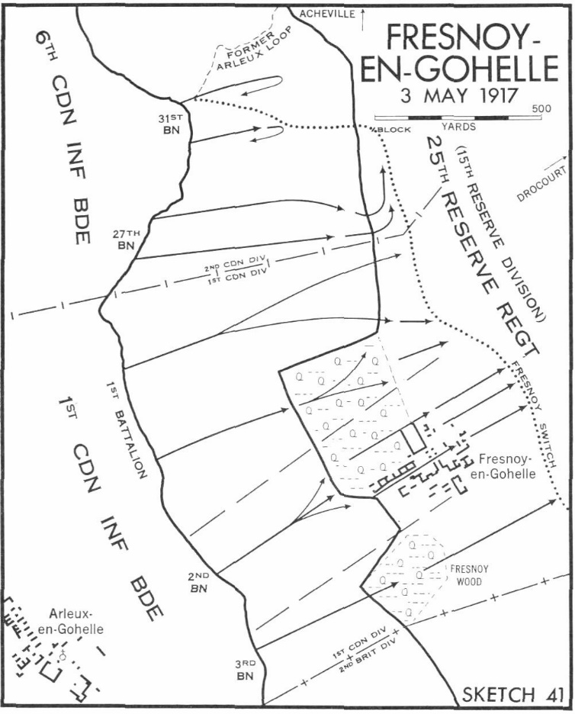
Map of the Battle of Fresnoy,
3 May 1917.
Credit: Official History of the Canadian Army in the First Word War: Canadian Expeditionary Force 1914-1919, G.W.L. Nicholson

The red-roofed village of Fresnoy was positioned between two wood lands. The 1st Canadian Brigade (Ontario) was assigned the objective. The 2nd Battalion (Eastern Ontario) [Albert’s Battalion] was to capture the town, and the 1st and 3rd Battalions were to secure the wooded areas located on the sides of the town. The Canadians rehearsed the assault for two days on mock enemy positions, akin to the operational preparation to the attack on Vimy Ridge.
In the German trenches, soldiers were on a high state of alert after nearly a month of combat. German intelligence sensed another push after witnessing a build-up of troops along the Allied lines. At roughly the time as the British offensive began, the Germans began to shell the British and Canadian lines. A duel between the German and British heavy and medium artillery commenced.
As both sides shelled each other, the signal was given to launch the attack. The Canadian rolling barrage hit Fresnoy at 3:45am, cutting much of the enemy wire. Many Germans from the 25th Reserve Division were forced to seek shelter from the inferno of shells and shrapnel. The artillery pounded and careened into the trench network that surrounded the French village. Following behind the screen of exploding earth and sandbags was the attacking Canadians. In effort to repulse the attack, German machine gun fire raked the approaches to the village; luckily the darkness hid the Canadians as they approached Fresnoy.

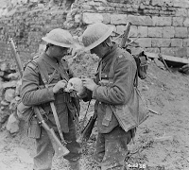
Examining a Skull found on a battlefield
of Vimy Ridge.

Credit: Library and Archives

Once the Canadians had breached the wire in front of the village, the 3rd Battalion swung south, clearing out the German trenches with enfilading fire. The 3rd Battalion had captured 500 yards beyond their objective (support lines), but in the process they had sustained high losses, losing 1 of their 3 assault companies, roughly 200 men. In the northern sector of the attack, the 1st Battalion quickly overcame the enemy wire, and advanced upon the trenches parallel to the woods known as Fresnoy Park. The 1st Battalion had the easiest task of the 3 units on 3 May, their assigned objective was lightly held and quickly taken.

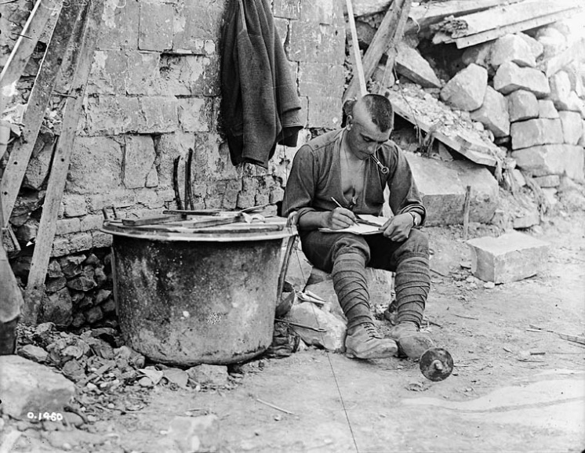
Canadian writing home from the line, May 1917
Credit: Library and Archives
In the centre of the attack, the 2nd Battalion’s attack was carried out with surgical pin-point accuracy. The three machine gun posts that guarded the town had been silenced within minutes with the use of rifle grenades and covering fire as the assault squads advanced upon the German guns. After cleaning out the trench network, the battalion proceeded to secure the town, neutralizing any remaining resistance that they encountered in buildings. By 6am, the battalion was consolidating their newly won position and digging new defences 250 yards east of Fresnoy.
Once enemy commanders realized the nature of the rupture of their line at Fresnoy, two rapid counter-attacks were ordered. Around 10am, the Canadians received a peppering of high explosive shells on Fresnoy. After the shelling had subsided, units from the German 15th Reserve Division were spotted advancing upon the village from the north east. The enemy counter attack was quickly broken up after the British and Canadian artillery unleashed a torrent of shells and machine gun fire among the attacking infantry. In the early afternoon two more units, the German 4th Guard Division and 185 Infantry Division, were ordered into the fray. The second German attack was able to enter into the Canadian lines, but after the arrival of a stokes mortar crew and a liberal use of grenades, the enemy attack could not advance any further and withdrew.

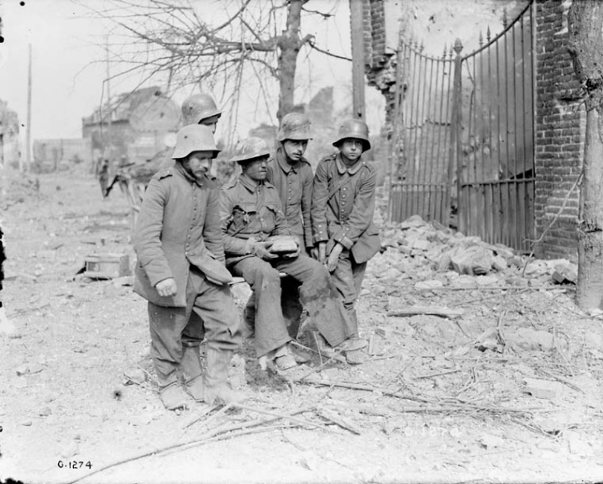
German Prisoners of War helping a wounded Canadian, Arleux 1917.
Credit: Library and Archive

As the sun set on 3 May 1917, the Canadians had been involved in nearly 16 hours of strenuous defense and assault. They had lost 1,269 men taking Fresnoy. On the German side, the first day of the 3rd Battle of the Scarpe, official records list their deepest losses occurring at Fresnoy. The loss of Fresnoy did not sit well with the German High Command. One German regimental historian wrote that the Canadians had knocked Fresnoy, “out of the German defensive wall which had to be replaced without delay.” The Allies occupying the town had a commanding sight over sections of German trenches in the Oppy-Méricourt line and the Hindenberg Line (Wotan Stellung).

The War Diary of the 2nd Battalion states after the battle that morale was “splendid during the whole period under review … all the Company Commanders reported to me that the men, in spite of the incessant shelling, were in good spirits and very confident. This excellent condition lasting throughout, and even on relief when the Battalion was heavily bombarded with gas shells, many volunteered to stop to carry out wounded. They carried out five captured machine guns through heavy shelling and gas.”

The casualty report for Fresnoy for the 2nd Battalion was 10 officers and 400 other ranks.
The 2nd Battalion moved out of the trenches and into Elbe Shelters on 5th May, and then to Barlin on 6th May where they stayed until 3rd June. Training musketry and bombing was interspersed with bathing parties, football and boxing finals (a boxing competition where “bouts were fought and a scientific sparring was displayed”), Church parade, a shooting competition and a garden party given by the C.O. in the grounds of Chateau du Maire.

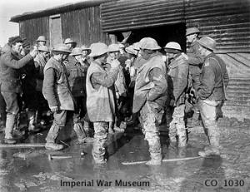

Canadian troops, wearing leather jerkins and trench waders,
utside a coffee stall in the mud. {Image courtesy of IWM]

They were back in the Front Line on 14th June, relieving the 3rd Canadian Battalion, and again on 22nd/23rd June (Railway Embankment area). By 26th June they were back from the Front Line, in Ottawa Huts, near Mont St Eloi. Inter-divisional sports were held at
Hersin.

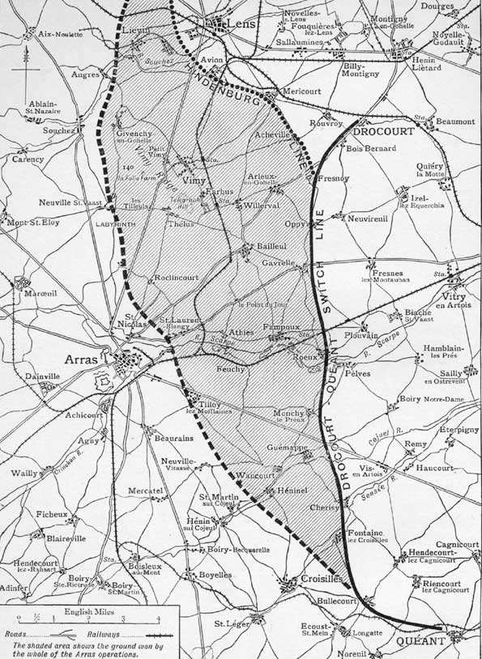
The village of Loos, where Albert’s battalion was when he died, is just north of Lens
Vimy Ridge
On 4th July, the Battalion moved to Brigade Reserve. The weather was showery. From 5th to 7th July, there were working parties, digging new trenches and improving others. There was considerable aerial activity on 10th July with intermittent bombardment by enemy artillery. One “other rank” was killed.

On 13th July, the 2nd Battalion relieved the 7th Canadian Infantry at Winnipeg Huts. They prodeeded to the front line area in front of the village of Loos on 22nde July. There were 24 officers and 698 men in their ranks. They arrived in the trenches at 6.00 a.m. on 23rd July. “Relief effected with but one casualty”. Weather was fine and very warm. They stayed in these trenches until 2nd August, which was the day when Albert was killed.

From 11.30 p.m. to midnight on 28th July, “gas bombs were projected by the enemy but no attempt was made to enter our lines. Weather warm and clear.”

At 12.30 a.m. on 28th July, “the enemy again employed gas bombs and shells against our left front line company, and the village of Loos. As respirators in almost all cases were quickly adjusted, we had only a very few cases reported up to noon. Weather showery.”

31st July. Weather cool and cloudy, turning to rain at night.

1st August. “There was intermittent machine gun fire during the night. At 3.45 a.m. to 4.30 a.m., our trenches were bombarded by enemy light guns. Our artillery opened up about 4 a.m. and succeeded in stopping it. Throughout the day there was litle activity except by a few of our heavy guns which bombarded enemy trenches and wire. Weather cool and showery.”

2nd August 1917 – the day of Albert’s death – “Intermittent machine gun fire continued through the early morning. At 4.00 a.m a barrage was put down by the enemy on the battalion on our right. The day was very quiet except for our heavies. At 11 p.m. parties of the 16 Canadian Battalion began to arrive and to relieve parties of the 2nd Canadian Battalion. Weather threatening.”

There is no mention of any casualties that day or when they moved out of the trenches on the night of 2nd August but the letter which Albert’s father received (at 4 Ham Hill) from the Canadian Record Office in London on 13th August definitely states that he died in action rather than “of wounds” so we have to believe that he died while his battalion was in the front line trenches at Loos.

There was a report in the Western Gazette on 17th August 1917:

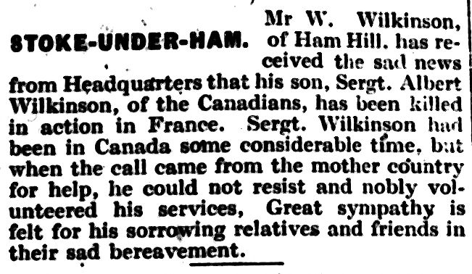

Albert is remembered at the Maroc British Cemetery, Grenay, about 15 kilometers south-east of Bethune.

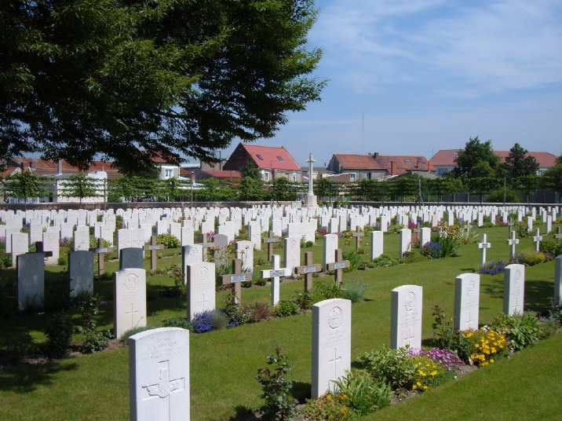

With special thanks to Eileen Caines and Carol Parker for their help in
writing about Albert.

