Fred Sparks’ Story

Killed in the last months of the War, after having been wounded twice.

The Sparks family moved to Stoke (North Street) around 1889. His parents, John and Fanny/Jenny Sparks, were born in Ilminster. Their first batch of children, John, Joseph, Sarah, Mary Ann and Bessie were all born in Ilminster. Then James and Fred were born in Chard, and Walter in Kingsbury. William and Daisy/Dolly were born in Stoke sub Hamdon.

By 1901, the family were living on Percombe Hill. John Sparks Senior had died, leaving Fred’s mother a widow with seven children. John and James are still at home, working as general labourers. Fred was 18 and working as a carter. Walter was 16 – “yard man to factory”, and then there were Elizabeth 14, William 12 and Dolly 10.

Fred, like many of the Stoke men, moved to Wales in search of work, and it was presumably in Wales that he met the woman he was to marry, Lucy Evans. Lucy was born in Llangunlo, Radnorshire, in 1864. She was 41 at the time of her marriage to Fred in 1905. Four years earlier, she had been living in Llangunlo with her widowed mother, Anne Evans, and Bessie Aiken – Anne’s 8 year old grand-daughter.

She gave her age as 38 on the 1911 census (Fred was 33), but in fact she would have been 47. She and Fred were living with Bessie Aiken at 11 Protheroe Street, Llangynwyd. Bessie was said to be their niece. There were two boarders living in the house but Fred and Lucy had no children of their own.

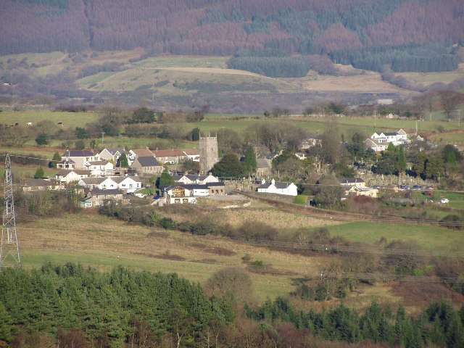
Llangynwyd Village

Was Bessie was Lucy’s illegitimate daughter? Did Lucy see in the lonely Somerset boy her last chance of marriage? Or perhaps Lucy and her mother offered him friendship and the odd hot meal and then she and Fred fell in love. Whatever the situation was, at least Fred had a little experience of being a husband and stepfather before he was killed in the War, something which many of the boys from Stoke never had.

Six of the men of Stoke who died during the War were working in Wales before they joined up, including Fred. Frank Boon enlisted at Brecon. Albert Bowden, Hugh Grinter, Fred Hellier and John Hayward were all in the South Wales area north of Cardiff. Fred was working as an engine driver (stationary) which sounds as if it might have been something to do with the coal industry.
The Western Gazette reports that Fred had been in France for over nine months when he was wounded in April/May 1917. This would have brought his entry into France to around July 1916, and we know that he enlisted in Yeovil. At the time of his death, Fred was with the 1/5th Battalion of the Duke of Cornwall’s Light Infantry (No. 31810), but according to Soldiers Died in the Great War, he was initially in the Somerset Light Infantry (No. 22412). Not knowing which battalion of the Somerset Light Infantry he was in, or when he was transferred to the Duke of Cornwall’s Light Infantry, it is difficult to know which actions he took part in.
On 4th May 1917 the Western Gazette reports:
A Wounded Soldier – News has been received that Private F Sparks has been wounded in the left shoulder during the recent fighting in France. Pte Sparks who has been in France for over nine months is now in a Manchester Hospital.
On 19th October 1917, there is a further report in the paper:
Local Casualties – Pte Fred Sparks has been wounded while in action in France.
If Fred had transferred to the Duke of Cornwall’s Light Infantry by the beginning of 1918, he would have been involved in the German Spring Offensive – Germany’s attempt to end the War. Germany had an extra 500,000 troops from the Russian Front. The Allies were undermanned and demoralised after the battles of Passchendaele.

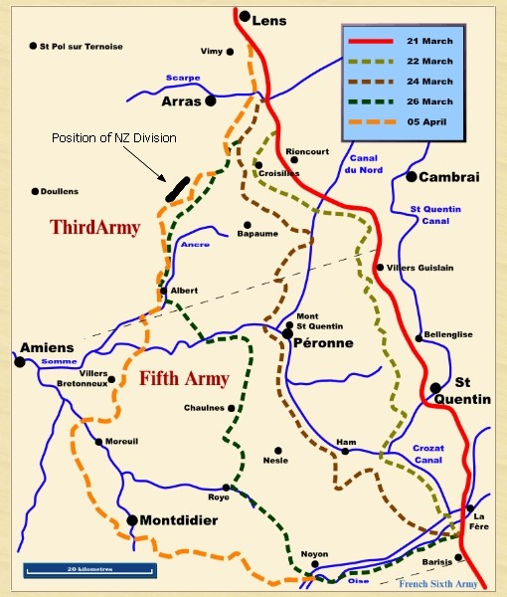
The 61st Division was with the General Gough’s Fifth Army, north west of St Quentin

There was a weakness in the British line to the west of Cambrai on the Somme, and it was in this area, on March 21st 1918, that the big German attack took place. Fred Spark’s Battalion was here, north west of St Quentin, as part of the 61st Division, with General Gough’s Fifth Army. The 61st Division lost many men as it fought a chaotic but ultimately successful withdrawal back over the Somme crossings over the next ten days. General Gough had the command of the Fifth Army taken from him.
Andrew Roberts writes:
The offensive saw a great wrong perpetrated on a distinguished British commander that was not righted for many years. Gough's Fifth Army had been spread thin on a forty-two-mile front lately taken over from the exhausted and demoralised French. The reason why the Germans did not break through to Paris, as by all the laws of strategy they ought to have done, was the heroism of the Fifth Army and its utter refusal to break. They fought a thirty-eight-mile rearguard action, contesting every village, field and, on occasion, yard . . . With no reserves and no strongly defended line to its rear, and with eighty German divisions against fifteen British, the Fifth Army fought the Somme offensive to a standstill on the Ancre, not retreating beyond Villers-Bretonneux.

By the time it was relieved at the gates of Amiens, the Division had been involved in continuous action since August 1917 and was exhausted. What was left of the Division was moved north to what had been a quieter part of the line on the La Bassee Canal near Bethune. Unfortunately it was near where the Germans launched the second phase of their offensive on 9 April 1918. The Division became involved and many casualties were incurred.
The 61st Division took part in the Battles of the Lys during April – Estaires, Hazebrouck and Bethune.
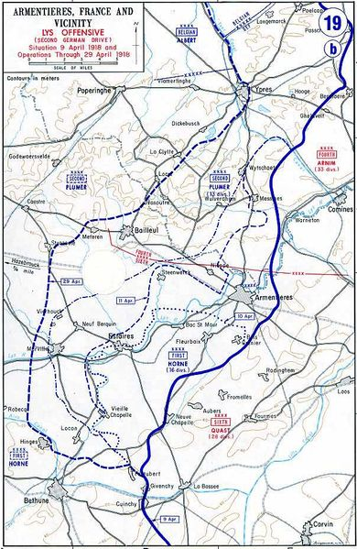
Ypres
Estaires
Bethune
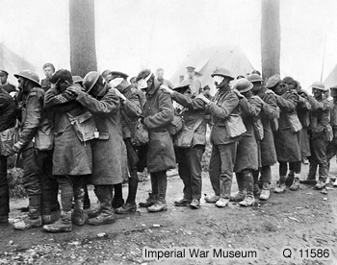
Dressing Station – Bethune – April 1918 – Troops blinded by tear gas

[Imperial War Museum]

The Division then took part in the Advance in Flanders (also known as the 5th Battle of Ypres) between 18th August and 6th September 1918.

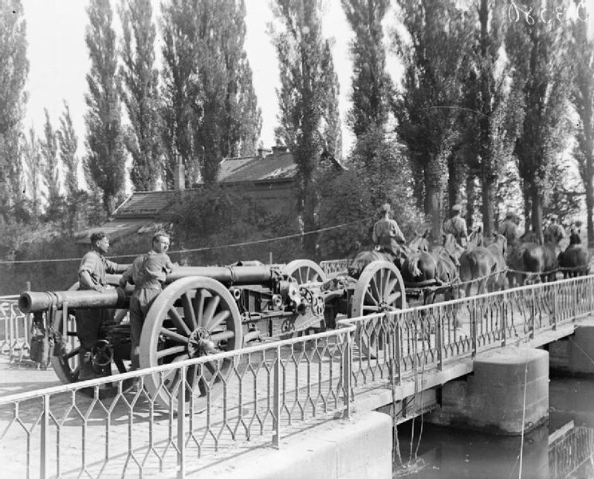
A British 60 pounder gun on Mk 1 carriage moving forward through St Venant during the advance in Flanders – 22nd August 1918

Fred Sparks was killed on 14th September. Unusually, his name is actually mentioned in the War Diary, but we don’t know exactly how he died.

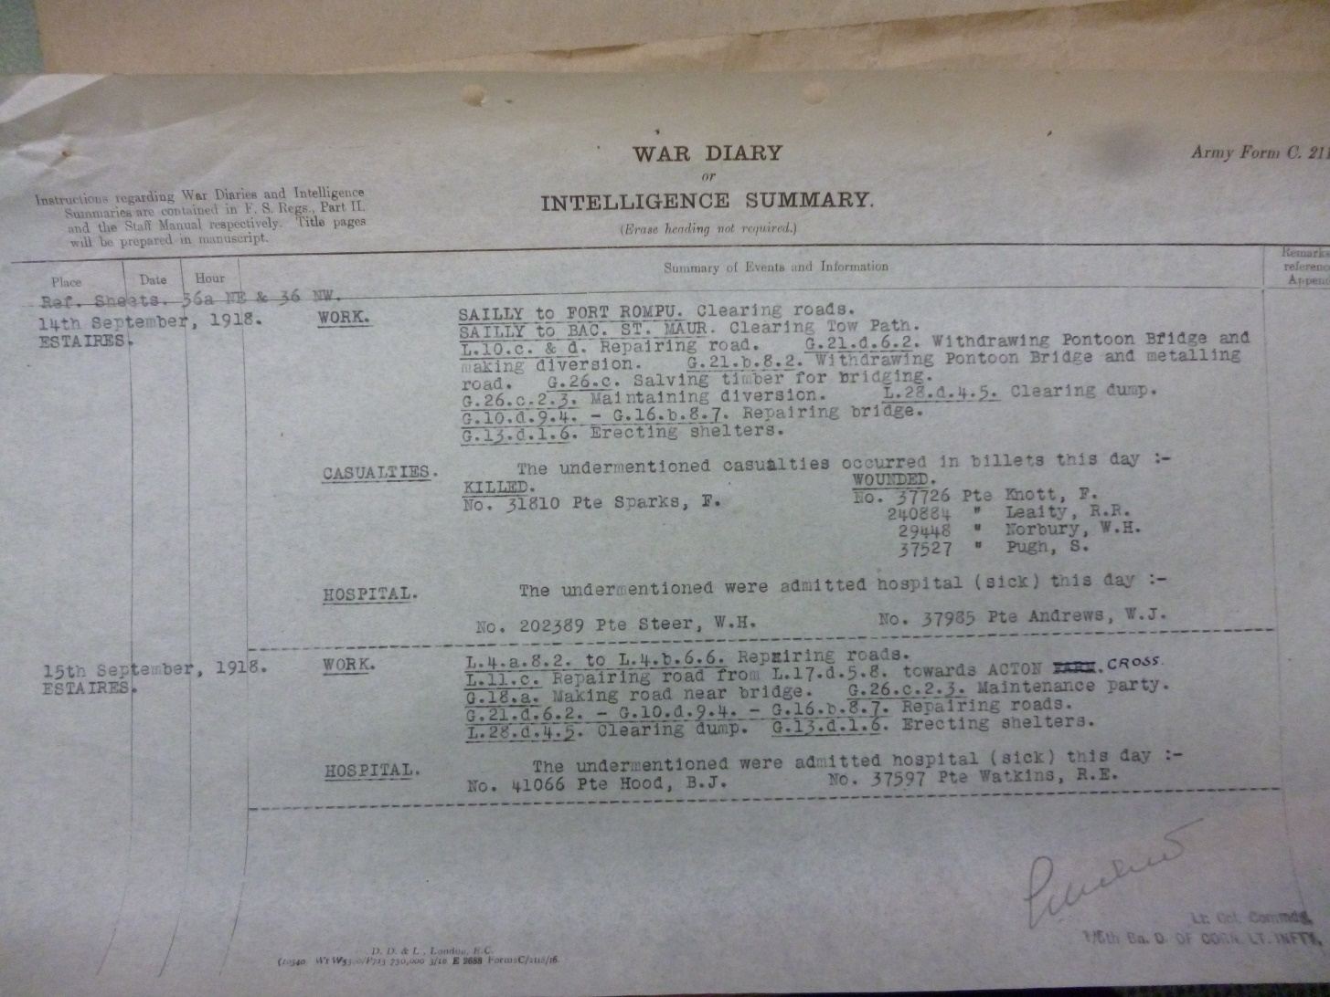

There is a report in the Western Gazette on 4th October 1918:

Killed in Action – Private Sparks, fourth son of the late Mr J Sparks of Percombe, Stoke under Ham, has been killed in action. The deceased who has twice been previously wounded, was killed on 14th September 1918. He was one of the brave lads to answer Kitchener’s call. Much sympathy is felt for his relatives in their loss.

Fred is remembered with honour in the Estaires Communal Cemetery and Extension.

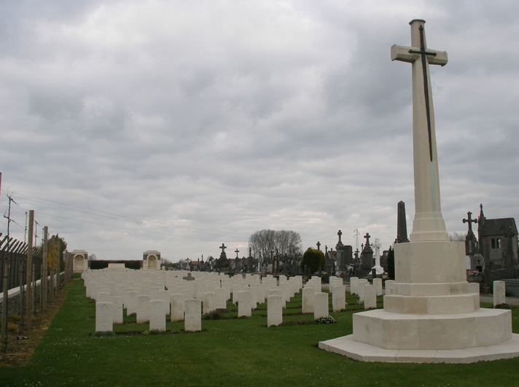

There was a Lucy Sparks who died in Bridgend aged 53 in the autumn of 1923. This may have been Fred’s wife.

